**Objective Questions:**

1. In analyzing the dataset with Power BI, ensure data cleaning to address inconsistencies and missing values before further analysis?

Ans: The data has been cleaned and made ready for analyzing using multiple ways as

1. Removed the extra columns from the data surviving no purpose
2. The data type of order dae and delivery date has been changed to Dae format
3. The column Reason were having inconsistency in the data with blank cells ,hence replacing those blank cells with “No Reason” as a value.
4. A column named Order Year is created for further calculation

**2**. How can we calculate the total revenue generated by all the sales?

Ans: Using the card method of visualisation ,the total revenue of the sales is calculated.It is around 107.24M in the Main tab of the file.

**3.** What is the total number of unique customers who made purchases in each year? Is there any increase in the number over the years?

Ans: 25179 is the total number of unique customers who made purchases in each year. There is a increase in the number

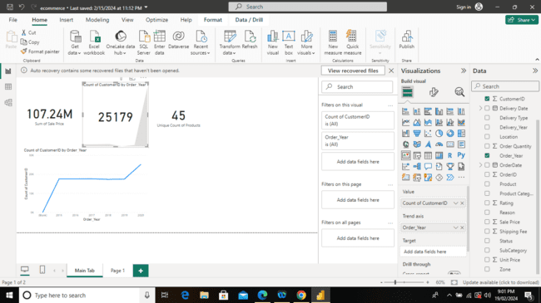

**4.** .How can we determine the total number of unique products available in the

Company?

Ans: By navigating to the Main tab one can see the unique count of products given i.e 44 by using the card visualisation .

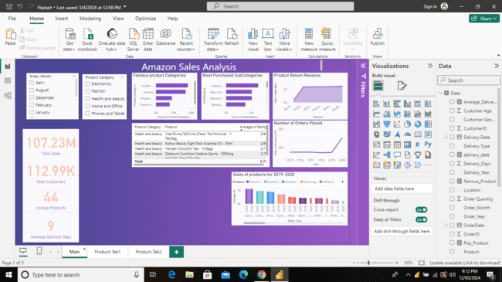

1. What is the average number of days it takes for products to be delivered, get the metric for only the delivered orders?

Ans: It takes around 9 days on an average for delivering the orders.

We have also applied a filter for that particular measure for status having

Delivered Value.

Measure is created with the formula as -

Average_Delivery_Days = AVERAGE(Data[Delivery_Days])

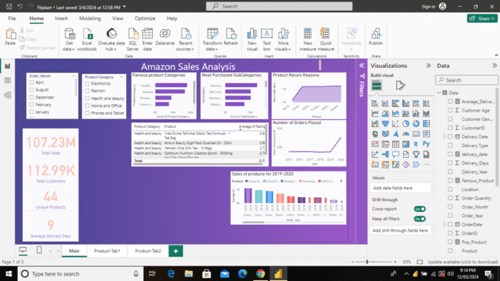

1. Which products, categories, and subcategories are the most popular?

Ans: In the main tab of the file one can see the most popular products, category

and also subcategories.

There are visualisation techniques of bar graph and table used for it.

| Category | Health and beauty |
| --- | --- |
| Sub Category | Vitamins and dietary supplements |
| Product | * Vida Divina TeDivina (Detox Tea Formula) - 1 Tea Bag * Optimum Nutrition Creatine Sports - 5000mg per Daily Serve Powder * Hemani Ultra Slim Tea - 10 Bags * Cq Amaigrissant Slimming Tea - 20 Tea Bags * Aichun Beauty Eight Pack Essential Oil - 30ml |

The product category is calculated by using two different measures

1. Famous_Product =

CALCULATE (

DISTINCTCOUNT ( Data[Product] ),

ALLEXCEPT ( 'Data', 'Data'[Product Category], 'Data'[SubCategory] )

)

2. Pop_Product = MAXX('Data',[Famous_Product])

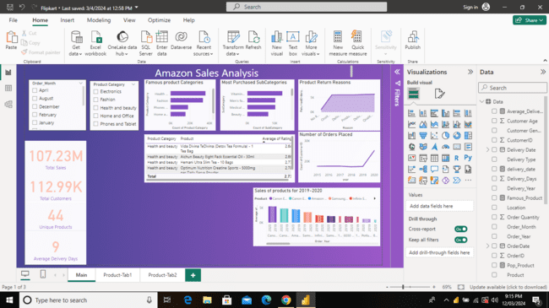

1. Which products have seen an increase or decrease in sales over the year?

Ans: Almost Every product have seen an increase or decrease in sales over the

Year.  
 In order to get the accurate comparisons for the latest year from Data we have chosen 2020 and 2019 for the Sale Price of the Products.

**Subjective Question:**

1. How does revenue break down by year and by-product? Evaluate how different products contribute to annual revenue and come up with suggestions to increase the sales of the low-selling items.

Ans: In the Product tab there are product wise and year wise break down of the

Total sales of the products present.

There are almost 45 different products present. Out of which 2 products have

the low average order quantity.

These are calculated as follows:

AverageOrderQuantity = AVERAGEX(VALUES('Data'[Product]), CALCULATE(SUM('Data'[Order Quantity])))

LowSellingProducts = [AverageOrderQuantity] < AverageOrderQuantity

| Product |
| --- |
| Canon EOS 600D 18MP CMOS DSLR Camera - Black |
| Canon EOS 60D CMOS DSLR Camera Bundle - 18 - 55mm Lens - Black |

These are some products which are low selling.

In order to increase the sale of low selling products we can put those products on sale,by applying the discount on the products for selling them quicker.

We can also advertise this to enhance the marketing.

We can also take feedback from customers so that the Root Cause Analysis can be done based on the feedback and we can work upon them to increase the sales.

1. How many products were returned? Examine the possible reasons for returns and consider how this metric could inform improvements in product descriptions or quality control.

Ans: Almost 31,000 products were returned and the reasons provided by customers

were as follows

| Reason | ReturnedOrdersCount |
| --- | --- |
| Quality-Defective item | 6065 |
| Delivey - Missing item/part | 6013 |
| Product - Not fitting expectation | 5872 |
| Delivery-Wrong item | 5868 |
| Onsite -Description mismatch | 5827 |
| No Reason | 881 |

A new measure was created in order to find the total returned products.

ReturnedOrdersCount = CALCULATE( COUNTROWS('Data'), 'Data'[Status] = "Returned" )

Since we can see most of the products were returned There can be many possible reasons including

* Poor packaging
* Damage while transporting
* Item Misplaced
* Fraud items

The above reasons can be handled by focusing on each aspect of the product.

Good quality packaging products can be used to avoid damage while transporting.

1. Whenever a customer goes to Amazon, they’ll filter the most rated products in order to buy the better category. Can you verify this using any visualisation or table that the ratings of products impact their sales value?

Ans: The sales value does get affected by the most rated products. In the main tab we can see the scatter plot.The first column is having more number of dots and the total sales of the products with high count rating is higher as compared to other ratings.

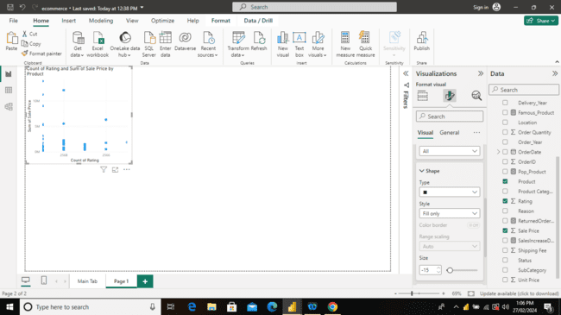

4 Investigate how revenue distribution varies across different locations. Explore which geographical areas contribute most to sales and consider the strategic implications for regional marketing and distribution efforts. How might location-based trends inform the company's approach to market segmentation and resource allocation?

Ans:

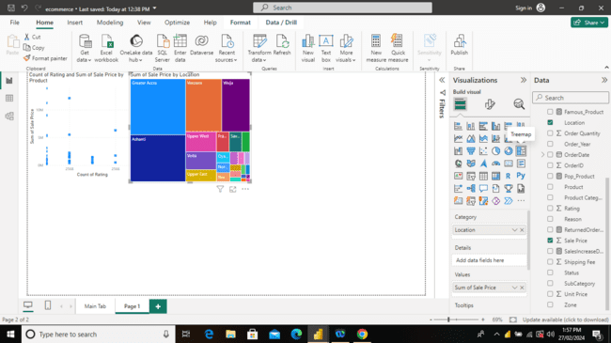

Maximum sale is in the Greater Accra location with a total of 20M of sales.

Minimum sales is in the Dawhenya Location with a total of 85K.To maximise the

sales in region having less sales some strategic considerations can be as-

* Marketing Strategies:

Customising marketing messages and campaigns for each region based on identified preferences.

* Resource Efficiency:

Allocating marketing budgets and resources efficiently by focusing efforts on regions with the highest potential return.

* Localised Product Offerings:

Considering offering region-specific products or services based on identified preferences.

5. Determine which month could benefit from enhanced promotional offers to

boost sales. Can you suggest some targeted marketing strategies here?

Ans: 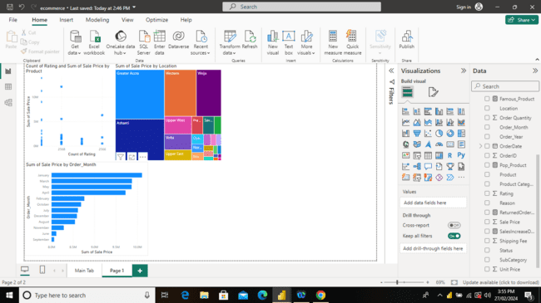

As we can see in the chart ,in the month of January , maximum sales happen.

Hence promotional offers can boost sales in January.

Some of the marketing strategies can be-

1. Month-Specific Promotions:

* Designing promotions and discounts tailored to the identified low-performing months.
* Considering limited-time offers, flash sales, or exclusive deals to attract customer attention.

1. Seasonal Campaigns:

* Aligning marketing campaigns with the seasons or events that impact sales.
* Creating promotions or product bundles associated with specific months.

3.Customer Feedback Incentives:

* Incentivizing customers to provide feedback and suggestions during specific months.
* Using insights to refine products, services, or marketing strategies.

6. Identify which products may require increased marketing efforts. Which

items have high prices yet underperform in sales?

Ans: Below 5 are the low selling products

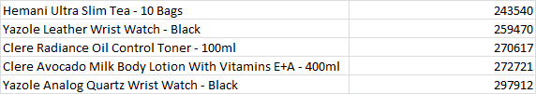

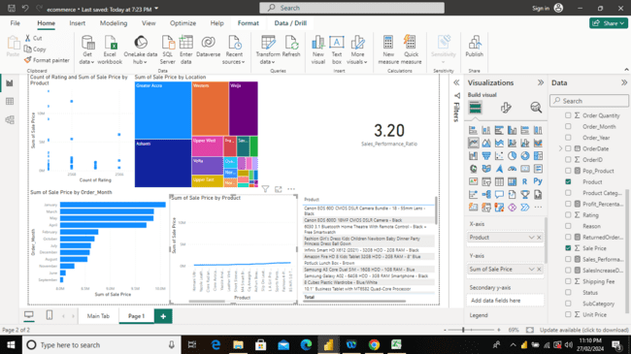

Hence these products might require increased marketing efforts as they have low total sales.

Below is the table containing the products having low profit hence underperformed top five products.

| Product | Profit_Percentage |
| --- | --- |
| Canon EOS 60D CMOS DSLR Camera Bundle - 18 - 55mm Lens - Black | 0.002443783 |
| Canon EOS 600D 18MP CMOS DSLR Camera - Black | 0.987854481 |
| 6030 3.1 Bluetooth Home Theatre With Remote Control - Black + Free Smartwatch | 4.466953918 |
| Fashion Girl's Dress Kids Children Newborn Baby Dinner Party Princess Dress Ball Gown | 4.491342167 |
| Infinix Smart HD X612 (2021) - 32GB HDD - 2GB RAM - Black | 4.499198926 |

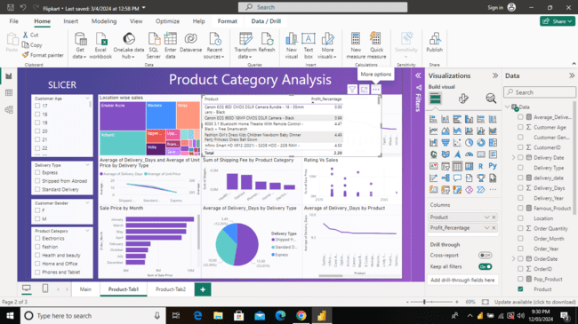

In order to get this table we need a measure named Profit_percentage.

Profit_Percentage = DIVIDE(SUM(Data[Sale Price]) -SUM( Data[Unit Price]), SUM(Data[Unit Price]), 0) * 100

7. Assess which products should have discounts. How can targeted incentives drive

sales and customer loyalty for specific products?

Ans: The low selling products and the underperformance products should have discounts so that users can buy them at lower price and the sales will also be increased.

Some of the underperforming products are-

| Product |
| --- |
| Canon EOS 60D CMOS DSLR Camera Bundle - 18 - 55mm Lens - Black |
| Canon EOS 600D 18MP CMOS DSLR Camera - Black |
| 6030 3.1 Bluetooth Home Theatre With Remote Control - Black + Free Smartwatch |



We can build the strategies for the discounts like-

* Offering discounts on slow-moving products to clear inventory.
* Creating bundle discounts to encourage customers to buy complementary products.

Leverage Loyalty Programs:

* Incorporating discounts as part of a loyalty program to incentivize repeat purchases. This can enhance customer loyalty over time.
* Continuously monitoring the impact of discounts on sales and customer loyalty.

8. Come up with a loyalty program to benefit the company’s customers. From the available lot of customers come up with strategies to bucket them and provide benefits under different loyalty programs.

Ans:Designing a loyalty program involves understanding customer behaviour, preferences, and creating tailored strategies to incentivize repeat business. Here's a step-by-step approach to create a loyalty program and categorise customers for different benefit tiers:

### 1. Customer Types:

* High-Spending Customers:
  + Those who consistently make large purchases.
* Frequent Shoppers:
  + Customers who make frequent transactions, even if the individual purchases are smaller.
* New Customers:
  + Those who recently joined and need incentives to become regulars.

### 2. Loyalty Zone:

* Gold Zone(High-Spending):
  + Exclusive access to premium products.
  + Personalised shopping assistance.
  + Higher percentage cash back or discounts.
* Silver Zone(Frequent Shoppers):
  + Points for every purchase leading to discounts.
  + Early access to sales or new product launches.
* Bronze Zone(New Customers):
  + Welcome discounts or vouchers for the first few purchases.
  + Bonus points for the first transaction.

### 3. Referral Program:

* Encourage Referrals:
  + Offer additional benefits for referring friends.
  + Both the referrer and the new customer receive rewards.

9.**Wait Times Correlated with Demographics and Care:** Explore how average wait times vary across different product categories to optimize scheduling and staffing.

Ans:

The wait time can affect the products in many ways.

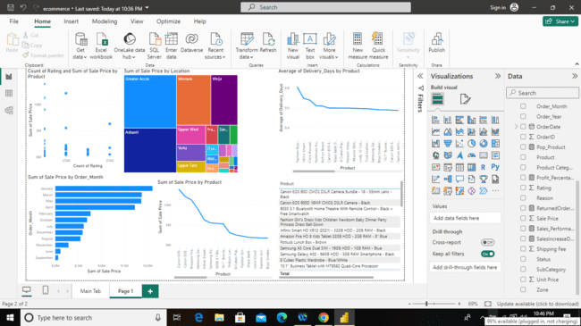

As we can see in the graph above most of the products are getting delivered in about 9 days.

Optimising scheduling and staffing for most products involves strategic planning, efficient resource allocation, and responsiveness to demand fluctuations.

There are some ways to optimise scheduling and staffing

### Flexible Shifts:

* Implementing flexible work shifts to accommodate varying demand throughout the day.

### Automation:

* Automating routine and repetitive tasks in the order fulfilment process.

### Dynamic Scheduling:

* Implementing dynamic scheduling systems that can adapt to changing demand.

### Demand Forecasting:

* Utilising historical sales data to forecast demand for each product.

10.Explore if there is any relationship between the Delivery type and waiting time between ordering and receiving an item.

Ans:

Below is the pi chart explaining about the relationship between delivery type and waiting time between ordering and receiving an item.

Most of the shipped from abroad products had a average delivery time of around 15 days which is almost 52% of total products,

standard delivery products had a average time of 10 days and it makes the 35% of total products

While Express delivery is least famous among three types having 3 days of average time and makes around 12% of total products.

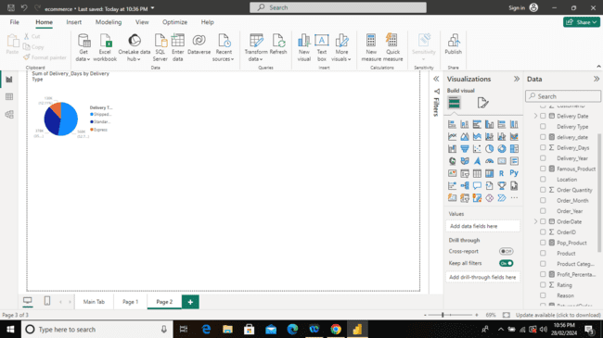

11. Is there any relationship between shipping charges and product type?

Ans:

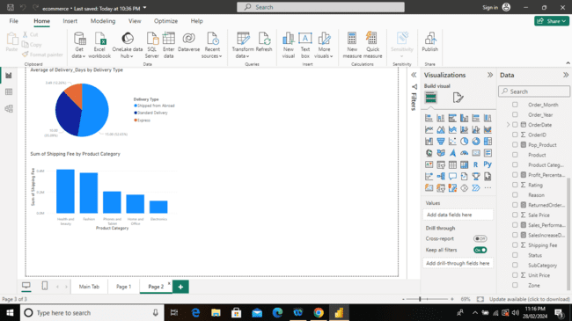

Health and beauty type of product category has the highest shipping charges, followed by fashion ,phones and tablets, home and office and at last Electronics.

Since we have seen earlier that health and beauty is the most popular category of the products, it is safe to say that shipping charges for the same category are high.

12. Come up with strategies to decrease the low rating orders after analysing different factors like waiting time, shipping type, unit price, etc.

Ans:

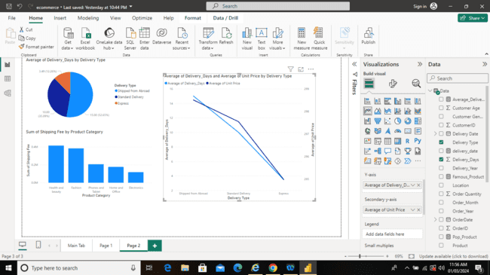

As we can see in the above image, we have plotted the graph for avg delivery days, avg price vs delivery type.

We can see that for products shipped from abroad has more price as well as it takes more days of delivery i.e. 15 when compared with other types.

The same phenomenon can be applied for other two types of delivery also viz. Standard delivery and Express.

Hence the higher the price, the more days of delivery are taken to ship and deliver a product.