Objective Questions:

1. What is the distribution of account balances across different regions?

Ans:

|  |  |
| --- | --- |
| 1 | France |
| 2 | Spain |
| 3 | Germany |



In the given above image we can see the distribution of Balances in France ,Germany and spain.

The distribution of account balances refers to how the monetary values in bank accounts are spread across various regions, namely France, Spain, and Germany. In the context of financial data, this analysis helps understand the economic activity and financial health of each region.

2. Identify the top 5 customers with the highest Estimated Salary in the last quarter of the year. (SQL)

Ans:

select c.CustomerId,c.EstimatedSalary,c.Bank_DOJ from warehouse_order.ci c join

warehouse_order.bc b on c.CustomerId=b.CustomerId

where b.Tenure=4

order by EstimatedSalary desc limit 5

With this given query we have got top 5 customers with highest salary for last tenure.

|  |  |
| --- | --- |
| CustomerId | EstimatedSalary |
| 15682834 | 199857.47 |
| 15687913 | 199805.63 |
| 15672152 | 199693.84 |
| 15698474 | 199661.5 |
| 15743040 | 199645.45 |

3. Calculate the average number of products used by customers who have a credit card. (SQL)

Ans: select round(avg(NumOfProducts))as average_products_used from warehouse_order.bc where HasCrCard=1

This is the query used to calculate average products use by credit card holders

|  |
| --- |
| average_products_used |
| 2.0 |

4. Determine the churn rate by gender for the most recent year in the dataset.

Ans: ChurnRate =

DIVIDE(

COUNTROWS(FILTER('Bank_Churn', 'Bank_Churn'[Exited] = 1 )),

COUNTROWS(Bank_Churn),

0

)

By using this measure we have calculated the churn rate as-

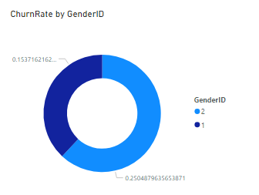

As we can see in the image above ,females have the most churn rate.

5. Compare the average credit score of customers who have exited and those who remain. (SQL)

Ans: SQL queries can be written as -

select (avg(CreditScore))as CreditScore from warehouse_order.bc where Exited=1

|  |
| --- |
| Credit score of excited |
| 645.35149729995135 |

select (avg(CreditScore))as CreditScore from warehouse_order.bc where Exited=0

|  |
| --- |
| Credit score of Stayed |
| 651.85319603164726 |

Percentage Difference= 1.01%

6. Which gender has a higher average estimated salary, and how does it relate to the number of active accounts? (SQL)

Ans:

To get the estimatedSalaries based on gender we can join the tables and group them by genderID

SELECT

ci.GenderId,

COUNT(bc.CustomerId) AS TotalActiveMembers,

ROUND(AVG(ci.EstimatedSalary)) AS AverageEstimatedSalary

FROM

warehouse_order.ci AS ci

JOIN

warehouse_order.bc AS bc

ON

ci.CustomerId = bc.CustomerId

WHERE

bc.IsActiveMember = 1

GROUP BY

ci.GenderId;

|  |  |  |
| --- | --- | --- |
| GenderId | TotalActiveMembers | AverageEstimatedSalary |
| 1 | 2867 | 99198 |
| 2 | 2284 | 99773 |

Here 1 is for Male while 2 is for Females. Hence we can see Average Estimated salary is higher for Females, and Total Active Members are higher for Male.

7. Segment the customers based on their credit score and identify the segment with the highest exit rate. (SQL)

Ans: WITH CreditScoreSegments AS (

SELECT

CASE

WHEN CreditScore >= 100 AND CreditScore < 500 THEN 'Low'

WHEN CreditScore >= 500 AND CreditScore < 700 THEN 'Medium'

WHEN CreditScore >= 700 AND CreditScore < 900 THEN 'High'

ELSE 'Unknown'

END AS CreditScoreSegment,

Exited

FROM

warehouse_order.bc

)

SELECT

CreditScoreSegment,

COUNT(Exited) AS TotalCustomers,

SUM(Exited) AS ExitedCustomers,

ROUND(SUM(Exited) / COUNT(Exited) * 100, 2) AS ExitRate

FROM

CreditScoreSegments

GROUP BY

CreditScoreSegment

ORDER BY

ExitRate DESC

LIMIT 3;

|  |  |  |  |
| --- | --- | --- | --- |
| CreditScoreSegment | TotalCustomers | ExitedCustomers | ExitRate |
| Low | 632 | 150 | 23.73 |
| Medium | 6220 | 1263 | 20.31 |
| High | 3148 | 624 | 19.82 |

As we can see in the table , segments with low credit scores i.s. CreditScore >= 100 AND CreditScore < 500 and the credit score associated with this segment is the highest of 23.73

8. Find out which geographic region has the highest number of active customers with a tenure greater than 5 years. (SQL)

Ans:

SELECT

c.GeographyID,

COUNT(*) AS ActiveCustomersCount

FROM

warehouse_order.ci c

join

warehouse_order.bc b

on c.customerId=b.customerId-- Replace with the actual table name

WHERE

b.IsActiveMember = 1

AND b.Tenure > 5

GROUP BY

c.GeographyID

ORDER BY

ActiveCustomersCount DESC

|  |  |
| --- | --- |
| GeographyID | ActiveCustomersCount |
| France | 797 |
| Spain | 431 |
| Germany | 399 |

France is the region having the highest Active Customers Count.

9. What is the impact of having a credit card on customer churn, based on the available data?

Ans:

We can calculate the churn rate by using the measure-

ChurnRate =

DIVIDE(

COUNTROWS(FILTER('Bank_Churn', 'Bank_Churn'[Exited] = 1 )),

COUNTROWS(Bank_Churn),

0

)

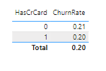

The impact of having a credit card on churn rate is almost same as that of having no credit card.

10. For customers who have exited, what is the most common number of products they have used?

Ans:

Customers who are exited from the bank have used the only 1 product mostly.

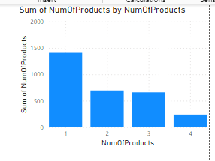

We can see in the image above , a total of 1409 customers have used 1 product.

11. Examine the trend of customers joining over time and identify any seasonal patterns (yearly or monthly). Prepare the data through SQL and then visualise it.

Ans:

In order to examine the trend we can write a query like

SELECT

FORMAT_DATE('%Y', Bank_DOJ) AS Year,

COUNT(CustomerId) AS NewCustomerCount

FROM

warehouse_order.ci

GROUP BY

Year

ORDER BY

Year;

|  |  |
| --- | --- |
| Year | NewCustomerCount |
| 2016 | 1951 |
| 2017 | 2143 |
| 2018 | 2593 |
| 2019 | 3313 |

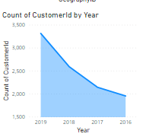

We can see in the year 2019 most customers have opened an account in the bank.

12. Analyse the relationship between the number of products and the account balance for customers who have exited.

Ans:

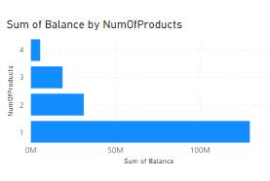

As we can see in the image above, the account balance of the customers who have used only 1 product is high and have also exited from the bank.

14. How many different tables are given in the dataset, out of these tables which table only consists of categorical variables?

Ans: There are two main tables in the dataset bank_Churn and CustomerInfo.

* bank_Churn table:
  + CustomerId: INTEGER
  + Surname: STRING
  + Age: INTEGER
  + GenderID: INTEGER
  + EstimatedSalary: FLOAT
  + GeographyID: INTEGER
  + Bank_DOJ: DATE
* CustomerInfo table:
  + CustomerId: INTEGER
  + CreditScore: INTEGER
  + Tenure: INTEGER
  + Balance: FLOAT
  + NumOfProducts: INTEGER
  + HasCrCard: INTEGER
  + IsActiveMember: INTEGER
  + Exited: INTEGER
* Hence most of the categorical Variables are present in the CustomerInfo table.

15. Using SQL, write a query to find out the gender-wise average income of males and females in each geography id. Also, rank the gender according to the average value. (SQL)

Ans: Wecan use a combination of SQL functions such as AVG(), GROUP BY, and window functions like RANK() to achieve this.

select GeographyID,GenderID,avg(estimatedSalary) as Income,

rank() over (partition by GenderID ORDER BY AVG(EstimatedSalary) DESC) as rank

from warehouse_order.ci

group by

GeographyID,GenderID

The output of the above given query for ranking the avg income by gender and geography id is given below-

|  |  |  |  |
| --- | --- | --- | --- |
| GeographyID | GenderID | Income | rank |
| 3 | 2 | 102446.4241 | 1 |
| 2 | 2 | 100734.1075 | 2 |
| 1 | 2 | 99564.25276 | 3 |
| 1 | 1 | 100174.2525 | 1 |
| 3 | 1 | 99905.03396 | 2 |
| 2 | 1 | 98425.68768 | 3 |

16. Using SQL, write a query to find out the average tenure of the people who have exited in each age bracket (18-30, 30-50, 50+)

Ans:

SELECT

CASE

WHEN ci.Age BETWEEN 18 AND 30 THEN '18-30'

WHEN ci.Age BETWEEN 31 AND 50 THEN '31-50'

ELSE '50+'

END AS age_bracket,

round(AVG(bc.Tenure),2) AS average_tenure

FROM

warehouse_order.ci

JOIN

warehouse_order.bc ON ci.CustomerId = bc.CustomerId

WHERE

bc.Exited = 1

GROUP BY

CASE

WHEN ci.Age BETWEEN 18 AND 30 THEN '18-30'

WHEN ci.Age BETWEEN 31 AND 50 THEN '31-50'

ELSE '50+'

END;

The output of the query is given as-

|  |  |
| --- | --- |
| age_bracket | average_tenure |
| 18-30 | 4.78 |
| 31-50 | 4.89 |
| 50+ | 4.83 |

17. Is there any direct correlation between salary and the balance of the customers? And is it different for people who have exited or not?

Ans:

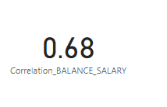

VAR X =

SUMX('Bank_Churn', 'Bank_Churn'[Balance] * RELATED('CustomerInfo'[EstimatedSalary]))

VAR Y =

SUMX('Bank_Churn', [Balance]^2)

VAR Z =

SUMX('CustomerInfo',[EstimatedSalary]^2)

RETURN

DIVIDE(X, SQRT(Y) * SQRT(Z))

As we can see in the image above, correlation coefficient came out to be 0.68 which is moderately positive But there is no strong relation between Balance and Salary..

And the plot for people who have exited is almost the same as that of those who have not exited from the bank.

18. Is there any correlation between the salary and the Credit score of customers?

Ans: correlation can be calculated by using the formula-

Correlation Coefficient =

VAR X =

SUMX('Bank_Churn', 'Bank_Churn'[CreditScore] * RELATED('CustomerInfo'[EstimatedSalary]))

VAR Y =

SUMX('Bank_Churn', [CreditScore]^2)

VAR Z =

SUMX('CustomerInfo',[EstimatedSalary]^2)

RETURN

DIVIDE(X, SQRT(Y) * SQRT(Z))

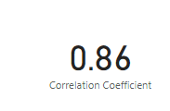

The value of 0.86 suggests that there is a strong positive relationship between the two variables.A coefficient of 0.86 indicates that as one variable increases, the other variable tends to increase as well, and vice versa, with very little variability.It's almost approaching a perfect positive correlation, meaning the relationship between the variables is highly consistent.

19. Rank each bucket of credit score as per the number of customers who have churned the bank.

Ans:

The query used for selecting the rank in order can be-

WITH CreditScoreSegments AS (

SELECT

CASE

WHEN CreditScore >= 100 AND CreditScore < 500 THEN 'Low'

WHEN CreditScore >= 500 AND CreditScore < 700 THEN 'Medium'

WHEN CreditScore >= 700 AND CreditScore < 900 THEN 'High'

ELSE 'Unknown'

END AS CreditScoreSegment,

Exited

FROM

warehouse_order.bc

)

SELECT

CreditScoreSegment,

COUNT(Exited) AS TotalCustomers,

SUM(Exited) AS ExitedCustomers,

ROW_NUMBER() OVER (ORDER BY SUM(Exited) DESC) AS CustomerRank,

ROUND(SUM(Exited) / COUNT(Exited) * 100, 2) AS ExitRate

FROM

CreditScoreSegments

GROUP BY

CreditScoreSegment

ORDER BY

CustomerRank;

|  |  |  |  |  |
| --- | --- | --- | --- | --- |
| CreditScoreSegment | TotalCustomers | ExitedCustomers | CustomerRank | ExitRate |
| Medium | 6220 | 1263 | 1 | 20.31 |
| High | 3148 | 624 | 2 | 19.82 |
| Low | 632 | 150 | 3 | 23.73 |

This is the output of the query as we can see the segment having Medium score has customer rank 1, high is having rank as 2 and Low segment has rank 3.

20. According to the age buckets find the number of customers who have a credit card. Also retrieve those buckets that have lesser than average number of credit cards per bucket.

Ans: Now to find the number of customers who have a credit card in age buckets we will use this query as-

SELECT

CASE

WHEN ci.Age BETWEEN 18 AND 30 THEN '18-30'

WHEN ci.Age BETWEEN 31 AND 50 THEN '31-50'

ELSE '50+'

END AS age_bucket,

COUNT(*) AS number_of_customers_with_credit_card

FROM

warehouse_order.ci ci

JOIN

warehouse_order.bc bc ON ci.CustomerId = bc.CustomerId

WHERE

bc.HasCrCard = 1

GROUP BY

age_bucket

ORDER BY

age_bucket;

And the output we will get as -

|  |  |
| --- | --- |
| age_bucket | number_of_customers_with_credit_card |
| 18-30 | 1400 |
| 31-50 | 4781 |
| 50+ | 874 |

Now for the second question we can use with function to get the previous query data stored

And work on it as a new table -

WITH crd_cnt AS(

SELECT

CASE

WHEN ci.Age BETWEEN 18 AND 30 THEN '18-30'

WHEN ci.Age BETWEEN 31 AND 50 THEN '31-50'

ELSE '50+'

END AS age_bucket,

COUNT(*) AS number_of_customers_with_credit_card,

FROM

warehouse_order.ci ci

JOIN

warehouse_order.bc bc ON ci.CustomerId = bc.CustomerId

WHERE

bc.HasCrCard = 1

GROUP BY

age_bucket

ORDER BY

age_bucket

)

select age_bucket ,number_of_customers_with_credit_card from crd_cnt

where number_of_customers_with_credit_card <(select avg(number_of_customers_with_credit_card) from crd_cnt)

|  |  |
| --- | --- |
| age_bucket | number_of_customers_with_credit_card |
| 18-30 | 1400 |
| 50+ | 874 |

This is the output of the query. As we can see there are only two groups where average of number_of_customers_with_credit_card is greater than the individual count of number_of_customers_with_credit_card.

21. Rank the Locations as per the number of people who have churned the bank and average balance of the customers.

Ans:

The query can be written as-

WITH ChurnedCustomers AS (

SELECT

ci.GeographyID,

COUNT(*) AS churned_customers_count

FROM

warehouse_order.bc bc

JOIN

warehouse_order.ci ci ON bc.CustomerId = ci.CustomerId

WHERE

bc.Exited = 1

GROUP BY

ci.GeographyID

),

AverageBalance AS (

SELECT

ci.GeographyID,

AVG(bc.Balance) AS average_balance

FROM

warehouse_order.bc bc

JOIN

warehouse_order.ci ci ON bc.CustomerId = ci.CustomerId

GROUP BY

ci.GeographyID

)

SELECT

c.GeographyID,

c.churned_customers_count,

a.average_balance,

RANK() OVER (ORDER BY c.churned_customers_count DESC, a.average_balance DESC) AS location_rank

FROM

ChurnedCustomers c

JOIN

AverageBalance a ON c.GeographyID = a.GeographyID

ORDER BY

location_rank;

And the output is given as-

|  |  |  |  |
| --- | --- | --- | --- |
| GeographyID | churned_customers_count | average_balance | location_rank |
| 3 | 814 | 119730.1161 | 1 |
| 1 | 810 | 62092.63652 | 2 |
| 2 | 413 | 61818.14776 | 3 |

22. As we can see that the “CustomerInfo” table has the CustomerID and Surname, now if we have to join it with a table where the primary key is also a combination of CustomerID and Surname, come up with a column where the format is “CustomerID_Surname”.

Ans:

We can use the concat method to join the customerID with surname as-

SELECT

CONCAT(ci.CustomerID, '_', ci.Surname) AS CustomerID_Surname,

ci.*,

bc.*

FROM

warehouse_order.ci

JOIN

warehouse_order.bc ON CONCAT(ci.CustomerID, '_', ci.Surname) = CONCAT(bc.CustomerID, '_', ci.Surname);

The output is-

CustomerID_Surname CustomerId Surname Age GenderID EstimatedSalary GeographyID Bank_DOJ CustomerId_1 CreditScore Tenure Balance NumOfProducts HasCrCard IsActiveMember Exited

15713346_Panina 15713346 Panina 24 1 88992.05 1 2017-05-07 15713346 794 6 146126.75 1 1 1 0

15748069_Clunie 15748069 Clunie 25 2 113266.09 1 2019-07-15 15748069 485 4 134467.26 1 1 1 0

24. Were there any missing values in the data, using which tool did you replace them and what are the ways to handle them?

Ans: By using the remove empty option of power bi ,any kind of empty rows were removed from both tables i.e.

There are many ways to handle them as-

Mean/Median/Mode Imputation: Replace missing values with the mean, median, or mode of the observed values in that column.

Dropping Missing Values: In some cases, it may be appropriate to drop rows or columns with missing values, especially if they are very few or not critical to your analysis.

25. Write the query to get the customer IDs, their last name, and whether they are active or not for the customers whose surname ends with “on”.

Ans:

SELECT

ci.CustomerId,

ci.Surname,

bc.IsActiveMember

FROM

warehouse_order.ci AS ci

JOIN

warehouse_order.bc AS bc

ON

ci.CustomerId = bc.CustomerId

WHERE

ci.Surname like '%on'

order by ci.Surname

This is the query that can be used to get the desired results as-

|  |  |  |
| --- | --- | --- |
| 15641110 | Abron | 0 |
| 15573599 | Adamson | 1 |
| 15589210 | Adamson | 0 |
| 15613048 | Anderson | 1 |
| 15661526 | Anderson | 0 |

Subjective Question:

1. Customer Behaviour Analysis: What patterns can be observed in the spending habits of long-term customers compared to new customers, and what might these patterns suggest about customer loyalty?

Ans-

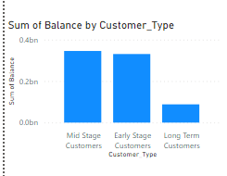

As we can see in the image above , the customers are divided into 3 types as-

Early Stage Customers for tenure values 3-4, Mid-Term Customers for tenure values 5-6, and Long-Term Customers for tenure value 7.

And Long term customers tend to spend less as compared to early stage customers.

For loyalty factor-

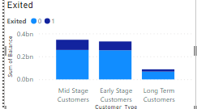

Most loyal customers are long term customers.

2. Product Affinity Study: Which bank products or services are most commonly used together, and how might this influence cross-selling strategies?

Ans: 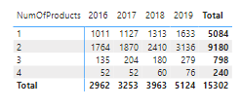

In the image given above there is a distribution of product purchase over the year and we can see that the products 1 and 2 were purchased a lot as there purchase count is higher i.e. 5084 and 9180 respectively.

And it is most likely that the products 3 and 4 must have been purchased together as they dont have as much as the purchase of products 1 and 2.

3. Geographic Market Trends: How do economic indicators in different geographic regions correlate with the number of active accounts and customer churn rates?

Ans: 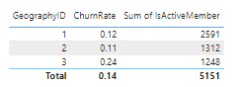

As we can see in the image the churn rate for Germany i.e. GeographyID 3 is higher as compared to others.

And the total active members in France i.e geography ID 1 is the highest.

4. Risk Management Assessment: Based on customer profiles, which demographic segments appear to pose the highest financial risk to the bank, and why?

Ans:

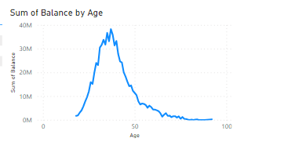

As we can see in the image above , the age group above 65 has a high financial risk as they do not have much balance in their account.

Since most of the retirements happen around the same age it is possible to have the low balance in the account during the same.

As far as the age group below 20 is concerned they are still in the learning phase of their life and hence they too have the low balance

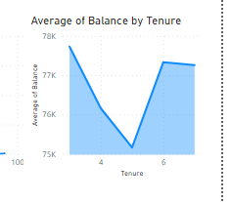

Also , the average balance of those having a tenure of 5 years is also low, and hence they are also at financial risk.

5. Customer Tenure Value Forecast: How would you use the available data to model and predict the lifetime (tenure) value in the bank of different customer segments?

Ans:

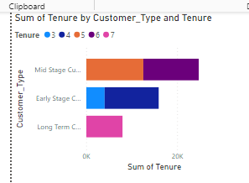

As we can see that the middle stage customers have the most tenure to be paid.

And the range of tenure for them is 5-6.

Hence based on this we can see the second largest segment is Early Stage Customers with the tenure of 3-4.

6. Marketing Campaign Effectiveness: How could you assess the impact of marketing campaigns on customer retention and acquisition within the dataset? What extra information would you need to solve this.

Ans: 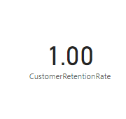

As we can see that we have got a customer retention rate of 1.

Which means that all customers who were present in the previous time period have remained with the company or organisation during the current time period.

The CustomerRetentionRate provides insights into the effectiveness of marketing campaigns in maintaining customer loyalty and preventing customer churn.

7.Customer Exit Reasons Exploration: Can you identify common characteristics or trends among customers who have exited that could explain their reasons for leaving?

Ans:

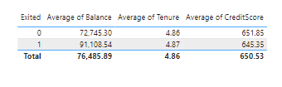

As we can see in the table the balance is high as compared to those who stayed.

* This could indicate that customers with higher balances may have different financial needs or expectations from the bank. They might be seeking better investment opportunities, higher interest rates, or more personalized services that the current bank couldn't provide.

Also the average tenure is of greater value than to those who remained.

* This suggests that customers who have been with the bank for a longer time are choosing to leave. Possible reasons for this could include dissatisfaction

And the credit score is the lowest for the excited customers.

* This could imply that customers with lower credit scores face more financial challenges or may be less satisfied with the bank's offerings.

8. Are 'NumOfProducts', 'IsActiveMember', and 'EstimatedSalary' important for predicting if a customer will leave the bank?

Ans: 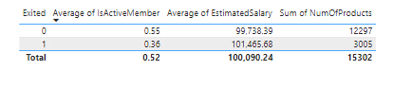

As we can see in the table, the 'NumOfProducts' used are less for those who are excited.

* It could indicate that customers who use a broader range of products have a stronger attachment to the bank and are less inclined to leave.

Active members were low in this case of excited customers.

* This implies that customers who are less engaged with the bank's services, indicated by lower activity levels, may be more prone to leaving. It suggests that maintaining high levels of customer engagement and encouraging regular interaction with the bank's offerings could help reduce churn rates.

And also Estimated salary was greater for those who exited.

* This observation might indicate that customers with higher incomes may have different financial needs or expectations that were not met by the bank.

9. Utilize SQL queries to segment customers based on demographics and account details.

ANS:

SELECT

CustomerID,

Age,

GenderID,

GeographyID,

EstimatedSalary,

FROM

warehouse_order.ci

WHERE

Age >= 30 -- Segment customers aged 30 and above

AND GenderID = 1 -- Segment male customers

AND GeographyID = 1 -- Segment customers from France

AND EstimatedSalary >= 50000 -- Segment customers with estimated salary greater than or equal to 50000

limit 5

This is the query and results are-

|  |  |  |  |  |
| --- | --- | --- | --- | --- |
| CustomerID | Age | GenderID | GeographyID | EstimatedSalary |
| 15625759 | 30 | 1 | 1 | 151869.35 |
| 15641122 | 30 | 1 | 1 | 83473.82 |
| 15586310 | 30 | 1 | 1 | 112187.11 |
| 15682757 | 30 | 1 | 1 | 107640.25 |
| 15739438 | 30 | 1 | 1 | 160979.66 |

10. How can we create a conditional formatting setup to visually highlight customers at risk of churn and to evaluate the impact of credit card rewards on customer retention?

Ans: 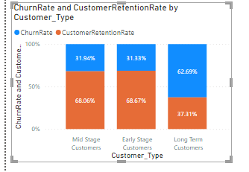

Here we are comparing the churn rates and retention rates based on the type of customer.

Early stage customers have the highest retention rate while long term customers have lowest.

To apply conditional formatting in Power BI, first select the visual. Open the "Format" pane, find "Conditional formatting," and click "Add rule." Choose the churn risk or rewards participation field. Define formatting options like colour scales. Adjust thresholds and styles, then apply the rule. Review to see highlighted areas for churn risk or rewards participation.

11. What is the current churn rate per year and overall as well in the bank? Can you suggest some insights to the bank about which kind of customers are more likely to churn and what different strategies can be used to decrease the churn rate?

Ans:

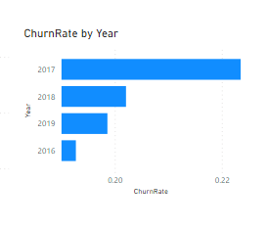

Churn rate can be seen in above image based on year. In 2017 it was the highest.

Risk of Customer Attrition: A churn rate of 22% suggests that the bank may be at risk of losing more customers if proactive measures are not taken to address the underlying reasons for churn.

Some of the strategies can be-

Retention Strategies: The bank should prioritise the development and implementation of targeted retention strategies aimed at reducing churn.

these strategies may include personalised incentives, improved customer service

13. How would you approach this problem, if the objective and subjective questions weren't given?

ANS:

f the objective and subjective questions weren't given, I would approach the problem by first understanding the dataset and its variables. Then, I would conduct exploratory data analysis to uncover patterns, trends, and relationships within the data. This would involve visualising the data, calculating descriptive statistics, and identifying any anomalies or missing values.

Next, I would prioritise the analysis based on the business goals and objectives of the bank. This might include focusing on key performance indicators (KPIs) such as churn rate, customer segmentation, product affinity, geographic trends, and risk assessment.

I would then develop SQL queries and data transformations to extract relevant insights from the dataset. This could involve segmenting customers based on demographics, analysing product usage patterns, evaluating churn rates by different variables, and identifying correlations between various factors.

14.In the “Bank_Churn” table how can you modify the name of the “HasCrCard” column to “Has_creditcard”?

Ans; ALTER TABLE Bank_Churn

CHANGE COLUMN HasCrCard Has_creditcard INT NULL; -- Assuming the data type is INT