**Analysis**

**Objective Questions**

**1. The data consists of some inconsistent and missing values so ensure that the data used for further analysis is cleaned.**

* The DateKey_Opening had dates in inconsistent format. So I fixed it using ‘Find and Replace’ in that column and applied date format generally used in India. Also extracted Year and Month from that.
* Fixed name of city ÛÁstanbul (in Turkey) to Istanbul in all of the sheets.
* Primary Cuisine had some of the empty cells which were replaced with No cuisine in the column**.**

**2. Using the LookUp functions, fill up the countries in the original data using the country code.**

**●** It has been done using VLOOKUP in the Raw Data sheet,

● Country Name= VLOOKUP($C2,'countrydescription'!$A$1:$B$16,2,FALSE)

**3. Create a table to represent the number of restaurants opened in each country.**

**● Here’s the Table representing the number of restaurants in each country:**

|  |  |
| --- | --- |
| *Country* | COUNTA of RestaurantID |
| Australia | 24 |
| Brazil | 60 |
| Canada | 4 |
| India | 8652 |
| Indonesia | 21 |
| New Zealand | 40 |
| Philippines | 22 |
| Qatar | 20 |
| Singapore | 20 |
| South Africa | 60 |
| Sri Lanka | 20 |
| Turkey | 34 |
| United Arab Emirates | 60 |
| United Kingdom | 80 |
| United States of America | 434 |
| **Grand Total** | **9551** |

● It can be seen in Yearwise analysis sheet of excel file.

It has been done using the COUNTA function for RestaurantID as values in the pivot table.

**4. Also, the management wants to look at the number of restaurants opened each year, so provide them with something here.**

Here’s the table to represent no. of restaurants each year:

To see this data in excel file:

● Go to the Yearwise analysis sheet in the excel file.

● Then go to the first pivot table

● Once clicked, we can get each year's distribution

|  |  |  |  |  |  |  |  |  |  |
| --- | --- | --- | --- | --- | --- | --- | --- | --- | --- |
| *Country* | 2010 | 2011 | 2012 | 2013 | 2014 | 2015 | 2016 | 2017 | 2018 |
| Australia | 4 | 1 | 3 | 6 |  | 4 | 2 | 1 | 3 |
| Brazil | 5 | 12 | 2 | 8 | 11 | 9 | 5 | 4 | 4 |
| Canada |  | 1 |  | 1 |  | 1 |  | 1 |  |
| India | 995 | 995 | 911 | 954 | 946 | 918 | 938 | 992 | 1003 |
| Indonesia | 1 | 5 |  | 1 | 4 | 3 | 1 | 1 | 5 |
| New Zealand | 4 | 6 | 4 | 2 | 4 | 4 | 4 | 5 | 7 |
| Philippines | 6 | 3 | 2 | 1 | 2 | 1 | 1 | 2 | 4 |
| Qatar | 4 | 1 | 2 | 4 | 2 | 2 | 4 |  | 1 |
| Singapore | 2 | 3 | 4 | 1 | 2 | 2 | 1 | 2 | 3 |
| South Africa | 4 | 4 | 7 | 8 | 5 | 7 | 10 | 9 | 6 |
| Sri Lanka | 1 | 2 | 3 | 4 | 2 | 3 | 2 | 2 | 1 |
| Turkey | 3 | 2 | 1 | 5 | 6 | 4 | 4 | 3 | 6 |
| United Arab Emirates | 4 | 3 | 16 | 6 | 9 | 8 | 2 | 6 | 6 |
| United Kingdom | 9 | 6 | 12 | 10 | 11 | 5 | 7 | 12 | 8 |
| United States of America | 38 | 54 | 55 | 50 | 47 | 53 | 46 | 46 | 45 |

**5. What is the total number of restaurants in India which are in the price range 4?**

**● Total such restaurants are = 388**

**To achieve this we can use this formula as**

=COUNTIFS('Raw Data'!Q:Q,4,'Raw Data'!D:D,"India")

1. **According to the data, what is the average number of voters for the restaurants in each country?**Here’s the table to represent no. of average votes in each country:

|  |  |
| --- | --- |
| *Country* | AVERAGE of Votes |
| Australia | 111.4166667 |
| Brazil | 19.61666667 |
| Canada | 103 |
| India | 137.212552 |
| Indonesia | 772.0952381 |
| New Zealand | 243.025 |
| Philippines | 407.4090909 |
| Qatar | 163.8 |
| Singapore | 31.9 |
| South Africa | 315.1666667 |
| Sri Lanka | 146.45 |
| Turkey | 431.4705882 |
| United Arab Emirates | 493.5166667 |
| United Kingdom | 205.4875 |
| United States of America | 428.2211982 |
| **Grand Total** | **156.9097477** |

To achieve this:

● Go to Dashboard sheet

● Find pivot table related to average votes

● And we can see the table below.

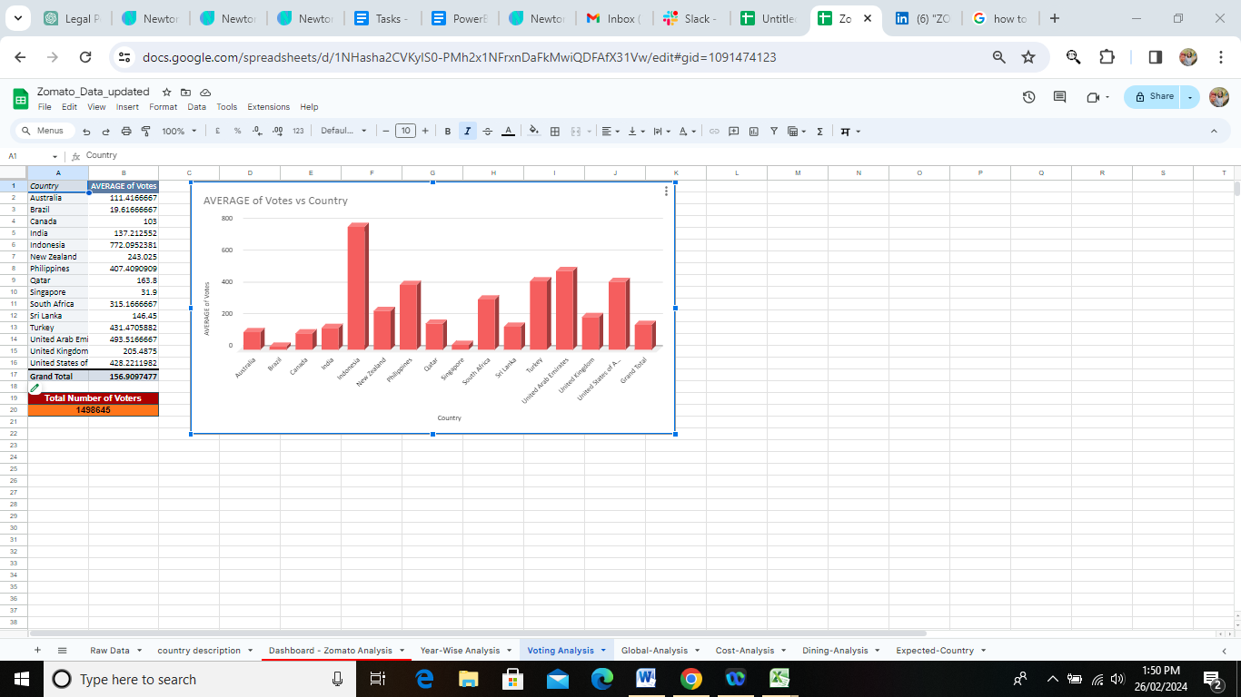

**Subjective Questions**

**1.**Suggest a few countries where the team can open newer restaurants with lesser competition. Which visualization/technique will you use here to justify the suggestions?

**Ans**:

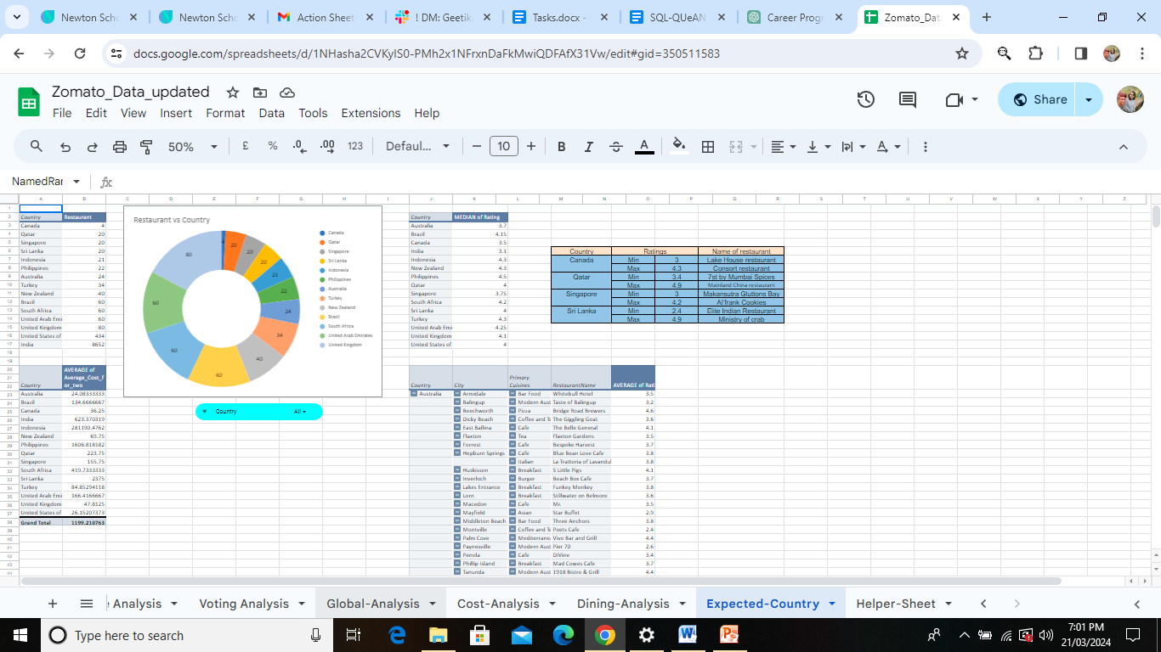

In the sheet of expected-country this Doughnout chart is present which gives the count wise distribution of restaurants in countries.

Few countries having less count of restaurants are Canada with, Qatar, Singapore and Sri Lanka with.

Along with that the Median Ratings and average cost for two is given in the below table.

|  |  |  |  |
| --- | --- | --- | --- |
| *Country* | MEDIAN of Rating | No of Restaurant | Average Cost for two |
| Canada | 3.5 | 4 | 36.25 |
| Qatar | 4 | 20 | 223.75 |
| Singapore | 3.75 | 20 | 155.75 |
| Sri Lanka | 4 | 20 | 2375 |

Using Pivot Tables and Simple Doughnout Chart as we are showing this in a categorical way of countries .would be preferred here as different countries are involved.

**2.** Come up with the names of States and cities in the suggested countries suitable for opening restaurants

**Ans**:

|  |  |  |  |  |
| --- | --- | --- | --- | --- |
| Country | Ratings | | Name of restaurant | City |
| Canada | Min | 3 | Lake House restaurant | Consort |
| Max | 4.3 | Consort restaurant | Vineland Station |
| Qatar | Min | 3.4 | 7st by Mumbai Spices | Doha |
| Max | 4.9 | Mainland China restaurant | Doha |
| Singapore | Min | 3 | Makansutra Gluttons Bay | Singapore |
| Max | 4.2 | Al’frank Cookies | Singapore |
| Sri Lanka | Min | 2.4 | Elite Indian Restaurant | Colombo |
| Max | 4.9 | Ministry of crab | Colombo |

This table is present in the Expected-Country sheet which gives the information about ratings in the suggested country along with cities

Doha in Qatar, Consort in Canada, Singapore and Colombo in Sri Lanka would be suitable for opening restaurants as all of them have average ratings which might help with the competition in the market.

In the Expected-Country sheet, pivot tables with the appropriate numbers are explained.

**3**.According to the countries you suggested, what is the current quality regarding ratings for restaurants that are open there?

**Ans**:

|  |  |
| --- | --- |
| *Country* | MEDIAN of Rating |
| Canada | 3.5 |
| Qatar | 4 |
| Singapore | 3.75 |
| Sri Lanka | 4 |

In the sheet of Expected-Country this pivot table is present which gives the information about ratings of restaurants in the country.

3.5 is the rating in Canada, 4.0 in Qatar , 3.75 in Singapore and 4 in Sri Lanka out of 5.Hence all the suggested countries have above average rating.

**4.**Also, what is the current expenditure on food in the suggested countries, so we can keep our financial expenditure in control?

**Ans**:

|  |  |  |  |  |
| --- | --- | --- | --- | --- |
| *Country* | AVERAGE of Average_Cost_for_two | MIN of Average_Cost_for_two | MAX of Average_Cost_for_two | Converted Average cost in Rupees |
| Canada | 36.25 | 25 | 70 | 1824 |
| Qatar | 223.75 | 50 | 550 | 3945 |
| Singapore | 155.75 | 20 | 500 | 8798 |
| Sri Lanka | 2375 | 1000 | 4500 | 998 |

In the cost-analysis sheet ,we can see the table having cost calculation for the suggested countries.

1824 Rs in Canada ,3945 Rs in Qatar ,8798 Rs in Singapore ,998 Rs in Sri Lanka are the average expenditure on food in the countries

For Singapore it is the highest cost and Sri lanka has lowest cost in terms of Rs.

.In the cost analysis sheet we can see the pivot table having the converted rupee value.

**5**.Come up with the names of restaurants from the recommended states that are our biggest competitors and also those that are rated in the lower brackets, i.e. 1-2 or 2-3.

**Ans**:

|  |  |  |  |
| --- | --- | --- | --- |
| Country | Ratings | | Name of restaurant |
| Canada | Min | 3 | Lake House restaurant |
| Max | 4.3 | Consort restaurant |
| Qatar | Min | 3.4 | 7st by Mumbai Spices |
| Max | 4.9 | Mainland China restaurant |
| Singapore | Min | 3 | Makansutra Gluttons Bay |
| Max | 4.2 | Al’frank Cookies |
| Sri Lanka | Min | 2.4 | Elite Indian Restaurant |
| Max | 4.9 | Ministry of crab |

In the sheet of expected country this table is present giving information about the ratings.

As we can see that there are competitions for us having max rating of 4.9 in Qatar and sri Lanka and low bracket rating restaurants are also given in the same.

From the above table we can know the minimum and maximum ratings of the suggested countries.

**6.** Which cuisines should we focus on in the newer restaurants to get better feedback? Does the choice of cuisines affect the restaurant ratings?

**Ans**:

|  |  |
| --- | --- |
| Country | Cuisine |
| Canada | Italian |
| Qatar | Chinese |
| Singapore | Bakery |
| Sri Lanka | Seafood |

In the Expected Country sheet the pivot table with countries, and their cuisines are given

In the table we can see the Cuisines of the suggested countries having maximum rating with associated food from restaurants .The choice of cuisines can impact restaurant ratings; diverse and popular cuisines often attract more customers, influencing ratings positively.

**7**.According to our current data, should we go for online delivery and table booking? Does that affect the customer’s ratings?

**Ans**:

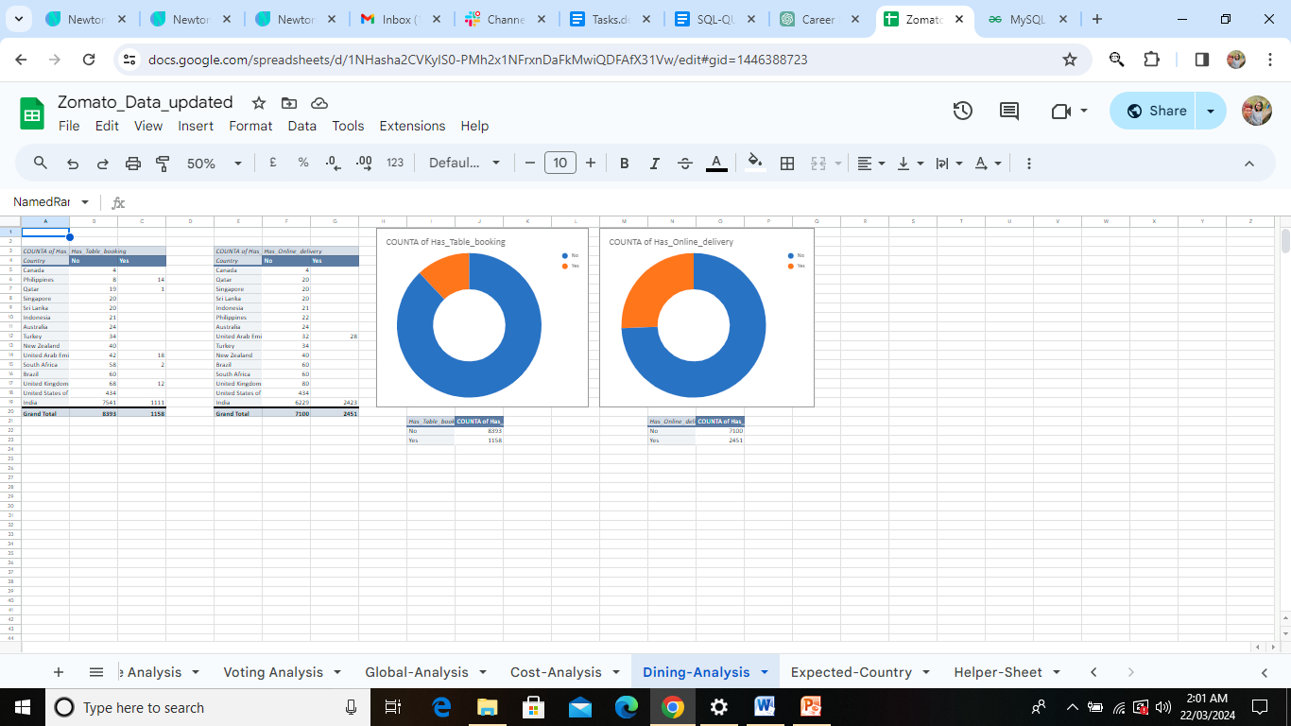

Given charts are present in Dining Analysis sheet.

Yes it affects the customer’s ratings, based on the analysis, offering both online delivery and table booking tends to result in higher customer ratings compared to not offering these services based on the preferences of the customer one can go for online delivery or table booking. This can be clearly seen in the charts.

**8.** Should the team keep the rate of cuisines higher? Will that affect the feedback? According to our data are the rates of cuisines and ratings, correlated?

**Ans:**

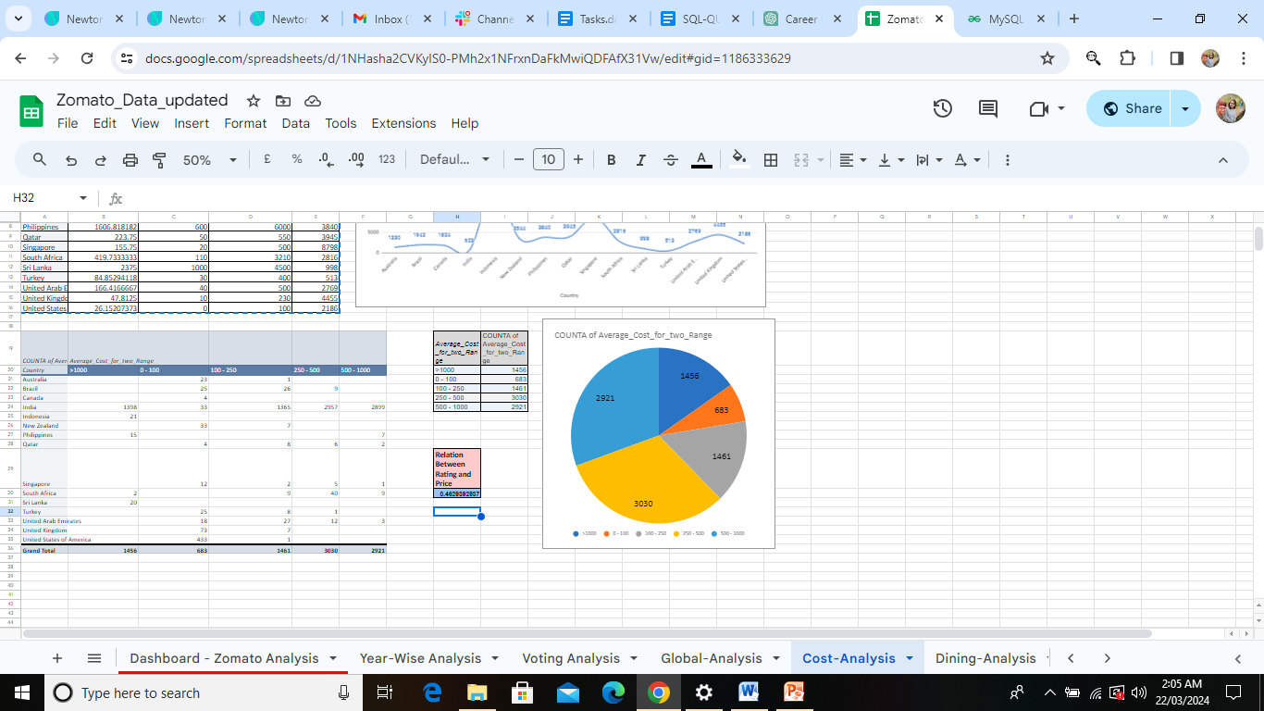

In the cost analysis sheet , this value is present and is calculated bu using the formula

=CORREL('Raw Data'!Q:Q,'Raw Data'!U:U)

According to datathe correlation between rates of cuisines and ratings has value of

0.4629392937 which is a moderate positive correlation suggesting that the rates of cuisines would affect the rating hence rate of cuisines should be moderate in order to get the positive feedback in terms of rating.

**9.**What is the distribution of the number of restaurants of different price ranges in all the countries?

**Ans:**

|  |  |
| --- | --- |
| *Average_Cost_for_two_Range* | COUNTA of Average_Cost_for_two_Range |
| >1000 | 1456 |
| 0 - 100 | 683 |
| 100 - 250 | 1461 |
| 250 - 500 | 3030 |
| 500 - 1000 | 2921 |

In the cost analysis sheet we can see the distribution of the restaurants of different price ranges in all the countries.

As we can see in the table it is grouped by the range of the average cost and the associated group has average cost for two.

Densely grouped range with a cost of 3030 belongs to 250-500.