**Task4**

Develop the queries to retrieve information from the OLAP operations performed and to gain a deeper understanding of the sales data through different dimensions, aggregations, and filters.

**Project: OLAP Operations (using Redshift or PostgreSQL)**

Objective: Perform OLAP operations (Drill Down, Rollup, Cube, Slice, and Dice) on the

"sales_sample" table to analyze sales data. The project will include the following tasks:

1.Database Creation

Create a database to store the sales data (Redshift or PostgreSQL).

CREATE DATABASE sales_db;

Create a table named "sales_sample" with the specified columns:

Product_Id (Integer)

Region (varchar(50))-like East ,West etc

Date (Date)

Sales_Amount (int/numeric)

CREATE TABLE sales_sample (

Product_Id INTEGER,

Region VARCHAR(50),

Date DATE,

Sales_Amount NUMERIC

);

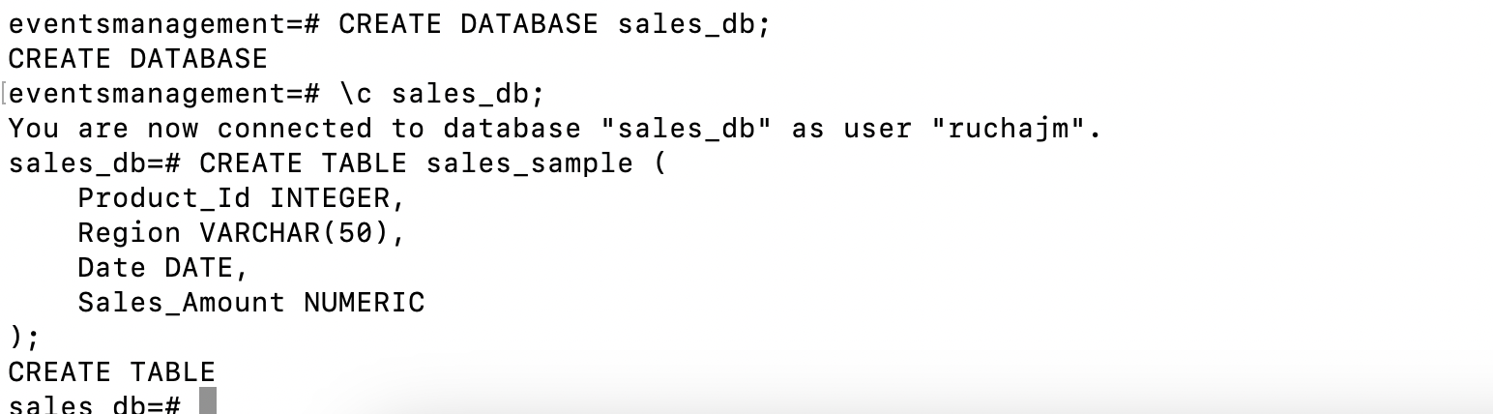

2.Data Creation

Insert 10 sample records into the "sales_sample" table, representing sales data.

INSERT INTO sales_sample (Product_Id, Region, Date, Sales_Amount) VALUES

(1, 'East', '2024-01-01', 1000),

(2, 'West', '2024-01-01', 1500),

(1, 'East', '2024-01-02', 1200),

(3, 'East', '2024-01-02', 1700),

(2, 'West', '2024-01-02', 1600),

(4, 'North', '2024-01-03', 1800),

(1, 'North', '2024-01-03', 1900),

(3, 'South', '2024-01-04', 2000),

(2, 'South', '2024-01-04', 2100),

(4, 'West', '2024-01-04', 2200);

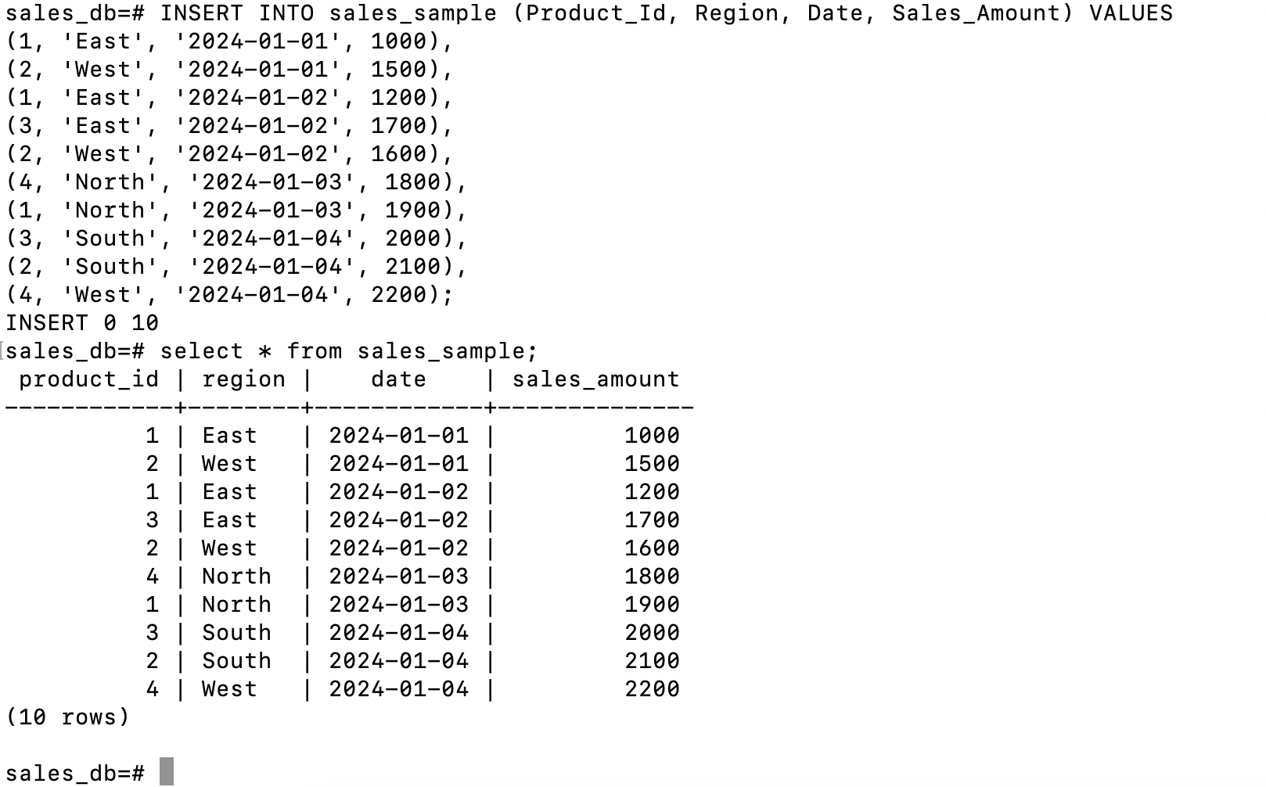

3.Perform OLAP operations

a)Drill Down-Analyze sales data at a more detailed level. Write a query to perform drill down

from region to product level to understand sales performance.

SELECT Region, Product_Id, SUM(Sales_Amount) AS Total_Sales FROM sales_sample GROUP BY Region, Product_Id ORDER BY Region, Product_Id;

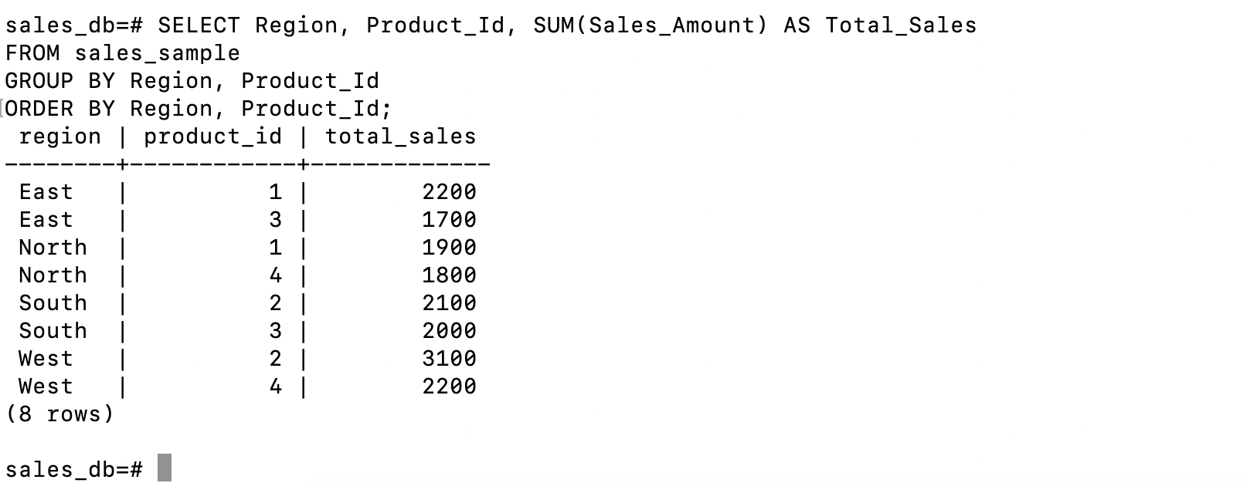

b)Rollup- To summarize sales data at different levels of granularity. Write a query to perform

roll up from product to region level to view total sales by region.

SELECT Region, SUM(Sales_Amount) AS Total_Sales FROM sales_sample GROUP BY Region ORDER BY Region;

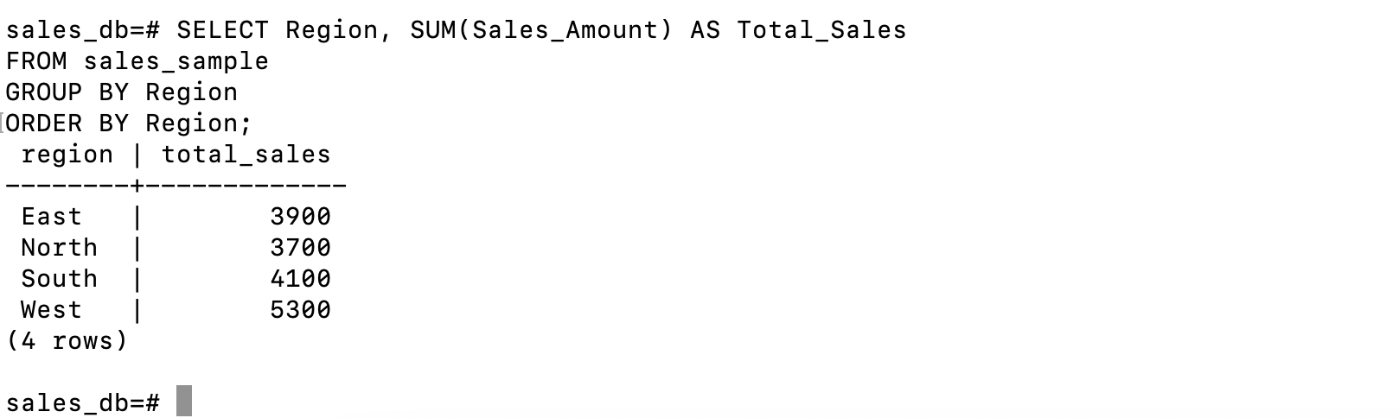

c)Cube - To analyze sales data from multiple dimensions simultaneously. Write a query to

Explore sales data from different perspectives, such as product, region, and date.

SELECT Product_Id, Region, Date, SUM(Sales_Amount) AS Total_Sales FROM sales_sample GROUP BY CUBE(Product_Id, Region, Date) ORDER BY Product_Id, Region, Date;

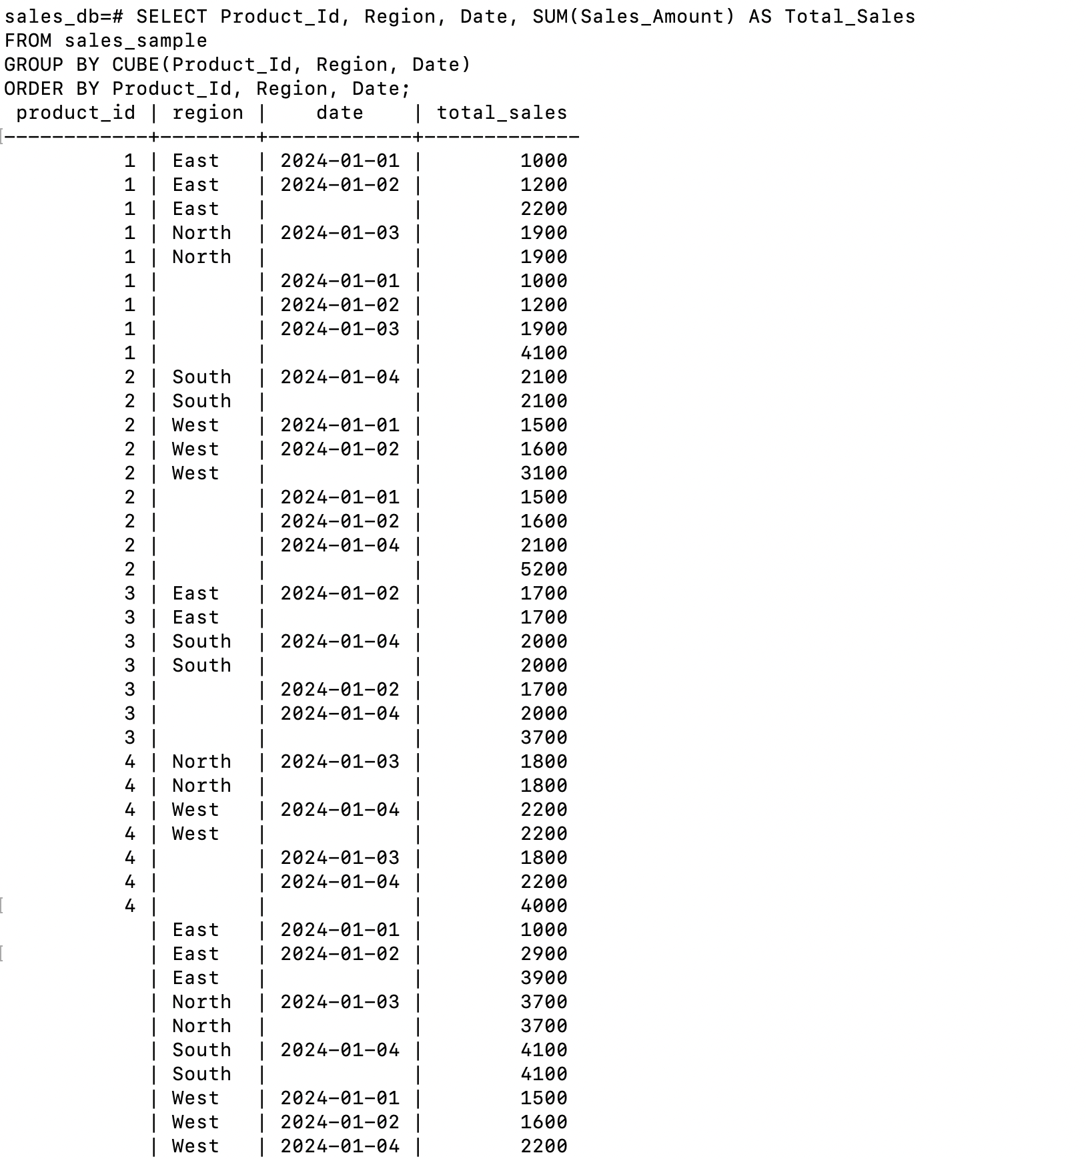

d)Slice- To extract a subset of data based on specific criteria. Write a query to slice the data to view sales for a particular region or date range.

SELECT Product_Id, Date, Sales_Amount FROM sales_sample WHERE Region = 'East' ORDER BY Date;

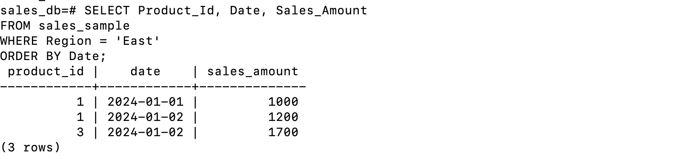

e)Dice - To extract data based on multiple criteria. Write a query to view sales for specific

combinations of product, region, and date

SELECT Product_Id, Region, Date, Sales_Amount FROM sales_sample WHERE Product_Id IN (1, 2) AND Region IN ('East', 'West') AND Date BETWEEN '2024-01-01' AND '2024-01-03' ORDER BY Product_Id, Region, Date;

