**Task 2-**

**Project: Student Database Management System(PostgreSQL)**

Objective: Design and implement a student database management system using PostgreSQL

that allows storing and retrieving student information efficiently. The project will include the

following tasks:

1.Database Setup

Create a database named "student_database."

I created a database called task2 instead of student_database

CREATE DATABASE task2;

Create a table called " student_table " with the following columns: Student_id (integer),

Stu_name (text), Department (text), email_id (text ),Phone_no (numeric), Address (text),

Date_of_birth (date), Gender (text), Major (text), GPA (numeric),Grade (text) should be A,B,C

etc.

CREATE TABLE student_table (

Student_id INTEGER PRIMARY KEY,

Stu_name TEXT,

Department TEXT,

email_id TEXT,

Phone_no NUMERIC,

Address TEXT,

Date_of_birth DATE,

Gender TEXT,

Major TEXT,

GPA NUMERIC,

Grade CHAR(1) CHECK (Grade IN ('A', 'B', 'C', 'D', 'F'))

);

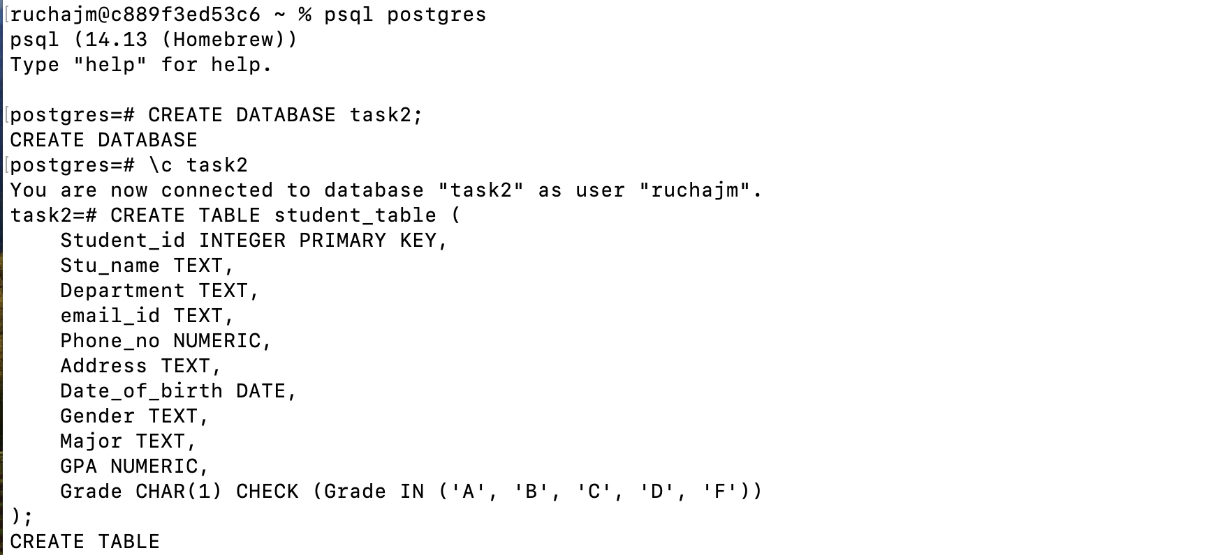

2.Data Entry

Insert 10 sample records into the "student_table" using INSERT command.

INSERT INTO student_table (Student_id, Stu_name, Department, email_id, Phone_no, Address, Date_of_birth, Gender, Major, GPA, Grade)

VALUES

(1, 'Alice Johnson', 'Computer Science', 'alice.johnson@example.com', '1234567890', '123 Elm St', '2000-01-15', 'F', 'Software Engineering', 3.9, 'A'),

(2, 'Bob Smith', 'Mathematics', 'bob.smith@example.com', '1234567891', '124 Elm St', '1999-05-20', 'M', 'Applied Mathematics', 3.2, 'B'),

(3, 'Charlie Brown', 'Physics', 'charlie.brown@example.com', '1234567892', '125 Elm St', '2001-09-10', 'M', 'Astrophysics', 2.8, 'C'),

(4, 'Diana Prince', 'Chemistry', 'diana.prince@example.com', '1234567893', '126 Elm St', '2000-11-30', 'F', 'Organic Chemistry', 3.6, 'B'),

(5, 'Eve Adams', 'Biology', 'eve.adams@example.com', '1234567894', '127 Elm St', '1998-12-25', 'F', 'Genetics', 4.0, 'A'),

(6, 'Frank Castle', 'Computer Science', 'frank.castle@example.com', '1234567895', '128 Elm St', '2002-02-14', 'M', 'Cybersecurity', 3.5, 'B'),

(7, 'Grace Kelly', 'English', 'grace.kelly@example.com', '1234567896', '129 Elm St', '2001-07-22', 'F', 'Literature', 2.9, 'C'),

(8, 'Hank Green', 'Economics', 'hank.green@example.com', '1234567897', '130 Elm St', '1999-03-18', 'M', 'Economics', 3.8, 'A'),

(9, 'Ivy League', 'History', 'ivy.league@example.com', '1234567898', '131 Elm St', '2000-08-05', 'F', 'Ancient History', 3.1, 'B'),

(10, 'Jack Daniels', 'Philosophy', 'jack.daniels@example.com', '1234567899', '132 Elm St', '2001-06-23', 'M', 'Ethics', 3.4, 'B');

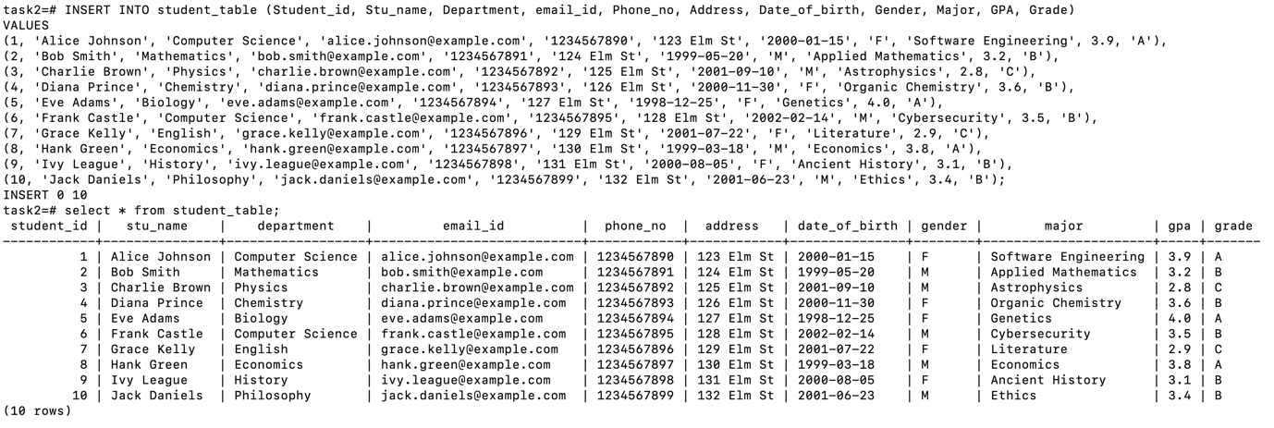

3.Student Information Retrieval

Develop a query to retrieve all students' information from the "student_table" and sort them in descending order by their grade.

SELECT * FROM student_table

ORDER BY Grade DESC;

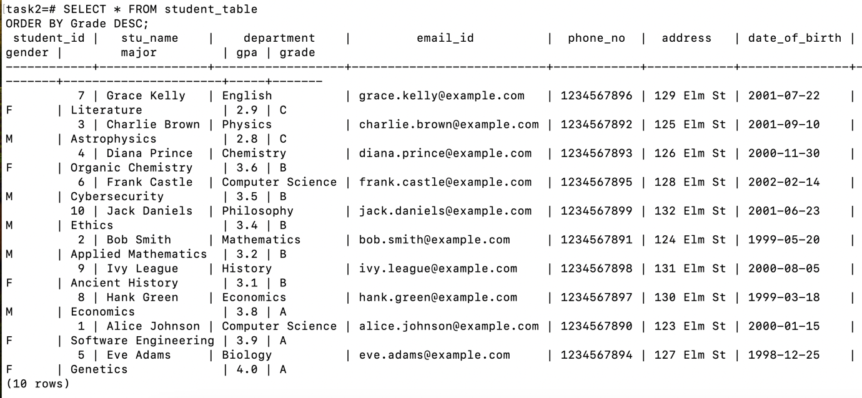

4.Query for Male Students:

.Implement a query to retrieve information about all male students from the "student_table."

SELECT * FROM student_table

WHERE Gender = 'M';

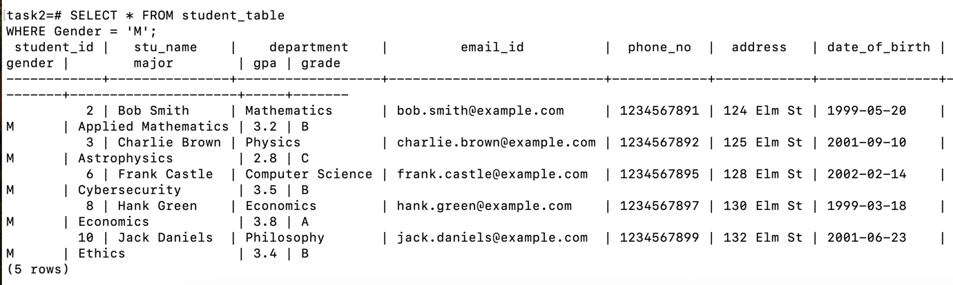

5.Query for Students with GPA less than 5.0

Create a query to fetch the details of students who have a GPA less than 5.0 from the

"student_table."

SELECT * FROM student_table

WHERE GPA < 5.0;

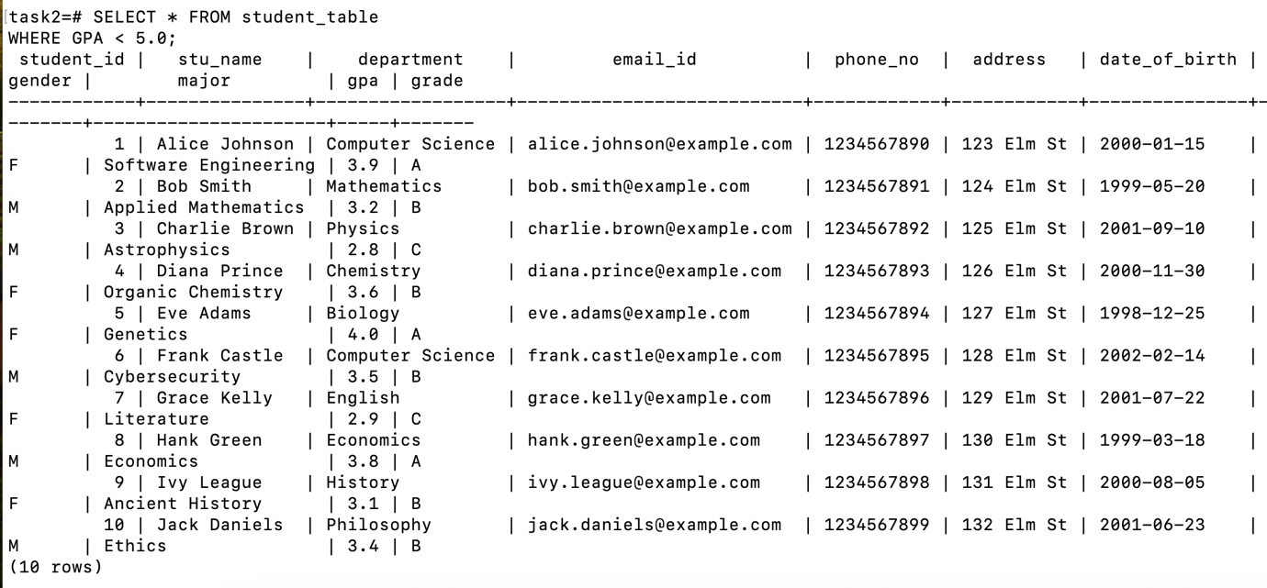

6.Update Student Email and Grade

Write an update statement to modify the email and grade of a student with a specific ID in the "student_table."

UPDATE student_table

SET email_id = 'new.email@example.com', Grade = 'A'

WHERE Student_id = 1;

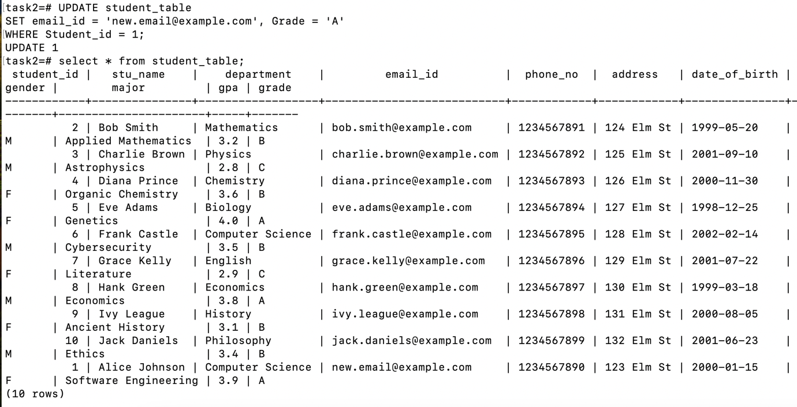

7.Query for Students with Grade "B"

Develop a query to retrieve the names and ages of all students who have a grade of "B" from

the "student_table."

SELECT Stu_name, DATE_PART('year', CURRENT_DATE) - DATE_PART('year', Date_of_birth) AS age

FROM student_table

WHERE Grade = 'B';

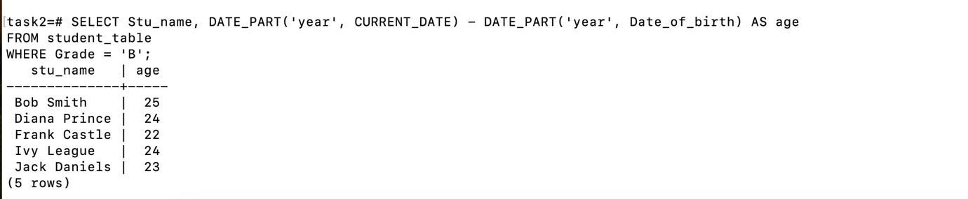

8.Grouping and Calculation

Create a query to group the "student_table" by the "Department" and "Gender" columns and calculate the average GPA for each combination.

SELECT Department, Gender, AVG(GPA) AS average_gpa

FROM student_table

GROUP BY Department, Gender;

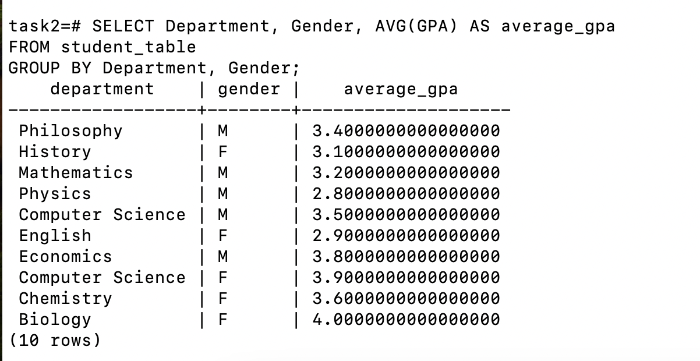

9.Table Renaming

Rename the "student_table" to "student_info" using the appropriate SQL statement.

ALTER TABLE student_table

RENAME TO student_info;

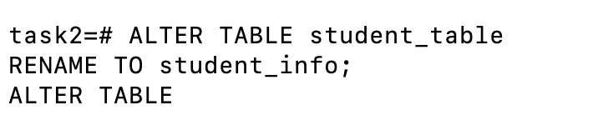

10.Retrieve Student with Highest GPA

Write a query to retrieve the name of the student with the highest GPA from the

"student_info" table.

SELECT Stu_name

FROM student_info

ORDER BY GPA DESC

LIMIT 1;

