**Task3**

**Project: Event Management System using PostgreSQL.**

Objective: To develop the application that allows users to create and manage events, track

attendees, and handle event registrations efficiently. The project will include the following

tasks:

1.Database Creation

Create a database named "EventsManagement."

CREATE DATABASE EventsManagement;

Create tables for Events, Attendees, and Registrations.

Events- Event_Id, Event_Name, Event_Date, Event_Location, Event_Description

CREATE TABLE Events (

Event_Id SERIAL PRIMARY KEY,

Event_Name VARCHAR(255) NOT NULL,

Event_Date DATE NOT NULL,

Event_Location VARCHAR(255),

Event_Description TEXT

);

Attendees- Attendee_Id, Attendee_Name, Attendee_Phone, Attendee_Email, Attendee_City

CREATE TABLE Attendees (

Attendee_Id SERIAL PRIMARY KEY,

Attendee_Name VARCHAR(255) NOT NULL,

Attendee_Phone VARCHAR(15),

Attendee_Email VARCHAR(255) UNIQUE NOT NULL,

Attendee_City VARCHAR(255)

);

Registrations-Registration_id, Event_Id, Attendee_Id,Registration_Date,Registration_Amount.

CREATE TABLE Registrations (

Registration_Id SERIAL PRIMARY KEY,

Event_Id INT NOT NULL,

Attendee_Id INT NOT NULL,

Registration_Date DATE NOT NULL,

Registration_Amount DECIMAL(10, 2),

FOREIGN KEY (Event_Id) REFERENCES Events(Event_Id),

FOREIGN KEY (Attendee_Id) REFERENCES Attendees(Attendee_Id)

);

The FOREIGN KEY constraint in the Registrations table references the Event_Id column in the

Events table and the Attendee_Id column in the Attendees table.

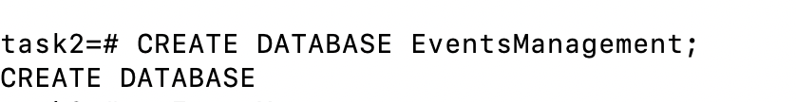

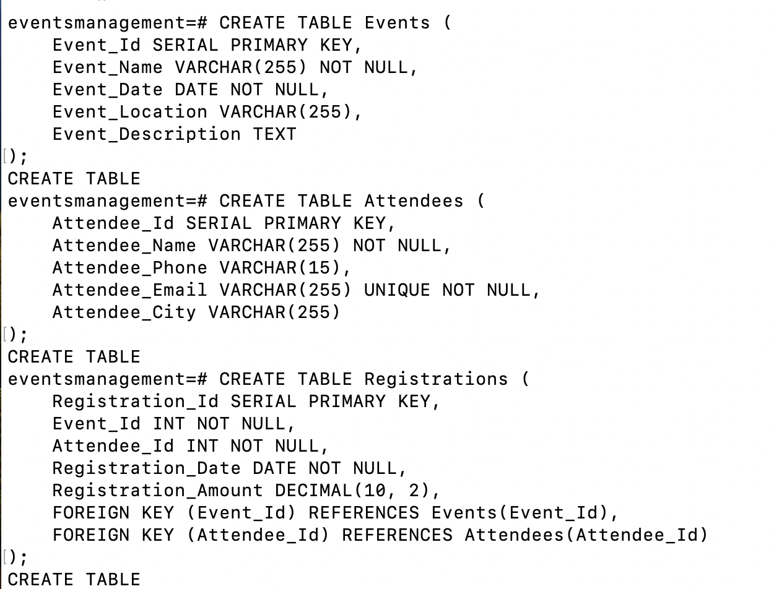

2.Data Creation

Insert some sample data for Events, Attendees, and Registrations tables with respective fields.

INSERT INTO Events (Event_Name, Event_Date, Event_Location, Event_Description) VALUES

('Tech Conference 2024', '2024-06-15', 'San Francisco', 'A conference about the latest in technology.'),

('Music Festival', '2024-07-20', 'Los Angeles', 'A festival featuring various music genres.'),

('Art Exhibition', '2024-08-10', 'New York', 'An exhibition showcasing contemporary art.');

INSERT INTO Attendees (Attendee_Name, Attendee_Phone, Attendee_Email, Attendee_City) VALUES

('Alice Johnson', '555-1234', 'alice.johnson@example.com', 'San Francisco'),

('Bob Smith', '555-5678', 'bob.smith@example.com', 'Los Angeles'),

('Charlie Brown', '555-8765', 'charlie.brown@example.com', 'New York');

INSERT INTO Registrations (Event_Id, Attendee_Id, Registration_Date, Registration_Amount) VALUES

(1, 1, '2024-05-01', 100.00),

(1, 2, '2024-05-02', 100.00),

(2, 3, '2024-06-15', 50.00);

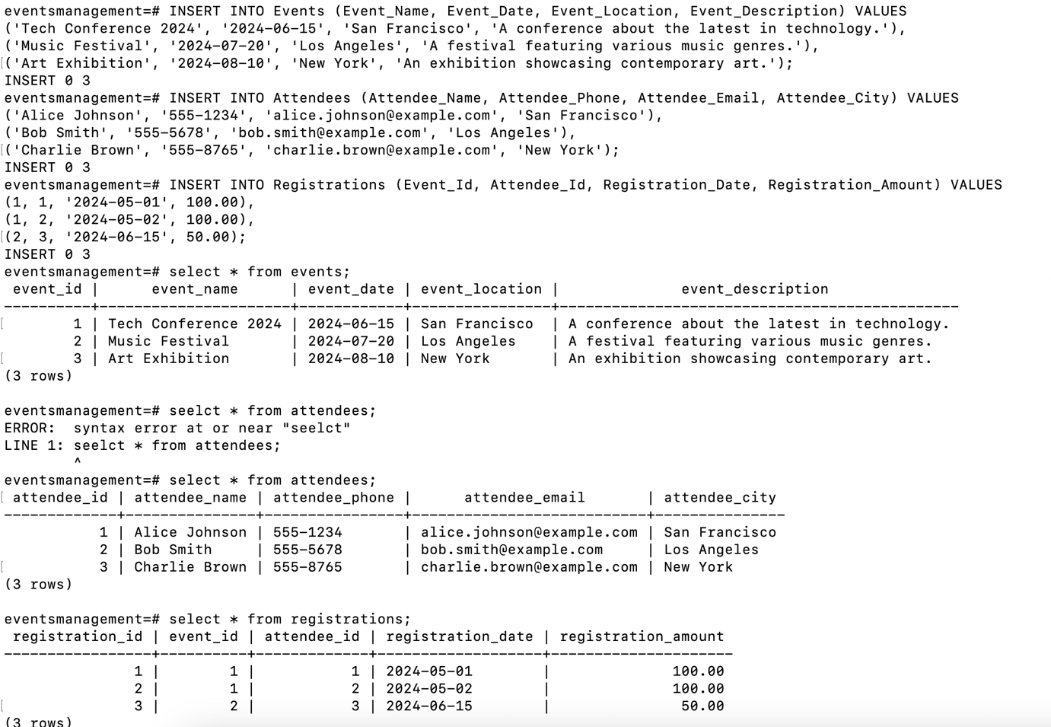

3. Manage Event Details

a) Inserting a new event.

INSERT INTO Events (Event_Name, Event_Date, Event_Location, Event_Description) VALUES

('Networking Event', '2024-09-01', 'San Jose', 'An event to network with industry professionals.');

b) Updating an event's information.

UPDATE Events

SET Event_Location = 'San Francisco', Event_Description = 'A major networking event.'

WHERE Event_Id = 4;

c) Deleting an event.

DELETE FROM Events

WHERE Event_Id = 4;

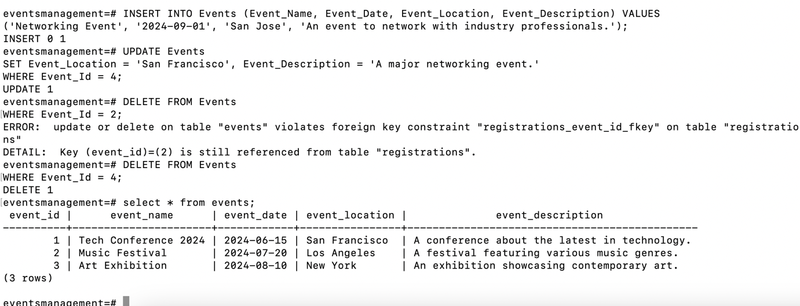

4) Manage Track Attendees & Handle Events

a)Inserting a new attendee.

INSERT INTO Attendees (Attendee_Name, Attendee_Phone, Attendee_Email, Attendee_City) VALUES

('David Lee', '555-4321', 'david.lee@example.com', 'San Francisco');

b)Registering an attendee for an event.

INSERT INTO Registrations (Event_Id, Attendee_Id, Registration_Date, Registration_Amount) VALUES

(1, 4, '2024-06-01', 100.00);

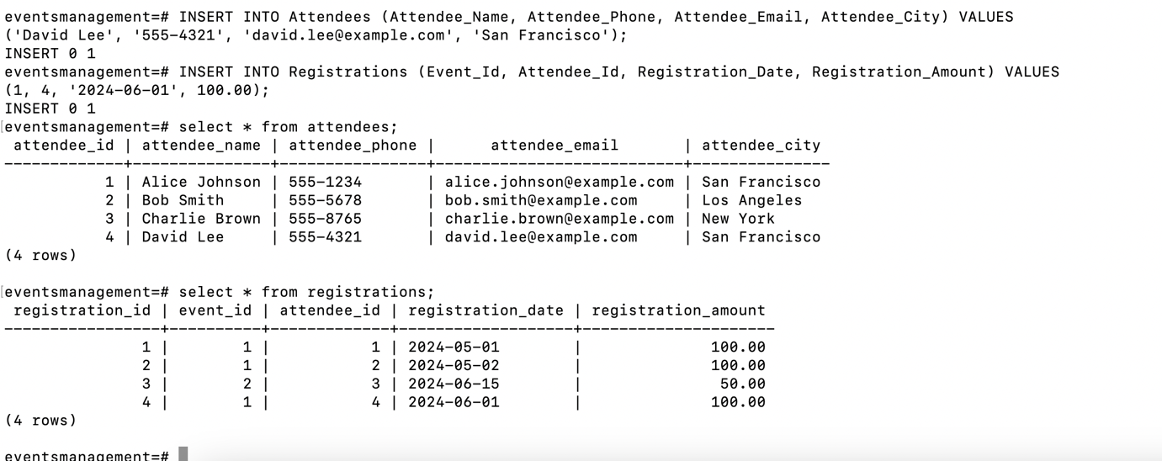

5.Develop queries to

1. retrieve event information

SELECT * FROM Events;

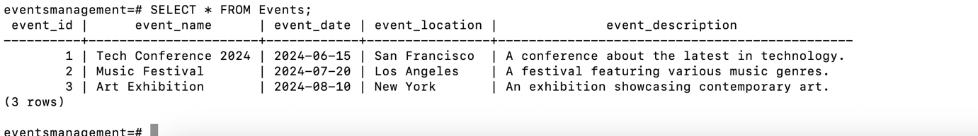

1. generate attendee lists

SELECT A.Attendee_Name, A.Attendee_Email

FROM Attendees A

JOIN Registrations R ON A.Attendee_Id = R.Attendee_Id

WHERE R.Event_Id = 1;

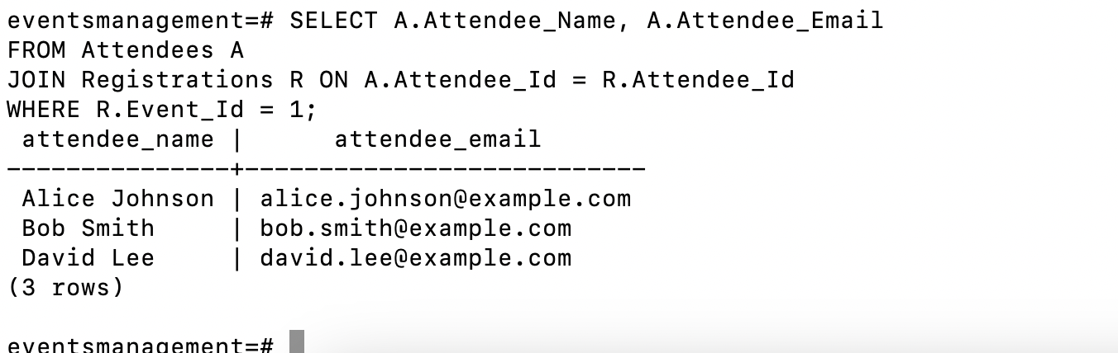

1. calculate event attendance statistics.

SELECT E.Event_Name, COUNT(R.Attendee_Id) AS NumberOfAttendees

FROM Events E

LEFT JOIN Registrations R ON E.Event_Id = R.Event_Id

GROUP BY E.Event_Name;

