**Assignment 5: Collections of Data**

Rucha P. Nimbalkar

University of Washington

IT FDN 110: Fall 2024

Prof. Randall Root

Nov. 13, 2024

**Abstract**

Data can be stored as a collection of tuples, lists, dictionaries, or sets. Dictionary is a collection of data in term of keys and values. It makes it easier to not only save data but also access it.

Keywords: dictionary, key, value.

**Assignment 5: Collections of Data**

Assignment 4 is the fifth coding assignment of the IT Fundamentals (IT FDN 110 A) course I am taking at University of Washington. The goal of this assignment is to help me understand the usage of dictionaries to save data and write in file.

In this assignment, a Python script gives the user a menu of choices. It is an upgrade of Assignment 4 wherein we are performing similar tasks, but we are saving the data in dictionary variables instead of list variables.

**Reflection**

In this week, I learnt more about dictionaries. I first learnt about dictionaries in Module 04.

**Program Summary**

I began the program using the starter file provided for Assignment 4. From my previous assignment, I have learnt to never change the code of another person without informing them and to never delete variables declared by another developer. I first updated the script header with my name (please refer fig. 1) and then I added the dictionary row variable (please see figure 2).

**Figure 1**

*Assignment 05 Python Starter Code with appropriate updates*

**Figure 2**

*Assignment 05 Dictionary variable added to the code.*

Then I started to work on adding the code for saving the data entered by the user when he/she/they choose option 1, in the student_data (list) variable. This list variable is then saved in the two- dimensional list variable students. When the user chooses option 2, the lists in the variable students are printed on the console. That means all the student_data lists will be printed on the console. So, I added the lines of code of that and tested them and it worked.

**Figure 3**

*Assignment 04 User entered input is saved in a list student_data which in turn is added to the two-dimensional list students.*

**Figure 4**

*Assignment 04 Code output for code in figure 3.*

Then I started working on saving data to the file. I started to think about adding code to write the students list in the file. For this, I will use a for loop and open the file in “a” (append) mode; followed by the write function to make sure all students are written in file. As I worked on the code, I realized I will need to access each list item from the two-dimensional list students, format each list item in a string format by separating it by comma and then write it to file in the for loop. I added the code lines.

**Figure 5**

*Assignment 04 File is opened in “a” (append) mode to write the data in it.*

I removed the variable csv_data and code lines related to Assignment 03 that were in the starter Assignment 04 file. I also modified the message in the else statement to suit my style. I had discussed the use of exit() function with Professor Root in the class , and he had been okay with me using the exit() function for the menu_choice “4” so I used that instead of the break statement as shown in figure 6.

**Figure 6**

*Assignment 04 Code lines added/updated to suit my style.*

After that I worked on adding a second for loop for menu_choice “3” elif block, to show records that were saved to the file. For that, I planned to use the same for loop but then modify it with a print function instead of the write function. I used curly braces to show each record by using string concatenation to surround each record (student data) and it automatically gets printed on a new line at each iteration, so I removed the new line character from the string formatting.

**Figure 7**

*Assignment 04 Two for loops for menu_choice “3”*

For menu_choice “2”, I was just printing the entire two-dimensional list as shown previously in figure when user wanted to see current data. But instead of just doing that, I thought of printing each list item by using a for loop.

**Figure 8**

*Assignment 04 Print current data on new line*

Since the code meets the given requirements, I decided to add some validations to the code for the user choices. This would be similar to what I did in Assignment 3. When the user chooses to print current data or save data to file, an appropriate error message is printed on screen telling them that they need to register students first (choose option 1) to see current data or save data. For this, I need to check if the students list is not empty. I can do that as long as the length of the list is greater than or equal to zero. I googled length of the list and found the length( ) function that can be used to find the length of a list on a freecodecamp article. I added the code for that for menu_choice “2” and it worked as shown in figure 9.

**Figure 9**

*Assignment 04 Print error message if use chooses to see current data first before adding any data.*

After that I worked on adding the validation for option “3”. I was able to add validations successfully as shown in figure 10.

**Figure 10**

*Assignment 04 Print error message if use chooses to save current data to the file before adding any data.*

I did not add validations for the input as we are immediately adding the input strings in the list student_data but I am actively thinking if I can do that. So far, I feel my code meets the requirements and has a couple of validations for the two choices. I ran the program, and it worked smoothly as shown in figure 11.

**Figure 11**

*Assignment 04 Overall Code Execution.*

I checked the “PythonLabs” folder, and I saw the file enrollments.csv and when I opened it, it contained the added records (please see figure 12).

**Figure 12**

*Data saved in enrollments.csv*

After that I ran my code from command terminal to verify if I get the same output there (please see figure 13).

**Figure 13**

*Assignment 04 Output in command terminal.*

I opened the enrollments.csv file again and I saw the two new student records added in command prompt were appended to the file (please see figure 14).

**Figure 14**

*Assignment 04 Data added in command prompt appended to enrollments.csv file*

On November 06th, 2024 I had an online class with Professor Root wherein he reviewed Assignment 04 and I realized that the data will be written in file in an “write” mode and the previous data from the file needs to be extracted to be displayed and re-written to the file. I also learnt that csv_data variable is required to read from the file, and this is something to keep in mind when working on another person’s code. I should be mindful when working with somebody else’s code and if I make any changes (delete something), I should add a comment about it. I opened my Assignment04.py file to fix the mistakes I made previously. I realized that I had deleted previously added the csv_data variable. I began thinking about adding code before the while loop to read contents from enrollments.csv. I looked at module 04 notes related to reading from files and working with file data and the lab assignments I had done this week. I added the code to read the file contents as shown in figure 15.

**Figure 15**

*Assignment 04 Add code to read the file contents.*

Then I changed the file open mode to “w” (write) mode instead of “a” (append) mode.

**Figure 16**

*Assignment 04 Open file in write mode to overwrite its contents*

I ran my code to check whether my code worked fine with these new improvements. The code worked smoothly and then I wondered if only the current saved data should be displayed on the console instead of the whole file contents. That is when I realized that I could use the csv_data variable for menu_choice “1” and “3”. I could save the user input in csv_data and then display it in menu_choice “3” block to show that it was just recenty added to the file. I added two more lines to the same block, and I ran the code, and it ran smoothly. I did not change the validations because they were not affected by the additional code lines. The current validations will always check whether the students list is empty or not. I ran the code in command terminal, and it ran successfully (please refer figure 17).

**Figure 17**

*Assignment 06 Final Output*

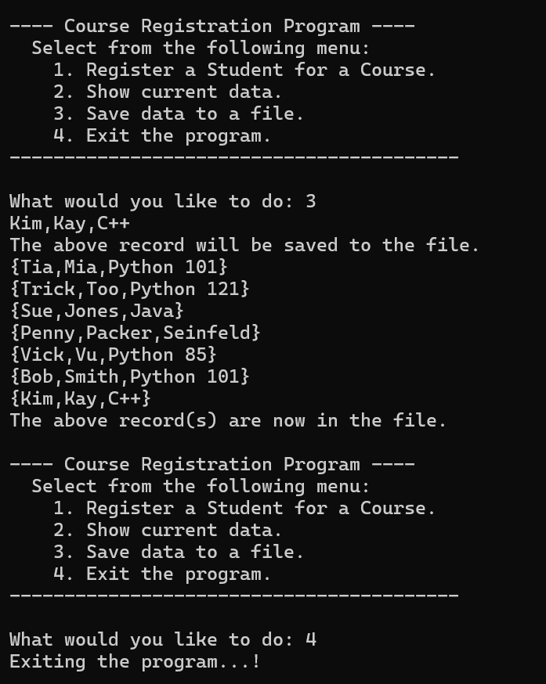

**References**

Randall, R.(n.d.). *IT Fundamentals* *110 A* [MOOC]. University of Washington. [Foundations of Programming (Python) - UW Professional & Continuing Education](https://www.pce.uw.edu/courses/foundations-of-programming-python)

*Python List Length – How to Get the Size of a List in Python.* (2022, March 3). FreeCodeCamp. Retrieved November 2, 2024, from [Python List Length – How to Get the Size of a List in Python](https://www.freecodecamp.org/news/python-list-length-how-to-get-the-size-of-a-list-in-python/)