Scenario 1:

What are the MAC and IP addresses in the header?

**1. PC C sends a packet to PC A**

1.a) What is the source MAC address of the packet as it leaves PC C: 3333...

1.b) What is the destination MAC address of the packet as it leaves PC C: 1111...

1.c) What is the source IP address of the packet as it leaves PC C: 203.34.175.3

1.d) What is the destination IP address of the packet as it leaves PC C: 203.34.175.2

Scenario 2:

ARP Request Required or Not?

Consider the scenario in the diagram below and answer the following questions:

1. If **PC A** needs to send a packet to **PC B**...  
   1.a)  No, because PC B is in different VLAN with PC A, so PC A will look for the MAC address of the router but it already has it in the ARP Table.
2. If **PC C** needs to send a packet to **PC A.**..  
   2.a)  No, because PC C ARP Table already have the PC A IP address and its MAC Address.
3. If **PC B** needs to send a packet to **PC A...**  
   3.a)  Yes, PC B doesn't have the MAC address of the router as PC B is in different VLAN with PC A.  
   3.b)   203.34.175.33
4. If **R1** needs to forward a packet to the **WEB Server.**..  
   4.a)  Yes, because R1 ARP Table doesn't have the MAC address attached with WEB Server IP address.  
   4.b)  45.50.10.10

### Scenario 3:

### What are the MAC and IP addresses in the header?

Consider the scenario in the diagram below and answer the following questions:

**1. PC A sends a packet to the Web Server**

1.a) What is the source MAC address of the packet as it leaves PC A: 1111

1.b) What is the destination MAC address of the packet as it leaves PC A: AAAA

1.c) What is the source IP address of the packet as it leaves PC A: 203.34.175.2

1.d) What is the destination IP address of the packet as it leaves PC A: 203.34.175.1

**2. The packet sent by PC A reaches R1 and then forwarded to the Web Server**

2.a) What is the source MAC address of the packet as it leaves R1: CCCC

2.b) What is the destination MAC address of the packet as it leaves R1: EEEE

2.c) What is the source IP address of the packet as it leaves R1: 45.50.10.9

2.d) What is the destination IP address of the packet as it leaves R1: 45.50.10.10

### Scenario 4

### ARP Request Required or Not?

Consider the scenario in the diagram and answer the following questions:

**1. Host B needs to send a message to Host A**1a) Will **Host B** send an ARP request? Yes? No? Why? NO.   
      Host B and Host A are in the same network, therefore, Host B will use Host A's MAC as the dest. MAC address. Host B already has Host A's MAC address in its ARP table, therefore, no ARP request required.   
1b) If YES, which IP address would **Host B**request a MAC address for?   
       N/A

**2. Host B needs to send a message to Host D**2a) Will **Host B** send an ARP request? Yes? No? Why? YES.   
      Host B and Host D are in the different networks, therefore, Host B will use its default gateway's MAC as the dest. MAC address. Host B does not have its default gateway's MAC address in the ARP table, therefore an ARP request required.   
2b) If YES, which IP address would **Host B**request a MAC address for? 172.16.20.254

**3. Host C needs to send a message to Host D**3a) Will **Host C** send an ARP request? Yes? No? Why? YES.   
      Host C and Host D are in the same network, therefore, Host C will use Host D's MAC as the dest. MAC address. Host C's ARP table is empty, therefore, an ARP request is required.   
3b) If YES, which IP address would **Host C**request a MAC address for? 172.16.10.2

**4. R1 needs to forward a message to Host A**4a) Will **R1** send an ARP request? Yes? No? Why? YES.   
      Gi0/0.20@R1 and Host A are in the same network, therefore, R1 will use Host A's MAC as the dest. MAC address. R1's ARP table is empty, an ARP request is required.   
4b) If YES, which IP address would **R1**request a MAC address for? 172.16.20.1

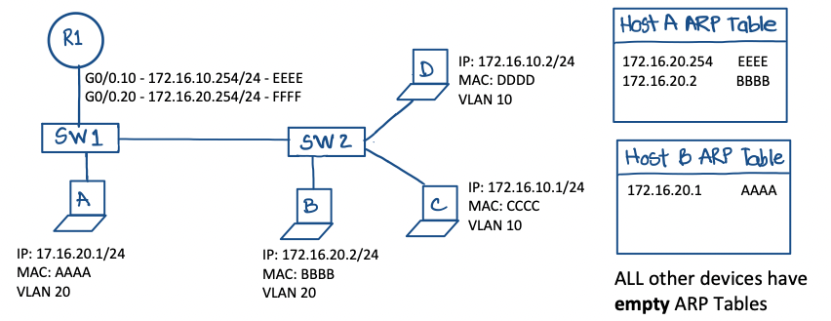

### Scenario 5

### ARP, L2/L3 Addressing and MAC Table

Consider the diagram below and answer the following questions:

#### **Host D sends a message to Host B**

**1. When the packet is sent by Host D**

1a) What is the source IP address? 172.16.10.2  
1b) What is the destination IP address? 172.16.20.2  
1c) What is the source MAC address? DDDD  
1d) What is the destination MAC address? EEEE

1e) What is the encapsulation protocol? 802.3 (Ethernet, not tagged)

**2. Does this packet traverse R1? Yes? No? Why?**  
       YES. Host D and Host B are in different networks, therefore, this packet needs to be processed by a layer 3 device for inter-VLAN routing.

**3. When the packet is forwarded by R1**

3a) What is the source IP address? 172.16.10.2  
3b) What is the destination IP address? 172.16.20.2  
3c) What is the source MAC address? FFFF  
3d) What is the destination MAC address? BBBB

3e) What is the encapsulation protocol? 802.1q (Ethernet, with VLAN tagging)

**4. How many ARP requests need to happen for this packet to be delivered to Host B.**  
       Two.  
       1. Host D ARP table is initially empty. When Host D sends the packet, it needs to request the MAC address of its default gateway  
       2. R1 ARP table is initially empty. When R1 forwards the packet to HostB, it needs to request the MAC address of Host B

**5. What are the contents of SW2 MAC address table after the packet has been delivered to Host B.**  
     At this point SW2 MAC Address table should have **4 entries**.  
     1. DDDD -   Fa0/3   << added when Host D sends the ARP request for 172.16.10.254   
     2. EEEE    -   G1/2    << added when R1 replies to Host D's ARP request   
     3. FFFF    -   G1/2    << added when R1 sends the ARP request for 172.16.20.2  
     4. BBBB   -   Fa0/1   << added when Host B replies to R1's ARP request

### Scenario 6:

### ARP, L2/L3 Addressing, MAC Table and Encapsulation

Consider the scenario in the diagram below and answer the following questions:

#### **1. When configuring device IP settings**

1.a) What is the default gateway IP of SW1?

1.b) What is the default gateway IP of SW2?

1.c) What is the default gateway IP of Host A?

1.d) What is the default gateway IP of Host B?

1.e) What is the default gateway IP of Host C?

#### **2. Host C sends a packet to Host B:**

2.a) Does Host C need to send an ARP request?

2.b) What is the source MAC address of the packet as it leaves Host C?

2.c) What is the destination MAC address of the packet as it leaves Host C?

2.d) What is the source IP address of the packet as it leaves Host C?

2.e) What is the destination IP address of the packet as it leaves Host C?

2.f) What is the encapsulation protocol used as the packet leaves Host C?

#### **3. The packet sent by Host C reaches R1:**

3.a) On which interface does R1 receive this packet?

3.b) Does this packet contain a VLAN ID tag? If Yes, what is the VLAN ID?

#### **4. R1 forwards the packet sent by Host C to Host B:**

4.a) What is the exit interface as the packet leaves R1?

4.b) Does R1 need to send an ARP request?

4.c) What is the source MAC address of the packet as it leaves R1?

4.d) What is the destination MAC address of the packet as it leaves R1?

4.e) What is the source IP address of the packet as it leaves R1?

4.f) What is the destination IP address of the packet as it leaves R1?

4.g) What is the encapsulation protocol used as the packet leaves R1?

4.h) Does this packet contain a VLAN ID tag? If Yes, what is the VLAN ID?

#### **5. What are the contents of SW1 MAC table after Host B received the packet?**

