WEEK 1 DATA SCIENCE PROJECT
Data Acquisition, Cleaning and Exploratory Data Analysis
Dataset: Titanic DatasetSubmitted By: Ruchi Ambatkar Course / Subject: Virtual Data Science with python Apprentice Intern Date: 03 October 2026
Page

Table of Contents
1. Introduction
2. Objective
3. Dataset Description
4. Data Acquisition
5. Tools and Technologies
6. Data Cleaning and Preprocessing
7. Exploratory Data Analysis
8. Visualizations and Interpretations
9. Key Insights
10. Challenges and Rationale
11. Conclusion
12. References
13. Appendix – Python Code
Page

1. Introduction
Data preparation is an important stage of a data science project. Before analysis or predictive modeling, raw data must be collected, inspected, cleaned, and explored. This project demonstrates that workflow using the publicly available Titanic dataset. Python libraries including Pandas, NumPy, Matplotlib, and Seaborn were used for data preparation and exploratory analysis.
2. Objective
Acquire a publicly available dataset from the internet.
Inspect the structure, data types, missing values, and duplicate records.
Clean and preprocess the dataset using Python.
Perform exploratory data analysis using summary statistics.
Create visualizations to identify trends, distributions, and relationships.
Document the methodology, cleaning decisions, visual outputs, and analytical insights.
3. Dataset Description
The Titanic dataset contains passenger-level information related to the Titanic voyage and survival outcome.
Column | Type | Description
PassengerId | int | Passenger identification number
Survived | int | Survival status (0 = did not survive, 1 = survived)
Pclass | int | Passenger class
Name | object | Passenger name
Sex | object | Passenger sex
Age | float | Passenger age
SibSp | int | Number of siblings/spouses aboard
Parch | int | Number of parents/children aboard
Ticket | object | Ticket number
Fare | float | Passenger fare
Cabin | object | Cabin identifier
Embarked | object | Port of embarkation
Initial dataset size: 891 rows and 12 columns.
Final cleaned dataset size: 891 rows and 11 columns.
4. Data Acquisition
A publicly available Titanic dataset was obtained from Kaggle and stored in the project under dataset/raw/Titanic-Dataset.csv. The raw file was retained unchanged so that the original data could be preserved and compared with the cleaned version.
Source: Kaggle Titanic Dataset (Yasser H.)
5. Tools and Technologies
Python
Jupyter Notebook
Pandas
NumPy
Matplotlib
Seaborn
6. Data Cleaning and Preprocessing
Initial inspection identified missing values in Age, Cabin, and Embarked. Duplicate records were also checked.
Issue | Observed | Action | Rationale
Age missing values | 177 | Filled with median age | Age is numerical; median is less sensitive to extreme values.
Embarked missing values | 2 | Filled with mode | Embarked is categorical; mode is an appropriate simple imputation.
Cabin missing values | 687 | Column removed | A very large proportion was missing, making reliable row-level imputation unsuitable for this analysis.
Duplicate rows | 0 | No removal required | No duplicate records were found.
Data types | Checked | Retained appropriate numeric/categorical types | Types were suitable for analysis.
After cleaning, the final dataset contained 0 missing values and 0 duplicate rows.
7. Exploratory Data Analysis
7.1 Overall Survival
Total passengers: 891. Survived: 342. Did not survive: 549. Overall survival rate: 38.38%.
7.2 Gender-wise Survival
Female survival rate: 74.20%. Male survival rate: 18.89%. These are descriptive results for this dataset and do not by themselves establish causation.
7.3 Passenger Class
Class 1 survival rate: 62.96%. Class 2: 47.28%. Class 3: 24.24%.
7.4 Age Analysis
Average age: 29.36 years. Median age: 28 years. Minimum age: 0.42 years. Maximum age: 80 years.
7.5 Fare Analysis
Average fare: 32.20. Median fare: 14.45. The distribution is therefore not centered only around the mean, indicating that the mean and median provide complementary summaries.
7.6 Correlation Analysis
A correlation matrix was calculated for numerical variables including Survived, Pclass, Age, SibSp, Parch, and Fare. The heatmap provides a compact view of pairwise linear relationships and identifies variables for further investigation.
8. Visualizations and Interpretations
Figure 1. Passenger Survival Distribution

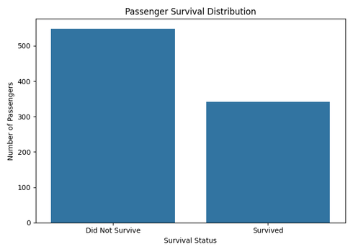

Interpretation: The chart shows that more passengers did not survive than survived. There were 549 passengers who did not survive and 342 who survived, giving an overall survival rate of 38.38%.
Figure 2. Passenger Survival by Gender

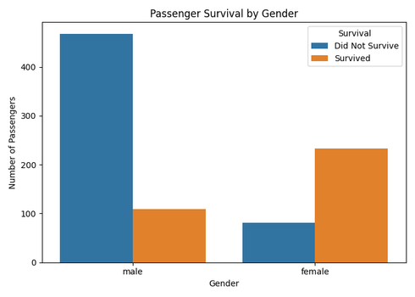

Interpretation: The visualization shows different survival outcomes by sex. The calculated survival rate was 74.20% for female passengers and 18.89% for male passengers in this dataset.
Figure 3. Passenger Survival by Class

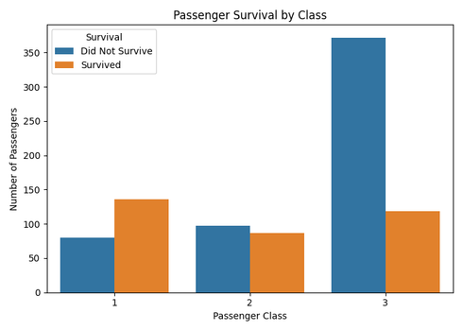

Interpretation: The chart shows different survival rates across passenger classes: 62.96% for first class, 47.28% for second class, and 24.24% for third class.
Figure 4. Age Distribution

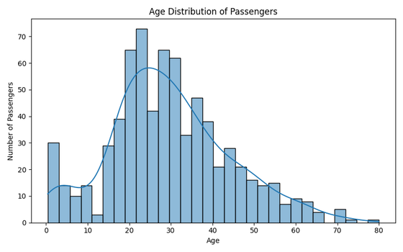

Interpretation: The histogram shows the distribution of passenger ages. The average age was 29.36 years and the median was 28 years, with ages ranging from 0.42 to 80 years.
Figure 5. Correlation Heatmap

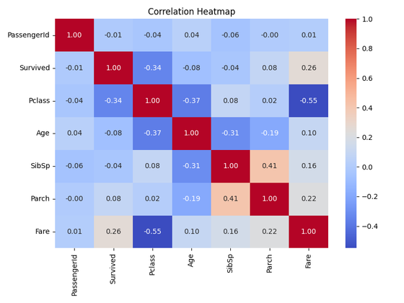

Interpretation: The heatmap provides an overview of pairwise correlations among numerical variables. It can be used to identify relationships that may be explored in further analysis.
Figure 6. Age vs Fare by Survival Status

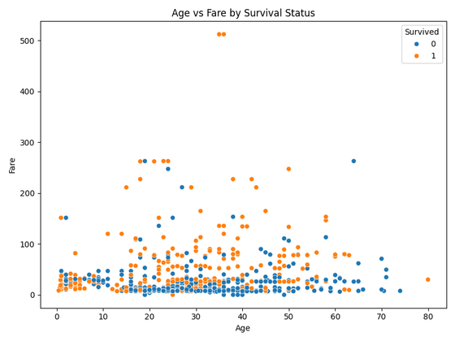

Interpretation: The scatter plot displays age against fare while distinguishing survival status. It provides a visual basis for examining whether age and fare show visible patterns associated with survival.
9. Key Insights
The cleaned dataset contains 891 passenger records and 11 retained columns.
342 passengers survived and 549 did not survive; the overall survival rate was 38.38%.
Survival rates differed between female and male passengers in the dataset.
Survival rates also differed across passenger classes, with the calculated rates varying from first to third class.
The average passenger age was 29.36 years and the median was 28 years.
The average fare was 32.20 while the median fare was 14.45.
The correlation heatmap provides candidate relationships for deeper statistical or predictive analysis.
10. Challenges and Cleaning Rationale
The main data-quality challenge was missing information. Age had 177 missing values, Embarked had 2, and Cabin had 687. Median imputation was selected for Age, mode imputation for Embarked, and Cabin was removed because most of its values were missing. Duplicate checking returned zero duplicates.
11. Conclusion
This project demonstrated a complete introductory data preparation workflow using the Titanic dataset. The data was acquired, inspected, cleaned, and explored using Python. Missing values were handled using appropriate simple techniques, duplicate records were checked, and the heavily incomplete Cabin column was removed. Exploratory analysis using summary statistics and six visualizations highlighted differences in survival outcomes across gender and passenger class and provided information about age, fare, and numerical-variable relationships. The resulting cleaned dataset provides a suitable foundation for further statistical analysis or predictive modeling.
12. References
Kaggle, Titanic Dataset.
Python Documentation.
Pandas Documentation.
Matplotlib Documentation.
Seaborn Documentation.
13. Appendix – Python Code
import pandas as pdimport numpy as npimport matplotlib.pyplot as pltimport seaborn as snsdf = pd.read_csv("../dataset/raw/Titanic-Dataset.csv")
# Missing-value analysisdf.isnull().sum()# Duplicate checkdf.duplicated().sum()
# Data cleaningcleaned_df["Age"] = cleaned_df["Age"].fillna(cleaned_df["Age"].median())cleaned_df["Embarked"] = cleaned_df["Embarked"].fillna( cleaned_df["Embarked"].mode()[0])cleaned_df = cleaned_df.drop(columns=["Cabin"])cleaned_df.to_csv( "../dataset/cleaned/Titanic-Cleaned.csv", index=False)
# Overall survivalcleaned_df["Survived"].value_counts()# Gender-wise survivalcleaned_df.groupby("Sex")["Survived"].mean() * 100# Class-wise survivalcleaned_df.groupby("Pclass")["Survived"].mean() * 100
# Correlation heatmapcorrelation = cleaned_df.select_dtypes(include="number").corr()sns.heatmap( correlation, annot=True, cmap="coolwarm", fmt=".2f")plt.title("Correlation Heatmap")plt.tight_layout()plt.savefig("../visualizations/correlation_heatmap.png")plt.show()

Page

