Global Happiness: Data Visualization and Storytelling
Week 2 Data Science Project
Advanced Data Visualization and Storytelling with Python

Dataset: World Happiness Report 2019
Tools: Python, Pandas, Matplotlib and Seaborn

1. Introduction
Data visualization transforms numerical data into visual formats that help readers identify patterns, compare values, and understand relationships. This project explores the World Happiness Report 2019 dataset to investigate happiness scores and their relationships with economic, social, and health-related factors.

2. Objectives
- Understand the distribution of happiness scores.
- Explore the relationship between GDP per capita and happiness.
- Compare countries with high and low happiness scores.
- Examine correlations among numerical variables.
- Explore multiple happiness-related factors in a single visualization.
- Communicate findings through clear charts and captions.

3. Dataset Description
The dataset contains 156 records and 9 columns after duplicate removal. The columns include overall rank, country or region, happiness score, GDP per capita, social support, healthy life expectancy, freedom to make life choices, generosity, and perceptions of corruption.
The dataset was checked for missing values and duplicate records. The cleaning checks showed no missing values in the displayed columns.

4. Methodology
- Loaded the dataset using Pandas.
- Removed extra whitespace from column names.
- Removed duplicate records.
- Checked missing values and inspected the data types.
- Created six visualizations using Matplotlib and Seaborn.
- Saved the charts as high-resolution PNG files.
- Interpreted each chart to support data-driven storytelling.

5. Visualizations and Interpretation

5.1 Happiness Score Distribution
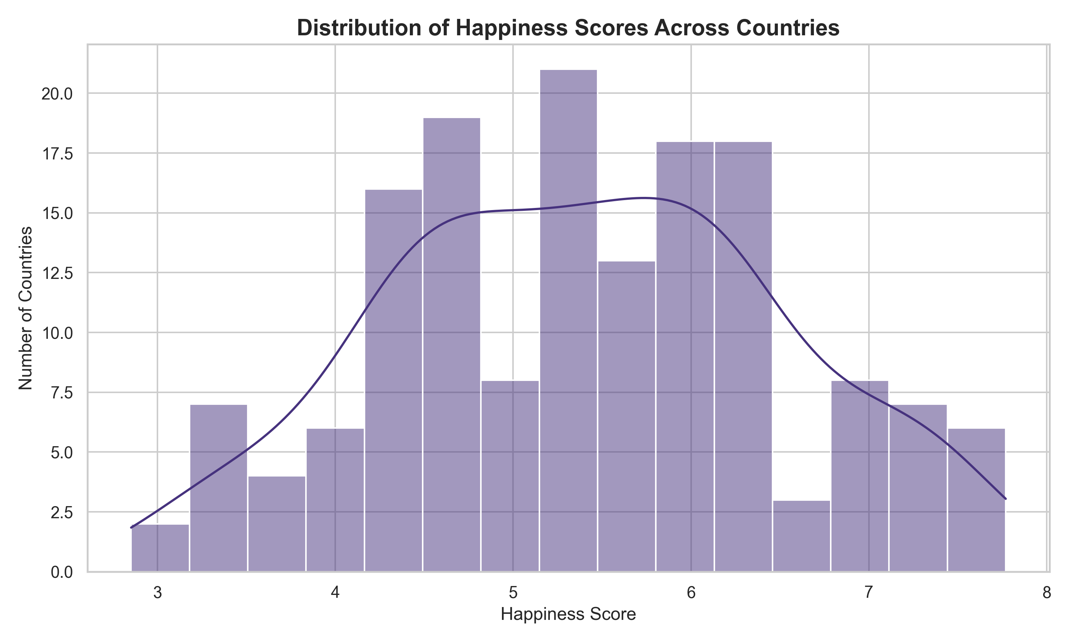
Caption: The histogram displays the distribution of happiness scores. The bars show how many countries fall within each score interval, while the KDE curve illustrates the overall distribution pattern.

5.2 GDP per Capita vs Happiness
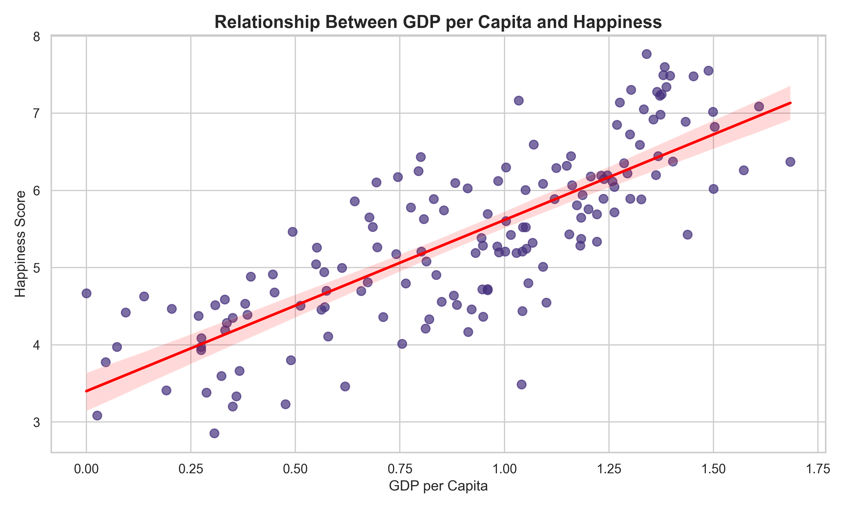
Caption: The scatter plot compares GDP per capita with happiness scores. The fitted trend line helps show whether these variables have a positive or negative linear association. Association alone does not establish causation.

5.3 Top 15 Happiest Countries
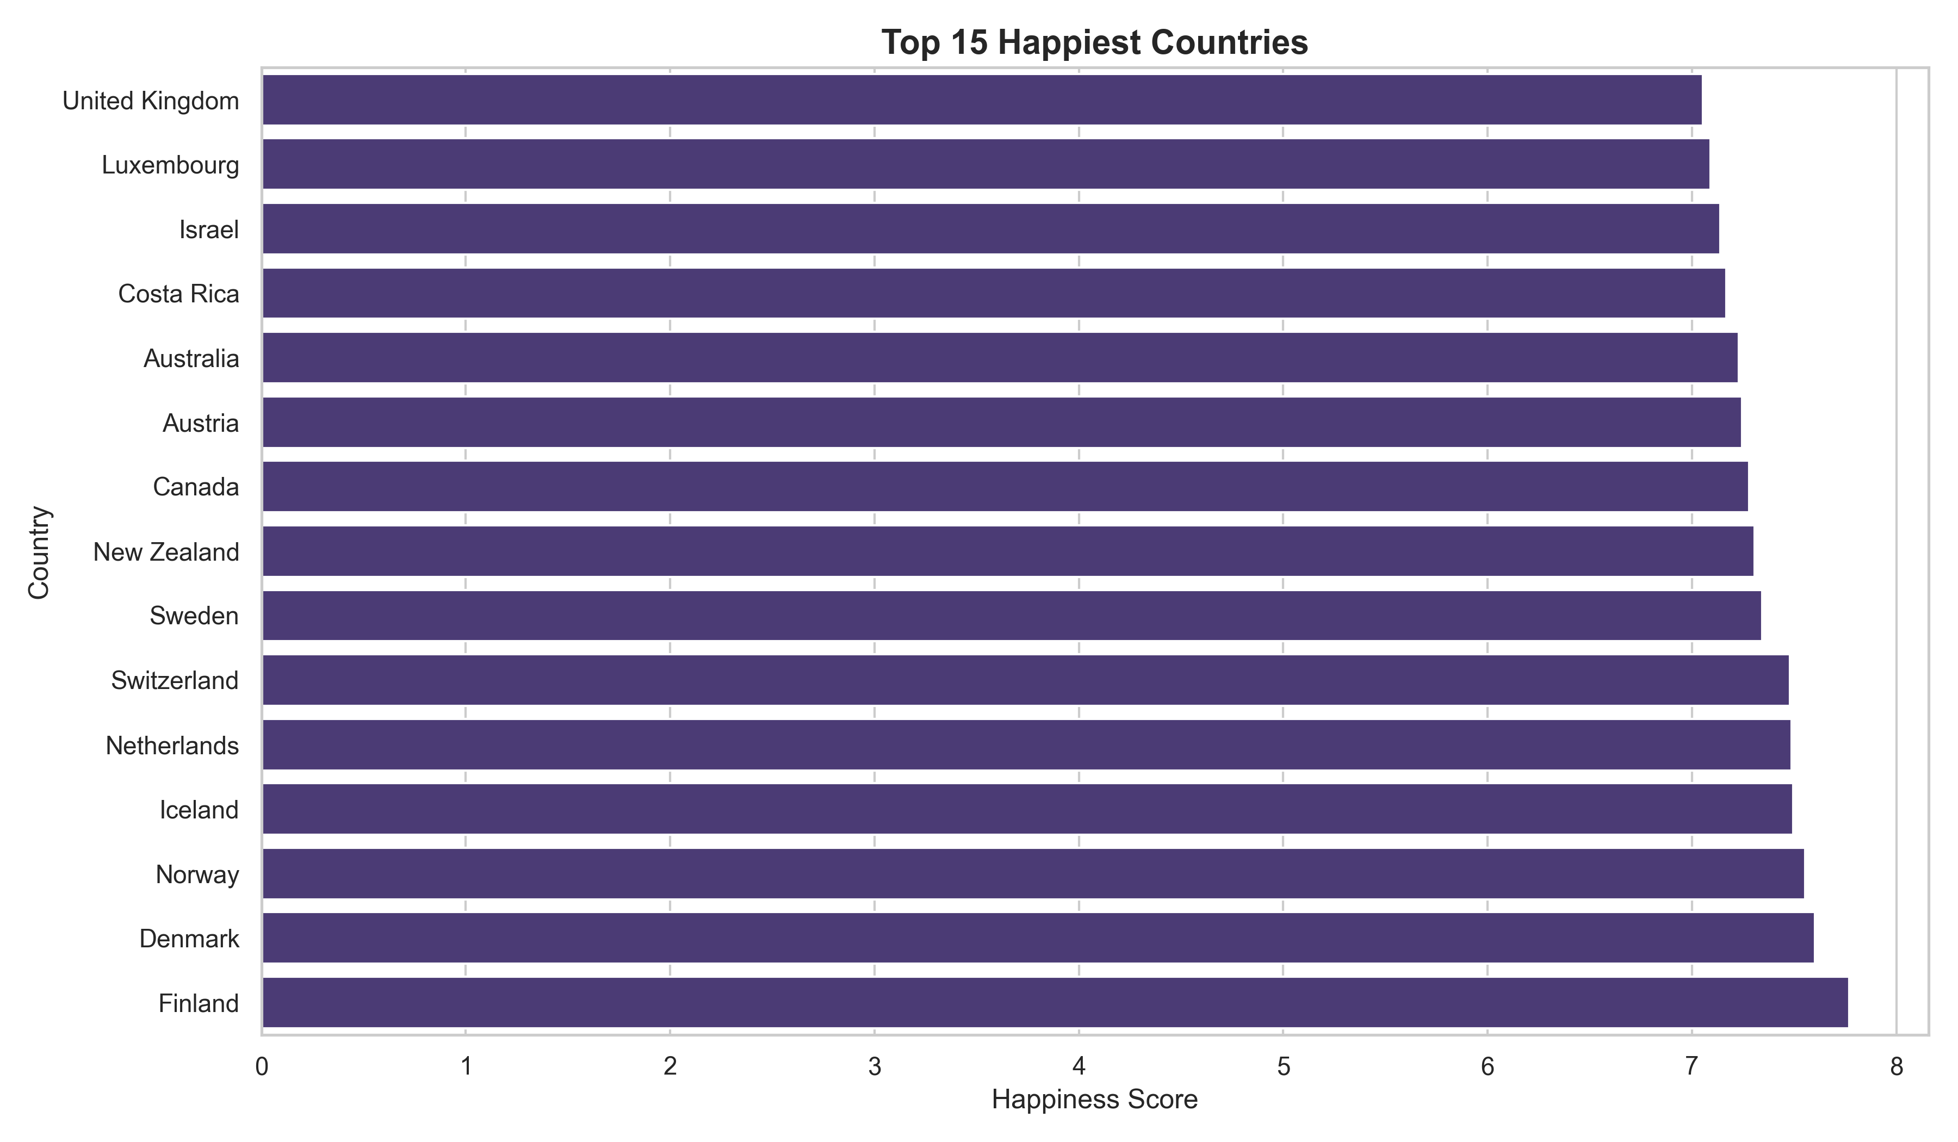
Caption: This horizontal bar chart compares the 15 countries with the highest happiness scores, making differences between their scores easy to observe.

5.4 Correlation Heatmap
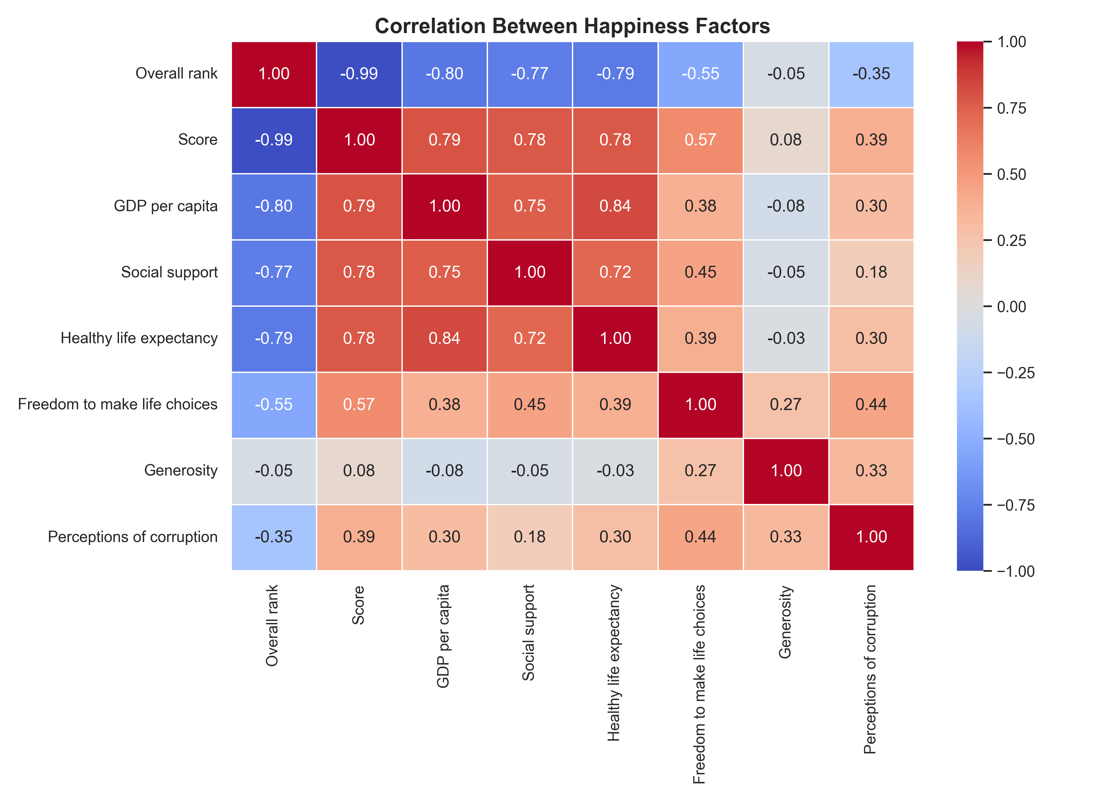
Caption: The heatmap displays pairwise correlations among numerical variables. Positive values indicate variables that tend to increase together, while negative values indicate an inverse linear relationship.

5.5 Countries with the Lowest Happiness Scores
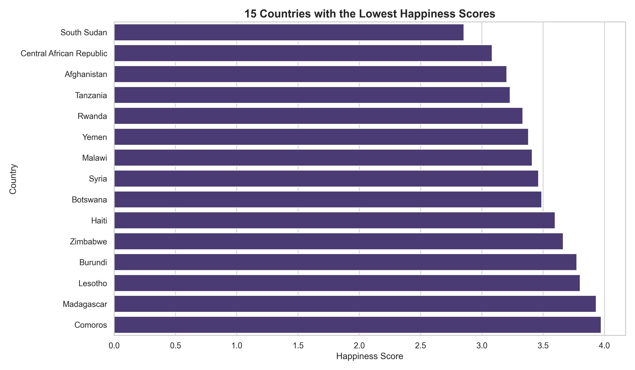
Caption: This chart compares the 15 countries with the lowest happiness scores and highlights variation among countries at the lower end of the distribution.

5.6 Multiple Happiness Factors
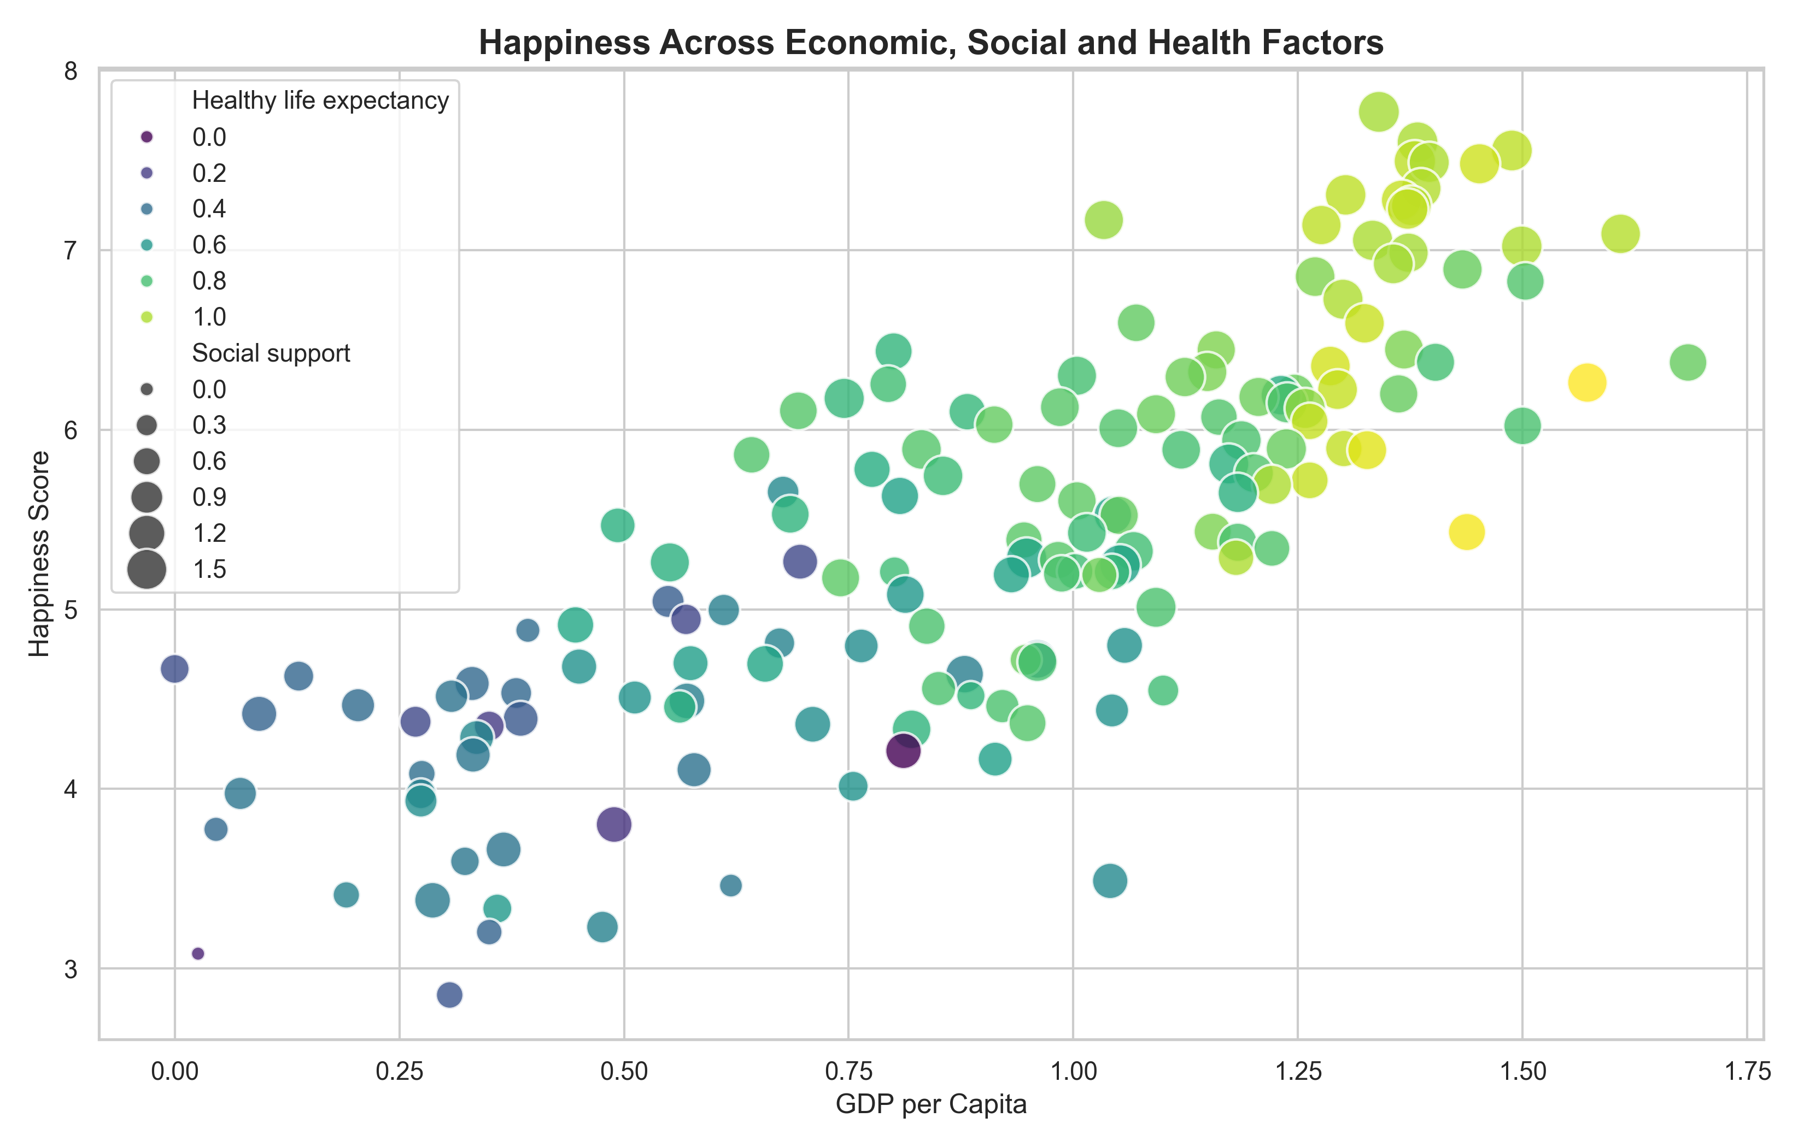
Caption: The bubble chart combines GDP per capita and happiness score, with bubble size representing social support and color representing healthy life expectancy. It helps explore several variables at once.

6. Key Findings
The five highest-scoring countries in this dataset include Finland, Denmark, Norway, Iceland, Netherlands. The lowest-scoring countries can be reviewed in the corresponding bar chart.
The Pearson correlation between GDP per capita and happiness score is 0.79. The correlation between social support and happiness score is 0.78, while the correlation between healthy life expectancy and happiness score is 0.78. These statistics describe linear associations in this dataset and should not be interpreted as proof of cause and effect.

7. Implications
The visualizations provide a structured way to compare happiness scores and investigate their associations with economic, social, and health-related indicators. Policymakers and researchers could use such comparisons to identify areas for further investigation. However, the charts alone cannot establish why a country has a particular score or prove that changing one indicator will directly change happiness.

8. Limitations
The analysis describes one dataset from 2019 and does not establish changes over time. Correlations may be affected by other factors, and the available indicators may not capture every aspect of well-being. The results should therefore be interpreted as exploratory findings.

9. Conclusion
This project demonstrates how Python visualization libraries can turn a structured dataset into meaningful charts and explanations. The six visualizations examine score distributions, country rankings, relationships, correlations, and multiple factors together. Combining visual evidence with cautious interpretation makes the analysis easier to understand and communicate.

