STATISTICAL ANALYSIS AND HYPOTHESIS TESTING
Project: Statistical Analysis of Study Time and Academic Performance
Week 3 Python Data Science Task
Submitted by: Ruchi Ambatkar
Tools: Python, Pandas, SciPy, Statsmodels, Matplotlib and Seaborn

Abstract
This project investigates the relationship between students' reported weekly study time and final mathematics grades using the UCI Student Performance dataset. Python is used for data preparation, visualization and statistical hypothesis testing. Spearman rank correlation is the primary analysis, while Welch's independent-samples t-test, one-way ANOVA and linear regression provide supplementary perspectives. The findings are interpreted using a 5% significance level. Because the dataset is observational, the results describe associations rather than establishing causation.
1. Introduction
Statistical analysis enables researchers to investigate patterns in data and evaluate evidence for relationships between variables. In education, reported study habits may be associated with academic performance. This project examines that relationship using student data and statistical methods implemented in Python.
2. Objectives
Inspect and prepare a public student performance dataset.
Summarize final mathematics grades and study-time categories.
Visualize the distribution of grades and group differences.
Test the association between study time and final grades.
Compare group means and calculate a confidence interval.
Interpret the statistical findings and their limitations.
3. Dataset Description
The analysis uses the UCI Student Performance mathematics dataset. The original dataset contains 395 student records and 33 columns. The prepared analysis contains 395 valid records for the selected variables.
The studytime variable represents reported weekly study time in four ordered categories. G3 represents the final mathematics grade on a scale from 0 to 20.
4. Research Question and Hypotheses
Research question: Is there a statistically significant monotonic association between reported study time and final mathematics grades?
Null hypothesis (H0): There is no monotonic association between study time and final mathematics grades in the population.
Alternative hypothesis (H1): There is a monotonic association between study time and final mathematics grades in the population.
The significance level is alpha = 0.05. A p-value below 0.05 is treated as evidence against the corresponding null hypothesis.
5. Methodology
The dataset was loaded using Pandas and the relevant variables were checked for missing values and valid ranges. Exploratory visualizations were created using Matplotlib and Seaborn. Spearman correlation assessed the monotonic association between the ordinal study-time categories and final grades. Welch's t-test compared mean grades between categories 1-2 and categories 3-4. One-way ANOVA compared means across all four categories. Ordinary least squares regression summarized the coded linear trend.
6. Descriptive Statistics
Statistic | Study Time | Final Grade (G3)
count | 395.000 | 395.000
mean | 2.035 | 10.415
std | 0.839 | 4.581
min | 1.000 | 0.000
25% | 1.000 | 8.000
50% | 2.000 | 11.000
75% | 2.000 | 14.000
max | 4.000 | 20.000
7. Visual Analysis

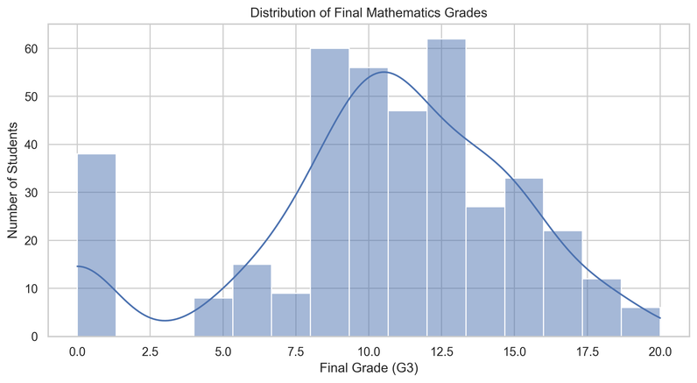

Figure 1: Distribution of final mathematics grades.

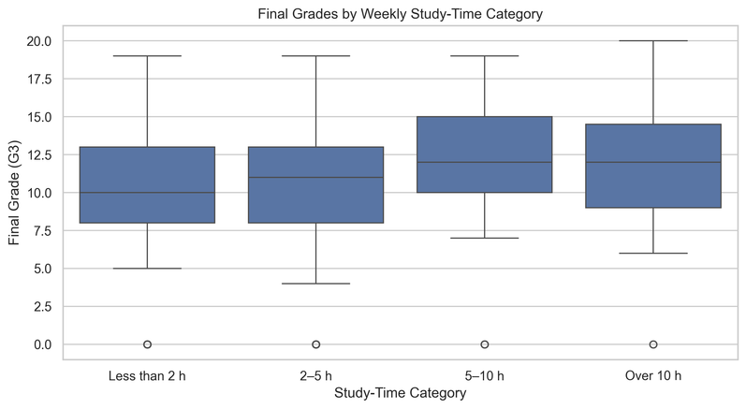

Figure 2: Final grades by study-time category.

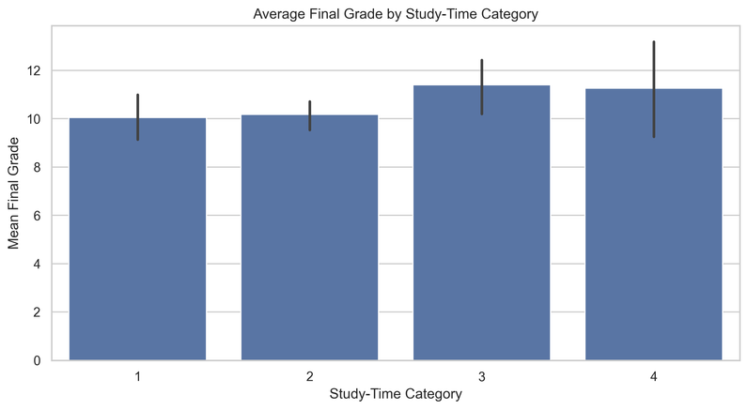

Figure 3: Average final grade by study-time category.

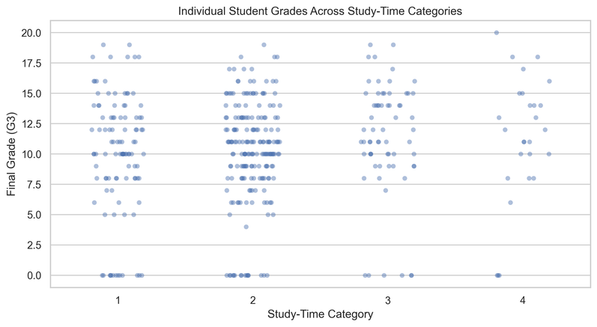

Figure 4: Individual grades across study-time categories.
8. Spearman Rank Correlation
Spearman correlation coefficient: 0.1052
P-value: 0.036674
Decision: Reject the null hypothesis for the Spearman test. The result provides evidence of a monotonic association.
9. Welch's Independent-Samples t-Test
Lower study-time group size: 303
Higher study-time group size: 92
Lower group mean: 10.129
Higher group mean: 11.359
Mean difference (higher minus lower): 1.230
t-statistic: 2.1831
P-value: 0.030669
95% confidence interval for the mean difference: (0.116, 2.344)
Decision: Reject the null hypothesis of equal population means for this two-group comparison.
10. One-Way ANOVA
F-statistic: 1.7278
P-value: 0.160723
Decision: Fail to reject the null hypothesis that all four population means are equal.
11. Regression Analysis
Estimated slope for study-time category: 0.5340
95% confidence interval for the slope: (-0.0048, 1.0728)
Regression p-value for the slope: 0.052061
The regression slope describes the estimated change in grade associated with a one-category increase in the coded study-time variable. It does not represent the effect of one additional hour.
12. Limitations
The study uses observational data and cannot establish causation. Study time is reported in broad categories rather than exact hours. Other factors, including prior achievement, attendance, motivation and family circumstances, may influence grades. Statistical assumptions should be checked before drawing firm conclusions. The findings may not generalize to every student population.
13. Conclusion
The Spearman test produced a correlation coefficient of 0.1052 and a p-value of 0.036674. The primary test provides evidence of a statistically significant monotonic association at the 5% level. The Welch t-test and ANOVA provide supplementary comparisons of academic performance across study-time groups. These results should be interpreted alongside confidence intervals, test assumptions and the limitations of observational data. The analysis does not establish that study time alone causes differences in grades.
14. References
Cortez, P., and Silva, A. M. G. (2008). Using Data Mining to Predict Secondary School Student Performance. FUBUTEC 2008.
UCI Machine Learning Repository. Student Performance Dataset. https://archive.ics.uci.edu/dataset/320/student+performance
SciPy Documentation: https://docs.scipy.org/doc/scipy/
Statsmodels Documentation: https://www.statsmodels.org/
Pandas Documentation: https://pandas.pydata.org/docs/

