Skill Training Template
Skill Training: Linear Algebra for Machine Learning – Week 1
Link: DeepLearning.AI - Learning Platform
Evidence:
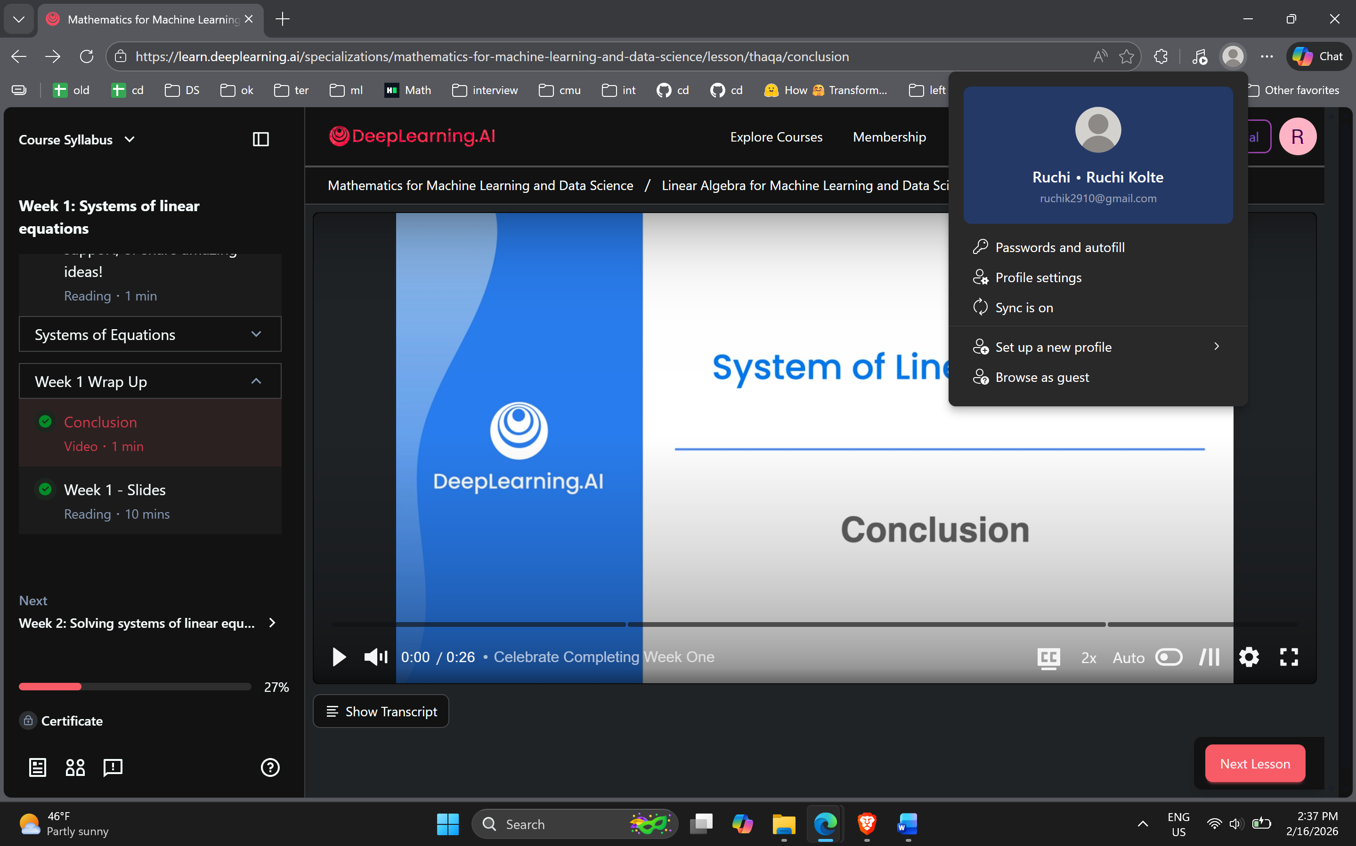
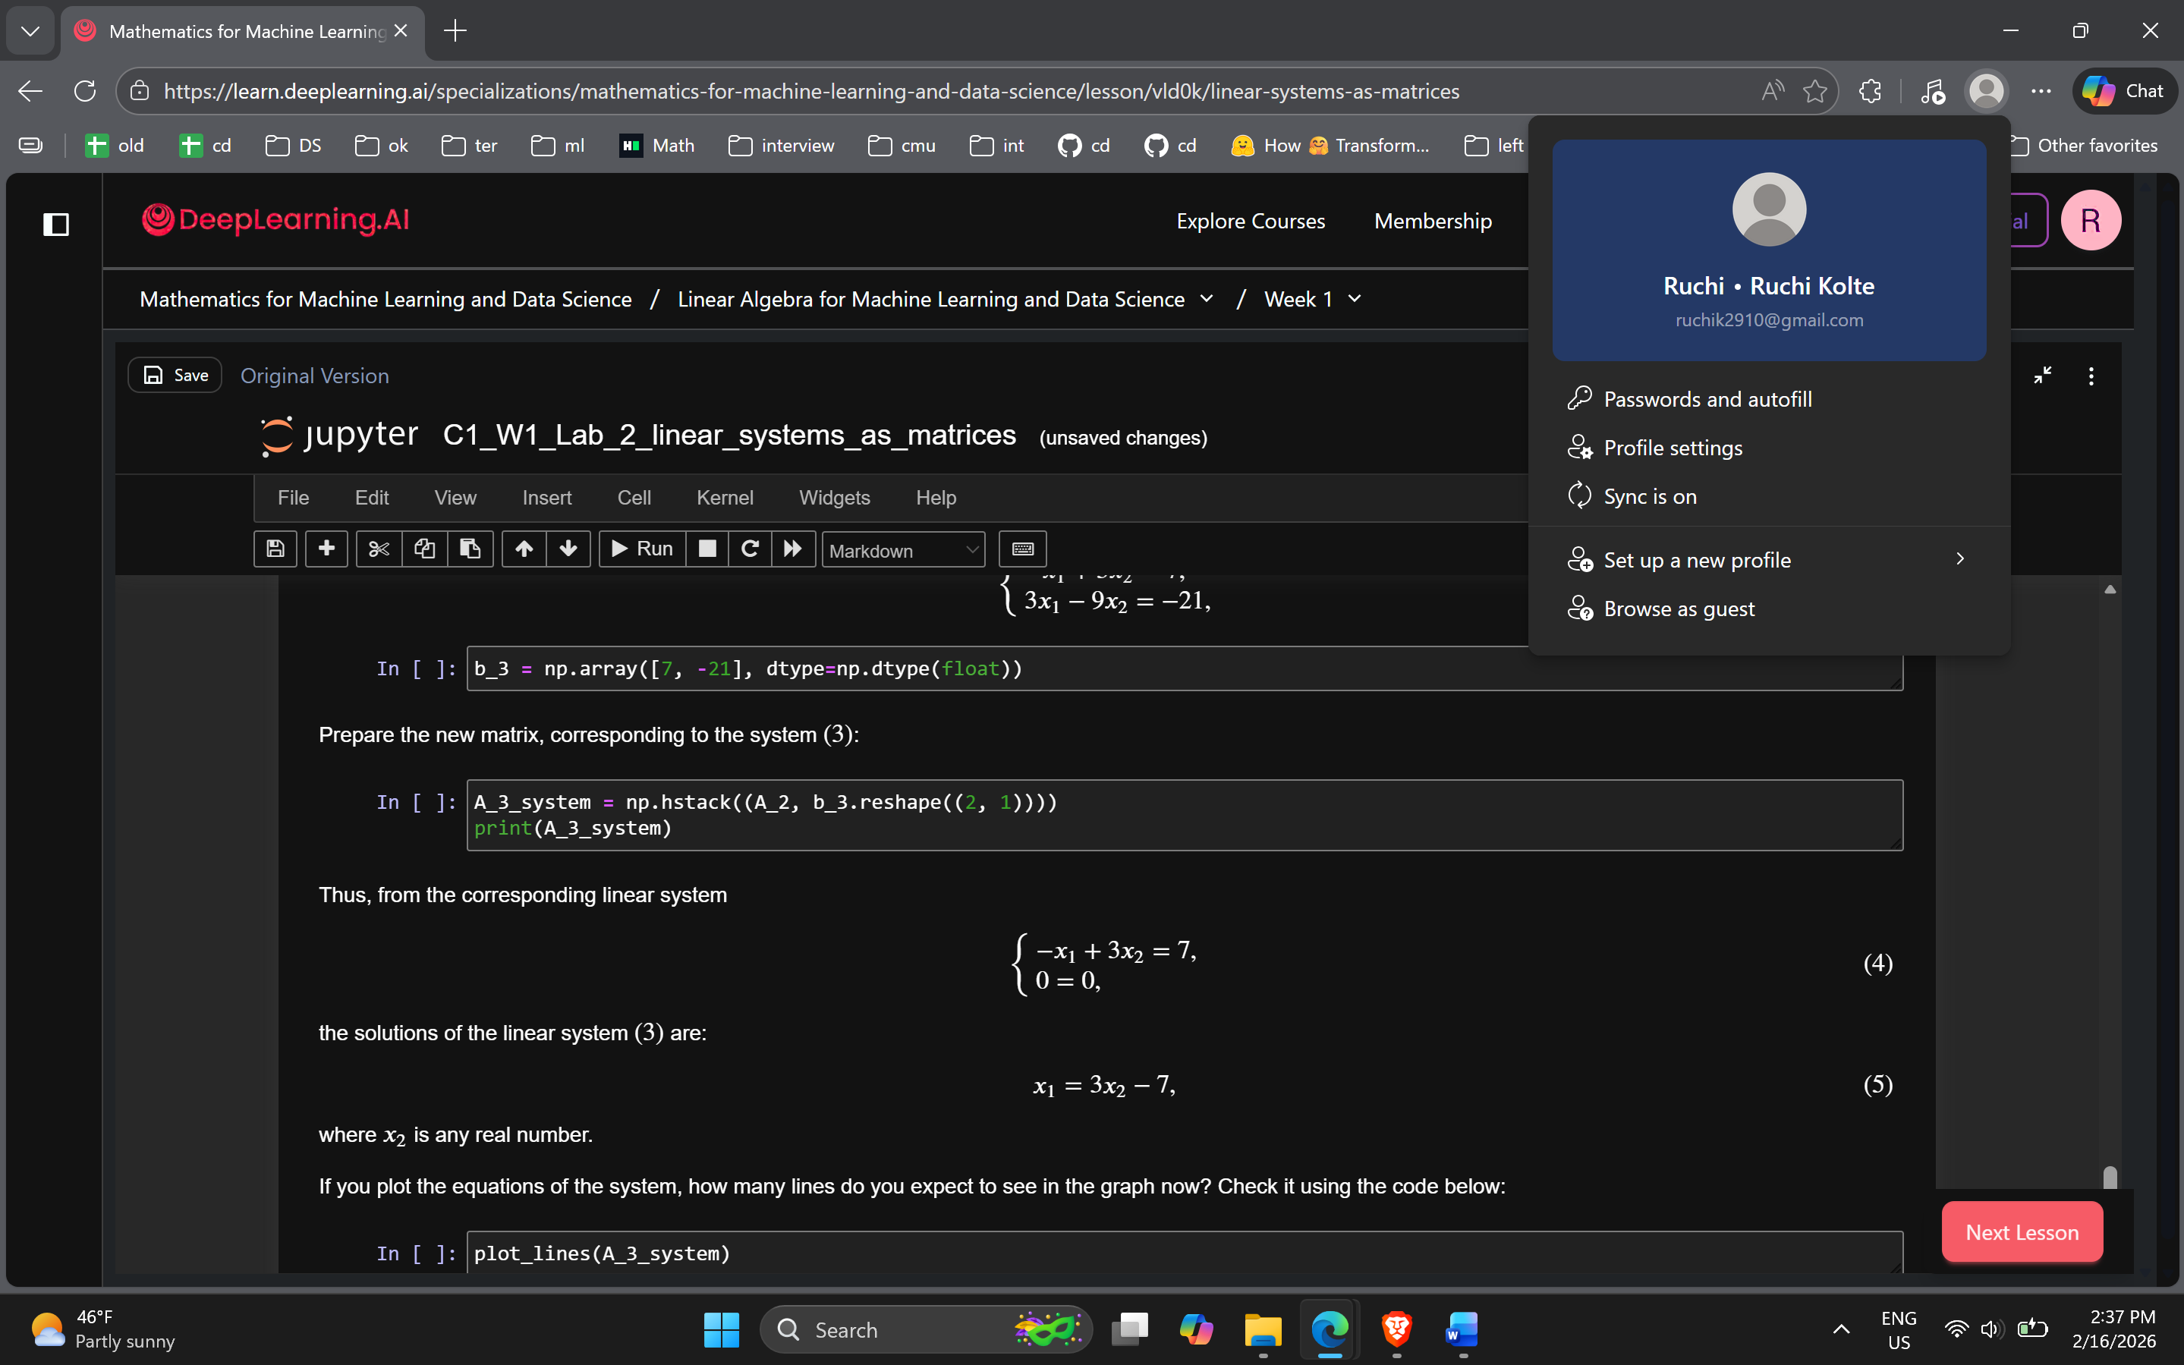

Your session Notes (a minimum of 5 bullets):
- Linear regression uses linear relationships between the independent and dependent features and takes into account the weight of the feature, the value of the feature itself and the bias.
- It is essential to know how to translate a system of sentences into appropriate system of variables.
- If rows or columns of a matrix are linearly dependent with determinant 0, the matrix is singular otherwise it is non-singular
- The determinant helps determine whether a particular matrix is singular or non-singular by subtracting the products of diagonal elements and anti-diagonal elements.
- In a system, if two rows can be expressed as multiples of on and another, these rows can be reduced to find the answers.
- In multiple linear regression, a unique weight is multiplied to each vector/feature and added to the total bias to find the future prediction.
- Numpy lets you perform various operations on vector data which can be used in various use cases like matrix multiplication or applying various machine learning algorithms.
Key Takeaways: (3 bullets)
- To understand the working of machine learning better, it is important to have a strong grasp of linear algebra, calculus, probability and statistics.
- The determinant is essential in determining the singularity of a matrix which further helps us understand whether the vectors are linearly dependent or independent.
- In linear regression, linearly independent variables are multiplied with weights and added by the bias to find out the value of the dependent variable or the prediction.
Future Application: (3 bullets)
- I will use the hands-on numpy exercise to experiment with practicing mathematical equations involving matrices purely with code.
- I am curious about in which all models is finding the determinant essential and how it helps improve models.
- I found the training quite hands-on, but it felt very basic so far. It could have been more comprehensive, showed how and where the learned concepts apply to machine learning algorithms and help develop that intuition rather than revising the basics in Week 1.

Put Rust into practice | LinkedIn Learning
https://www.linkedin.com/learning/learning-docker-17236240/get-up-and-running-quick-with-docker

https://www.linkedin.com/learning/level-up-rust/put-rust-into-practice
https://www.linkedin.com/learning/linux-bash-shells-and-scripts-streamlining-tasks-and-enhancing-workflows-with-automation/the-path-to-bash-shell-mastery

Skill Training Template
Skill Training:
Link: [URL]
Evidence: Attach screenshot(s). MUST show:
- Your actual work (completed assignment or quiz, not just a submission page)
- Your name + computer's date/time (For chrome, click on your profile name and ensure screenshot shows your computer's date/time)
- No more than 2 screenshots per action item
Your session Notes (a minimum of 5 bullets):
- [Add a minimum of 4 (up to 10) bullet points from your notes.]
- While developing applications, a common problem arises that the application runs fine on one system but not another. There are certain packages, dependencies and compute resources that the application needs. Docker helps bridge this gap.
- Virual machine depends on the hardware that it is installed on and shares common compute resources while for docker it uses the compute resources of the host device.
- TControl Group – monitor restrict cup, network, memory.
- Dontainers are bound to parent OS – Windows windows linux linux
- Docker container files are flexible, cli is flexible even images can be added to docker containers.
- Namespaces provides abstraction
- Run = create + start + attach
Key Takeaways: (3 bullets)
- [Your most important takeaway.]
- [Add a second key concept you learned.]
- [Add a third key concept you learned.]
Future Application: (3 bullets)
- [Share how you'll apply what you learned.]
- [What genuine questions do you have or want to learn next?]
- [Suggestion for how the training itself could be improved]

