**Innovative Project/Practical 2019**

**Programming Language: R**

**DASHBOARD using Shiny Package in R.**

**Code**

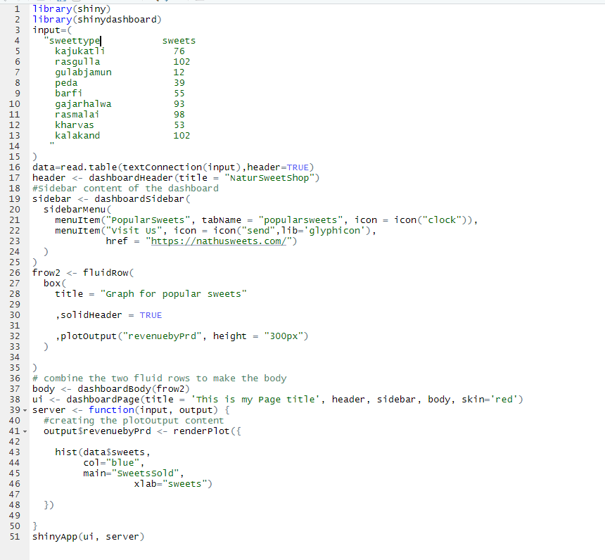

**Console**

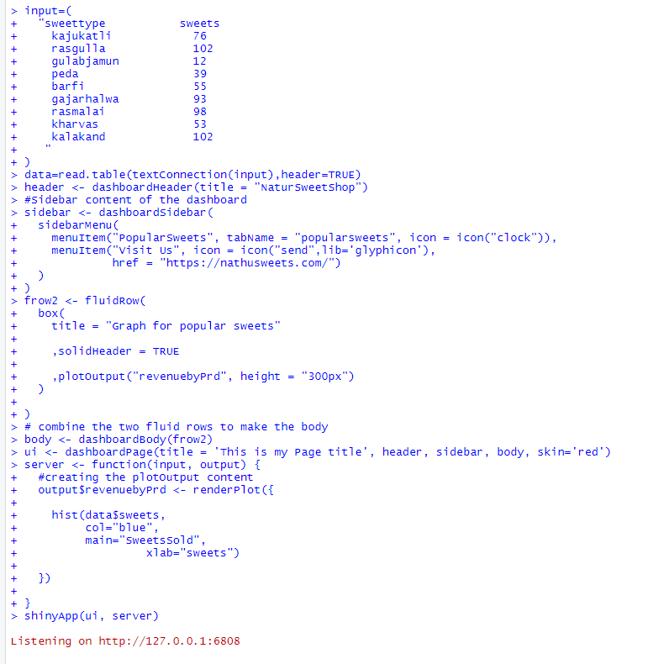

**Output**

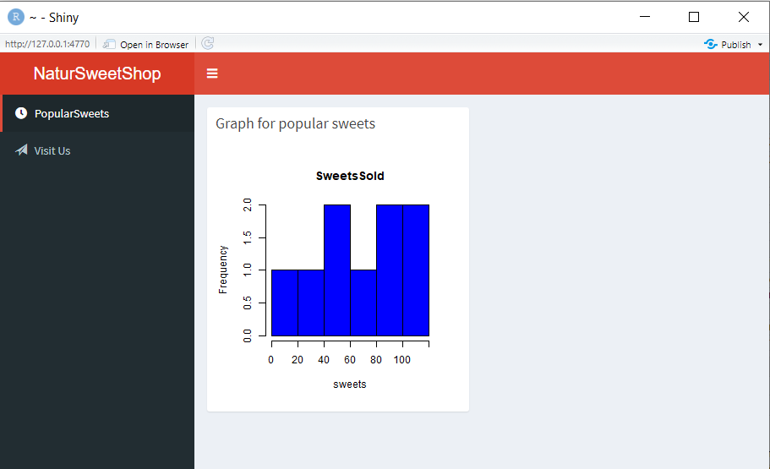

Directed to the website given in the href attribute

