NAME OF STUDENT: RUCHI BAJRACHARYA

STUDENT ID: 2133112

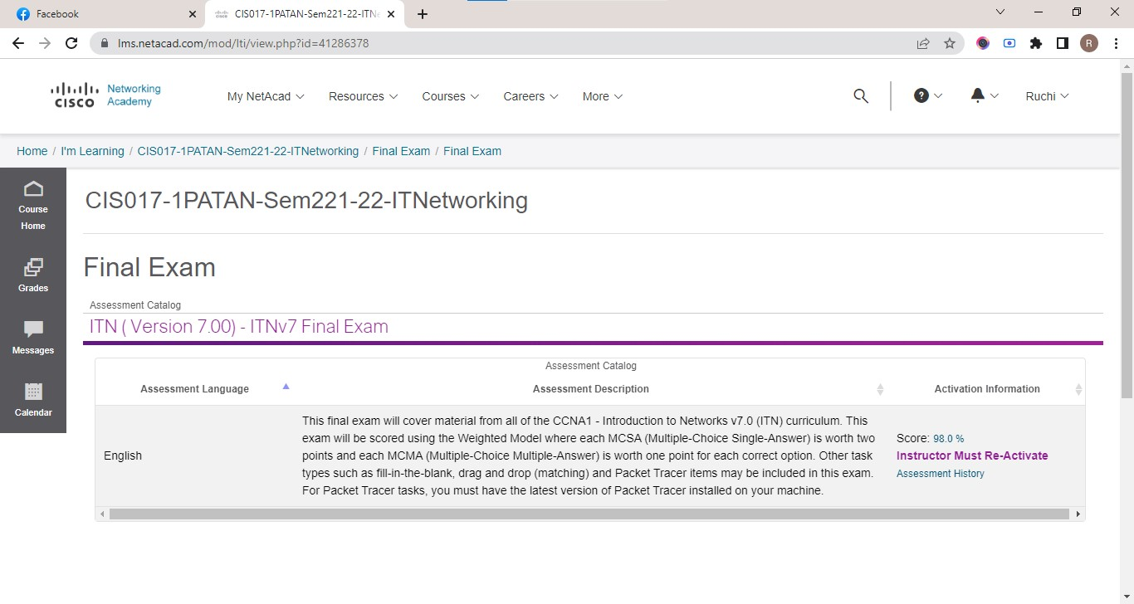

Figure :FINAL EXAM

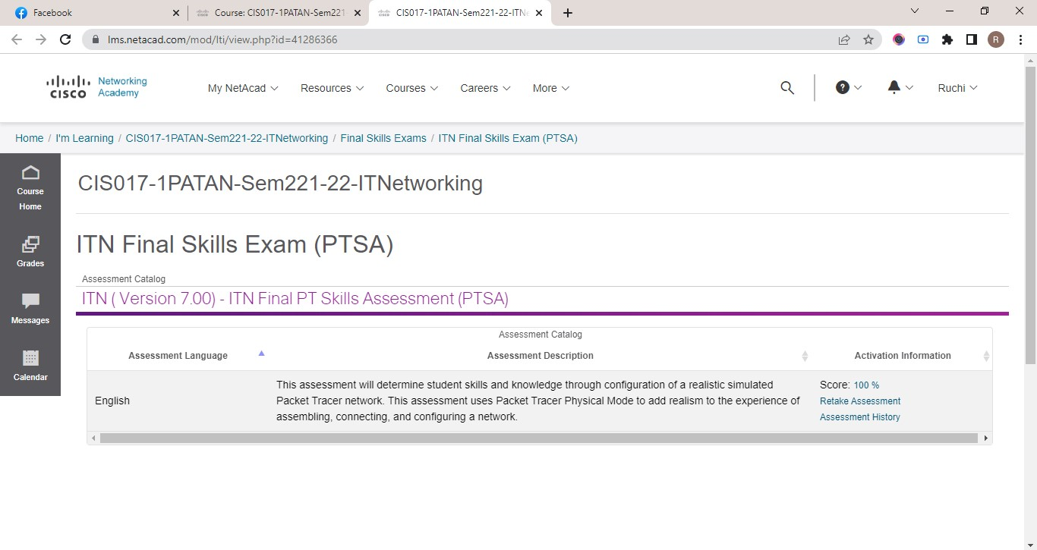

Figure : ITN FINAL SKILLS EXAM(PTSA)

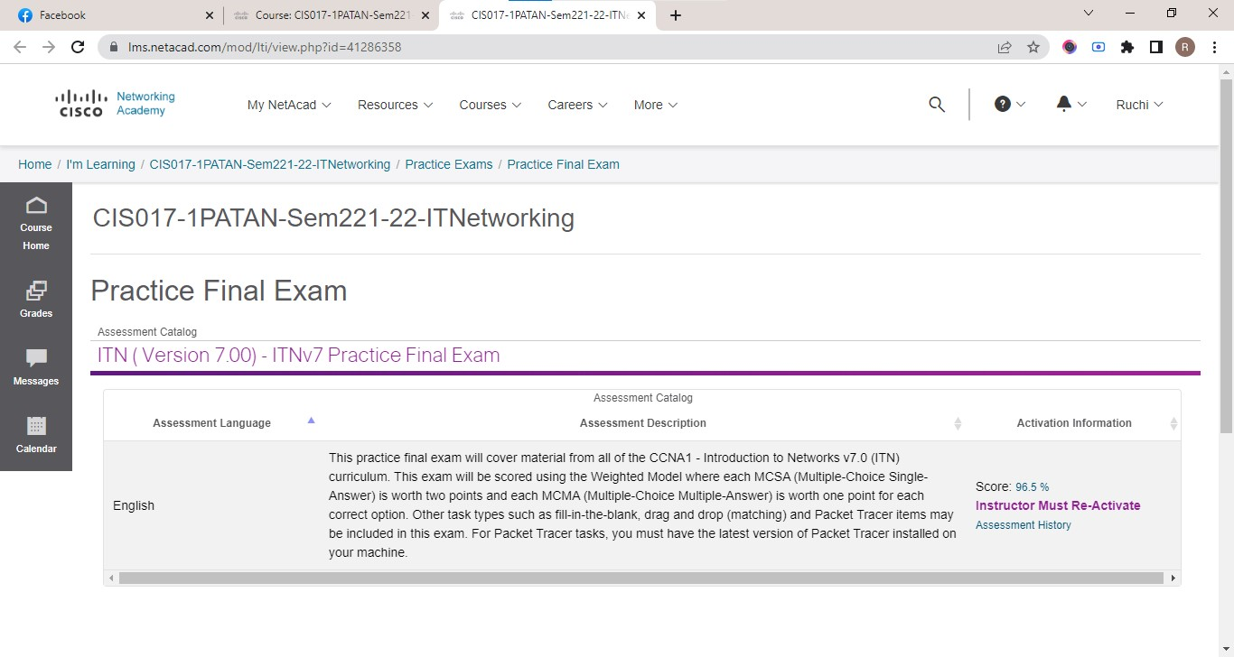

Figure : PRACTICE FINAL EXAM

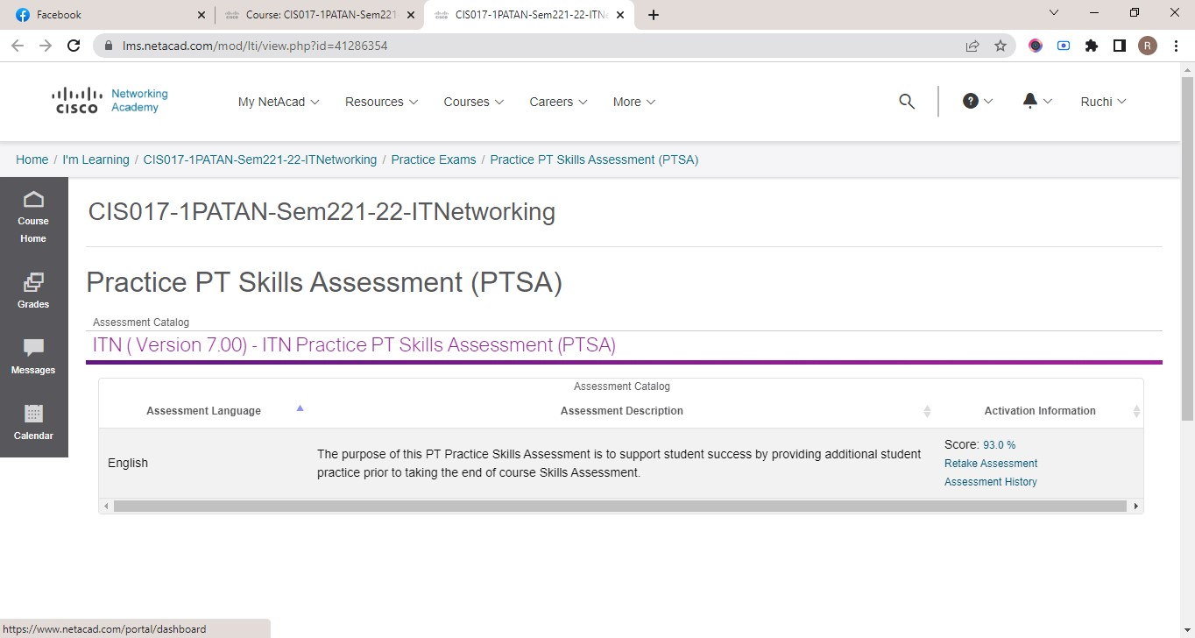

Figure : PRACTICE PT SKILLS ASSESSMENT(PTSA)

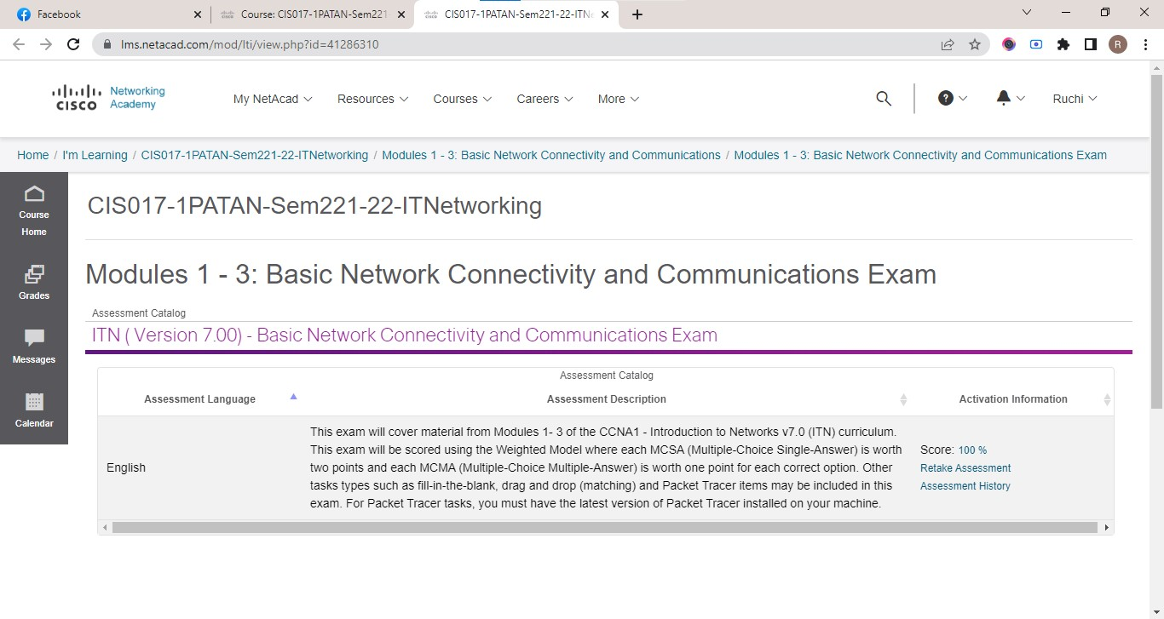

Figure :MODULES:1-3

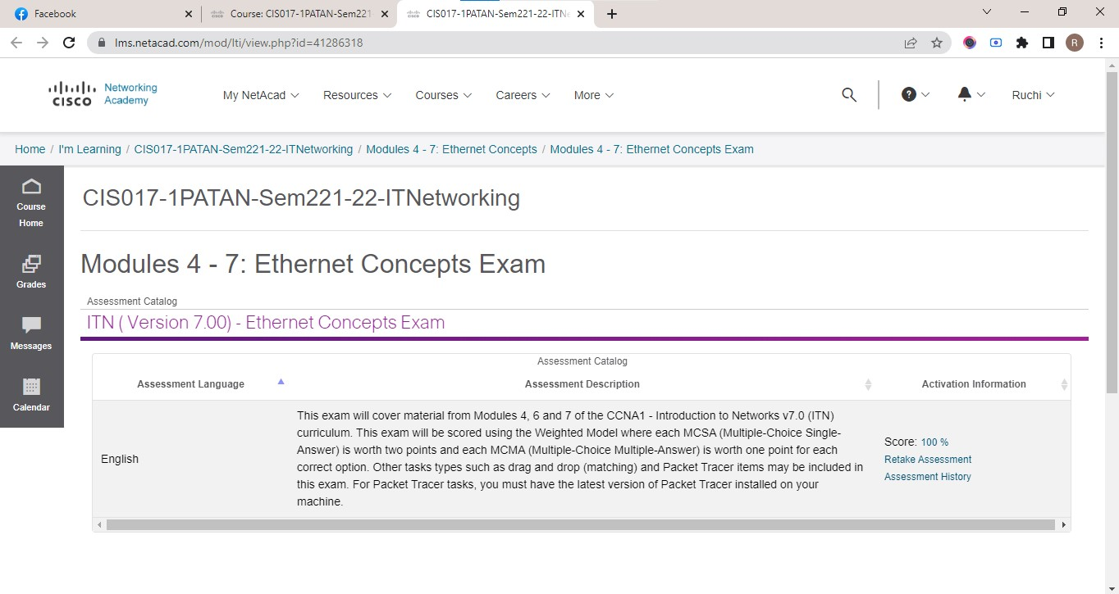

Figure :MODULES 4-7

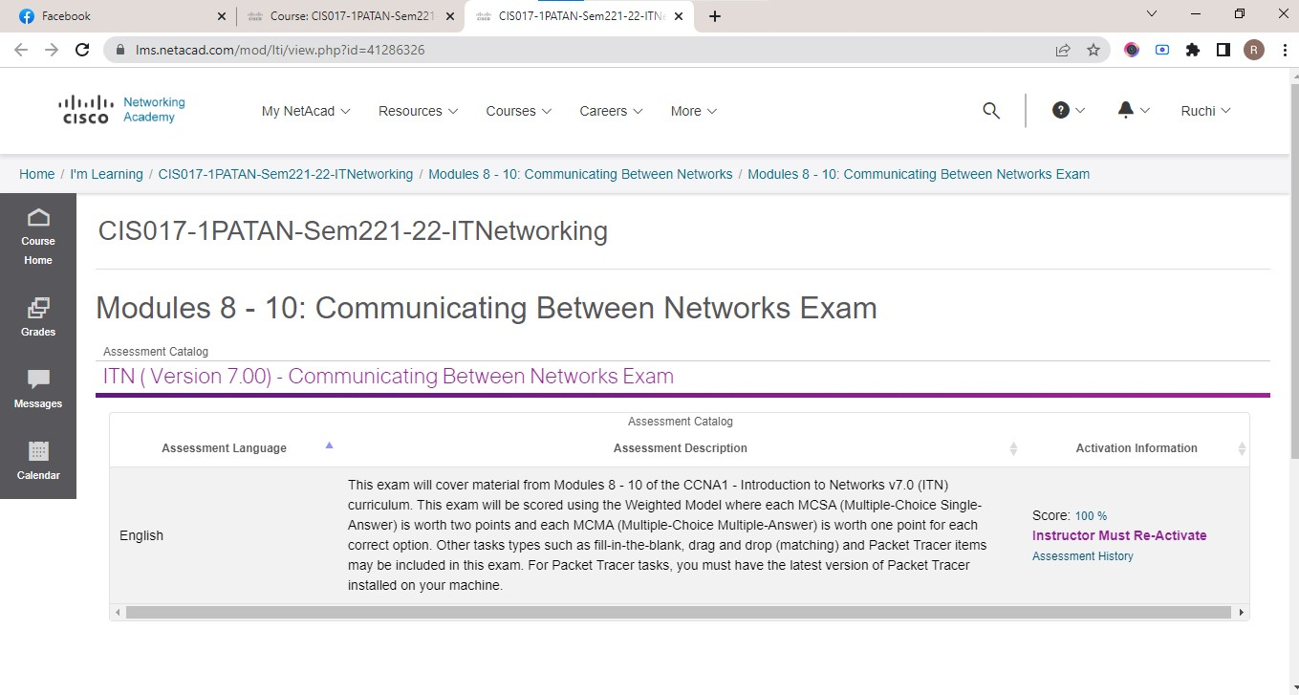

Figure :MODULE 8-10

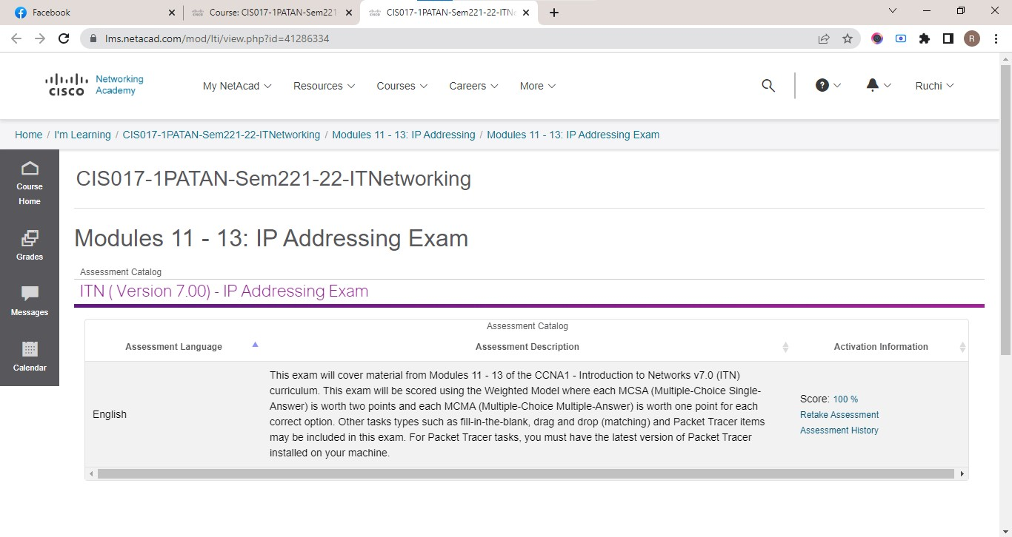

Figure :MODULES 11-13

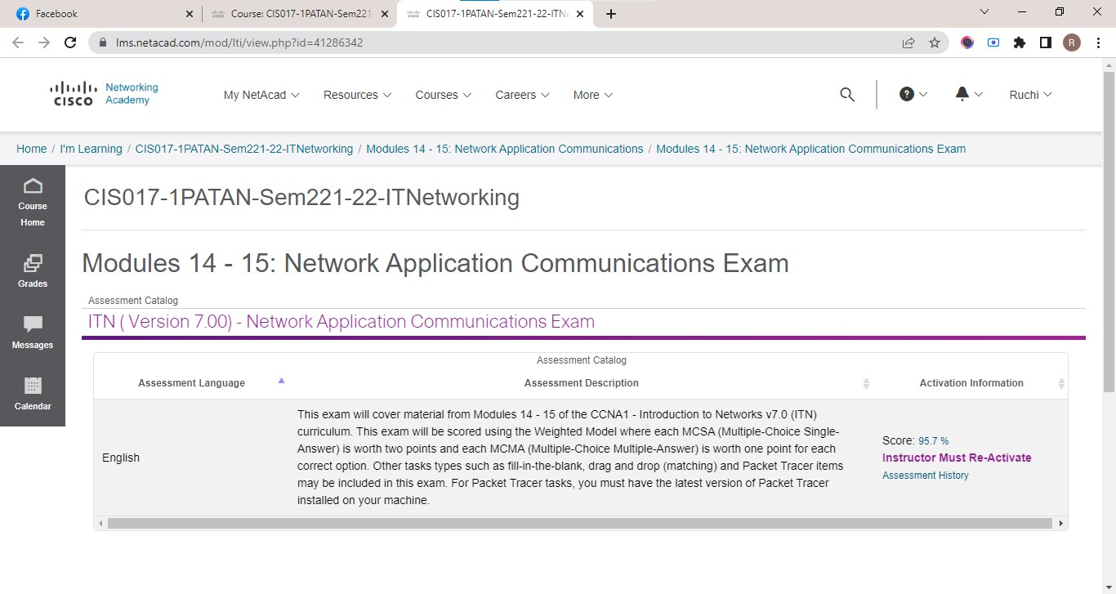

Figure :MODULES 14-15

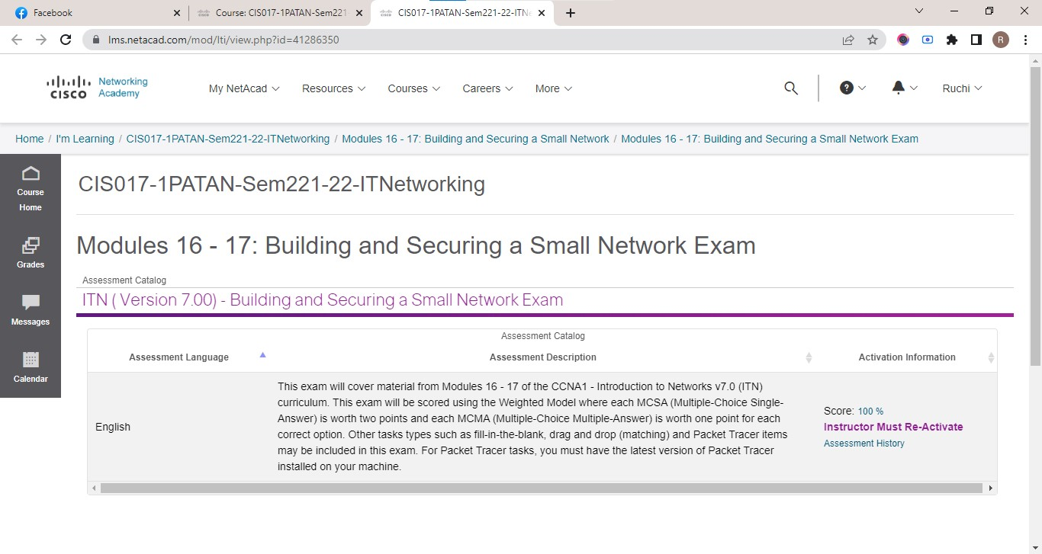

Figure :MODULES 16-17