Project proposal for DST & Texas Instruments Inc.

India Innovation Challenge Design Contest 2017

Anchored by NSRCEL, IIM Bangalore

FOOD QUALITY TESTER

Dr. Shyama Prasad Mukherjee International Institute of Information Technology Naya Raipur, Chhattisgarh.


Name College ID/Roll UG/PG Course/Branch Semester
No.

Student 1 16100032 UG CSE Third

Student 2 16101042 UG ECE Third

Student 3 16101046 UG CSE Third

Student 4 16101045 UG ECE Third

Student 5

Dr.Ramesh vaddi(mentor)

Mandatory Supporting Document [to be added along with proposal]
- Teams to provide a scanned copy of the college ID of all the team members, OR,

- A scanned copy of the letter from College duly signed and sealed by HOD/Faculty Mentor identifying all team members as students of the college

Note:
- Suggested Length of project proposal – 6-7 pages

- Teams to ensure that the information provided is not plagiarized and all sources are acknowledged in the proposal.

Project Abstract

The project that we are proposing for this contest namely FQT(food quality tester) is a device meant for checking the amount of harmful chemicals such as pesticides
and insecticides present in food items.It also detects the quantity of harmful chemicals inside the food items. Here food items mainly refers to fruits and vegetables
which form a part of daily consumption of people around the globe. The idea is mainly to innovate such a portable device which people can carry with them while buying fruits and vegetables
so that they are aware of what they are buying and consuming. In other aspect it will also help in raising the standard of food items in long run as people once aware of the
contaminated food items would not buy it and so the sale of such products would go down.Thus the product will help in creating a healthy public with the rate of contamination in the market going down.

Team Members – Roles & Responsibilities

S.No. | Student | Role (Choose one of the | Justification
 | Member | following – Marketing,
 | Name | Technical, Operations &
 |  | Other Roles as
 |  | applicable)
1 | Khushboo Priya | Technical | Since I was interested in technical aspect of project and it always wanted to make a market changing product .
2 | Purvi Agrawal | Technical | My interest lies in application of electronics and communication and in sensors.
3 | Sakshita Jayaswal | Technical And Marketing | This design contest proposed by TI gives me an opportunity to implement my entrepreneurship qualities as I aspire to study management in future.
4 | Ruchi Dhamnani | Technical and Marketing | Since I want to enhance my management skills. And create socially impactful solution to persisting problems.
5 | Dr. Ramesh Vaddi | Mentor | Overall mentoring, specifications, prototype, outreach support, etc

Market Analysis

Teams to provide a detailed study about the customer needs [in context of India] leading to identification of the problem being solved which covers the Total Addressable Market (TAM), Serviceable Addressable Market (SAM), study of existing solutions [Competition] and opportunities for enhancing/improving the solution leading to the proposed solution.

Teams to validate their analysis with using graphs, illustrations and quantitative data from different sources as applicable.

- Customer Need Identification -The product is unique in its kind since there is no such product in the market which can actually tell the quality of food that a person is buying. As a result of this people suffer from cancer at an increasing rate without any detectable reasons. This product has the capability to flourish as a successful home appliance. This is because the feature of this product is independent of any other electronic appliance in the market.
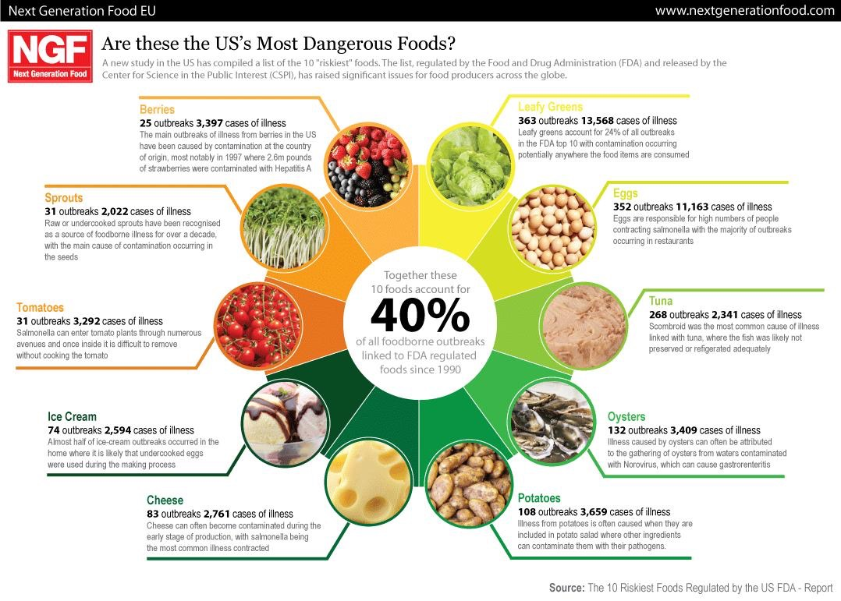

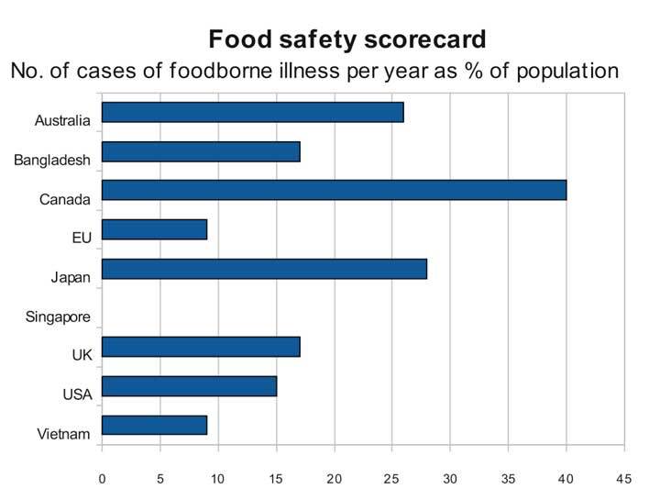

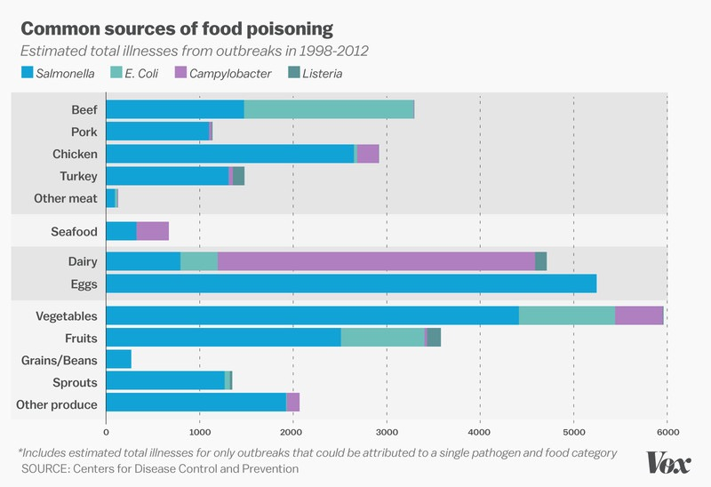

- Serviceable Addressable Market (SAM) Identification & Justification - < Teams toshare details of their SAM and support with analysis as applicable>
In today’s world the people are highly concerned about what they eat.so. our TAM will be each household of Indian economy. Deviating from idealism the TAM of our product does not actually match the SAM.There are certain families in India who are below poverty line as such they won’t be able to afford this product.Also there are certain families who are dormant and traditional in their beliefs and uses,as such they may also refrain from the use of this product.Thus, families and various food suppliers such as Fssai and restaurants mainly find their use.

- Product Differentiation w.r.t. Competition & Justification - < Teams to Highlight thedifferentiated featues of their product w.r.t. to completion/existing product with justification>
The above table shows the existing technology in the market regarding this aspect. However our project is quite different from the above solution as our device aims at detecting presence and quantity of following chemicals diphenylamine,calcium carbide,chlorpyrifos,oxytocin, acetate ,phosphene and trichlorphon found majorly in vegetables and fruits including apples. The above products are able to detect utmost one or two chemicals which do not give a complete analysis of the food item(fruits and vegetables).
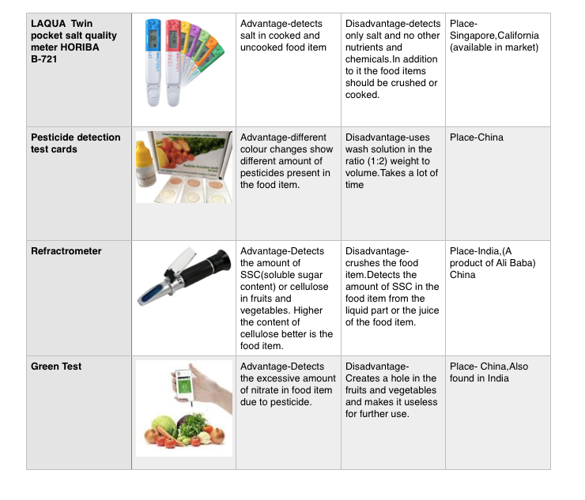

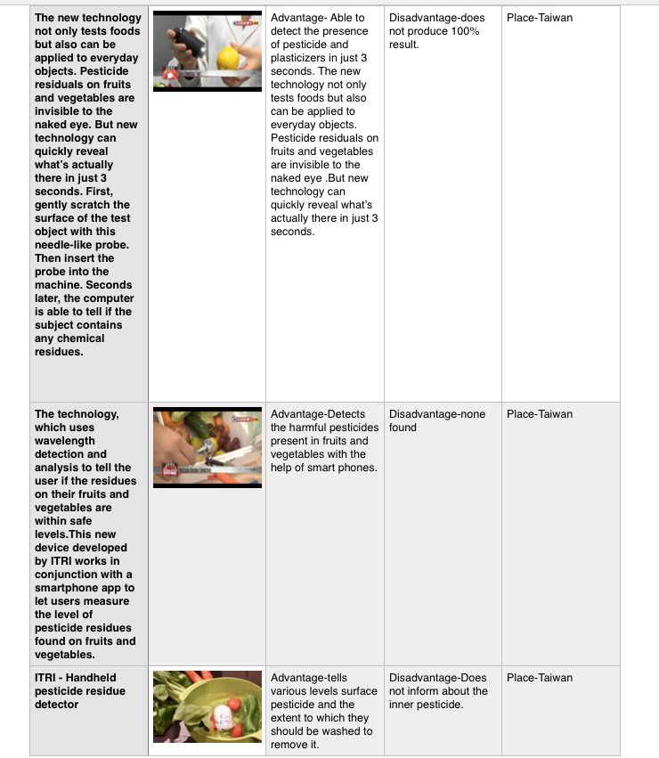

- Understanding of your customer & user- < Teams to identify their customer & userand share their product positioning to enable ease of adoption for both of these >

Note: Users refer to people using the product/service, and a customer is one whopays for the product/services. Depending on product both could be same ordifferent.
The product mainly aims at the households of India.Being a product meant for detecting the impurities and contamination in the daily consumption of people, it aims every family of India to be its potential customer.
The suspected customer of our product are the companies dealing with home appliances and the user include the household section of India. In addition to this restaurants can also be considered as suspected
customers. This product will be very easy in adoption just like operating any other home appliance. This is because we are planning to make it a portable device.

- Distribution Channel Identification - < Teams to share how would you deliver theproduct/service to the customers/users>
We have decided to share the product through a website created by us such that this product will be the copy right of the website under a company head. We may give the distributorship of this product to various wholesalers

Proposed Design

- Objective - <Teams toshare their proposed solution in brief>
This project aims at producing a portable food quality tester that detects the harmful chemicals present in the fruits and vegetables.It will detect the major chemicals found commonly in fruits and vegetablesthus pointing to the quality of the food item.The need fulfilled by this product is highly in demand because of the increasing rate of diseases like food poisoning without any detectable and valid reason.

- Proposed Solution

  - Block Diagram - A clear block diagram highlighting all the subsystems andsupported with a detailed explanation for each block/subsystem.

Teams to share all relevant circuit diagrams, any simulation results, and details of any software algorithms to support your proposed solution. Teams are encouraged to use WEBENCH for power designing power supply.

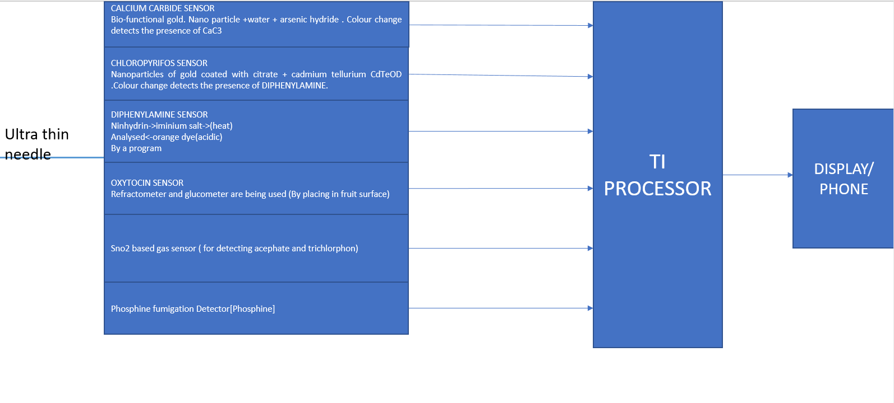

- Component Used - List all the TI Parts and non-TI parts to be used in designing theproposed solution

 | TI Part Number |  | How is it being used in the proposed solution? Explain
 | (link all the parts to |  | its role/functionality
 | their respective
 | product page on the
 | TI website)
Part 1. –LMP91000 (ACTIVE)  Configurable AFE Potentiostat for Low-Power Chemical Sensing Applications |  |  | We will be using this sensor for the detection of ethylene oxide, ammonia and will detect the content of pesticide residue in fruits/vegetables products.
Part 2.MSP 432 micro controller link: www.ti.com/product/MSP430F2003 |  |  | The micro controller will receive the data from the sensors and it will check whether the chemical level are higher than prescribed if yes then it will display it in LCD display and also will send a message in your phone.

Non - TI Parts | How is it being used in the proposed solution? Explain
 | its role/functionality
Part 1  Phosphine fumigation sensor | This sensor is available in market. It reliably measures oxygen, organic vapours, combustible gases, and harmful concentrations of CO, H2S, CO2, Cl2, HCN, NH3, NO2, PH3, and SO2 with high sensitivity to keep the user safe.  For the detection of phosphine, the XAM 5000 can measure phosphine in the range of 0-2000ppm.
Dräger X-am 5000
Part 2  Handheld data storage function acetylene C2H2 gas detector | This sensor is available in market. It measures the presence of C2H2 with high sensitivity.
Model Number:
YT-1200H-C2H2
Part3 Electrochemical Gas Sensor ME3-C2H4 | This product is also available.It detects C2H4/ Ethylene  with in the range of 0~100ppm.
Part 4  Chlorpyrifos sensor | This sensor is not available currently but we can make it by referring to research paper.The basic idea is to use nanoparticles of gold and cadmium tellurium quantum dot (CdTe QD) for the detection and quantitative removal of chlorpyrifos which is a commonly used pesticide found in fruits/vegetables. Gold nanoparticles coated with citrate changes its colour from pink to purple in the presence of chlorpyrifos. We will use CdTe QDs and glucose oxidase for detection of chlorpyrifos.
Part 5Diphenylamine sensor | We will be making this sensor whose method will be based on the reaction of diphenylamine with ninhydrin which gives an iminium salt, on heating which formed orange colour dye in acidic medium. The colour system formed particular pattern on an inert support. Scanner detects the product on TLC strips.All the analytical parameters and optimum reaction conditions was evaluated. The sensors are used to detect diphenylamine in real sample i.e. fruits.
Part 6  Oxytocin Sensor | This sensor is currently not available in market we will be taking reference from research paper. The study is focused on detecting the presence of Oxytocin, used in fruits like pumpkin, watermelon, cucumber etc., illegally to make them appear bigger .The pesticide can be detected using a wireless sensor. In India, Oxytocin is cheaper than fertiliser, so it is used to inject in fruits to appear them bigger. In the proposed system, the concept of two devices the refractometer and the glucometer is taken into consideration.  The device refractometer is used to detect the content of nutrients present in the fruits or vegetables.
Part 7  Detecting Pesticide Residue by Using Modulating Temperature Over a Single SnO2-Based Gas Sensor | This sensor is currently not available in market we have to make this sensor, many research paper have been published. The method uses a single SnO2-based gas sensor in a rectangular temperature mode to perform the qualitative analysis of acephate and trichlorphon in fruit/vegetables.

Innovativeness of the Proposed Solution

Teams have to explain the uniqueness/differentiation of their proposed solution with respect to the existing competition in the current scenario. Teams can differentiate their proposed solution on the following vectors – size, power, performance, cost, functionality & others as applicable

The major differentiating and unique feature of this product is that it does not destroy the food item which is to be tested, hence it is more economical.There is no such product right now exactly. The common man generally do this is by visual perception and slightly smelling.
Current product available :- A product named “SOEKS” in other parts of country used for detection of nitrates content in raw food. In India, there are no such product developed yet but in other countries there are products developed to check the nitrate content of food by piercing the fruit/vegetable and this will destroy the fruits.
Right now, the piercing of fruit or vegetable for testing it's quality is of considerable amount, and may lead to wastage of food even if it passes test as consumers would be reluctant to buy it, only solution to this problem is to reduce the size of testing pin or detect it by some physical features, which is the prime goal of this project.
The customers right now are mainly ignorantly consuming contaminated fruits and vegetables thus suffering from health diseases. Therefore the major competition that we face is none because the other products developed destroy the food item externally.

This design/product further can generate demand for developing high precision chemical sensors for detecting such harmful chemicals in food, which are not many today unfortunately.

Impact of the proposed solution

Teams have to explain the impact of their proposed solution on the customer/relevant industry and Justify with data as applicable.

The product is surely to have a positive impact in the economy of any country. This is because as a result of the introduction of this product in the market people will mainly concentrate on buying chemical free
food items as a result of which public health will improve. Also the market will become free from the sale of contaminated products.

This product has direct impact on consumers and sellers as in today’s world everyone is concerned about health, however the food we are consuming for making us healthy is itself contaminated.
As we see there is no such low cost technology developed yet to check whether the food item is safe for consumption or not, so this product will be of great use for every house holder as one can directly check the product without purchasing it and consequently it will reduce health issues on large scale and save large money in multiple ways. These food commodities are reported to be contaminated with toxic and health hazardous chemicals. Chemicals like calcium carbide / ethephon and oxytocin are reportedly being used in fruit and vegetable market / farms for artificial ripening of fruits and for increasing the size of fruits and vegetables respectively. Calcium carbide more commonly known as ˜masala” is a carcinogenic agent and banned under PFA Rules,1955. Ethephon is a pesticide and so it is not recommended as a ripening enhancer.Oxytocin is a mammalian hormone, used as a drug in veterinary services which is not advised for use in fresh fruits and vegetables.
It tests the food items without damaging or piercing the food items.
Food bought can be devoid of any chemical content thus increasing high quality food consumption among the masses. This can also help the law makers/governing bodies to test quality of food.

Saves cost upto great extent as this device prevents the consumption of harmful chemicals through food and in the long run prevents the expenditure on diseases.

