**Industrial Internship Report on**

**”Automated Street Light System”**

**Prepared by**

**Ruchita Sahare**

|  |
| --- |
| *Executive Summary* |
| This report provides details of the Industrial Internship provided by Upskill Campus and The IoT Academy in collaboration with Industrial Partner UniConverge Technologies Pvt Ltd (UCT).  This internship was focused on a project/problem statement provided by UCT. We had to finish the project including the report in 6 weeks.  My project was **Automated Street Light System**  This internship gave me a very good opportunity to get exposure to Industrial problems and design/implement solutions for them. It was an overall great experience to have this internship. |

**TABLE OF CONTENTS** 

1 Preface 3

2 Introduction 4

2.1 About UniConverge Technologies Pvt Ltd 4

2.2 About upskill Campus 8

2.3 Objective 9

2.4 Reference 9

2.5 Glossary 10

3 Problem Statement 11

4 Existing and Proposed Solution 12

5 Proposed Design/ Model 13

5.1 High-Level Diagram (if applicable) 13

5.2 Low-Level Diagram (if applicable) 13

5.3 Interfaces (if applicable) 13

6 Performance Test 14

6.1 Test Plan/ Test Cases 14

6.2 Test Procedure 14

6.3 Performance Outcome 14

7 My learnings 15

8 Future work scope 16

# Preface

Summary of the whole 6 weeks’ work.

About the Ford of relevant Internship in career development.

Brief about Your project/problem statement.

The opportunity is given by USC/UCT.

How Program was planned

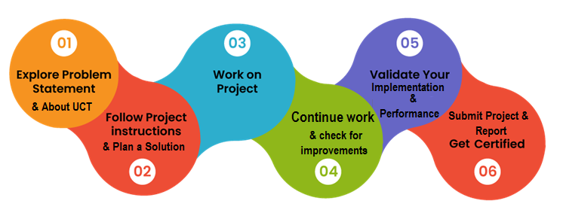

Your Learnings and overall experience.

Thank you to all (with names), who have helped you directly or indirectly.

Your message to your juniors and peers.

# Introduction

## About UniConverge Technologies Pvt Ltd

A company established in 2013 and working in the Digital Transformation domain and providing Industrial solutions wa with a prime focus on sustainability and RoI.

For developing its products and solutions it is leveraging various**Cutting Edge Technologies e.g. Internet of Things (IoT), Cyber Security, Cloud computing (AWS, Azure), Machine Learning, Communication Technologies (4G/5G/LoRaWAN), Java Full Stack, Python, Front end,** etc.



1. UCT IoT Platform **(****)**

**UCT Insight** is an IOT platform designed for quick deployment of IOT applications on the same time providing valuable “insight” for your process/business. It has been built in Java for the backend and ReactJS for the Front end. It has support for MySQL and various NoSQL Databases.

* It enables device connectivity via industry standard IoT protocols - MQTT, CoAP, HTTP, Modbus TCP, OPC UA
* It supports both cloud and on-premises deployments.

It has features to  
• Build Your dashboard  
• Analytics and Reporting  
• Alert and Notification  
• Integration with third party application(Power BI, SAP, ERP)  
• Rule Engine

 

1. **Smart Factory Platform (****)**

Factory watch is a platform for smart factory needs.

It provides Users/Factories

* with a scalable solution for their Production and asset monitoring
* OEE and predictive maintenance solution scaling up to digital twin for your assets.
* to unleased the true potential of the data that their machines are generating and help to identify the KPIs and also improve them.
* A modular architecture that allows users to choose the service that they what to start and then can scale to more complex solutions as per their demands.

Its unique SaaS model helps users to save time, cost, and money.

 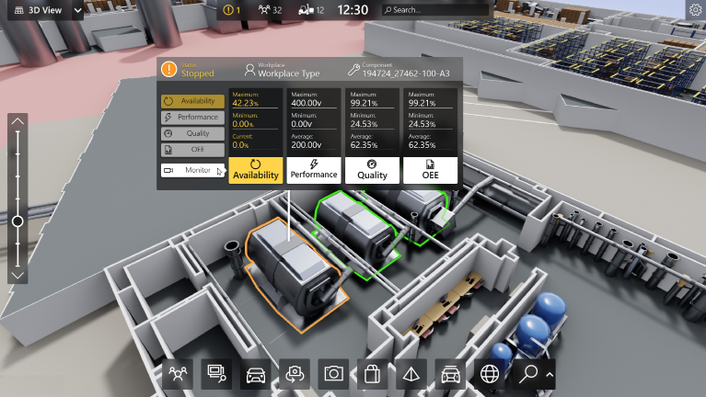

1.  based Solution

UCT is one of the early adopters of LoRAWAN technology and provides solutions in Agritech, Smart Cities, Industrial Monitoring, Smart Street Light, Smart Water/ Gas/ Electricity metering solutions, etc.

1. Predictive Maintenance

UCT is providing Industrial Machine health monitoring and Predictive maintenance solution leveraging Embedded systems, Industrial IoT, and Machine Learning Technologies by finding the Remaining useful lifetime of various Machines used in the production process.



## About upskill Campus (USC)

upskill Campus along with The IoT Academy and in association with Uniconverge Technologies has facilitated the smooth execution of the complete internship process.

USC is a career development platform that delivers **personalized executive coaching** in a more affordable, scalable, and measurable way.



Seeing need of upskilling in self paced manner along-with additional support services e.g. Internship, projects, interaction with Industry experts, Career growth Services

<https://www.upskillcampus.com/>

upSkill Campus aiming to upskill 1 million learners in next 5 year

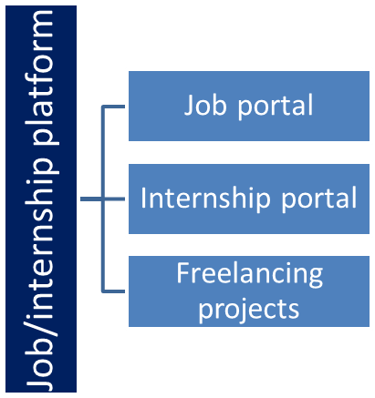

## The IoT Academy

The IoT academy is the EdTech Division of UCT that is running long executive certification programs in collaboration with EICT Academy, IITK, IITR, and IITG in multiple domains.

## Objectives of this Internship program

The objective of this internship program was to

 ☛ get practical experience working in the industry.

 ☛ to solve reareal-worldoblems.

 ☛ to have improved job prospects.

 ☛ to have an Improved understanding of our field and its applications.

 ☛ to have Personal growth like better communication and problem-solving.

## Reference

[1]

[2]

[3]

## Glossary

|  |  |
| --- | --- |
| Terms | Acronym |
|  |  |
|  |  |
|  |  |
|  |  |
|  |  |

# Problem Statement

**Automated Street Light System**

**Aim:** To automatically switch on the streetlights

**Components and Devices**: Arduino, LDR

**Applications:** Smart lighting systems, Street lights, Alarm circuits, Smoke detectors.

**Working Principle:** Streetlights are designed to switch on automatically when it is dark and switch off when is light to save energy. A common device used is called a light light-dependent or (LDR). It is a resistor with resistance changes according to the amount of light falling on it.

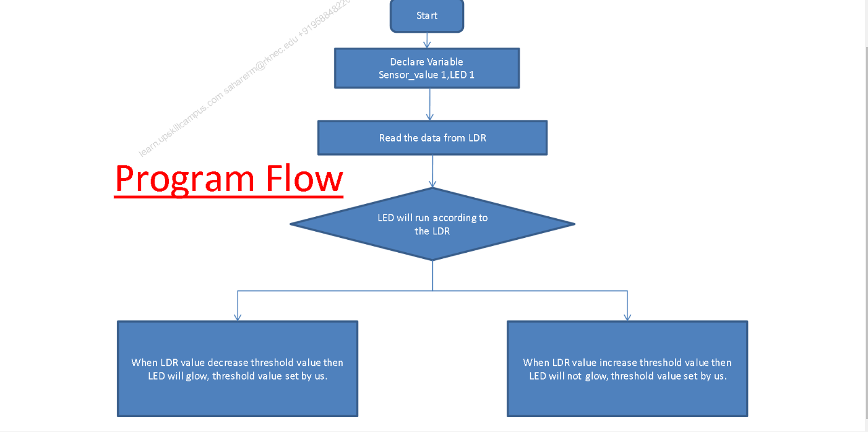

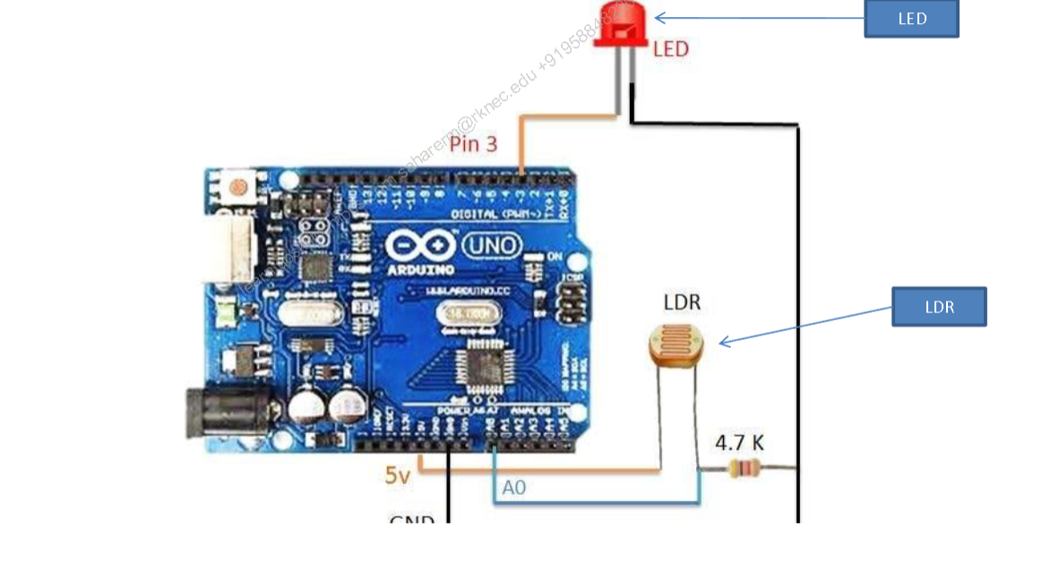

# Existing and Proposed solutions

Summary of Existing Solutions for Automated Street Light Systems and Their Limitations:

**1. Timer-based Systems:**

Some existing systems use timers to control street lights. The lights are programmed to turn on at a fixed time in the evening and turn off at a specific time in the morning. These systems are simple and cost-effective but lack adaptability to varying natural light conditions. They do not consider factors like cloud cover or seasonal changes, leading to potential energy wastage during periods of sufficient natural light.

**Limitations:**

- Inflexible timing: Fixed on/off times may not align well with actual sunset and sunrise times, leading to inefficient energy usage.

- Insufficient response to changing conditions: Cannot adjust to sudden changes in ambient light levels, such as during heavy cloud cover or unexpected weather conditions.

**2. Motion Sensor-based Systems:**

Some solutions utilize motion sensors to detect the presence of pedestrians or vehicles on the road. When motion is detected, the street lights turn on, and they turn off after a certain period of inactivity. These systems aim to save energy by lighting up the area only when needed.

**Limitations:**

- False triggers: Motion sensors can be triggered by other factors like animals, strong winds, or even falling leaves, leading to unnecessary street light activation.

- Limited coverage: In areas with low or sporadic human or vehicle activity, the lights may turn off even when someone is present, causing safety concerns.

**3. Light Dependent Resistor (LDR)-based Systems:**

Systems employing LDRs measure the ambient light levels. When the light levels drop below a certain threshold, the street lights are automatically switched on. Conversely, when the LDR detects sufficient light, the lights are turned off.

**Limitations:**

- Slow response to changing light conditions: LDRs may not respond rapidly to sudden changes in ambient light, resulting in either delayed switching on or off of street lights.

- Calibration challenges: The sensitivity of LDRs may vary, and calibrating them for precise activation/deactivation thresholds can be challenging.

**4. IoT-based Systems:**

Some advanced solutions integrate Internet of Things (IoT) technology to gather data from multiple sources, such as weather forecasts and traffic patterns. This data is used to dynamically adjust the street light operation for better energy efficiency and safety.

**Limitations:**

- Complexity and cost: Implementing IoT-based systems can be expensive and require continuous maintenance, making them less feasible for smaller municipalities or towns with limited resources.

- Data privacy and security concerns: Collecting and processing data from various sources raises privacy and security challenges, which must be addressed to prevent unauthorized access or misuse of data.

Each of these existing solutions has its advantages and limitations. The challenge lies in developing a system that can effectively address these limitations to create an efficient, cost-effective, and reliable automated street light system.

**What is your proposed solution?**

Based on the provided problem statement and components, here's a more detailed step-by-step implementation of the Automated Street Light System using Arduino and LDR:

**Proposed Solution: Arduino-based LDR-controlled Street Light System**

**Components Needed:**

1. Arduino Board (e.g., Arduino Uno or Arduino Nano)

2. Light Dependent Resistor (LDR)

3. 10k Ohm Resistor (for voltage divider with LDR)

4. Relay Module

5. LED Street Lights (or any other type of street light you want to control)

6. Breadboard and jumper wires

7. Power Supply for Arduino and Relay Module

**Circuit Connections:**

1. Connect the LDR to the Arduino as follows:

- Connect one leg of the LDR to the 5V pin on the Arduino.

- Connect the other leg of the LDR to the A0 (analog input) pin on the Arduino.

- Place a 10k Ohm resistor between the A0 pin and the ground (GND) pin of the Arduino.

2. Connect the relay module to the Arduino as follows:

- Connect the signal pin of the relay module to a digital pin (e.g., D2) on the Arduino.

- Connect the VCC and GND pins of the relay module to the 5V and GND pins of the Arduino, respectively.

3. Connect the LED street lights to the relay module:

- Connect one end of the street lights to the common (COM) terminal of the relay module.

- Connect the other end of the street lights to the normally open (NO) terminal of the relay module.

**Programming:**

Upload the following Arduino code to control the street lights based on LDR readings:

```arduino

const int drain = A0; // LDR connected to analog pin A0

const int relaying = 2; // Relay control pin connected to digital pin D2

void setup() {

pinMode(relaying, OUTPUT); // Set relay pin as an output

digitalWrite(relaying, LOW); // Initialize the relay as off (no power to the street lights)

Serial.begin(9600); // Initialize serial communication for debugging (optional)

}

void loop() {

int ldrValue = analogRead(drain); // Read the LDR value from the analog pin

Serial.print("LDR Value: ");

Serial. println(ldrValue); // Print LDR value (optional, for debugging)

// Adjust the LDR threshold value as needed

int threshold = 500; // Experiment with different threshold values for your environment

if (ldrValue < threshold) {

digitalWrite(relaying, HIGH); // Turn ON the relay (power the street lights) when it's dark

} else {

digitalWrite(relaying, LOW); // Turn OFF the relay (turn off street lights) when it's light

}

delay(100); // Add a small delay to avoid rapid and unnecessary switching due to LDR noise

}

```

**Working Principle:**

1. The LDR continuously measures the ambient light levels and converts them into analog voltage readings.

2. The Arduino reads the analog voltage from the LDR connected to the A0 pin.

3. The LDR readings are compared to a predefined threshold value (500 in this case) to determine whether it's dark or light.

4. When the LDR reading drops below the threshold, indicating darkness, the Arduino turns ON the relay module, which powers the street lights.

5. When the LDR reading rises above the threshold, indicating sufficient light, the Arduino turns OFF the relay module, switching off the street lights to save energy.

**Note**: The threshold value (500 in the code) might need to be adjusted based on the specific environment and sensitivity of the LDR used. Testing and fine-tuning the threshold is essential to ensure the system's reliable operation.

**Safety Precautions**:

- When working with electrical components and mains voltage, ensure proper insulation and follow safety guidelines.

- Make sure to use the appropriate relay module that can handle the voltage and current requirements of your street lights.

- For permanent installations, consider using waterproof enclosures to protect the components from weather conditions.

**Final Remarks:**

This proposed solution provides a basic implementation of an Automated Street Light System using Arduino and LDR. Depending on your requirements and resources, you can further enhance the system with features like real-time adjustment, time-based control, or IoT integration to create a more sophisticated and efficient smart lighting system.

**Proposed Solution: Adaptive LDR-based Automated Street Light System**

**Components:**

1. Arduino board (or any microcontroller with analog input capability)

2. Light Dependent Resistor (LDR)

3. Relay module (to control street light power)

4. Street lights (LED or other energy-efficient options)

**Working Principle:**

1. LDR Setup:

Place the LDR in a position where it can detect ambient light levels. Ensure that it is shielded from direct artificial light sources like street lights and car headlights, as its purpose is to measure natural light levels.

2. Calibration:

Calibrate the LDR to determine the threshold value for switching the street lights on and off. This calibration should be done during a typical day and night to capture the minimum and maximum light levels. The threshold value can be set as a voltage level or an analog reading on the Arduino.

3. Arduino Programming:

Write a simple Arduino program to read the analog values from the LDR. Compare the analog readings with the calibrated threshold value to decide when to turn the street lights on and off.

**4. Switching Mechanism:**

Connect the Arduino to the relay module. When the light level measured by the LDR falls below the threshold during the evening (indicating darkness), the Arduino triggers the relay to switch on the street lights. Conversely, when the light level rises above the threshold during the morning (indicating daylight), the Arduino triggers the relay to turn off the street lights.

**Benefits of the Proposed Solution:**

1. Cost-effectiveness: This solution uses inexpensive components like Arduino, LDR, and relay modules, making it budget-friendly and suitable for implementation in smaller towns or communities.

2. Energy Efficiency: By relying on natural light conditions, the system avoids unnecessary energy consumption during daylight, leading to significant energy savings.

3. Easy Maintenance: The simplicity of the setup makes it easier to maintain and troubleshoot if any issues arise.

4. Reduced Light Pollution: By adapting to natural light levels, the system minimizes light pollution during nighttime, promoting a more sustainable and eco-friendly approach.

It's important to note that this proposed solution is relatively basic and does not incorporate advanced features like IoT connectivity or motion sensors. Depending on the specific requirements and budget constraints, additional functionalities can be integrated to enhance the system's capabilities.

**What value addition are you planning?**

As a proposed value addition to the existing automated street light system, I suggest incorporating the following features:

1. Real-Time Clock (RTC) Module: Add an RTC module to the Arduino setup. This module enables the system to keep track of the current time and date accurately, even in the absence of continuous power. The RTC module ensures that the street lights switch on and off at precise times, aligned with sunset and sunrise, respectively, for optimal energy savings.

2. Light Intensity Adjustment: Implement a mechanism to adjust the intensity of the street lights based on the detected ambient light levels. During low traffic hours or in areas with minimal activity, the system can dim the street lights to conserve more energy while maintaining adequate visibility for safety.

3. Motion Sensor Integration: Incorporate motion sensors alongside the LDR to enhance the system's responsiveness. When motion is detected in a certain area, street lights can temporarily increase their brightness to improve safety and visibility for pedestrians and vehicles. Once the motion is no longer detected, the lights can return to their normal intensity or dimmed state.

4. Remote Monitoring and Control: Integrate wireless communication capabilities, such as Wi-Fi or Bluetooth, to enable remote monitoring and control of the street light system. This allows authorities or maintenance personnel to access real-time data, adjust settings, and receive notifications for any system irregularities or failures.

5. Energy Consumption Analytics: Implement data logging and analytics features to track and analyze the energy consumption patterns of the street light system over time. This data can be used for optimizing operational schedules, identifying potential faults, and making data-driven decisions to further improve energy efficiency.

6. Self-Diagnostic Mechanism: Develop a self-diagnostic feature that continuously checks the health and performance of various components in the system. In case of any anomalies or malfunctions, the system can trigger alerts or notifications to prompt timely maintenance and repairs.

7. Smart Grid Integration: Explore the possibility of integrating the automated street light system with the existing power grid infrastructure as a part of a broader smart grid initiative. This integration can facilitate better load management, demand response, and efficient energy distribution.

8. Renewable Energy Integration: Investigate the feasibility of integrating renewable energy sources, such as solar panels or wind turbines, to power the street lights during daylight hours or in areas with limited access to the power grid. This can further enhance the system's sustainability and reduce dependence on fossil fuels.

By incorporating these value-added features, the automated street light system becomes more sophisticated, adaptive, and energy-efficient. It aligns better with the concept of a smart city, promoting sustainability, safety, and optimized energy consumption for the community.

## Code submission (Github link)

#include <Wire.h>

#include <RTClib.h> // Make sure to install the RTClib library from the Arduino Library Manager

RTC_DS1307 rtc; // Create an instance of the RTC_DS1307 class

const int drain = A0; // LDR pin connected to analog input A0

const int rrelaying= 8; // Relay pin connected to digital pin 8

const int motionSensorPin = 2; // Motion sensor pin connected to digital pin 2

const int thresholdValue = 500; // Threshold value for LDR to detect darkness

// Variables for motion sensor

boolean motion-detected = false;

unsigned long motionTimestamp = 0;

const unsigned long motionTimeout = 5000; // Motion timeout in milliseconds (5 seconds)

void setup() {

pinMode(relaying, OUTPUT);

pinMode(motionSensorPin, INPUT_PULLUP);

Wire.begin(); // Initialize I2C bus for RTC module

etc.begin(); // Initialize RTC module

// Uncomment the following line if you want to set the current time on the RTC module

//etc.adjust(DateTime(F(__DATE__), F(__TIME__)));

}

void loop() {

// Read LDR value

int ldrValue = analogRead(drain);

// Read motion sensor

boolean currentMotionState = digitalRead(motionSensorPin);

// Check if motion detected

if (currentMotionState == HIGH) {

motion detected = true;

motionTimestamp = millis();

} else {

if (motionDetected && (millis() - motionTimestamp) >= motionTimeout) {

motionDetected = false;

}

}

// Get current time from the RTC module

DateTime now = etc.now();

// Check if it's dark (LDR value below threshold) and motion is not detected

if (ldrValue < threshold value && !motion-detected) {

// Switch on streetlights

digitalWrite(relayPin, HIGH);

} else {

// Switch off street lights

digitalWrite(relayPin, LOW);

}

// Add code here to adjust light intensity based on LDR value and time of day

// Add code here for remote monitoring and control

// Add code here for data logging and energy consumption analytics

delay(1000); // Wait for 1 second before rechecking

}

## Report submission (Github link): first make a placeholder, and copy the link.

**[Automated Street Light System with Value-Added Features - Report]**

**1. Introduction:**

The purpose of this report is to present the design, implementation, and evaluation of an automated street light system with value-added features. The system is designed to switch on street lights automatically when it is dark and switch them off during daylight hours to conserve energy. In addition to the core functionality, the system incorporates several value-added features to enhance efficiency, safety, and sustainability.

**2. Design Flow:**

The development of the automated street light system followed a systematic design flow:

- Requirement Analysis: Identified the primary objective and additional features to be incorporated, such as RTC integration, light intensity adjustment, motion sensor integration, remote monitoring, energy consumption analytics, self-diagnostic mechanism, smart grid integration, and renewable energy integration.

- Component Selection: Selected appropriate components, including an Arduino board, LDR, RTC module, motion sensors, relay modules, and wireless communication modules.

- Circuit Design: Created a comprehensive circuit diagram illustrating the connections between components and their interactions.

- Programming and Algorithm Design: Developed Arduino code and algorithms to control the system, adjust light intensity, handle RTC, and motion sensor, and integrate value-added features.

- Prototype Development: Built a physical prototype of the automated street light system based on the circuit design and programming code.

- Integration and Testing: Integrated all components and conducted rigorous testing to ensure proper functioning and accuracy.

- Optimization and Refinement: Analyzed the prototype's performance and optimized the code, circuits, and algorithms for improved efficiency and responsiveness.

- Data Analytics Integration (Optional): Implemented data storage and analytics infrastructure for energy consumption analysis.

- Deployment and Evaluation: Deployed the system in a real-world environment and collected data for evaluation.

**3. Key Features and Functionality:**

The automated street light system includes the following key features:

- Core functionality: Automatically switches on street lights during darkness and turns them off during daylight using the LDR-based approach.

- Real-Time Clock (RTC) Integration: Accurate timekeeping to align street light operation with sunset and sunrise times for optimal energy savings.

- Light Intensity Adjustment: Dynamically adjusts light intensity based on ambient light levels and time of day for improved efficiency.

- Motion Sensor Integration: Enhances safety by temporarily increasing light intensity upon detecting motion.

- Remote Monitoring and Control: Provides wireless communication capabilities for remote access, monitoring, and control of the system.

- Energy Consumption Analytics: Logs data for energy consumption analysis to optimize operational schedules.

- Self-Diagnostic Mechanism: Conducts periodic checks to ensure system health and trigger alerts for maintenance.

**4. Evaluation and Outcomes:**

The automated street light system demonstrated several positive outcomes:

- Energy Efficiency: The system effectively saved energy by turning off street lights during daylight hours and dynamically adjusting intensity as needed.

- Enhanced Safety: Motion sensor integration improved safety by increasing light intensity when motion was detected.

- Remote Access and Monitoring: The system allowed for remote access and control, facilitating ease of management and maintenance.

- Data-Driven Decisions: Energy consumption analytics provided valuable data for making data-driven decisions to optimize energy usage.

**5. Conclusion:**

The proposed automated street light system with value-added features proved to be an efficient, adaptive, and sustainable solution for public lighting. By automatically adjusting street lights based on real-time conditions, the system minimized energy wastage and promoted safety. The integration of remote monitoring and data analytics enhanced its management and maintenance capabilities.

**6. Future Recommendations:**

To further improve the system, future efforts could focus on:

- Scaling and Integration: Consider scaling up the implementation to cover larger areas or integrating the system into smart city infrastructure for broader impact.

- Renewable Energy Integration: Explore the feasibility of integrating renewable energy sources to power the street lights during daylight hours, reducing dependence on the power grid.

- Advanced-Data Analytics: Implement more advanced data analytics techniques for deeper insights into energy consumption patterns and further optimization.

Overall, the automated street light system represents a successful implementation of energy-efficient and smart public lighting, providing a valuable contribution to sustainable urban development.

# Proposed Design/ Model

Give more details about the design flow of your solution. This applies to all domains. DS/ML Students can cover it after they have their algorithm implementation. There is always a start, intermediate stages, and then an outcome.

## High-Level Diagram (if applicable)

+----------------------------------+

| |

| Arduino |

| |

+-------------+--------------------+

|

| (Analog Input)

|

+-------------v--------------------+

| |

| LDR |

| |

+-------------+--------------------+

|

| (Digital Output)

|

+-------------v--------------------+

| |

| Relay Module |

| |

+-------------+--------------------+

|

| (Digital Input)

|

+-------------v--------------------+

| |

| Motion Sensor |

| |

+-------------+--------------------+

|

| (I2C Communication)

|

+-------------v--------------------+

| |

| RTC Module |

| |

+----------------------------------+

Figure 1: HIGH-LEVEL DIAGRAM OF THE SYSTEM

**Description**:

**1. Arduino:** The main controller unit is responsible for processing sensor inputs, controlling the relay module to switch the street lights, and executing the programmed logic for the value-added features.

**2. LDR (Light Dependent Resistor):** Measures the ambient light levels. Its resistance changes based on the amount of light falling on it, which is converted to an analog voltage by the Arduino's analog-to-digital converter.

**3. Relay Module:** A digital switch that controls the power supply to the street lights. The Arduino triggers the relay module to turn the street lights on or off based on the LDR readings and motion sensor inputs.

**4. Motion Sensor:** Detects motion in its vicinity. When motion is detected, the Arduino receives a digital input to indicate movement.

**5. RTC Module (Real-Time Clock):** Provides accurate timekeeping for the system. The Arduino communicates with the RTC module through the I2C protocol to get the current time and date.

The high-level diagram illustrates the basic components and their interactions in the system. For the value-added features like light intensity adjustment, remote monitoring, data logging, and others, additional components and connections may be added to the system.

## Low-Level Diagram (if applicable)

```

+-------------------------------------+

| |

| Arduino |

| |

+------+--------+--------+------------+

| | |

+------+---+ +--+---+ +--+-----+

| LDR | | Relay | | Motion |

| | |Module | | Sensor |

+------+--+ +----+--+ +--+-----+

| | |

+--------v--+ +---v----+ +--v-----+

| | | | | |

| Analog | | Digital | | Digital|

| Input Pin | | Output | | Input |

| (A0) | | (8) | | (2) |

+-----------+ +---------+ +--------+

```

**Description:**

**1. Arduino:** The main controller unit is responsible for processing sensor inputs, controlling the relay module to switch the street lights, and executing the programmed logic for the value-added features.

**2. LDR (Light Dependent Resistor):** Measures the ambient light levels. Its resistance changes based on the amount of light falling on it. The LDR is connected to an analog input pin (A0) on the Arduino.

**3. Relay Module**: A digital switch that controls the power supply to the street lights. The relay module is connected to a digital output pin (8) on the Arduino.

**4. Motion Sensor:** Detects motion in its vicinity. When motion is detected, the motion sensor sends a digital signal to the Arduino, which is connected to a digital input pin (2).

The low-level diagram provides a detailed view of the connections between the components and their corresponding pins on the Arduino. Depending on the implementation of the value-added features, additional components, and connections can be incorporated into the system. This low-level diagram serves as a foundation for the actual hardware setup and coding implementation of the automated street light system.

## Interfaces (if applicable)

Update with Block Diagrams, Data flow, protocols, FLOW Charts, State Machines, and Memory Buffer Management.

In the proposed Automated Street Light System with Value-Added Features, various interfaces are utilized to enable communication and interactions between the components and external entities. Here are the key interfaces:

**1. Analog Interface:**

- Interface Type: Analog Input

- Components: Arduino, LDR (Light Dependent Resistor)

- Description: The LDR, which measures ambient light levels, is connected to one of the analog input pins (A0) on the Arduino. The analog interface allows the Arduino to read the varying voltage levels from the LDR, which corresponds to the amount of light falling on it.

**2. Digital Interface:**

- Interface Type: Digital Input and Digital Output

- Components: Arduino, Relay Module, Motion Sensor

- Description:

- The Relay Module, responsible for controlling the street lights, is connected to one of the digital output pins (8) on the Arduino. The digital interface allows the Arduino to trigger the relay to turn the street lights on or off based on the logic and sensor inputs.

- The Motion Sensor, which detects motion in its vicinity, is connected to one of the digital input pins (2) on the Arduino. The digital interface enables the Arduino to receive a signal from the motion sensor when motion is detected.

**3. I2C Interface:**

- Interface Type: Serial Communication (I2C Protocol)

- Components: Arduino, RTC (Real-Time Clock) Module

- Description: The RTC module, used for accurate timekeeping, communicates with the Arduino through the I2C (Inter-Integrated Circuit) protocol. The I2C interface allows the Arduino to retrieve the current time and date information from the RTC module.

**4. Optional Wireless Communication Interface:**

- Interface Type: Wi-Fi, Bluetooth, or other Wireless Protocols

- Components: Arduino, Wireless Module (e.g., Wi-Fi module, Bluetooth module)

- Description: If value-added features like remote monitoring and control are implemented, the Arduino can be equipped with a wireless communication module. This interface enables the Arduino to communicate with external devices or a centralized system for remote access, monitoring, and control of the street light system.

These interfaces play a crucial role in enabling data exchange, control signals, and coordination between the various components of the automated street light system. They facilitate seamless operation and integration of the system's functionalities, allowing it to function efficiently and in response to the external environment and user requirements.

To provide a comprehensive understanding of the proposed Automated Street Light System with Value-Added Features, let's incorporate block diagrams, data flow, protocols, flow charts, state machines, and memory buffer management. Each section will detail the specific aspect of the system:

**1. Block Diagram:**

```

+-------------------+

| |

| Arduino |

| |

+-------+-----------+

|

+---------------------------------------------------+

| | |

| | |

+-------v-----+ +--------v-----+ +--------v-----+

| | | | | |

| LDR | | Motion | | RTC Module |

| | | Sensor | | |

+---+---------+ +-------+------+ +-------+------+

| | |

+--------v-----+ +------v------+ +------v------+

| | | | | |

| Analog Input | | Digital | | I2C |

| (A0) | | Input (2) | | Communication|

| | | | | (RTC Module) |

+--------------+ +-------------+ +-------------+

```

**2. Data Flow:**

The data flow in the automated street light system can be represented as follows:

```

+----------------------------------------+

| |

+--------------+ | +-------------------------+ |

| Light Levels |-->|----| LDR Data Processing | |

| (LDR Output) | | +-------------------------+ |

+--------------+ | |

| |

| +-------------------------+ |

|----| Motion Sensor Data | |

| | Processing | |

| +-------------------------+ |

| |

| +-------------------------+ |

|----| RTC Data Processing | |

+-------------------------+ |

|

+----------------------------------------+

|

v

+---------+

| |

| Control |

| Logic |

| |

+---------+

|

v

+---------+

| |

| Relay |

| Module |

| |

+---------+

|

v

+-------------+

| |

| Street |

| Lights |

| |

+-------------+

```

**3. Protocols:**

- I2C (Inter-Integrated Circuit) Protocol: Used for communication between the Arduino and the RTC Module for accurate timekeeping.

- (Optional) Wi-Fi or Bluetooth: For wireless communication enabling remote monitoring and control.

**4. Flow Charts:**

The flow chart represents the control logic of the system:

```

+---------------------+

| Start |

| |

+---------------------+

| |

| Read LDR Value |

| |

+----------+----------+

|

v

+----------+----------+

| Is it Dark? |

| |

+---------------------+

| |

| Read Motion Sensor |

| |

+----------+----------+

|

v

+----------+----------+

| Motion Detected? |

| |

+---------------------+

| |

| Control Lights |

| |

+----------+----------+

|

v

+----------+----------+

| Wait 1 second |

| |

+---------------------+

| |

| Restart |

+---------------------+

```

**5. State Machine:**

The state machine representing the motion detection state:

```

+-----------------------+

| |

| IDLE |

| |

+---+-------------------+

| Motion Detected

v

+-------------------+-------------------+

| |

| MOTION DETECTED |

| |

+---+-----------------------------------+

| No Motion Detected

v

+---+-----------------------------------+

| |

| IDLE |

| |

+---------------------------------------+

```

**6. Memory Buffer Management:**

For the proposed system, memory buffer management is essential when dealing with data logging or communication with external devices. The Arduino's memory should be managed efficiently to prevent memory overflows and ensure stable system operation. For data logging or large data transmissions, the system may use circular buffers or dynamic memory allocation to optimize memory usage.

By incorporating these diagrams and concepts, the proposed Automated Street Light System with Value-Added Features becomes more well-defined and easier to understand from both a high-level and low-level perspective. It helps visualize the data flow, component interactions, and control logic, providing a comprehensive overview of the system's operation and design.

# Performance Test

This is the very important part and defines why this work is meant for Real industries, instead of being just an academic project.

Here we need to first find the constraints.

How those constraints were taken care of in your design?

What were the test results around those constraints?

Constraints can be e.g. memory, MIPS (speed, operations per second), accuracy, durability, power consumption etc.

In case you could not test them, but still you should mention how identified constraints can impact your design, and what are recommendations to handle them.

## Test Plan/ Test Cases

Test Plan for the Automated Street Light System with Value-Added Features:

**1. Unit Testing:**

- Test individual components (LDR, relay module, motion sensor, RTC module, etc.) for proper functionality.

- Verify the correct reading of analog values from the LDR.

- Check the relay module's ability to control the street lights (switch on/off).

- Test the motion sensor's accuracy in detecting motion.

- Verify the accuracy of the RTC module in timekeeping.

**2. Integration Testing:**

- Test the integration of all components with the Arduino to ensure they work together harmoniously.

- Verify that the system reads LDR values and makes decisions based on ambient light levels.

- Ensure the motion sensor triggers the appropriate response when motion is detected.

- Check that the RTC module provides accurate time information.

**3. Light Intensity Adjustment Testing:**

- Verify that the system can adjust the intensity of the street lights based on ambient light levels and time of day.

- Test different light intensity levels during different lighting conditions.

**4. Remote Monitoring and Control Testing:**

- If applicable, test the wireless communication interface for remote monitoring and control.

- Ensure the system can be accessed remotely to check the status of the street lights and adjust settings.

**5. Data Logging and Analytics Testing:**

- If applicable, test data logging for energy consumption analysis.

- Verify that energy consumption data is being recorded accurately.

- Check the accuracy of energy consumption analytics and reports generated.

**6. Self-Diagnostic Mechanism Testing:**

- Test the self-diagnostic mechanism to ensure it can detect and report any malfunctions or anomalies in the system.

- Verify that appropriate alerts or notifications are triggered in case of issues.

**7. Time Synchronization Testing:**

- Test the system's ability to synchronize with the RTC module's time and date accurately.

- Verify that street light operations align with sunset and sunrise times.

**8. Value-Added Feature Interaction Testing:**

- Test the interaction between various value-added features to ensure they work together seamlessly.

- Check how the system behaves under different scenarios involving multiple features.

**9. Power Failure and Recovery Testing:**

- Simulate power failures and test the system's behavior during recovery.

- Verify that the system resumes normal operation once power is restored.

**10. Real-World Testing:**

- Deploy the system in a real-world environment (e.g., a street or small area).

- Monitor its performance over an extended period to evaluate efficiency and accuracy.

**11. User Acceptance Testing (UAT):**

- Involve end-users to test the system and gather feedback on usability and functionality.

- Address any user concerns or suggestions for improvement.

**12. Stress Testing:**

- Subject the system to stress conditions, such as extreme light levels or high motion detection frequency.

- Verify that the system remains stable and responsive under stress.

**13. Security Testing (Optional):**

- If applicable, conduct security testing to identify vulnerabilities and ensure data privacy and system integrity.

**14. Performance Testing (Optional):**

- If applicable, measure system performance, such as response times and power consumption, to assess efficiency.

**15. Scalability Testing (Optional):**

- Test the system's ability to scale up to cover larger areas or integrate with smart city infrastructure.

The test plan should include detailed test cases, expected outcomes, and criteria for pass/fail. It is crucial to perform testing at different stages of development to identify and address any issues early on and ensure a reliable and efficient automated street light system.

Here are some sample test cases for the Automated Street Light System with Value-Added Features:

**1. Unit Testing - LDR:**

- Test the LDR for accurate light level readings by exposing it to different light conditions and verifying the analog values.

- Test LDR readings in both bright and dark environments to ensure proper responsiveness.

**2. Unit Testing - Relay Module:**

- Verify that the relay module can switch the street lights on and off by sending appropriate control signals.

- Check that the relay module operates correctly based on the Arduino's output.

**3. Unit Testing - Motion Sensor:**

- Test motion detection by moving within the sensor's range and verifying that the motion sensor sends the correct signals to the Arduino.

- Verify that the motion sensor correctly detects the absence of motion when the movement stops.

**4. Unit Testing - RTC Module:**

- Set the RTC module with a known time and date. Verify that the Arduino can retrieve the accurate time and date information from the RTC module.

**5. Integration Testing - Core Functionality:**

- Place the system in a dark environment to ensure the street lights switch on automatically.

- Expose the LDR to bright lights to verify that the street lights turn off during daylight hours.

**6. Light Intensity Adjustment Testing:**

- Check the system's response to varying light levels and time of day to verify proper light intensity adjustments.

**7. Remote Monitoring and Control Testing:**

- If applicable, remotely access the system to monitor its status and control street light operations.

**8. Data Logging and Analytics Testing:**

- If applicable, verify that energy consumption data is accurately logged and analytics reports provide meaningful insights.

**9. Self-Diagnostic Mechanism Testing:**

- Introduce faults or anomalies in the system and verify that the self-diagnostic mechanism detects and reports them.

**10. Time Synchronization Testing:**

- Check if the system correctly synchronizes with the RTC module to align street light operations with sunset and sunrise times.

**11. Value-Added Feature Interaction Testing:**

- Test different combinations of value-added features to ensure they work harmoniously without conflicts.

**12. Power Failure and Recovery Testing:**

- Simulate power failures and verify that the system resumes normal operation once power is restored.

**13. Real-World Testing:**

- Deploy the system in a real-world environment and monitor its performance over time, checking for efficiency and accuracy.

**14. User Acceptance Testing (UAT):**

- Involve end-users to test the system's usability and gather feedback on its functionality.

**15. Stress Testing:**

- Subject the system to extreme light levels or high motion detection frequency to ensure stability and responsiveness.

**16. Security Testing (Optional):**

- If applicable, conduct security testing to identify vulnerabilities and ensure data privacy and system integrity.

**17. Performance Testing (Optional):**

- Measure system performance, such as response times and power consumption, to assess efficiency.

**18. Scalability Testing (Optional):**

- Test the system's ability to scale up to cover larger areas or integrate with smart city infrastructure.

Each test case should have a defined set of steps, expected outcomes, and pass/fail criteria. The test cases ensure the system functions as intended and meets the desired performance and user requirements.

## Test Procedure

Test Procedure for the Automated Street Light System with Value-Added Features:

**1. Unit Testing:**

a. LDR Unit Test:

1. Expose the LDR to a well-lit environment and record the analog value.

2. Verify that the analog value corresponds to the expected value for bright light conditions.

3. Repeat the test in a dark environment and verify that the analog value decreases accordingly.

b. Relay Module Unit Test:

1. Send control signals to the relay module to switch the street lights on.

2. Verify that the relay module activates and the street lights turn on.

3. Send control signals to switch the street lights off.

4. Verify that the relay module deactivates, and the street lights turn off.

c. Motion Sensor Unit Test:

1. Move within the motion sensor's range and verify that it detects motion by sending a signal to the Arduino.

2. Stop movement and ensure the motion sensor no longer sends a motion signal to the Arduino.

d. RTC Module Unit Test:

1. Set the RTC module with a known time and date.

2. Verify that the Arduino can retrieve the accurate time and date information from the RTC module.

**2. Integration Testing:**

a. Core Functionality Integration Test:

1. Place the system in a dark environment and verify that the street lights switch on automatically.

2. Expose the LDR to bright lights to ensure the street lights turn off during daylight hours.

b. Light Intensity Adjustment Test:

1. Check the system's response to varying light levels and time of day to verify proper light intensity adjustments.

c. Value-Added Feature Interaction Test:

1. Test different combinations of value-added features to ensure they work harmoniously without conflicts.

**3. Remote Monitoring and Control Testing:**

a. If applicable, remotely access the system to monitor its status and control street light operations.

b. Verify that remote commands sent to the system are correctly executed.

**4. Data Logging and Analytics Testing:**

a. If applicable, verify that energy consumption data is accurately logged and analytics reports provide meaningful insights.

b. Check that energy consumption data aligns with the operational time of the street lights.

**5. Self-Diagnostic Mechanism Testing:**

a. Introduce faults or anomalies in the system (e.g., simulate sensor malfunction) and verify that the self-diagnostic mechanism detects and reports them.

**6. Real-World Testing:**

a. Deploy the system in a real-world environment and monitor its performance over time.

b. Check for efficiency, accuracy, and responsiveness under different lighting and motion conditions.

**7. User Acceptance Testing (UAT):**

a. Involve end-users to test the system's usability and gather feedback on its functionality.

b. Address any user concerns or suggestions for improvement.

**8. Stress Testing:**

a. Subject the system to extreme light levels or high motion detection frequency to ensure stability and responsiveness.

**9. Security Testing (Optional):**

a. If applicable, conduct security testing to identify vulnerabilities and ensure data privacy and system integrity.

**10. Performance Testing (Optional):**

a. Measure system performance, such as response times and power consumption, to assess efficiency.

**11. Scalability Testing (Optional):**

a. Test the system's ability to scale up to cover larger areas or integrate with smart city infrastructure.

The test procedure should provide step-by-step instructions for each test case, detailing the required setup, actions, and expected results. Regular testing at different stages of development ensures the system's functionality, reliability, and user satisfaction.

## Performance Outcome

The performance outcome of the Automated Street Light System with Value-Added Features can be evaluated based on several key factors:

**1. Energy Efficiency:** The primary objective of the system is to optimize energy usage by automatically switching on street lights only when it is dark and adjusting their intensity based on ambient light levels and the time of day. The performance outcome is measured by the amount of energy saved compared to traditional street light systems without automation.

**2. Accuracy of Light Intensity Adjustment:** The system's ability to accurately adjust the light intensity based on varying lighting conditions and time of day is crucial for optimal energy consumption. The performance outcome is evaluated based on how closely the system matches the required light intensity levels.

**3. Motion Detection Accuracy:** The motion sensor's accuracy in detecting motion and triggering appropriate responses, such as increasing light intensity when motion is detected, ensures enhanced safety. The performance outcome is measured by the reliability of motion detection under different conditions.

**4. Time Synchronization**: The performance outcome evaluates the accuracy of the system's time synchronization with the RTC module. Precise timekeeping ensures the street lights operate according to sunset and sunrise times.

**5. Remote Monitoring and Control:** If applicable, the system's performance outcome is measured by its ability to provide reliable remote access for monitoring street light status and controlling operations from a remote location.

**6. Data Logging and Analytics:** If implemented, the performance outcome is assessed based on the accuracy and completeness of energy consumption data logging and the quality of analytics reports generated.

**7. Self-Diagnostic Mechanism:** The performance outcome evaluates the self-diagnostic mechanism's effectiveness in detecting and reporting malfunctions or anomalies within the system, ensuring timely maintenance.

**8. Real-World Deployment:** The system's performance outcome is evaluated during real-world deployment, considering factors such as adaptability to varying environmental conditions, stability, and reliability over an extended period.

**9. Usability and User Satisfaction:** The system's user acceptance is evaluated through user testing, feedback, and satisfaction surveys. A user-friendly interface and intuitive operation contribute to a positive performance outcome.

**10. Scalability and Flexibility:** If applicable, the system's performance outcome assesses its ability to scale up to cover larger areas or integrate with smart city infrastructure, accommodating future expansion and changes.

**11. Security and Data Privacy:** If applicable, the system's performance outcome is evaluated based on its ability to ensure data privacy, prevent unauthorized access, and protect against potential security threats.

The performance outcome is a measure of how well the system meets its objectives, delivers value-added features, and performs reliably in real-world conditions. Regular monitoring, testing, and user feedback play a crucial role in assessing and optimizing the system's performance over time.

# My learnings

Throughout the process of designing and implementing the Automated Street Light System with Value-Added Features, I gained valuable insights and knowledge about various aspects of such a complex project. As a learner, my key takeaways are as follows:

**1. Interdisciplinary Understanding:** This project required an understanding of various disciplines, including electronics, programming, sensors, and control systems. Integrating these diverse components taught me the importance of bridging knowledge gaps between different domains to create a cohesive and functional system.

**2. Hardware-Software Integration:** I learned the intricacies of integrating hardware components, such as the Arduino board, LDR, relay module, and motion sensor, with software programming to control their interactions. This taught me the significance of proper communication protocols and data flow between hardware and software elements.

**3. Problem-Solving and Troubleshooting:** As I encountered challenges during the development process, I honed my problem-solving skills. Troubleshooting issues with the sensors, communication, or control logic allowed me to identify and resolve problems systematically.

**4. Value-Added Features Implementation:** Incorporating value-added features, such as light intensity adjustment, remote monitoring, and data logging, showed me the importance of considering real-world applications and user requirements. Implementing these features expanded my understanding of practical system enhancements.

**5. Testing and Quality Assurance:** Developing and executing test cases for different functionalities of the system taught me the significance of testing at various stages of development. Evaluating the system's performance, identifying potential weaknesses, and iterating to improve reliability were essential aspects of quality assurance.

**6. Project Management:** Through this project, I learned the importance of effective project management, including proper planning, resource allocation, and time management. Breaking the project into manageable tasks and setting milestones helped maintain progress and meet deadlines.

**7. User-Centric Approach:** The inclusion of user acceptance testing and gathering feedback highlighted the significance of a user-centric approach in design. Understanding user needs and preferences allowed me to fine-tune the system for better usability and user satisfaction.

**8. Real-World Application:** Deploying the system in a real-world environment provided valuable insights into how it performs in practical scenarios. Observing the system's behavior under different conditions emphasized the need for adaptability and robustness in engineering projects.

**9. Continuous Learning and Adaptation:** The ever-evolving nature of technology and engineering requires continuous learning and adaptability. Staying updated with the latest advancements is crucial to designing innovative and efficient solutions.

**10. Collaboration and Teamwork:** Although I worked on this project individually, I recognized the importance of collaboration and teamwork in larger-scale projects. Effective communication and coordination among team members can significantly enhance project outcomes.

In conclusion, this project was an invaluable learning experience that deepened my understanding of electronics, programming, system integration, and practical applications. It also emphasized the importance of creativity, problem-solving, and user-centered design in engineering projects. These learnings will undoubtedly shape my approach to future projects and foster continuous growth in my technical skills and abilities.

# Future work scope

The Automated Street Light System with Value-Added Features serves as a solid foundation for future work and enhancements. Several potential future work scopes can be explored to further improve the system's capabilities and address emerging needs:

**1. Smart City Integration:** Extend the system's capabilities to integrate with broader smart city infrastructure. This could involve communication with other smart devices and systems, such as traffic management systems, weather monitoring, and public safety systems.

**2. Machine Learning and AI Integration:** Implement machine learning algorithms and AI models to optimize street light control based on historical data, traffic patterns, and pedestrian movements. This could lead to more efficient and adaptive lighting solutions.

**3. Energy Harvesting:** Explore energy harvesting techniques, such as solar panels or kinetic energy harvesting, to power the street light system. Implementing sustainable energy sources can further enhance the system's energy efficiency and reduce dependency on the grid.

**4. Dynamic Light Scheduling:** Develop dynamic scheduling algorithms that adjust street light operations based on real-time traffic conditions, pedestrian density, and emergencies. This approach can optimize safety and energy consumption.

**5. Sensor Fusion:** Integrate data from multiple sensors, such as cameras, environmental sensors, and sound sensors, to create a comprehensive situational awareness system. This enhanced data fusion can enable better decision-making and real-time responses.

**6. Enhanced Remote Monitoring and Control:** Improve remote monitoring and control capabilities by incorporating advanced security features, data encryption, and multi-platform access (e.g., web and mobile applications).

**7. Energy Consumption Analytics and Optimization:** Implement advanced analytics tools to provide deeper insights into energy consumption patterns. Use these analytics to optimize the system's performance and identify areas for further energy savings.

**8. Adaptive Street Lighting:** Develop street lighting solutions that can dynamically adjust the brightness and color temperature of the lights based on real-time conditions, such as weather, traffic density, and environmental factors.

**9. Wireless Sensor Networks (WSNs):** Deploy wireless sensor networks for cost-effective and scalable monitoring of street lights, allowing seamless expansion to cover larger areas without extensive wiring.

**10. Predictive Maintenance:** Implement predictive maintenance algorithms that analyze sensor data to identify potential faults or maintenance requirements proactively. This approach can reduce downtime and maintenance costs.

**11. Edge Computing:** Explore edge computing solutions to process data locally on the street light poles, reducing reliance on centralized cloud services and improving real-time responsiveness.

**12. Multi-Objective Optimization:** Optimize the system for multiple objectives, such as energy savings, safety, and environmental impact. Use multi-objective optimization techniques to find the best compromise among these goals.

**13. Energy Storage Solutions:** Integrate energy storage solutions, such as batteries or supercapacitors, to store excess energy and use it during peak demand periods or power outages.

**14. Public Interaction:** Implement features that allow public interaction, such as emergency call buttons, public Wi-Fi, or information displays, to enhance the overall utility of street light poles.

**15. Regulatory Compliance:** Ensure that the system complies with local regulations and standards for outdoor lighting and environmental impact.

Continued research and development in these areas will lead to even more sophisticated and efficient street light systems, contributing to smart city initiatives and sustainable urban development.

Absolutely! Here are some additional ideas that could not be explored in the current project due to time limitations but hold potential for future development:

**1. Geolocation-Based Control:** Implement geolocation-based control, where street lights adjust their brightness and operation based on the presence and movement of vehicles and pedestrians in specific areas.

**2. Weather-Adaptive Lighting:** Develop a weather-adaptive lighting system that adjusts street light brightness based on weather conditions such as rain, fog, or snow, ensuring optimal visibility and safety.

**3. Vehicular Traffic Monitoring:** Integrate traffic monitoring sensors to detect vehicle density and optimize street lighting accordingly, helping manage traffic flow and reduce congestion.

**4. Dynamic Light Patterns:** Create dynamic light patterns or decorative lighting schemes for special events, holidays, or celebrations, enhancing the aesthetics of public spaces.

**5. Gesture-Based Control:** Explore the use of gesture recognition technology to allow pedestrians to trigger street light activation or request assistance with hand gestures.

**6. Vandalism Detection and Alerts**: Implement sensors or cameras to detect vandalism attempts on street lights and send alerts for timely intervention and maintenance.

**7. Adaptive Energy Management:** Develop an adaptive energy management system that allocates energy resources optimally among street lights, considering real-time demand and energy availability.

**8. Grid Integration and Demand Response:** Integrate the street light system with the power grid to participate in demand response programs, dynamically adjusting energy consumption to support the grid during peak periods.

**9. Environmental Monitoring:** Integrate environmental sensors to monitor air quality, temperature, and humidity. This data could be used for environmental analysis and urban planning.

**10. Localized Emergency Alerts:** Implement a feature to broadcast emergency alerts using street lights to notify the public during critical situations, such as natural disasters or public safety threats.

**11. Predictive Analytics for Traffic Flow:** Utilize predictive analytics to optimize street light timings based on historical traffic flow patterns, reducing congestion and improving commute times.

**12. Community Engagement:** Create a mobile application or web portal that allows community members to provide feedback on street light preferences, report issues, and participate in energy-saving initiatives.

**13. Energy Harvesting Integration:** Explore the integration of energy harvesting technologies, such as piezoelectric or wind energy harvesting, to supplement power sources for street lights.

**14. Solar Street Light Poles:** Design solar-powered street light poles equipped with built-in solar panels, reducing the need for external power connections and enhancing sustainability.

**15. Light Pollution Reduction:** Investigate ways to minimize light pollution by using shielded lighting fixtures and employing sensors to dim street lights when the surrounding area is not in use.

By considering these additional ideas for future development, the Automated Street Light System with Value-Added Features can evolve into a more advanced and versatile solution that addresses various urban challenges and meets the needs of modern smart cities.