**A Database Mini Project Report**

On

**“Mess Management System under Student Requirement”**

Submitted to the

**Savitribai Phule Pune University**

In partial fulfillment for the award of the Degree of

Bachelor of Engineering

In

Information Technology

By

**PRAJAKTA GHUMATKAR**

(33148& TE-9)

**RUCHIKA PANDE**

(33143& TE-9)

**SHWETA PATIL**

(33145 & TE-9)

**SHRADDHA RAJBHOJ**

(33152& TE-9)

Under the guidance of

**Prof. Priyanka Makkar**

**Prof. R. B. Murumkar**



Department Of Information Technology

**Pune Institute of Computer Technology College of Engineering**

Sr. No 27, Pune-Satara Road, Dhankawadi, Pune - 411 043.

**2019-2020**



**CERTIFICATE**

This is to certify that the mini project report entitled **“Mess Management System Under Student Requirement”**beingsubmitted by **Prajakta Ghumantkar, Shweta Patil , Ruchika Pande, Shraddha Rajbhoj** is a record of bonafide work carried out by him/her under the supervision and guidance of **Dr.Emmanuel M**in partial fulfillment of the requirement for **TE (Information Technology Engineering) – 2015 course** of Savitribai Phule Pune University, Pune in the academic year 2019-2020.

Date: 15/10/2019

Place: Pune

Guide Subject Coordinator Head of the Department

Principal

This Project Based Seminar report has been examined by us as per the Savitribai Phule Pune University, Pune requirements at **Pune Institute of Computer Technology, Pune – 411043** on .………..

Internal Examiner External Examiner

**ACKNOWLEDGEMENT**

I would like to thank Mr. R.B. Miramar Sir and Mrs. P. Maker Mama (Lab teachers) of the IT department for giving encouragement, enthusiasm and invaluable assistance to us and helped us with all the difficulties and clear our all doubts and giving new ideas to add in our project. Without their constant motivation and mentoring this project would not have been possible.Dr.Emmanuel Sir mentored us with this great project.

In building this application of "MESS MANAGEMENT SYSTEM UNDER STUDENT REQUIREMENT" thanks to my team members Prajakta Ghumatkar, Ruchika Pande, Shraddha Rajbhoj, ShwetaPatil have given their full contribution. Shraddha Rajbhoj and Shweta Patil collected all the required information and had great work with frontend at the same time Ruchika Pande and Prajakta Ghumatkar put and related all information and had great work with backend.

1. Prajakta Ghumatkar

2. Ruchika Pande

3. Shweta Patil

4. Shraddha Rajbhoj

(Students Name & Signature)

CONTENTS

|  |  |  |
| --- | --- | --- |
| Sr. No | Title | Page no |
| 1. | Content’s Abstract | 6 |
| 2. | Introduction | 6 |
| 3. | Overview | 7 |
| 4. | Background and Motivation | 8 |
| 5. | Methodology | 10 |
| 6. | Scope | 10 |
| 7. | Requirements | 11 |
| 8. | E-R Diagram | 12 |
| 9. | Schema Diagram | 13 |
| 10. | Relational Database Design | 14 |
| 11. | Database Normalization | 16 |
| 12. | Graphical User Interface | 19 |
| 13. | Conclusion | 24 |
| 14 | References | 24 |

1. ABSTRACT

In this project, we have created an application which is user friendly. In this application there is front end andback end for front end we have use MySQL database to store the data and for user interface we have use the java. This project aims to check the tedious job of manually finding a mess of your taste. It’s a platform where students and mess register themselves, and the further interaction between them is direct.

It provides further functionalities that of sorting mess according to student’s requirement and that of updating attendance.

2. INTRODUCTION

In this project we have created an application "MESS MANAGEMENT SYSTEM UNDER STUDENT REQUIREMENT" which is userfriendly.The data of mess and user is store using MySQL database and Java provide the userinterface.The connectivity between frontend and backend is done by JDBC.Theuser is able to select a mess as per his/her requirements according to mess-type which can be Veg, Non-Veg or Jain also he will be able to select mess-time which can be 1-time or 2-time and time-period of 15days or 1 month.

When new user or mess arrives their data is successfully stored in the database as is used further, as per the function provided by the application we can create, delete and modify the data of user .We can alsodisplay data of particular user as per the information provided.

**Front-end**

In frontend there is various user friendly pages built with the help of Java which is used to get informationfrom user and mess, provides various button which is used to store the data in backend or to accessother frontend page.

**Back-end**

In backend the data entered by the user and mess is stored in MySQL tables by using the insertfunction; also we can delete or update data.

Even if the user does not have knowledge about MySQL, Java or any other programming language he/she can create database easily.

3. OVERVIEW

This report discusses the result of the work done in development of the "MESS MANAGEMENT SYSTEM" Java as the frontend which makes it user-friendly and MySQL as backend which is used to store data. All important information is stored in MySQL database.

4. BACKGROUND AND MOTIVATION

The definition of our problem lies in the manual and fully automated system.

**Manual System**

The students are often unable to find the best mess in their locality according to their requirements. The system is very time consuming as one needs to visit different mess to find the best mess that meets their requirement. One might not have the knowledge of all the available mess in their locality.

Once the student has joined the mess, traditionally, the practice followed is distributing manual printed coupon to students at a prepaid cost. However this system demands more logistics in printing, distributing coupons, maintaining attendance and moreover maintaining the account of each student's entitlement and payment.

**Technical System**

Our software application manages majority of the tasks related to mess right from searching a suitable mess, online payments, managing the attendance, maintaining the history of the mess joined till date.

It greatly reduces paperwork. The database remains safe and long-lasting.

OBJECTIVES

**1. Convenient**

Our application makes the task of the students and mess owners easier. Moreover the application is easy to use.

**2. Better prices**

In our application, the mess owner provides the subscription plan and the students are able to avail the mess facilities at lower prices through our platform.

**3. Time efficient**

Our application saves the time of the students, as he/she can find a suitable mess according to his/her requirements in their locality.

**4. Systematic management**

Through our application the mess owners can manage the student’s attendance, maintain transaction history and student details.

**FEATURES**

1. Allows both, the students and the mess owners to register themselves.

1. Already existing users are allowed to Login directly to their dashboard.

3. Students can view their profile, attendance status and history of the mess.

4. Based on their preferences, the students are given a list of available mess.

1. Students are able to perform the transactions.
2. Mess owners can view their profile and the list of students registered in their mess.
3. Mess owners can update the attendance of the each student when he/she eats in the mess.

5. METHODOLOGY

To implement the above goals, following methodology needs to be followed:

1. Specifying various components of Architecture such as mess and user.

2. To draw E-R diagrams and Schema, this consists of various attributes.

3. To get relation between various components of Architecture.

4. To install IDE for Java and also for MySQL as we are using it to develop.

5. To implement above relation using java and MySQL.

6. SCOPE OF THE PROJECT

The scope of project is clear to give simple and attractive "MESS MANAGEMENT SYSTEM" under student’s requirement subject. In student’s point of view, the scope of our application includes finding the best mess for the students in its locality, online transactions and maintenance of the history of the past mess joined. In mess owner’s point of view, the scope of our application includes maintaining the attendance and managing the student’s record that have enrolled under their mess.

**Future Scope of the project**

The future scope of our project is to include the QR code in our application to mark the attendance.

7. REQUIREMENTS

**Hardware requirements**

* Minimum Windows 95 software
* IBM-compatible 486 system
* Hard Drive and Minimum of 8 MB memory
* A CD-ROM drive
* Mouse and keyboard

**Software requirements**

* Operating System
* Java SDK or JRE 1.6 or higher
  + - Java Servlet Container (Free Servlet Container available)
    - Supported Database and library that supports the database connection with Java.
    - Front-end: JSP
    - Back-end: Mysql
    - Apache Tomcat server
    - Java EE as perspective in Eclipse
    - MySQL-connector-Java

8. ER DIAGRAM

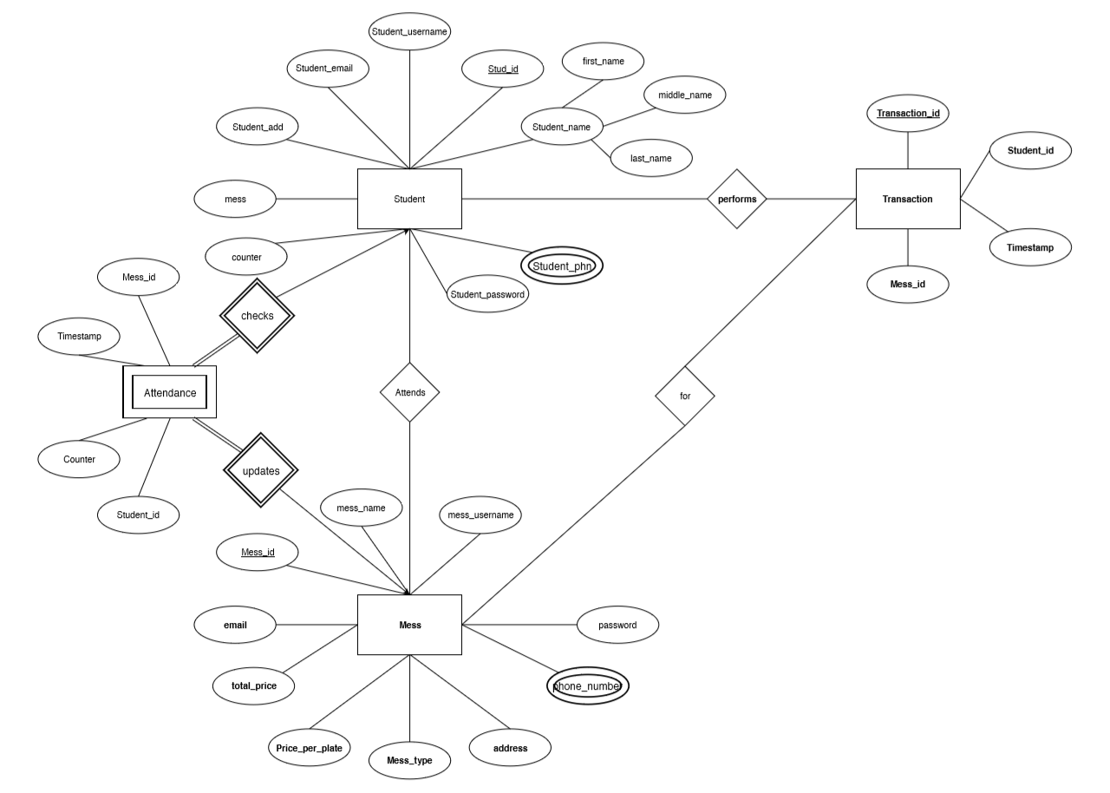

**9.** SCHEMA DIAGRAM

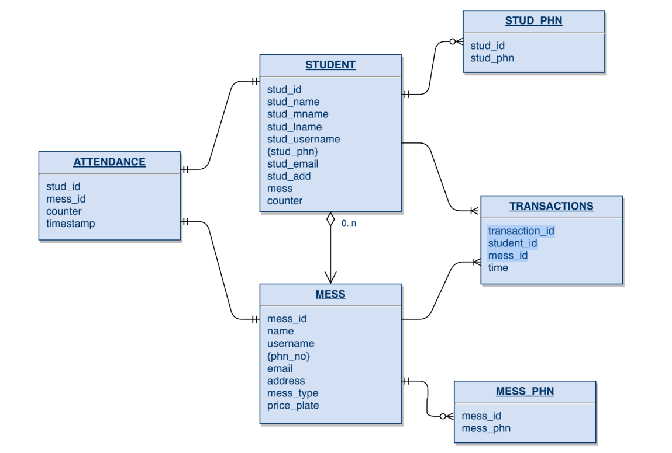

10. RELATIONAL DATABASE DESIGN

1. **Mess Table**

|  |  |  |  |  |  |
| --- | --- | --- | --- | --- | --- |
| **FIELD** | **TYPE** | **NULL** | **KEY** | **DEFAULT** | **EXTRA** |
| Mess_id | Int | NO | Primary | Null | Auto_increment |
| Name | Varchar(30) | Yes |  | Null |  |
| Username | Varchar(15) | Yes | Unique | Null |  |
| Password | Int | Yes |  | Null |  |
| Phn_no | Bigint | Yes |  | Null |  |
| Email | Varchar(50) | Yes |  | Null |  |
| Address | Varchar(50) | Yes |  | Null |  |
| Mess_type | Varchar(20) | Yes |  | Null |  |
| Price_plate | Float | Yes |  | 0 |  |

**2. Student Table**

|  |  |  |  |  |  |
| --- | --- | --- | --- | --- | --- |
| **FIELD** | **TYPE** | **NULL** | **KEY** | **DEFAULT** | **EXTRA** |
| Stud_id | Int | NO | Primary | Null | Auto_increment |
| Stud_name | Varchar(30) | NO |  | Null |  |
| Stud_username | Varchar(15) | NO | Unique | Null |  |
| Stud_password | Int | NO |  | Null |  |
| Stud_phn | Bigint | Yes |  | Null |  |
| Stud_email | Varchar(50) | Yes |  | Null |  |
| Stud_add | Varchar(50) | Yes |  | Null |  |
| mess | Int | Yes | Foreign | Null |  |
| counter | Int | Yes |  | 0 |  |

**3. Transaction Table**

|  |  |  |  |  |  |
| --- | --- | --- | --- | --- | --- |
| **FIELD** | **TYPE** | **NULL** | **KEY** | **DEFAULT** | **EXTRA** |
| Student_id | Int | NO | Foreign | Null |  |
| Transaction_id | Int | NO | Primary | Null |  |

**11. DATABASE NORMALIZATION**

1. **First Normal Form:**

The relation is in 1NF if it has no repeating groups. So here, all tables have no repeating groups so they are in 1NF. All attributes in relation must have atomic values and single values.

**Tables:**

**1. Student**

|  |  |  |  |  |
| --- | --- | --- | --- | --- |
| Stud_id | Stud_name | Stud_username | Stud_password | Stud_phn |
| Stud_email | Stud_add | Mess | Counter |  |

1. **Mess**

|  |  |  |  |  |  |  |
| --- | --- | --- | --- | --- | --- | --- |
| Mess_id | Name | Username | Password | Phn_no | Email | Address |
| Mess_type | Price_plate |  |  |  |  |  |

**33. Transaction**

|  |  |  |  |
| --- | --- | --- | --- |
| Transaction_id | Stud_id | Mess_id | Time |

1. **Second Normal Form**

A relation is said to be in second normal form if it is already in first normal form and it has no partial dependency. As per the rule of 2NF, every non-prime attribute must be dependent upon prime attribute.

1. **Student**

There is no partial dependency in student table. Here all non-key attributes are dependent upon all key attributes. So 2NF is followed.

1. **Mess**

There is no partial dependency in mess table. Here all non-key attributes are dependent upon all key attributes. So 2NF is followed.

1. **Transactions**

Also there is no partial dependency in transaction table. In fact it has composite key. This table contains all key attributes. Hence 2NF is followed.

1. **Third Normal Form**

A relation is said to be in third normal form if it is already in 1st and 2nd NF and has no transitive dependency i.e. no non-prime attribute should be transitively dependent on prime key attribute.

**1. Student**

This table already follows second normal form. Also there is no transitive dependency as we already have split the table accordingly. So it is in third normal form.

**2. Mess**

Even this table already follows second normal form and there is no transitive dependency as we already have split the table accordingly. So it is also in third normal form.

**3. Transactions**

Even this table already follows second normal form and there is no transitive dependency as we already have split the table accordingly. So it is also in third normal form.

**Tables**

**1. Student**

|  |  |  |  |  |
| --- | --- | --- | --- | --- |
| Stud_id | Stud_name | Stud_username | Stud_password | Stud_phn |
| Stud_email | Stud_add | Mess | Counter |  |

**2. Mess**

|  |  |  |  |  |  |  |
| --- | --- | --- | --- | --- | --- | --- |
| Mess_id | Name | Username | Password | Phn_no | Email | Address |
| Mess_type | Price_plate |  |  |  |  |  |

**3**

**3. Transaction**

|  |  |  |  |  |
| --- | --- | --- | --- | --- |
| Transaction_id | Stud_id | Mess_id |  |  |

12. GRAPHICAL USER INTERFACE

The application is very user friendly and uses a GUI interface implemented inJava andEclipse to Communicate with the user. Various features are self – explanatory. Registration steps are mentioned on the page which helps the user navigate through the registration process. User is able to apply filters easily to view a list of available mess. The UI is simple and easy to use.

SNAPSHOTS OF THE APPLICATION

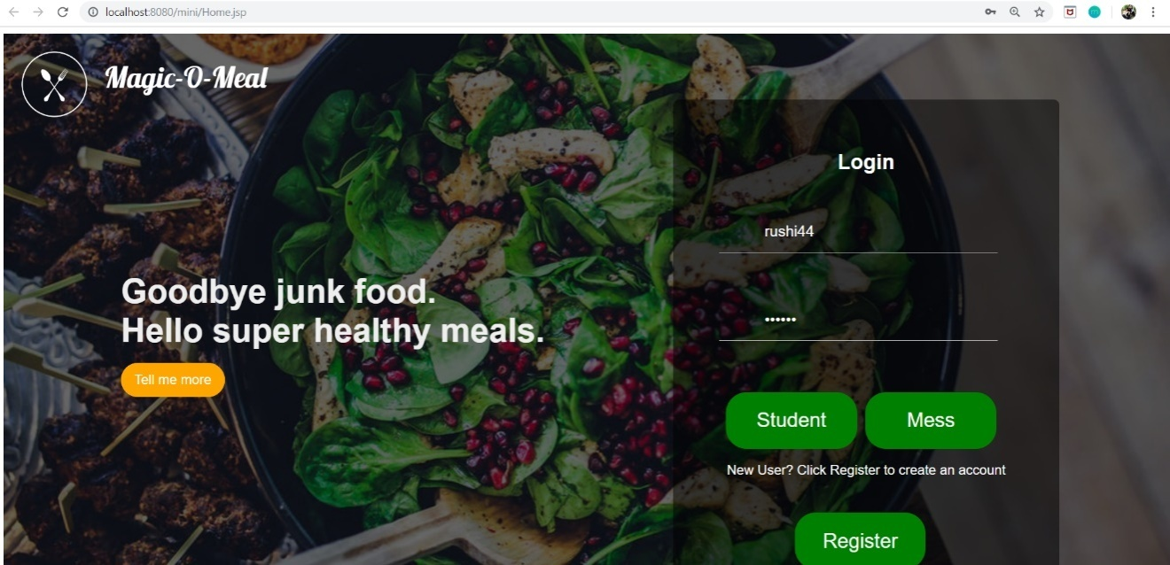

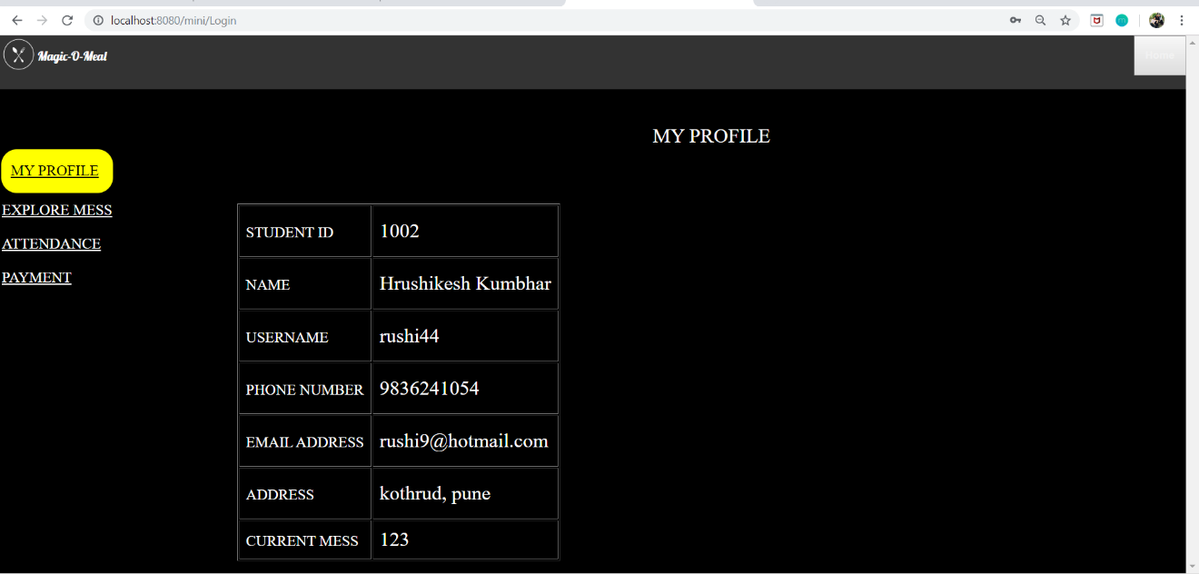

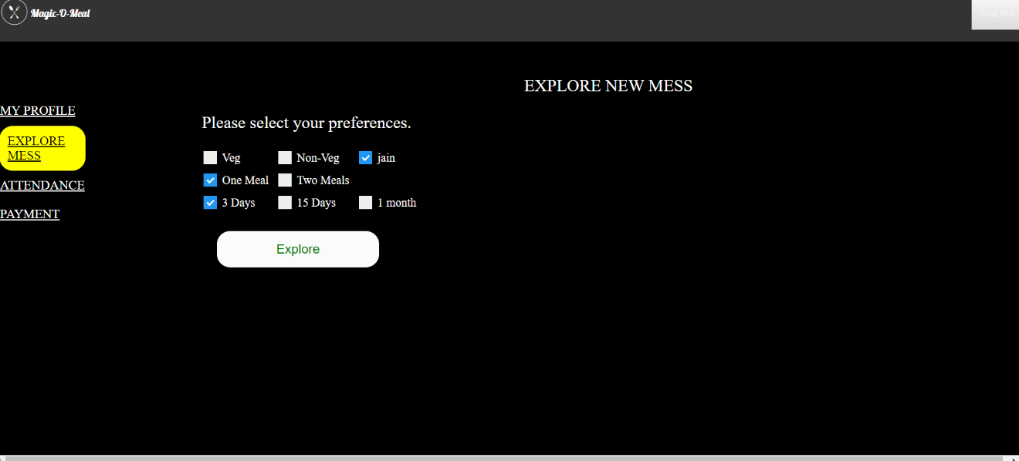

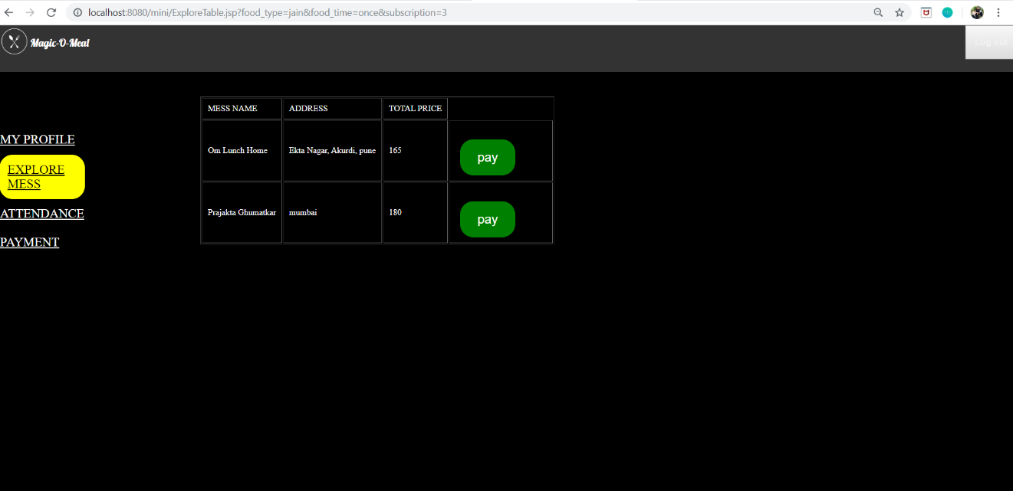

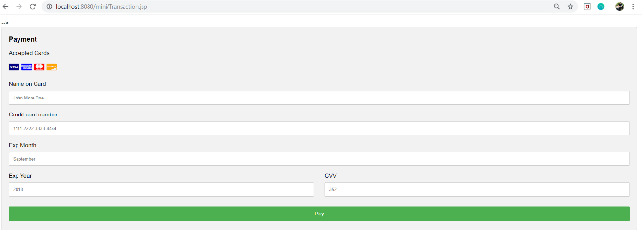

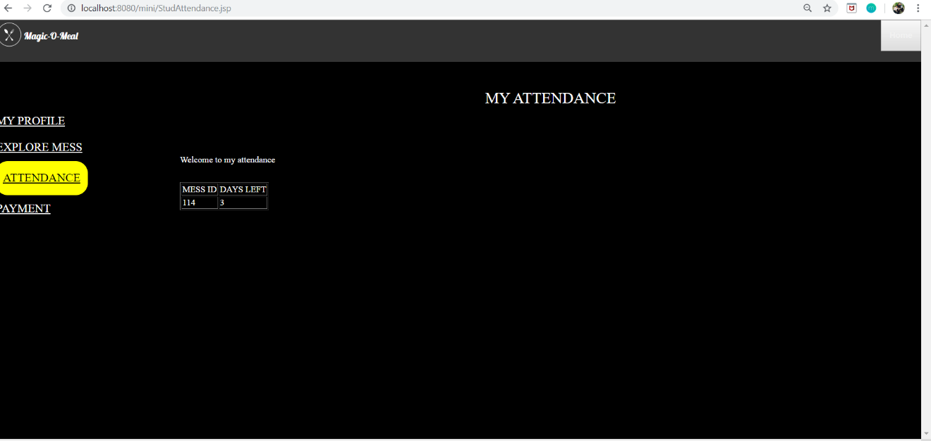

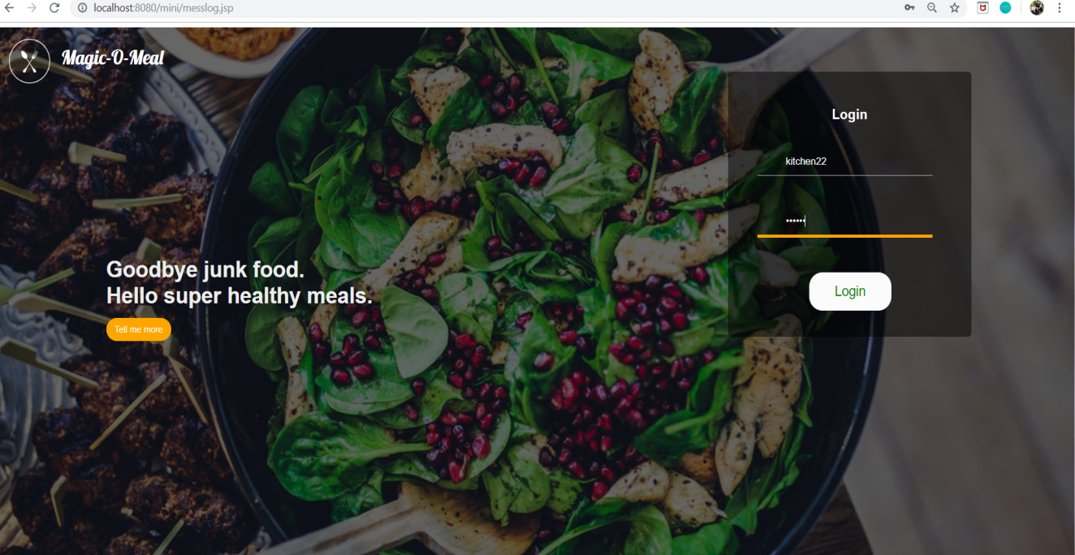

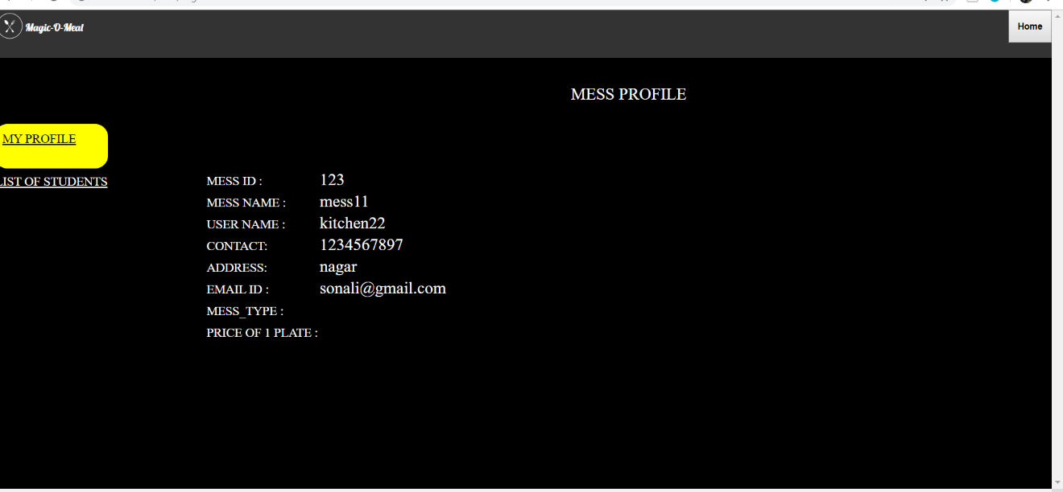

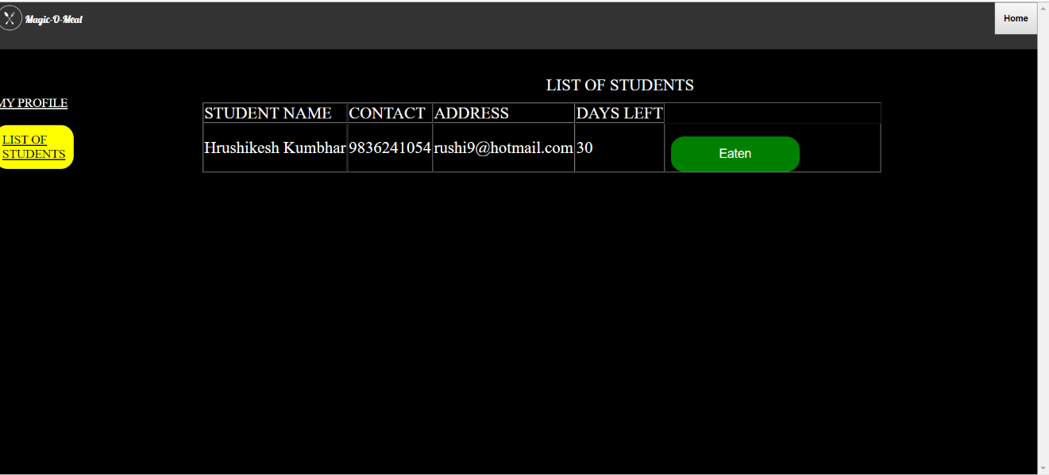

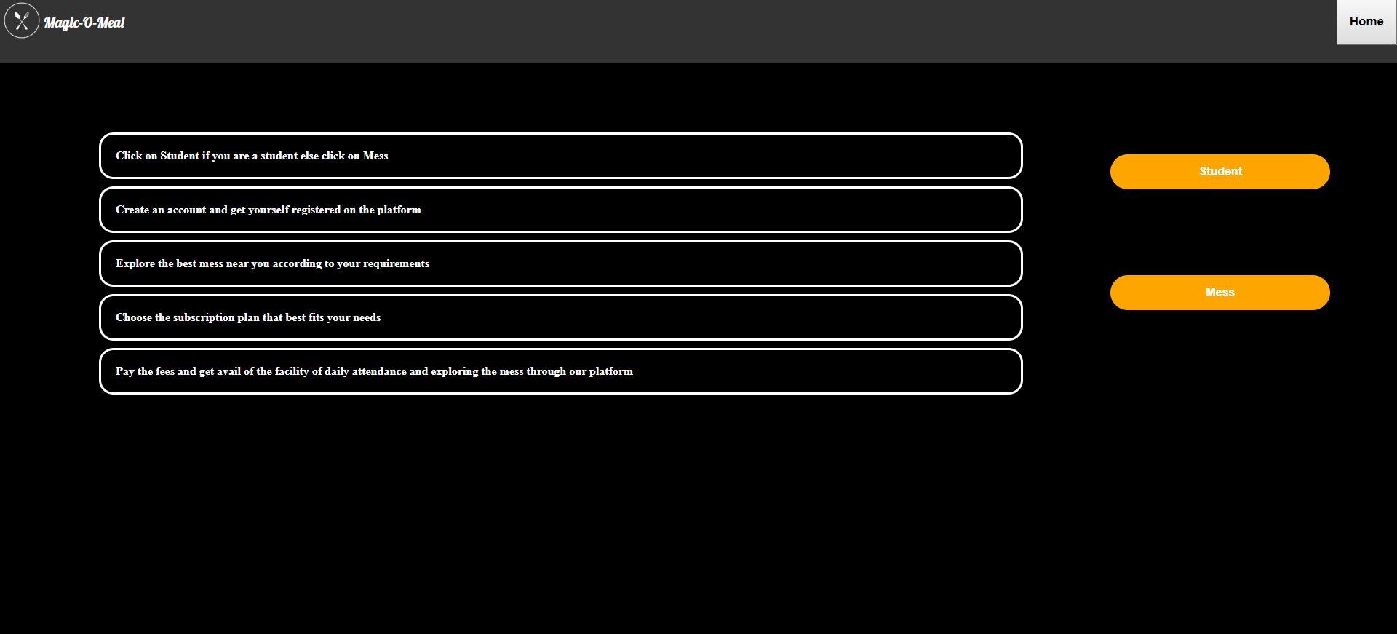

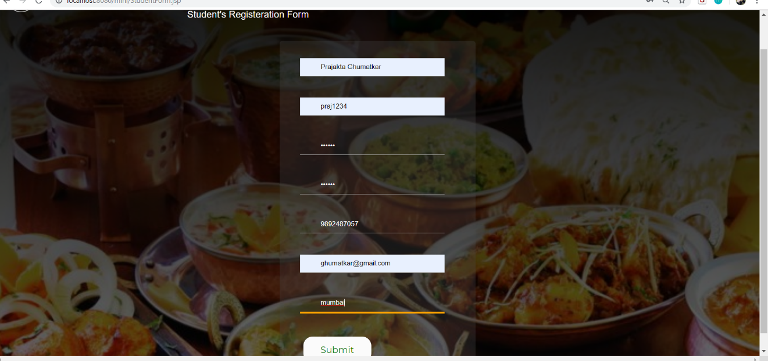

**13. CONCLUSION**

         Thus we have successfully implemented the Mess Management System which provides a platform for easy interaction between the mess owners and students. Students can easily find mess of their own choice according to their budget and register themselves with that mess.

**14. REFERENCES**

1. MySQL - (Database Backend)

2. JAVA, ECLIPSE - (Front End)

3. JDBC - (Connectivity)