☁️ AZURE DATA FACTORY
Quick Revision & Interview Notes
Simple • Clear • Interview-Ready

What is Azure Data Factory?
Azure Data Factory (ADF) is Microsoft Azure's cloud-based ETL (Extract, Transform, Load) and data integration service.
It allows you to create, schedule, and manage data pipelines that move and transform data from various sources to destinations.

📥  Extract  Pull data from sources | ⚙️  Transform  Clean & process data | 📤  Load  Send to destination

Key Facts:
▸ Fully managed, serverless — no infrastructure to manage
▸ Supports 90+ data sources (SQL, Oracle, SAP, REST APIs, Blob Storage, etc.)
▸ Drag & drop pipeline designer + code support
▸ Integrates with Azure Synapse, Databricks, HDInsight

Storage Redundancy Options in ADF
When creating storage accounts used by Azure Data Factory, you must choose a redundancy option. This controls how many copies of your data Azure keeps — and where.

💡 Why it matters: Redundancy = Protection against hardware failure, disasters, and outages. Higher redundancy = higher cost.

1. LRS — Locally Redundant Storage
3 copies of data in a single datacenter.  📦 Simple Example:  ▸ Like keeping 3 copies of a file in 3 lockers — same room.  ✅ Safe from hardware (disk) failure  ❌ NOT safe if entire datacenter goes down (fire, flood)  Use Case:  ▸ Dev/Test environments  ▸ Learning projects  ▸ Non-critical data | 📍 Datacenter A  🗂️ Copy 1  🗂️ Copy 2  🗂️ Copy 3  Cost: 💰 Cheapest

2. ZRS — Zone Redundant Storage
3 copies spread across 3 different Availability Zones in the same region.  📦 Simple Example:  ▸ 3 different buildings in Hyderabad — 1 copy each.  ✅ Safe even if an entire zone (building) goes down  ❌ NOT safe if the entire region (city) goes down  Use Case:  ▸ Production applications  ▸ High availability requirements | 📍 Same Region  🏢 Zone 1 → Copy 1  🏢 Zone 2 → Copy 2  🏢 Zone 3 → Copy 3  Cost: 💰💰 Medium

3. GRS — Geo Redundant Storage
6 copies total — 3 in primary region + 3 in secondary region.  📦 Simple Example:  ▸ 3 copies in Mumbai, 3 copies in Chennai as backup.  ✅ Protected even if entire primary region goes down  ❌ Secondary data NOT directly readable — only after failover  Use Case:  ▸ Banking & Insurance  ▸ Critical business data | 🇮🇳 Mumbai (Primary)  Copy 1  Copy 2  Copy 3  ⬇️ Replicated to  🏙️ Chennai (Secondary)  Copy 4  Copy 5  Copy 6  Cost: 💰💰💰 High

4. GZRS — Geo-Zone Redundant Storage
⭐ Best of Both Worlds: ZRS + GRS combined = Maximum protection at the highest cost.

Primary region: 3 copies across 3 zones.  Secondary region: 3 additional copies.  ✅ Survives zone failure  ✅ Survives region failure  ✅ Highest level of protection  Use Case:  ▸ Mission-critical enterprise systems  ▸ Zero downtime tolerance | Primary Region  🏢 Zone 1 → Copy  🏢 Zone 2 → Copy  🏢 Zone 3 → Copy  ⬇️ + GRS Replication  Secondary Region  3 Extra Copies  Cost: 💰💰💰💰 Highest

Quick Comparison Table

Type | Copies | Scope | Cost
LRS | 3 copies | 1 Datacenter | 💰 Cheapest
ZRS | 3 copies | 3 Zones (1 Region) | 💰💰 Medium
GRS | 6 copies | 2 Regions | 💰💰💰 Expensive
GZRS | 6 copies | 3 Zones + 2 Regions | 💰💰💰💰 Highest

🎯 Interview Tip: When asked "which redundancy to choose?" — mention the trade-off: LRS=cost, ZRS=zone HA, GRS=disaster recovery, GZRS=maximum protection. Always relate to use case!

ADF Quick Revision Notes • More topics coming soon • Good luck! 🚀

🔗 Linked Service & 📦 Dataset
The Foundation of Every ADF Pipeline

💡 Quick Memory Trick
🔗 Linked Service = "Kahan connect karna hai?" (WHERE to connect)
📦 Dataset = "Connect hone ke baad kya uthana hai?" (WHAT to pick)

🔗 Linked Service  Interview Definition  A Linked Service in ADF is a connection configuration that stores the connection string and credentials required to connect ADF to an external data source or compute resource. It acts as a bridge — telling ADF where the data lives and how to authenticate into it. Think of it as a saved login profile that ADF uses every time it needs to talk to that source.  Contains:  ▸ Server name / endpoint URL  ▸ Username & password (credentials)  ▸ Authentication type (Key, OAuth, MSI)  ▸ Connection type (Azure SQL, Blob, REST…) | 📦 Dataset  Interview Definition  A Dataset in ADF represents the actual data structure or object inside the data source that you want to work with — such as a specific table, file, folder, or container. It always references a Linked Service and points to the exact location of the data within that source.  Contains:  ▸ Which Linked Service to use  ▸ Table name / file path / container  ▸ Schema / column structure  ▸ File format (CSV, JSON, Parquet…)

How They Work Together
In ADF, every Dataset must reference a Linked Service. You cannot create a Dataset without first creating a Linked Service. The flow is:

🔗  Linked Service  Connection Info | ➡️ | 📦  Dataset  Points to specific data | ➡️ | ⚙️  Pipeline Activity  Uses dataset to copy/transform

Real-World Analogy Examples

Analogy | Linked Service | Dataset
📧 Gmail | Gmail Login (credentials) | Inbox Folder
🏦 Bank App | Your account login | Transaction history table
📚 Library | Library card / entry pass | The specific book/shelf
🗄️ SQL Server | Server URL + Username + Password | Table: dbo.Sales

Key Rules to Remember
Rule 1: One Linked Service can be used by multiple Datasets. (1 login → access many tables)

Rule 2: A Dataset must always reference exactly ONE Linked Service.

Rule 3: Linked Service stores credentials → Dataset stores structure/location. They are separate for security & reusability.

🎯 Interview Tip: Linked Service = Connection. Dataset = Data pointer. In a Copy Activity, you pick source dataset and sink dataset — both backed by their own Linked Services.

ADF Quick Revision Notes • More topics coming soon • Good luck! 🚀

⚙️ ADF Activities
Copy • GetMetadata • If Condition • ForEach • Data Flow + Parameterised Datasets

Activities — Quick Overview

Activity | What it does | When to use
📋 Copy Activity | Moves data from source to sink | Migrate / load data into storage or DW
🔍 GetMetadata | Reads file/folder info (count, size, exists) | Check file before processing it
❓ If Condition | Branches pipeline: True path / False path | Conditional logic based on metadata result
🔁 ForEach | Loops over a list of items, runs child activity | Process multiple files/tables in one pipeline
⚡ Data Flow | Spark-powered ETL transformations visually | Complex transform, filter, join, aggregate

📋 1. Copy Activity
The most used activity in ADF — moves data from source to destination

Copy Activity reads data from a source dataset and writes it to a sink (destination) dataset. It supports 90+ connectors — SQL, Blob, ADLS, REST, Oracle, SAP, etc.

📥 Source (Where data comes from)  ▸ Azure SQL DB  ▸ Blob Storage / ADLS  ▸ REST API  ▸ Oracle / SAP  ▸ On-prem SQL via IR | 📤 Sink (Where data goes to)  ▸ Azure SQL / Synapse  ▸ ADLS Gen2  ▸ Cosmos DB  ▸ Blob Storage  ▸ Snowflake / Databricks

Key Settings to Know:
▸ Mapping — column-level mapping between source & sink
▸ Copy Behavior — Preserve, Merge, Overwrite, Flatten Hierarchy
▸ Fault Tolerance — skip incompatible rows instead of failing
▸ Degree of Copy Parallelism — how many parallel reads/writes

🎯 Interview Scenario: "How would you load daily CSV files from Blob Storage into Azure SQL?"
Use Copy Activity. Source = Blob Storage (CSV dataset), Sink = Azure SQL dataset. Schedule with a Tumbling Window Trigger. Use GetMetadata + ForEach for multiple files.

🔍 2. GetMetadata Activity
Reads file/folder properties — does NOT move data, only reads info about data

GetMetadata fetches information ABOUT a file or folder — not the file content itself. You use its output to make decisions in the pipeline (e.g. check if a file exists before copying it).

What it can fetch:
▸ exists — does this file/folder exist? (True/False)
▸ itemName — name of the file
▸ itemType — File or Folder
▸ size — file size in bytes
▸ lastModified — last modified timestamp
▸ childItems — list of all files inside a folder ← used with ForEach!

Output syntax: @activity('GetMetadataActivity').output.exists or .output.childItems

🎯 Interview Scenario: "How do you avoid pipeline failure if source file doesn't exist?"
Use GetMetadata → check @activity('GetMeta').output.exists == true → wrap in If Condition → only run Copy Activity in the True path.

❓ 3. If Condition Activity
Like an if-else in code — routes pipeline execution based on a True/False expression

If Condition evaluates a boolean expression. If TRUE → executes activities in True branch. If FALSE → executes activities in False branch. You can nest other activities inside each branch.

Expression examples:
// Check if file exists
@activity('GetMetaData').output.exists

// Check file size > 0
@greater(activity('GetMetaData').output.size, 0)

// Check item count
@greater(activity('GetMetaData').output.itemCount, 0)

✅ True Branch  ▸ Run Copy Activity  ▸ Send success notification  ▸ Execute stored procedure | ❌ False Branch  ▸ Log error to table  ▸ Send failure email alert  ▸ Skip and do nothing (empty)

🎯 Interview Scenario: "How do you build a pipeline that only processes a file if it has data?"
GetMetadata (get size/itemCount) → If Condition (size > 0) → True path: Copy Activity → False path: Web Activity to send alert email.

🔁 4. ForEach Activity
Loops over a list of items and runs child activities for each — like a for loop in code

ForEach takes an array (list) as input and runs the activities inside it for every item in the list. The current item in each iteration is accessed using @item().

Two modes:
▸ Sequential — processes one item at a time (order matters)
▸ Parallel — processes multiple items at once (faster, set batch count)

How it works with GetMetadata:
Step 1: GetMetadata → output.childItems (returns array of files)

Step 2: ForEach → Items = @activity('GetMeta').output.childItems

Step 3: Inside ForEach → Copy Activity
Source file = @item().name ← current file in loop

@item() explained: Inside a ForEach loop, @item() refers to the current element being processed. If looping over files, @item().name gives the filename of each file in that iteration.

🎯 Interview Scenario: "How do you copy 50 CSV files from a folder to SQL — one pipeline?"
GetMetadata (childItems of folder) → ForEach (loop over childItems) → inside loop: Copy Activity with parameterised dataset where filename = @item().name

⚡ 5. Data Flow Activity (Spark)
Visual ETL transformation engine powered by Apache Spark clusters — for heavy data transformations

Data Flow is ADF's transformation tool. Unlike Copy Activity (which just moves data), Data Flow transforms it — filter rows, join tables, aggregate, derive columns, split streams — all visually with no code needed.

Under the hood it uses Apache Spark clusters. ADF auto-manages the cluster (spin up / spin down). You just design the transformation graph.

Transformation steps (as seen in your screenshots):
📥 Source sourceCSV | Import data from dataset (CSV, SQL, etc.)
✅ Select selectCols | Pick only needed columns, rename them
🔽 Filter filterRows | Filter rows based on condition (like WHERE in SQL)
✂️ Conditional Split visa / split | Route rows into multiple streams based on conditions (like mastercard vs amex)
📊 Aggregate aggregate | GROUP BY + aggregate functions (SUM, MAX, COUNT)
➕ Derived Column derivedColumn | Create new/calculated columns
✏️ Alter Row alterRows | Set row policy: Insert / Update / Upsert / Delete
📤 Sink sink | Write transformed data to destination

Copy vs Data Flow: Copy Activity = Move data as-is (no transformation). Data Flow = Move + Transform data (filter, join, aggregate, derive). Use Copy for simple loads, Data Flow for complex ETL.

🎯 Interview Scenario: "When would you use Data Flow instead of Copy Activity?"
When you need to transform data — e.g. split payment data by card type (Visa/Mastercard), aggregate by customer_id, calculate new columns, then write to sink. Copy Activity can't do this alone.

🎛️ Parameterised Datasets & @item()
Make your pipelines dynamic — one pipeline to rule them all

What is a Parameterised Dataset?
By default, a Dataset points to one fixed file or table. A Parameterised Dataset has parameters — like variables — that let you change the file name, folder path, table name etc. dynamically at runtime.

Without Parameters → 1 dataset = 1 file (hardcoded path)
With Parameters → 1 dataset = any file (path passed at runtime)

❌ Without Parameters (Bad)  ▸ dataset_jan.csv → 1 dataset  ▸ dataset_feb.csv → 1 dataset  ▸ dataset_mar.csv → 1 dataset  ▸ = 12 datasets for 12 months 😱 | ✅ With Parameters (Good)  ▸ 1 dataset with fileName parameter  ▸ Pass "jan.csv" → processes jan  ▸ Pass "feb.csv" → processes feb  ▸ = 1 dataset for all months 🎉

How to Create a Parameter in Dataset
In ADF → open Dataset → go to Parameters tab → Add parameter (e.g. name: fileName, type: String).
Then in the Connection tab, instead of hardcoding the file name, click "Add dynamic content" and reference the parameter:

// In dataset Connection > File path
@dataset().fileName

// Full path example
container/folder/@{dataset().fileName}

Key syntax: @dataset().parameterName — references a parameter defined in the Dataset

How Pipeline Passes Value to Dataset
When you use the parameterised dataset inside a Copy Activity, you pass the actual value in the Dataset Properties section:

// Inside Copy Activity → Source Dataset Properties
fileName: "sales_jan_2024.csv" ← hardcoded value

// OR dynamically from a pipeline parameter
fileName: @pipeline().parameters.inputFile

// OR from ForEach loop (most common)
fileName: @item().name

@item() — The ForEach Loop Variable
@item() — What is it?
@item() is the built-in variable inside a ForEach loop that holds the current element being processed in that iteration.
Think of it like the loop variable "i" or "item" in a for-each loop in Java/Python.

@item() gives you the full object. To access a property, use dot notation:

// If ForEach items = list of files from GetMetadata childItems:
@item() → { "name": "sales.csv", "type": "File" }
@item().name → "sales.csv"
@item().type → "File"

// If ForEach items = custom array like ["table1","table2"]:
@item() → "table1" (directly the string value)

Full Pattern: GetMetadata → ForEach → Parameterised Dataset
The Golden Pattern 🏆 This is the most common interview scenario. Process all files in a folder dynamically without hardcoding any filename.

# | Step | What it does
1 | 🔍 GetMetadata | Get childItems of folder → returns array of all file names
2 | ❓ If Condition | Check itemCount > 0 (folder not empty)
3 | 🔁 ForEach | Loop over @activity('GetMeta').output.childItems
4 | 📋 Copy Activity | Source dataset gets fileName = @item().name dynamically
5 | 📤 Sink | Write each file to Azure SQL / ADLS destination

🎯 Interview Scenario: "Design a pipeline to load all files from Blob Storage folder into SQL daily"
GetMetadata (childItems) → If Condition (itemCount > 0) → ForEach (sequential/parallel) → Copy Activity with parameterised source dataset (fileName = @item().name). Schedule with daily Trigger.

ADF Quick Revision Notes • More topics coming soon • Good luck! 🚀

⏰ Triggers • 🔀 Set Variable • 🚀 Execute Pipeline
Variables vs Parameters • Real Scenarios • Screenshots included

Set Variable Activity
🔀 Set Variable Activity
Store a value during pipeline execution — use it in later activities as a dynamic input

Set Variable lets you create a pipeline-level variable and assign a value to it during runtime. You can then use that variable in any later activity using @variables('varName').

Real Scenario — Store file count from GetMetadata:
Step 1: GetMetadata → output.childItems (array of files)

Step 2: Set Variable
Variable Name : var_files
Value : @activity('GetMetadata').output.childItems

Step 3: ForEach
Items : @variables('var_files') ← use stored value

Step 4: If Condition
Expression : @greater(length(variables('var_files')), 0)

📸 Your ADF — GetMetadata → Set Variable (StoreFiles → var_files)
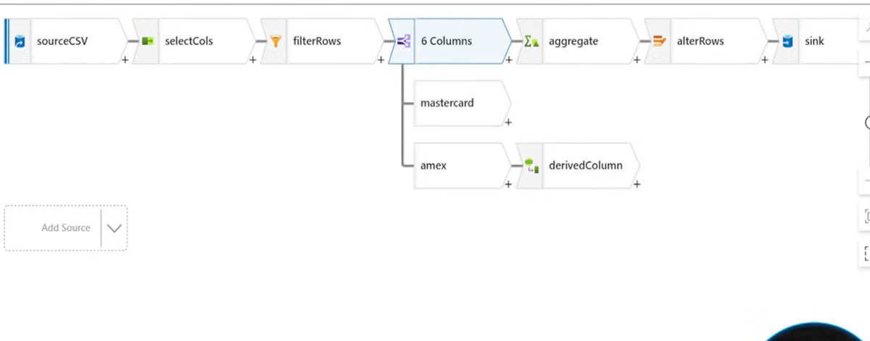
GetMetadata output is stored in var_files via Set Variable, then used by ForEach downstream

Why use Set Variable instead of referencing activity output directly?
▸ Store complex output (like an array) once — reuse many times
▸ Cleaner expressions — @variables('var_files') vs long @activity() chains
▸ Update value mid-pipeline based on conditions (Append Variable)
▸ Useful in loops — track counters, error flags, status strings

🎯 Interview Scenario: "How did you track how many files were processed in a pipeline?"
Declared an integer variable var_count = 0. Inside ForEach, after each successful Copy Activity, used Append Variable (or Set Variable with @add) to increment the count. At the end, Web Activity sent this count in a Teams notification.

GetMetadata vs Set Variable — Key Difference

Aspect | 🔍 GetMetadata | 🔀 Set Variable
Purpose | Reads info FROM a storage source | Stores a value INSIDE the pipeline
Data comes from | Azure Blob, ADLS, SQL etc. | Another activity output / expression
Output access | @activity('GetMeta').output.exists | @variables('var_files')
Can update mid-run? | No — read-only snapshot | Yes — can be updated anytime
Scope | One-time fetch from external source | Lives throughout the pipeline run
Use with ForEach | Get list of files to loop over | Store that list, pass to ForEach

Pipeline Variables vs Pipeline Parameters
One-liner: Parameter = passed FROM OUTSIDE into the pipeline (read-only). Variable = created INSIDE the pipeline (read/write at runtime).

📌 Pipeline Parameter  ▸ Defined in pipeline → Parameters tab  ▸ Value is PASSED when pipeline is triggered or called  ▸ Read-only — cannot change once pipeline starts  ▸ Use for: file paths, dates, environment names  ▸ Syntax: @pipeline().parameters.paramName  ▸ Example: date = "2024-01-01" passed by trigger | 📦 Pipeline Variable  ▸ Defined in pipeline → Variables tab  ▸ Value is set/updated INSIDE the pipeline using Set Variable activity  ▸ Read/Write — can change during pipeline run  ▸ Use for: counters, status flags, intermediate results  ▸ Syntax: @variables('varName')  ▸ Example: var_count updated after each loop

// PARAMETER — passed at trigger time, fixed during run
@pipeline().parameters.sourceFolder → "csvfiles/2024/jan/"

// VARIABLE — set inside pipeline, can change
@variables('var_status') → "processing" → "done"

// DATASET parameter — passed FROM pipeline to dataset
@dataset().fileName → "sales.csv"

Aspect | 📌 Parameter | 📦 Variable
Who sets the value | Trigger / parent pipeline / manual run | Set Variable activity inside pipeline
Can change during run? | No (read-only) | Yes (mutable)
Defined in | Pipeline → Parameters tab | Pipeline → Variables tab
Typical type | String, Int, Bool, Array | String, Int, Bool, Array
Access syntax | @pipeline().parameters.name | @variables('name')
Best use | Input config (date, folder, env) | Runtime tracking (count, flag, list)

Execute Pipeline Activity
🚀 Execute Pipeline Activity
Call one pipeline from inside another — build modular, reusable pipelines

Execute Pipeline activity triggers a child pipeline from a parent pipeline. This is how you build modular ADF designs — one master pipeline that orchestrates multiple child pipelines.

✅ Why use it?  ▸ Break large pipelines into smaller reusable ones  ▸ Cleaner, easier to debug and maintain  ▸ Pass parameters to child pipeline  ▸ Wait for child to complete (synchronous) OR fire and forget (async) | 🏗️ Common pattern  ▸ Master pipeline → triggers child pipelines  ▸ Child 1: Ingest raw data  ▸ Child 2: Transform data  ▸ Child 3: Load to warehouse  ▸ Master monitors all statuses

Two execution modes:
▸ Wait on Completion = TRUE → Parent waits, child result affects parent status
▸ Wait on Completion = FALSE → Parent fires child and moves on (parallel)

// Pass parameter to child pipeline inside Execute Pipeline activity
Parameters:
sourceFolder : @pipeline().parameters.sourceFolder
runDate : @formatDateTime(utcNow(), 'yyyy-MM-dd')

// Child pipeline receives these as its own parameters

🎯 Interview Scenario: "How would you design a pipeline that loads 5 different tables every day?"
Create 1 child pipeline per table (parameterised with tableName). Create 1 master pipeline with 5 Execute Pipeline activities (parallel). Pass tableName as parameter to each child. Master triggers all 5 on schedule.

⏰ Types of Triggers in ADF
Schedule • Tumbling Window • Storage Event • Custom Event

Trigger Type | Fires when | Best for
⏰ Schedule | Fixed time/recurrence (daily 9AM, every hour) | Regular batch loads, daily ETL
🪟 Tumbling Window | Fixed windows, can backfill past dates | Hourly/daily with historical reprocessing
📦 Storage Event | File arrives / deleted in Blob Storage | Real-time file-based ingestion
🔔 Custom Event | Custom event published to Event Grid topic | Event-driven pipelines, microservices

⏰ 1. Schedule Trigger
Runs pipeline at a fixed time or interval — like a cron job

The simplest trigger. Set a start time, recurrence (every day/hour/minute), and end date. ADF fires the pipeline automatically.
▸ Supports: Minute, Hour, Day, Week, Month intervals
▸ Can set specific days/times (e.g. Mon-Fri at 8AM only)
▸ Multiple pipelines can share one Schedule Trigger
❌ Does NOT support backfill — missed runs are skipped

🎯 Interview Scenario: "Load sales data from SQL to ADLS every day at 6AM"
Create a Schedule Trigger with startTime=6AM, recurrence=1 day. Attach it to the Copy pipeline.

🪟 2. Tumbling Window Trigger
Fixed non-overlapping time windows — with the power to reprocess past windows

Tumbling Window divides time into equal-sized, non-overlapping windows. Unlike Schedule, it tracks each window separately — so if a run fails, you can rerun just that window. And crucially, you can trigger past windows to backfill historical data.

✅ Tumbling Window can do  ▸ Reprocess past intervals (backfill data)  ▸ Retry only the failed window  ▸ Each window has start/end time accessible  ▸ Dependencies between windows possible  ▸ @trigger().outputs.windowStartTime available | ❌ Schedule Trigger cannot do  ▸ Cannot backfill — missed windows lost forever  ▸ Retry reruns from current time  ▸ No window context passed to pipeline  ▸ Each run is independent  ▸ No window start/end time

// In pipeline, access window times from Tumbling Window trigger:
@trigger().outputs.windowStartTime → "2024-01-01T00:00:00Z"
@trigger().outputs.windowEndTime → "2024-01-02T00:00:00Z"

// Use in Copy Activity as date filter:
query: SELECT * FROM Orders WHERE date >= '@{trigger().outputs.windowStartTime}'

🎯 Interview Scenario: "Your manager says hourly data loads have been missing since last Tuesday — how do you fix it?"
Use Tumbling Window Trigger. Go to Monitor → Trigger Runs → select the failed windows → Rerun. Each missed hour will be reprocessed in order. Schedule Trigger cannot do this.

📦 3. Storage Event Trigger
Auto-fires when a file is created or deleted in Azure Blob Storage / ADLS — real-time ingestion

Storage Event Trigger listens to Azure Event Grid. The moment a file is created (or deleted) in a specified container, ADF automatically starts the pipeline. No polling — instant reaction.

▸ Event types: Blob Created OR Blob Deleted
▸ Works with Azure Blob Storage and ADLS Gen2
▸ Filter by path prefix and/or suffix to trigger only specific files
▸ "Ignore empty blobs" — skip 0-byte files (avoid false triggers)

🔴 The Manager Problem — Wrong Files Issue:
What if your manager accidentally drops wrong files (e.g. budget.xlsx, notes.txt) into the same folder? Without filtering, your pipeline would trigger on every file and fail.

📸 Storage Event Trigger — Your ADF setup with path filter
Container: source | Blob path begins with: csvfiles/Fact_Sales_1.csv | Event: Blob created only

Solution — Add Blob Path Filter: Set "Blob path begins with" = csvfiles/Fact_Sales_1.csv. Now the trigger ONLY fires when exactly that file arrives. Any other file dropped by manager is completely ignored.

📍 Blob path begins with  ▸ Filter by folder or file prefix  ▸ csvfiles/ → any file in csvfiles folder  ▸ csvfiles/Fact_Sales → files starting with Fact_Sales  ▸ Most common filter — restrict by folder path | 📍 Blob path ends with  ▸ Filter by file extension or suffix  ▸ ".csv" → only CSV files trigger  ▸ ".parquet" → only parquet files  ▸ Combine both for precise file targeting

Available in pipeline when Storage Event fires:
// Access the file that triggered the pipeline:
@triggerBody().folderPath → "csvfiles"
@triggerBody().fileName → "Fact_Sales_1.csv"

// Full path:
@concat(triggerBody().folderPath, '/', triggerBody().fileName)
→ "csvfiles/Fact_Sales_1.csv"

🎯 Interview Scenario: "How would you trigger a pipeline automatically when a new sales CSV arrives in Blob Storage?"
Create a Storage Event Trigger on container "source". Set Blob path begins with "csvfiles/" and ends with ".csv". Event = Blob Created. Inside pipeline, use @triggerBody().fileName to dynamically pick up the arriving file name and pass it to the parameterised dataset.

🔔 4. Custom Event Trigger
Fires when a custom event is published to Azure Event Grid — for event-driven architectures

Custom Event Trigger subscribes to an Event Grid Topic. Any system (web app, IoT device, another Azure service) can publish a custom JSON event to that topic, and ADF will fire the pipeline.

▸ You define the event subject/type filter — only matching events fire the pipeline
▸ Pipeline receives the event payload — access it via @triggerBody()
▸ Used in microservices / event-driven architectures
▸ Example: Order service publishes "OrderCompleted" event → ADF loads order data

Storage Event Trigger  ▸ Tied to Blob Storage specifically  ▸ Fires on file create/delete only  ▸ No custom payload — just file info  ▸ Simple file-based use cases | Custom Event Trigger  ▸ Works with any Event Grid publisher  ▸ Fires on any custom business event  ▸ Full JSON payload available  ▸ Complex event-driven architectures

🎯 Interview Scenario: "How would you trigger ADF when your web app confirms a customer order is ready?"
Web app publishes a custom event to Event Grid topic with subject "order.completed". Custom Event Trigger in ADF listens to this subject. Pipeline fires automatically and loads the order data from the source system.

Data Flow — Your Pipeline Screenshots

Here are the actual data flow screens from your project for reference during revision:

📸 Data Flow — Full Pipeline Overview (sourceCSV → selectCols → filterRows → split → aggregate → derivedColumn → sink)

📸 Aggregate settings — Group by customer_id, max(product_id) | 📸 Conditional Split — Visa / Mastercard / Amex streams

ADF Quick Revision Notes • More topics coming soon • Good luck! 🚀

⏰ Triggers • 🔀 Set Variable • 🚀 Execute Pipeline
Variables vs Parameters • Real Scenarios • Screenshots included

Set Variable Activity
🔀 Set Variable Activity
Store a value during pipeline execution — use it in later activities as a dynamic input

Set Variable lets you create a pipeline-level variable and assign a value to it during runtime. You can then use that variable in any later activity using @variables('varName').

Real Scenario — Store file count from GetMetadata:
Step 1: GetMetadata → output.childItems (array of files)

Step 2: Set Variable
Variable Name : var_files
Value : @activity('GetMetadata').output.childItems

Step 3: ForEach
Items : @variables('var_files') ← use stored value

Step 4: If Condition
Expression : @greater(length(variables('var_files')), 0)

📸 Your ADF — GetMetadata → Set Variable (StoreFiles → var_files)
GetMetadata output is stored in var_files via Set Variable, then used by ForEach downstream

Why use Set Variable instead of referencing activity output directly?
▸ Store complex output (like an array) once — reuse many times
▸ Cleaner expressions — @variables('var_files') vs long @activity() chains
▸ Update value mid-pipeline based on conditions (Append Variable)
▸ Useful in loops — track counters, error flags, status strings

🎯 Interview Scenario: "How did you track how many files were processed in a pipeline?"
Declared an integer variable var_count = 0. Inside ForEach, after each successful Copy Activity, used Append Variable (or Set Variable with @add) to increment the count. At the end, Web Activity sent this count in a Teams notification.

GetMetadata vs Set Variable — Key Difference

Aspect | 🔍 GetMetadata | 🔀 Set Variable
Purpose | Reads info FROM a storage source | Stores a value INSIDE the pipeline
Data comes from | Azure Blob, ADLS, SQL etc. | Another activity output / expression
Output access | @activity('GetMeta').output.exists | @variables('var_files')
Can update mid-run? | No — read-only snapshot | Yes — can be updated anytime
Scope | One-time fetch from external source | Lives throughout the pipeline run
Use with ForEach | Get list of files to loop over | Store that list, pass to ForEach

Pipeline Variables vs Pipeline Parameters
One-liner: Parameter = passed FROM OUTSIDE into the pipeline (read-only). Variable = created INSIDE the pipeline (read/write at runtime).

📌 Pipeline Parameter  ▸ Defined in pipeline → Parameters tab  ▸ Value is PASSED when pipeline is triggered or called  ▸ Read-only — cannot change once pipeline starts  ▸ Use for: file paths, dates, environment names  ▸ Syntax: @pipeline().parameters.paramName  ▸ Example: date = "2024-01-01" passed by trigger | 📦 Pipeline Variable  ▸ Defined in pipeline → Variables tab  ▸ Value is set/updated INSIDE the pipeline using Set Variable activity  ▸ Read/Write — can change during pipeline run  ▸ Use for: counters, status flags, intermediate results  ▸ Syntax: @variables('varName')  ▸ Example: var_count updated after each loop

// PARAMETER — passed at trigger time, fixed during run
@pipeline().parameters.sourceFolder → "csvfiles/2024/jan/"

// VARIABLE — set inside pipeline, can change
@variables('var_status') → "processing" → "done"

// DATASET parameter — passed FROM pipeline to dataset
@dataset().fileName → "sales.csv"

Aspect | 📌 Parameter | 📦 Variable
Who sets the value | Trigger / parent pipeline / manual run | Set Variable activity inside pipeline
Can change during run? | No (read-only) | Yes (mutable)
Defined in | Pipeline → Parameters tab | Pipeline → Variables tab
Typical type | String, Int, Bool, Array | String, Int, Bool, Array
Access syntax | @pipeline().parameters.name | @variables('name')
Best use | Input config (date, folder, env) | Runtime tracking (count, flag, list)

Execute Pipeline Activity
🚀 Execute Pipeline Activity
Call one pipeline from inside another — build modular, reusable pipelines

Execute Pipeline activity triggers a child pipeline from a parent pipeline. This is how you build modular ADF designs — one master pipeline that orchestrates multiple child pipelines.

✅ Why use it?  ▸ Break large pipelines into smaller reusable ones  ▸ Cleaner, easier to debug and maintain  ▸ Pass parameters to child pipeline  ▸ Wait for child to complete (synchronous) OR fire and forget (async) | 🏗️ Common pattern  ▸ Master pipeline → triggers child pipelines  ▸ Child 1: Ingest raw data  ▸ Child 2: Transform data  ▸ Child 3: Load to warehouse  ▸ Master monitors all statuses

Two execution modes:
▸ Wait on Completion = TRUE → Parent waits, child result affects parent status
▸ Wait on Completion = FALSE → Parent fires child and moves on (parallel)

// Pass parameter to child pipeline inside Execute Pipeline activity
Parameters:
sourceFolder : @pipeline().parameters.sourceFolder
runDate : @formatDateTime(utcNow(), 'yyyy-MM-dd')

// Child pipeline receives these as its own parameters

🎯 Interview Scenario: "How would you design a pipeline that loads 5 different tables every day?"
Create 1 child pipeline per table (parameterised with tableName). Create 1 master pipeline with 5 Execute Pipeline activities (parallel). Pass tableName as parameter to each child. Master triggers all 5 on schedule.

⏰ Types of Triggers in ADF
Schedule • Tumbling Window • Storage Event • Custom Event

Trigger Type | Fires when | Best for
⏰ Schedule | Fixed time/recurrence (daily 9AM, every hour) | Regular batch loads, daily ETL
🪟 Tumbling Window | Fixed windows, can backfill past dates | Hourly/daily with historical reprocessing
📦 Storage Event | File arrives / deleted in Blob Storage | Real-time file-based ingestion
🔔 Custom Event | Custom event published to Event Grid topic | Event-driven pipelines, microservices

⏰ 1. Schedule Trigger
Runs pipeline at a fixed time or interval — like a cron job

The simplest trigger. Set a start time, recurrence (every day/hour/minute), and end date. ADF fires the pipeline automatically.
▸ Supports: Minute, Hour, Day, Week, Month intervals
▸ Can set specific days/times (e.g. Mon-Fri at 8AM only)
▸ Multiple pipelines can share one Schedule Trigger
❌ Does NOT support backfill — missed runs are skipped

🎯 Interview Scenario: "Load sales data from SQL to ADLS every day at 6AM"
Create a Schedule Trigger with startTime=6AM, recurrence=1 day. Attach it to the Copy pipeline.

🪟 2. Tumbling Window Trigger
Fixed non-overlapping time windows — with the power to reprocess past windows

Tumbling Window divides time into equal-sized, non-overlapping windows. Unlike Schedule, it tracks each window separately — so if a run fails, you can rerun just that window. And crucially, you can trigger past windows to backfill historical data.

✅ Tumbling Window can do  ▸ Reprocess past intervals (backfill data)  ▸ Retry only the failed window  ▸ Each window has start/end time accessible  ▸ Dependencies between windows possible  ▸ @trigger().outputs.windowStartTime available | ❌ Schedule Trigger cannot do  ▸ Cannot backfill — missed windows lost forever  ▸ Retry reruns from current time  ▸ No window context passed to pipeline  ▸ Each run is independent  ▸ No window start/end time

// In pipeline, access window times from Tumbling Window trigger:
@trigger().outputs.windowStartTime → "2024-01-01T00:00:00Z"
@trigger().outputs.windowEndTime → "2024-01-02T00:00:00Z"

// Use in Copy Activity as date filter:
query: SELECT * FROM Orders WHERE date >= '@{trigger().outputs.windowStartTime}'

🎯 Interview Scenario: "Your manager says hourly data loads have been missing since last Tuesday — how do you fix it?"
Use Tumbling Window Trigger. Go to Monitor → Trigger Runs → select the failed windows → Rerun. Each missed hour will be reprocessed in order. Schedule Trigger cannot do this.

📦 3. Storage Event Trigger
Auto-fires when a file is created or deleted in Azure Blob Storage / ADLS — real-time ingestion

Storage Event Trigger listens to Azure Event Grid. The moment a file is created (or deleted) in a specified container, ADF automatically starts the pipeline. No polling — instant reaction.

▸ Event types: Blob Created OR Blob Deleted
▸ Works with Azure Blob Storage and ADLS Gen2
▸ Filter by path prefix and/or suffix to trigger only specific files
▸ "Ignore empty blobs" — skip 0-byte files (avoid false triggers)

🔴 The Manager Problem — Wrong Files Issue:
What if your manager accidentally drops wrong files (e.g. budget.xlsx, notes.txt) into the same folder? Without filtering, your pipeline would trigger on every file and fail.

📸 Storage Event Trigger — Your ADF setup with path filter
Container: source | Blob path begins with: csvfiles/Fact_Sales_1.csv | Event: Blob created only

Solution — Add Blob Path Filter: Set "Blob path begins with" = csvfiles/Fact_Sales_1.csv. Now the trigger ONLY fires when exactly that file arrives. Any other file dropped by manager is completely ignored.

📍 Blob path begins with  ▸ Filter by folder or file prefix  ▸ csvfiles/ → any file in csvfiles folder  ▸ csvfiles/Fact_Sales → files starting with Fact_Sales  ▸ Most common filter — restrict by folder path | 📍 Blob path ends with  ▸ Filter by file extension or suffix  ▸ ".csv" → only CSV files trigger  ▸ ".parquet" → only parquet files  ▸ Combine both for precise file targeting

Available in pipeline when Storage Event fires:
// Access the file that triggered the pipeline:
@triggerBody().folderPath → "csvfiles"
@triggerBody().fileName → "Fact_Sales_1.csv"

// Full path:
@concat(triggerBody().folderPath, '/', triggerBody().fileName)
→ "csvfiles/Fact_Sales_1.csv"

🎯 Interview Scenario: "How would you trigger a pipeline automatically when a new sales CSV arrives in Blob Storage?"
Create a Storage Event Trigger on container "source". Set Blob path begins with "csvfiles/" and ends with ".csv". Event = Blob Created. Inside pipeline, use @triggerBody().fileName to dynamically pick up the arriving file name and pass it to the parameterised dataset.

🔔 4. Custom Event Trigger
Fires when a custom event is published to Azure Event Grid — for event-driven architectures

Custom Event Trigger subscribes to an Event Grid Topic. Any system (web app, IoT device, another Azure service) can publish a custom JSON event to that topic, and ADF will fire the pipeline.

▸ You define the event subject/type filter — only matching events fire the pipeline
▸ Pipeline receives the event payload — access it via @triggerBody()
▸ Used in microservices / event-driven architectures
▸ Example: Order service publishes "OrderCompleted" event → ADF loads order data

Storage Event Trigger  ▸ Tied to Blob Storage specifically  ▸ Fires on file create/delete only  ▸ No custom payload — just file info  ▸ Simple file-based use cases | Custom Event Trigger  ▸ Works with any Event Grid publisher  ▸ Fires on any custom business event  ▸ Full JSON payload available  ▸ Complex event-driven architectures

🎯 Interview Scenario: "How would you trigger ADF when your web app confirms a customer order is ready?"
Web app publishes a custom event to Event Grid topic with subject "order.completed". Custom Event Trigger in ADF listens to this subject. Pipeline fires automatically and loads the order data from the source system.

Data Flow — Your Pipeline Screenshots

Here are the actual data flow screens from your project for reference during revision:

📸 Data Flow — Full Pipeline Overview (sourceCSV → selectCols → filterRows → split → aggregate → derivedColumn → sink)

📸 Aggregate settings — Group by customer_id, max(product_id) | 📸 Conditional Split — Visa / Mastercard / Amex streams

ADF Quick Revision Notes • More topics coming soon • Good luck! 🚀

🗂️ Pipeline Designs + Quick Interview Recap
VarPipeline explained • Real pipeline screenshots • Must-know ADF interview topics

Your ADF Project — All Pipelines Explained
Here are all 5 pipelines from your project with screenshots and explanation of what each one does:

1. pipelinemanager — The Master Orchestrator
This is the master/parent pipeline. It runs three activities in sequence:
▸ Copy CSV → copies the source CSV file
▸ DeleteFile → deletes the source file after copy (clean-up)
▸ ExecuteGitPipeline → calls child pipeline "pipelineGit" to run next steps

📸 pipelinemanager — Copy CSV → Delete → Execute pipelineGit
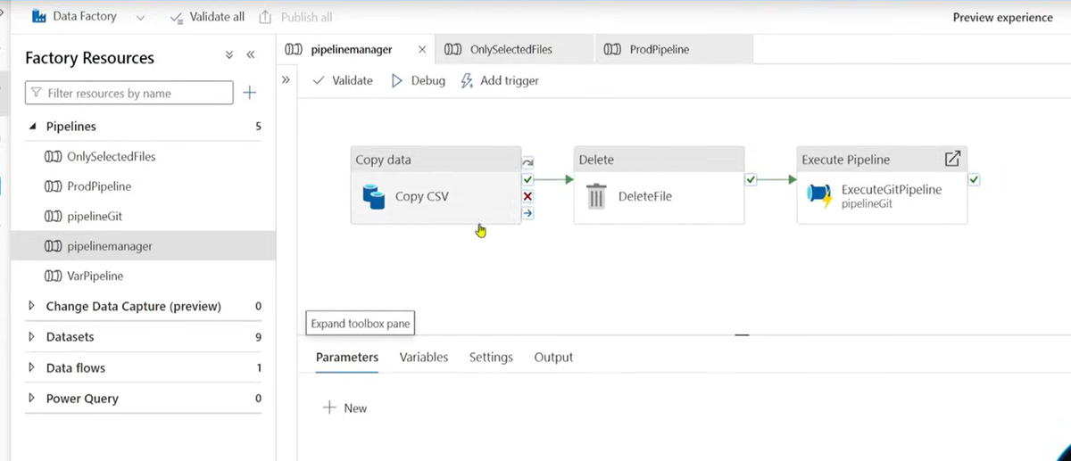

🎯 Interview Scenario: "What does your master pipeline do?"
pipelinemanager copies the CSV, deletes the source file (so it doesn't reprocess it), then calls pipelineGit as a child pipeline using Execute Pipeline activity.

2. OnlySelectedFiles — The Smart File Picker
This pipeline validates, reads metadata, loops through files, and runs a data transformation. Full ETL flow:
▸ FilesValidation → Validation activity checks file exists before processing
▸ Get Metadata → gets childItems (list of files) from folder
▸ ForEachCSV → loops over each file using @item().name
▸ Data Transformation → runs a Data Flow activity for each file

📸 OnlySelectedFiles — Validation → GetMetadata → ForEach → Data Flow
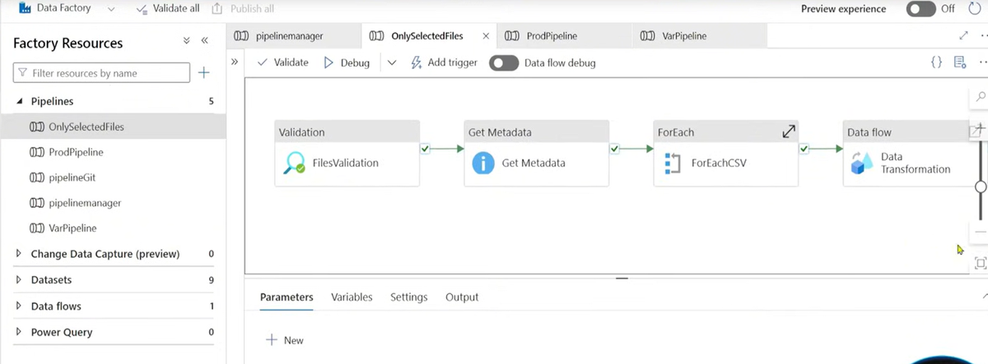

Validation Activity (bonus): Validates that a file/path actually exists before pipeline proceeds. Avoids failures on missing files. Acts like a pre-check gate.

3. ProdPipeline — The Production Orchestrator
This is the production-level parent pipeline. It has two Execute Pipeline activities chained:
▸ ExecuteManagerPipeline → runs pipelinemanager first (copies + cleans up files)
▸ ExecuteOnSelected → runs OnlySelectedFiles next (validates + transforms)
This is a master-of-masters pattern — one trigger on ProdPipeline runs the full end-to-end flow.

📸 ProdPipeline — Executes pipelinemanager → then OnlySelectedFiles
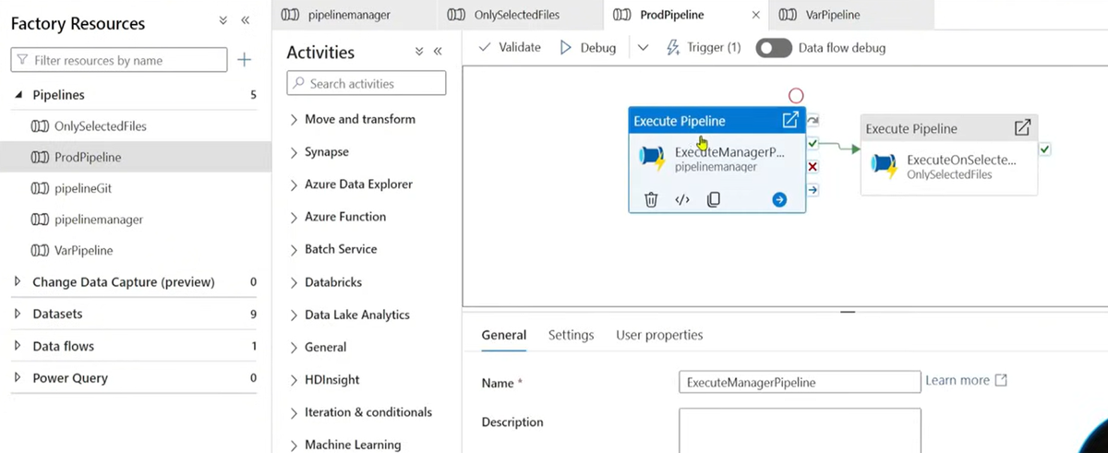

Why chain Execute Pipeline activities? Clean separation of concerns. Each child pipeline can be tested/run independently. ProdPipeline just orchestrates. Easier to debug — if step 2 fails, step 1 is confirmed done.

4. VarPipeline — The Variable Demo Pipeline
This is the pipeline you were confused about! VarPipeline demonstrates how to use Set Variable activity in practice.

What VarPipeline does:
Step 1 — Get Metadata activity runs on the Blob Storage folder and fetches the list of files (childItems array).
Step 2 — Set Variable activity (named "StoreFiles") takes the output of Get Metadata and stores the childItems array into a pipeline variable called var_files.
Purpose: Now any later activity (ForEach, If Condition, etc.) can use @variables('var_files') instead of writing the long @activity('GetMetadata').output.childItems expression every time. Cleaner and reusable.

📸 VarPipeline — Get Metadata → StoreFiles (Set Variable storing childItems)
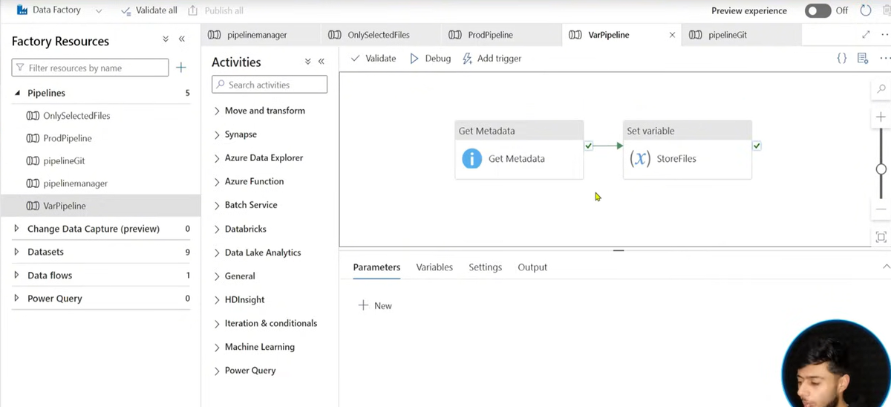

// Without VarPipeline approach (messy):
ForEach → Items: @activity('GetMetadata').output.childItems
If Condition → @greater(length(activity('GetMetadata').output.childItems), 0)

// With VarPipeline approach (clean):
Set Variable "var_files" = @activity('GetMetadata').output.childItems

ForEach → Items: @variables('var_files')
If Cond → @greater(length(variables('var_files')), 0)

🎯 Interview Scenario: "Why did you create a separate VarPipeline?"
To demonstrate the Set Variable pattern — instead of repeating @activity().output.childItems in every activity, we store it once in var_files. This makes the pipeline cleaner, reusable, and easier to debug.

🎯 ADF Interview Cheat Sheet
Most asked questions + one-line answers — read this before your interview

Integration Runtime (IR) — Must Know
IR is the compute infrastructure that ADF uses to run activities and move data. Think of it as the engine that actually does the work.

IR Type | What it is | When to use
Azure IR | Managed cloud compute — fully serverless | Cloud-to-cloud data movement (Blob → SQL)
Self-hosted IR | Software installed on your on-prem/VM server | On-premise SQL, file shares behind firewall
Azure-SSIS IR | Managed cluster to run SSIS packages | Lift-and-shift legacy SSIS ETL to cloud

🎯 Interview Scenario: "How do you connect ADF to an on-premise SQL Server?"
Install Self-Hosted Integration Runtime on a server in the on-prem network. Register it in ADF. Create a Linked Service using SHIR as the connect-via option. ADF tunnels through SHIR to reach on-prem SQL.

Monitoring & Debugging — Quick Points
▸ Monitor tab → see all Pipeline Runs, Trigger Runs, Activity Runs
▸ Rerun a failed pipeline run directly from Monitor — no need to retrigger
▸ Activity output/error visible by clicking the activity run row
▸ Debug mode → runs pipeline without publishing, uses debug settings
▸ Tumbling Window failed runs → can rerun specific windows only
▸ @activity('name').output → access any activity's output in expressions

Interview tip: Always mention you use the Monitor tab to check failed runs. Mention activity-level error messages, not just pipeline-level. Shows you actually work with ADF.

Key Expressions Cheat Sheet
// Activity output
@activity('GetMetadata').output.childItems → array of files
@activity('GetMetadata').output.exists → true/false
@activity('GetMetadata').output.size → file size

// Variables
@variables('var_files') → stored variable value

// Parameters
@pipeline().parameters.sourceFolder → pipeline param
@dataset().fileName → dataset param

// ForEach item
@item() → current loop element
@item().name → filename in loop

// Trigger info
@trigger().outputs.windowStartTime → tumbling window start
@triggerBody().fileName → storage event file name
@triggerBody().folderPath → storage event folder

// Useful functions
@concat(variables('folder'), '/', item().name) → build dynamic path
@formatDateTime(utcNow(), 'yyyy-MM-dd') → today's date string
@greater(length(variables('var_files')), 0) → array not empty?
@pipeline().RunId → unique run ID

Top 10 ADF Interview Q&A

Q1: What is the difference between Copy Activity and Data Flow?
→ Copy Activity moves data as-is with no transformation (fast, simple). Data Flow uses Spark clusters to transform data — filter, join, aggregate, derive columns. Use Copy for simple loads, Data Flow for complex ETL.

Q2: How do you process multiple files dynamically without hardcoding?
→ GetMetadata (childItems) → Set Variable → If Condition (count > 0) → ForEach → Copy Activity with parameterised dataset where fileName = @item().name.

Q3: Tumbling Window vs Schedule Trigger — difference?
→ Schedule fires at fixed times but cannot backfill missed runs. Tumbling Window tracks each time window separately, supports backfill of historical windows, and exposes @trigger().outputs.windowStartTime.

Q4: What is a Linked Service vs Dataset?
→ Linked Service = connection string/credentials (WHERE to connect). Dataset = specific table/file inside that source (WHAT to pick). Dataset always references a Linked Service.

Q5: What is Self-Hosted Integration Runtime?
→ Software installed on an on-prem or VM server that acts as a bridge between ADF and resources behind a firewall. Required for on-premise SQL Server, file shares, or private network sources.

Q6: How do you avoid pipeline failure if source file is missing?
→ Use GetMetadata → check @activity('GetMeta').output.exists == true in an If Condition → only run Copy in the True branch. False branch can send an alert or log the miss.

Q7: What is a parameterised dataset and why use it?
→ A dataset with parameters (e.g. fileName) that can be set dynamically at runtime. Instead of 12 datasets for 12 files, use 1 dataset and pass the filename from ForEach's @item().name.

Q8: What is the difference between Pipeline Parameter and Pipeline Variable?
→ Parameter: passed FROM OUTSIDE (trigger/parent), read-only, set before run. Variable: created INSIDE pipeline, read-write, updated during run using Set Variable activity.

Q9: How do you trigger a pipeline automatically when a file lands in Blob?
→ Storage Event Trigger. Set container + Blob path filter (begins with / ends with). Event = Blob Created. Use @triggerBody().fileName inside pipeline to get the triggering filename.

Q10: What is Execute Pipeline activity used for?
→ Calls a child pipeline from a parent pipeline. Enables modular design. Can run synchronously (wait for child to complete) or asynchronously (fire-and-forget). Parameters can be passed to child.

🚀 You've Got This!
Covered: Storage Redundancy • Linked Service • Dataset • Activities
Triggers • Variables vs Parameters • Execute Pipeline • Data Flow
Integration Runtime • Top 10 Q&A • Expression Cheat Sheet

