🎵
Spotify Data Engineering Project
End-to-End Azure Medallion Architecture

Azure SQL • Azure Data Factory • ADLS Gen2 • Azure Databricks • Logic Apps
Autoloader • SCD Type 2 • Jinja2 • DLT Pipelines • Unity Catalog

📦 Bronze → 🥈 Silver → 🥇 Gold
Incremental CDC Ingestion | Autoloader Streaming | SCD Type 2 | Star Schema

📂 GitHub Repository
github.com/ruchika123yadav/Spotify-Data-Engineering-Project

📋 Project Overview

🎯 What This Project Does
This project simulates a real-world data engineering pipeline at a music streaming company like Spotify. The business problem being solved is straightforward but surprisingly tricky in practice: every day, hundreds of thousands of new user streams, song plays, and account updates land in the operational database. The analytics team needs this data in a clean, modelled form — fast — so that dashboards, reports, and machine learning models stay fresh. But you cannot afford to re-process the entire historical dataset every single day, because that would be slow, expensive, and pointless when 99 percent of the data hasn't changed.
The solution implemented here is a full end-to-end pipeline on Microsoft Azure that handles this elegantly. The pipeline pulls only NEW or CHANGED records from the source Azure SQL Database (this is called Change Data Capture, or CDC), drops them into a Bronze layer in the data lake, then progressively cleans, joins, and models them through Silver and Gold layers using Databricks. The final output is a Star Schema with SCD Type 2 dimensions — the gold standard format for analytics.

🆚 How This Differs from the Uber Project
The Uber project from earlier was real-time event-driven: when a user clicks 'Book a Ride' in a web app, an event flies into Azure Event Hubs and the pipeline reacts to it immediately. The Spotify project takes a different and arguably more common approach in industry — incremental batch processing. Instead of reacting to live events, this pipeline runs on a schedule (every few hours or daily) and asks the source database: 'What's new since I last looked?' This pattern handles roughly 80 percent of real data pipelines in companies that aren't doing pure real-time streaming.

Aspect | Uber Project | Spotify Project
Source | Azure Event Hubs (live events) | Azure SQL Database (incremental batch)
Pattern | Real-time streaming | Incremental CDC ingestion
Ingestion Tool | ADF + Event Hub listener | ADF CDC pipeline (Last_CDC_Date logic)
Streaming Engine | DLT Streaming Tables | Databricks Autoloader (cloudFiles)
Schema mgmt | Manual schema in DLT | Autoloader schema evolution + RocksDB
Gold output | Star Schema from OBT | SCD Type 2 via dlt.create_auto_cdc_flow
Alerting | None | Logic Apps → Email on pipeline pass/fail
Project structure | Single pipeline | Databricks Asset Bundles (CI/CD ready)
Auth to ADLS | SAS Token (Community Edition) | Managed Identity (production-grade)

☁️ Azure Resources Used
Six Azure services work together to make this pipeline run. Each one was deliberately chosen to play a specific role — none of them are decorative, and removing any one breaks the architecture.
Resource | Purpose & Why This Choice
Azure SQL Database | The source system holding operational Spotify data. Chosen because Azure SQL is what most real businesses already use for OLTP workloads.
Azure Data Factory (ADF) | Orchestrates the CDC ingestion. ADF was picked over alternatives like Synapse Pipelines because it's the most mature and widely-used orchestration tool in the Azure ecosystem.
Storage Account (ADLS Gen2) | The data lake. Three containers — Bronze, Silver, Gold — implement the Medallion Architecture. ADLS Gen2 (not Blob Storage) is essential because it supports hierarchical namespaces and is optimized for analytics workloads.
Azure Databricks | The transformation engine. Runs Autoloader for Silver and DLT pipelines for Gold. Picked because it offers the smoothest Spark experience on Azure and tight integration with ADLS via Unity Catalog.
Access Connector | A small but critical resource that gives Databricks a Managed Identity to access ADLS. Without it, you'd have to embed SAS tokens or access keys in code — a major security anti-pattern.
Logic Apps | Lightweight serverless workflow tool. Used here to send alert emails when ADF pipelines succeed or fail. Picked over Azure Monitor because Logic Apps is simpler to wire up for basic email notifications.

🏗️ The Medallion Architecture — Why Three Layers?
Why not just dump the source data into one big table and transform it in place? Because in real data engineering, separation of concerns is everything. Each layer in the Medallion Architecture has exactly ONE job, and this separation is what makes pipelines debuggable, recoverable, and trustworthy.

Layer | Job | If Something Breaks Here
🟫 Bronze | Land raw source data as-is. No transformations. | You can re-pull from source. No data loss.
🥈 Silver | Clean, deduplicate, type-cast, stream into Delta tables | You can re-process from Bronze without re-querying source.
🥇 Gold | Model into Star Schema, apply SCD Type 2, build dimensions/facts | You can rebuild from Silver — the cleaned data is preserved.

Think of the Medallion Architecture as a kitchen. Bronze is the unwashed ingredients straight from the market. Silver is the chopped, cleaned, prepped mise en place. Gold is the finished plated dish ready to serve. If someone messes up the dish, you don't go back to the market — you go back to the prepped ingredients.

🏭 Part 1: Azure Data Factory — Incremental Ingestion Pipeline

📖 Introduction to the Ingestion Problem
Before diving into the pipeline mechanics, it's worth understanding WHY incremental ingestion matters so much in production. Imagine the Spotify operational database has 50 million streaming records accumulated over five years. A naive full-load pipeline would read all 50 million records every single day, write them to the data lake, then have Databricks process all 50 million through every downstream layer. That's slow (potentially hours of compute), expensive (Spark clusters are billed by the minute), wasteful (99.99% of the data hasn't changed since yesterday), and brittle (one bad row in the historical data could crash the whole pipeline every single day).
The incremental approach flips this on its head. Each pipeline run asks the source database one simple question: 'Give me only the records you've added or changed since I last asked.' If 200,000 new streams happened yesterday, the pipeline processes 200,000 records — not 50 million. This is the foundational pattern behind almost every production data pipeline.

🧠 The Core Concept: CDC (Change Data Capture)
Key Idea: Every pipeline run asks 'What's new since my last run?' — not 'Give me everything'. This is what makes pipelines efficient, fast, and cost-effective in production.

CDC stands for Change Data Capture, and there are several ways to implement it. The most sophisticated approach uses database-level CDC features (like SQL Server's Change Tracking or Debezium for log-based CDC), but those require special database permissions and infrastructure. The approach used in this project is simpler and works with any database that has a date/timestamp column: a watermark-based CDC.
The watermark in this project is called Last_CDC_Date. It's a single date value stored in a JSON file in the Bronze container. The logic goes like this: 'I last successfully processed records up to date X. Give me everything after X. Once I'm done, update X to the maximum date I just saw.' Simple, durable, and works across any source system. The trade-off is that it can only detect inserts and updates that touch a timestamp column — it cannot detect deletes. For pure analytics use cases (like Spotify streaming analytics), this is usually fine.

🔧 Pipeline: incremental_ingestion — Step-by-Step Deep Dive
The pipeline is named incremental_ingestion in ADF. It is composed of four main activities chained together, plus a conditional branch at the end, plus a ForEach wrapper around everything for scalability. Each component has a specific purpose that's worth understanding in detail.

Step 1 — Lookup Activity: Read the Watermark
The Lookup activity is ADF's way of reading a small piece of data from a source and storing it in pipeline memory for use in subsequent activities. Here, it points to the CDC.json file stored in the Bronze container of ADLS Gen2 and reads out the Last_CDC_Date value.
What CDC.json looks like — and why it matters
On the very first pipeline run: Last_CDC_Date = '1990-01-01'
Why 1990? Because we want the first run to pick up ALL historical data — and no Spotify record exists before 1990
After run 1 completes successfully: Last_CDC_Date gets updated to the max date of records just loaded
On run 2: it might be '2024-03-15T08:00:00Z' — so run 2 only picks up records newer than that
This single file is the entire pipeline's memory between runs — it's the 'bookmark' that prevents reprocessing
Storing it in ADLS (not in a database) means it survives across pipeline restarts, region failures, and ADF outages

Why store the watermark in a JSON file in ADLS instead of a SQL Server table? Because the pipeline should not have a circular dependency on the same database it's pulling from. If the source SQL Database goes down, you should still be able to inspect, debug, and reset your watermark. Keeping the watermark in ADLS makes the pipeline more resilient and self-contained.

Step 2 — Set Variable: Capture Current Timestamp
Immediately after reading the old watermark, the pipeline captures the CURRENT timestamp into a pipeline variable. This timestamp will become the new Last_CDC_Date after the run completes. You might wonder: why not just capture the timestamp at the END of the run? Because of a subtle but important race condition.
The Race Condition Set Variable Prevents
Imagine the pipeline starts at 08:00:00 and takes 30 minutes to complete (finishes at 08:30:00)
Between 08:00 and 08:30, new records are still being inserted into the source SQL DB
If we capture the timestamp at the END (08:30) and use THAT as the new watermark...
...then any records inserted at 08:15 might get MISSED by the current run (because of timing)
...AND skipped by the next run (because they're before the 08:30 watermark)
By capturing the timestamp at the START (08:00) and using THAT as the new watermark...
...records inserted at 08:15 are guaranteed to be picked up by the next run
Small detail, massive correctness implication — this is the kind of thing senior data engineers obsess over

Step 3 — Copy Activity: Dynamic SQL Query
The Copy Activity is the workhorse of ADF — it moves data from a Source to a Sink. In this pipeline, it's configured with Linked Services for Azure SQL Database (Source) and ADLS Gen2 (Sink). The magic is in the dynamic SQL query, which uses ADF expressions to inject the Last_CDC_Date variable at runtime.
-- Dynamic SQL used in ADF Copy Activity (Source)
SELECT * FROM @{item().table_name}
WHERE updated_at > '@{variables('Last_CDC_Date')}'

-- At runtime, ADF substitutes the values:
-- SELECT * FROM DimUser WHERE updated_at > '2024-03-15T08:00:00Z'

-- CDC.json structure (Bronze container config file)
{
"Last_CDC_Date": "2024-03-15T08:00:00Z",
"pipeline_run_id": "abc-123-def",
"table_name": "factStream"
}
The output of this Copy Activity is one or more Parquet files in the Bronze container. Parquet is chosen over CSV because it's columnar, compressed, and includes schema information — Spark can read it 5-10x faster than CSV for analytics queries.

Step 4 — Conditional Path (True / False Branches)
After the Copy Activity finishes, the pipeline branches based on whether new data was actually copied. This conditional logic is what separates a hobby pipeline from a production-grade one — it handles the edge case where no new data exists, and it ensures the watermark only advances when there's something to advance to.

Condition | What Happened | Action Taken
✅ True — Data was copied | New records found and loaded into Bronze | A second Copy Activity updates CDC.json with the new Max_CDC_Date
❌ False — No new data | No records matched the filter | A Delete Activity cleans up any empty/temp files left in the container

The True path is where the magic happens. It takes the MAX(updated_at) from the newly-copied data and writes it back to CDC.json. Now the watermark has advanced, and the next run will pick up from this new position. The False path is hygiene — even when no rows are copied, ADF sometimes creates a zero-byte placeholder file in the destination container. Over time, these accumulate and clutter the data lake. The Delete Activity removes them so the Bronze container stays clean.

🔁 Scalability: ForEach Loop + Array Parameter
So far we've described the pipeline as if it handles one table. In reality, the Spotify project has five tables to ingest: DimUser, DimArtist, DimTrack, DimDate, and FactStream. The naive approach would be to copy-paste the pipeline five times, one per table. This is terrible practice — five times the code to maintain, five places to update if the logic changes, five potential places for bugs.
Pattern: Instead of building one pipeline per table, ONE pipeline handles ALL tables by iterating over an array of table names. Add a new table → add to the array. Zero code change required.

How the ForEach + Parameter pattern works
An Array Parameter is created containing all table names: ['DimUser', 'DimArtist', 'DimTrack', 'DimDate', 'FactStream']
The entire Lookup → SetVariable → Copy → Conditional chain is wrapped inside a ForEach Activity
ForEach passes the current table name as @{item()} into the Copy Activity's dynamic SQL
Each iteration processes one table independently — and ForEach can run them in PARALLEL (configurable)
Add a new table? Just add its name to the array parameter — no pipeline logic changes
This is called Metadata-Driven Pipeline Design — the SAME concept used in the Uber project's ADF pipeline

This pattern is so important in real-world data engineering that it has a name: 'Metadata-Driven Architecture'. The idea is that the LOGIC of your pipeline lives in code, and the CONFIGURATION (what tables, what columns, what schedules) lives in metadata (files, JSON configs, database tables). Done well, business analysts can onboard new data sources without ever touching pipeline code.

📬 Logic Apps — Pipeline Alerting
A pipeline that runs silently in production is a dangerous pipeline. If it fails at 3 AM and nobody knows until 9 AM when someone notices the dashboard is stale, you've already lost six hours. Logic Apps was integrated into this project specifically to solve this problem — every pipeline run, success or failure, fires off an email.
Email notifications on pipeline outcome
Logic App is wired to ADF as a webhook — ADF calls the Logic App URL on completion
On Pipeline SUCCESS: sends email with run details — rows copied, tables processed, timestamp
On Pipeline FAILURE: sends alert email with error message, failed activity name, run ID
Logic Apps was chosen over Azure Monitor because it's simpler for basic email workflows
For larger projects, Azure Monitor + Action Groups is more powerful (PagerDuty, Slack, SMS)
Real-world relevance: Pipeline owners MUST know immediately when something breaks — silence = downtime

Alerting fatigue is a real problem — if you send an email on EVERY pipeline run, people start ignoring them. A better pattern in production is: success emails go to a low-priority inbox or summary report, failure emails go to a high-priority inbox with on-call paging.

🔮 Part 2: Databricks Setup — Unity Catalog & External Locations

📖 Why Setup Matters Before Any Code
Most beginner Databricks tutorials skip straight to writing notebooks. That works for personal projects but is completely wrong for production. Before any data processing happens, you need a governance and access layer in place. This is the Unity Catalog — and skipping it means your tables have no permissions, no lineage, no audit trail, and no way to share data securely across teams.
Setting up Unity Catalog before writing any notebooks is the same as setting up Active Directory before letting people log into a company network. You wouldn't run a corporate IT environment without identity management — and you shouldn't run a Databricks workspace without Unity Catalog.

🗂️ Unity Catalog Hierarchy — The Mental Model
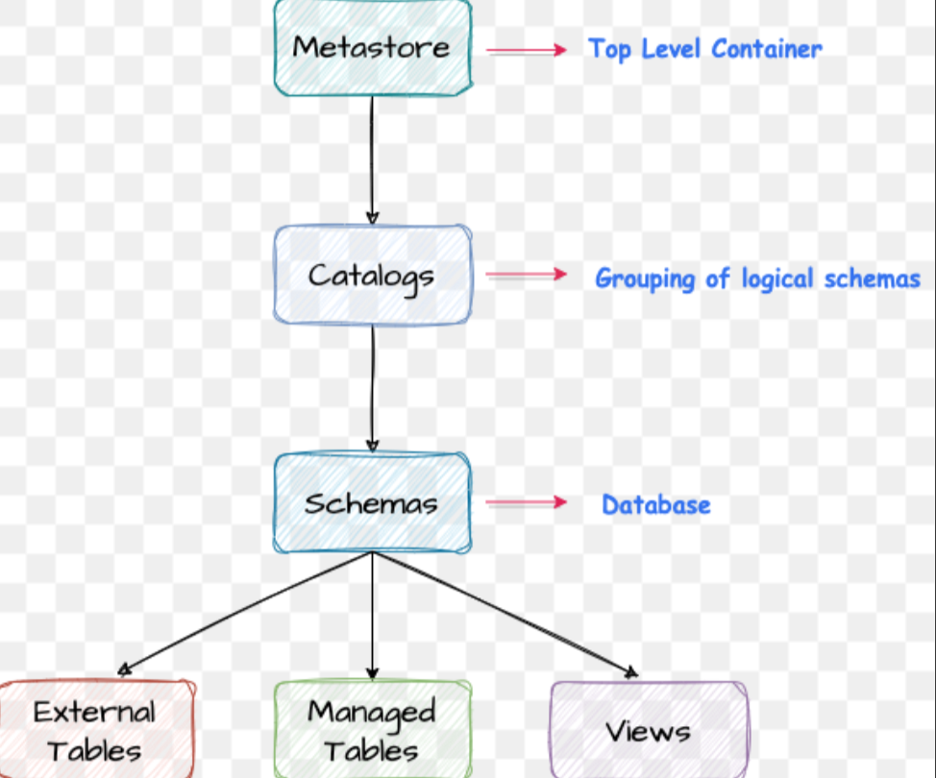
Unity Catalog: Metastore (top-level) → Catalogs → Schemas → Tables / Views / External Tables

Unity Catalog organizes everything in a strict four-level hierarchy. Understanding this hierarchy is critical because permissions, names, and references all follow this structure. A table is always accessed via the three-part name: catalog.schema.table — for example, spotify_cata.silver.DimUser.

Level | What It Is — Detailed Explanation
Metastore | The top-level container, one per Azure region per Databricks account. It holds all catalogs and is the root of permissions. In this project: spotify_metastore.
Catalog | Like a database server in traditional databases. Groups related schemas together. Created here: spotify_cata. Permissions can be granted at this level (e.g., 'finance team can read everything in finance_cata').
Schema | Equivalent to a database in traditional terminology. Contains tables, views, functions. In this project: silver schema, gold schema, etc. (Note: in some old docs, 'schema' is called 'database' — they mean the same thing.)
External Tables | Tables whose underlying DATA lives in ADLS Gen2 — Unity Catalog just stores the metadata pointer. DROP TABLE removes the pointer but keeps the data safe. Used here for all Spotify tables.
Managed Tables | Tables whose data is stored INSIDE Databricks-managed storage. DROP TABLE deletes both metadata AND data permanently. Use with caution.
Views | Virtual tables defined by saved SQL queries. Don't store data themselves — just present a view on top of underlying tables.

🔗 Access Connector — The Bridge to ADLS
Databricks runs in one Azure resource, and ADLS Gen2 runs in another. By default, they cannot talk to each other — Azure security boundaries are strict for good reason. To connect them, you need an authentication mechanism. There are three main options, and this project uses the most secure one.

Auth Method | Security Level | When to Use
Access Key | ❌ Low | Quick local testing — never production
SAS Token | ⚠️ Medium | When Managed Identity isn't available (e.g., Community Edition)
Managed Identity | ✅ High — Production standard | Always preferred in enterprise Azure environments

This project uses an Access Connector resource. The Access Connector is essentially a small Azure resource that owns a Managed Identity. You grant that Managed Identity the 'Storage Blob Data Contributor' role on the storage account, and then point Databricks at the Access Connector. Databricks now has a secure way to access ADLS without any keys, passwords, or tokens stored anywhere.

Why Managed Identity is the right choice
🔒 Zero credential exposure — no secrets/passwords stored in code or notebooks
🔄 Automatic rotation — Azure rotates the identity behind the scenes, no manual key rotation
📋 Built-in audit trail — every access shows up in Azure activity logs with the identity name
🚫 No secret leakage risk — even if a notebook is shared or committed to Git, no credentials leak
🏢 Enterprise compliance — passes SOC 2, HIPAA, PCI security audits out of the box
💡 Compare to Uber project: there we used SAS Token (Community Edition limitation) — here we use the proper enterprise pattern

In real Azure Data Engineer interviews, knowing the difference between Access Keys, SAS Tokens, Service Principals, and Managed Identity is a frequent question. The correct ranking from worst to best is: hardcoded Access Key < SAS Token < Service Principal with Key Vault < Managed Identity. Always default to Managed Identity when possible.

📍 External Locations — Mapping ADLS Paths
Once the Access Connector and credentials are configured, the next step is to register External Locations in Unity Catalog. An External Location is essentially a registered, permission-controlled pointer from Databricks into a specific path in ADLS. Any code in the workspace can use abfss:// paths to that location WITHOUT needing credentials — Unity Catalog handles the auth transparently.

External Location | ADLS Path Mapped
bronze_location | abfss://bronze@spotifystorageaccountru.dfs.core.windows.net/
silver_location | abfss://silver@spotifystorageaccountru.dfs.core.windows.net/
gold_location | abfss://gold@spotifystorageaccountru.dfs.core.windows.net/

Three External Locations are registered — one per Medallion layer. This isn't just for tidiness; it enables fine-grained access control. You could grant the Silver-layer team WRITE permission on silver_location but only READ on gold_location, and Unity Catalog enforces it. This is the kind of governance that's basically impossible to do with raw SAS tokens.

Once External Locations are set, ANY notebook or pipeline in the workspace can use abfss:// paths without credentials in the code — Unity Catalog handles auth transparently. This is the foundation of secure, governed data access.

📦 Databricks Asset Bundles (DAB) — Project Structure
In a beginner Databricks setup, all notebooks live in a flat workspace folder. Anyone can edit anything, there's no version control, and deployment to production is a manual copy-paste exercise. This breaks down completely once you have more than a couple of pipelines.
Databricks Asset Bundles (DAB) is Databricks' answer to this problem. It lets you structure a Databricks project like a real software project — with folders, version control (Git), reusable utilities, and CI/CD-driven deployment. This Spotify project uses DAB to organize everything cleanly.

spotifyProject — folder structure
spotifyProject/
├── databricks.yml ← DAB config: defines deployment targets, jobs
├── src/
│ ├── silver/ ← Silver layer notebooks (Autoloader per table)
│ │ ├── DimUser.py
│ │ ├── DimArtist.py
│ │ ├── DimTrack.py
│ │ ├── DimDate.py
│ │ └── FactStream.py
│ ├── gold/ ← Gold layer DLT pipeline files
│ │ ├── DimUser.py
│ │ ├── DimArtist.py
│ │ └── ... (one per table)
│ └── utils/
│ └── transformation.py ← Reusable transformation class (dropCol logic)
└── README.md

CI/CD note: with DAB, you can deploy this entire project to dev/staging/prod environments with a single command — `databricks bundle deploy --target prod`. This is what production data engineering teams use in 2024+. The author mentioned not completing the CI/CD asset bundle deployment piece — that's the natural next step for this project.

🥈 Part 3: Silver Layer — Autoloader Streaming

📖 The Silver Layer's Job
Once Bronze has the raw Parquet files dropped by ADF, the Silver layer's job is to pick them up, clean them, type-cast them, drop unnecessary columns, and write them out as proper Delta tables that downstream consumers can query. This sounds simple but has a hidden challenge: new files keep arriving in Bronze (every time ADF runs). How does Silver know which files are new and which have already been processed? Re-reading all files every time is wasteful and slow. Tracking it manually is error-prone.
This is where Autoloader comes in. Autoloader is Databricks' purpose-built solution for incrementally reading new files from cloud storage. It uses cloud-native file notification services, maintains its own internal bookmark of processed files, handles schema changes automatically, and is built on top of Spark Structured Streaming for fault tolerance and exactly-once semantics.

🚀 What is Autoloader — Deep Dive
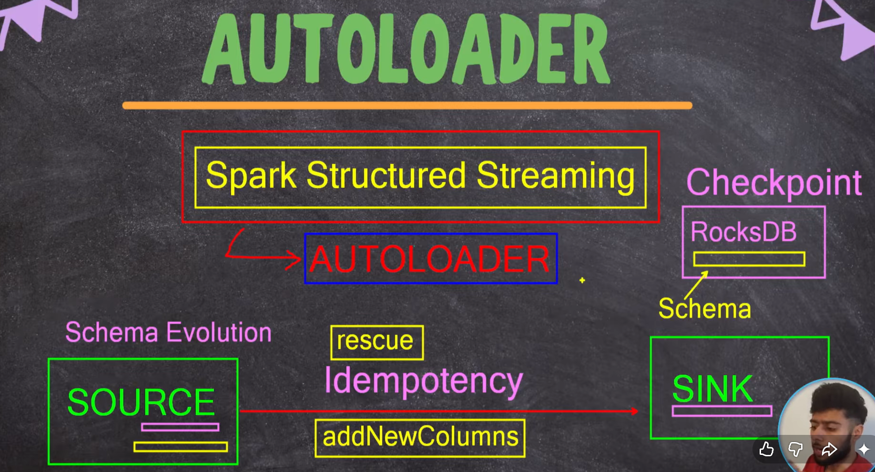
Autoloader is built on Spark Structured Streaming. SOURCE (Bronze files) → Autoloader (with Schema Evolution + Checkpoint in RocksDB + Idempotency) → SINK (Silver Delta tables)

Autoloader is invoked via the cloudFiles format in Spark. Under the hood, it does five distinct things, each one solving a real-world headache that data engineers used to handle manually.

Feature | What It Does & Why It Matters
Idempotency | Each file is processed EXACTLY once, even if the streaming job crashes and restarts. Built-in deduplication means no manual 'have I already processed this?' logic in your code.
Checkpoint (RocksDB) | Maintains an internal database (literally an embedded RocksDB instance) that tracks every file processed. Stored at the schemaLocation path. If the job dies and restarts an hour later, it resumes from EXACTLY where it left off.
Schema Inference | On first run, Autoloader looks at the source files and infers a schema. It then PERSISTS this schema at the schemaLocation so subsequent runs don't have to re-infer (which would be expensive).
Schema Evolution | If a new column appears in incoming files (e.g., 'subscription_plan' added to user data), Autoloader detects it and triggers a schema update. Options: ADD_NEW_COLUMNS (default), RESCUE, FAIL_ON_NEW_COLUMNS.
Schema Rescue | Unknown or unmapped columns are placed in a special _rescued_data column instead of being dropped. This means zero data loss on schema mismatch — bad data is captured, not silently discarded.
Spark Structured Streaming | Autoloader is essentially a smart wrapper around SSS. You get all SSS benefits — micro-batch processing, fault tolerance, end-to-end guarantees — without writing any of the boilerplate.

📂 Silver Container Folder Structure
For each table being processed by Autoloader, a specific three-folder structure is created in the Silver container. This isn't a random convention — each folder has a specific purpose and Autoloader expects exactly this layout.

Folder | Purpose
data/ | Contains the actual Delta table files — Parquet data files plus the _delta_log transaction log. This is what you query when you read the table.
checkpoint/ | Autoloader's internal state — the RocksDB database tracking which Bronze files have been processed. Never touch this manually.
display_checkpoint/ | A SEPARATE checkpoint for any display() calls run during development/debugging. Why separate? Because display() is interactive — you don't want it polluting the production checkpoint.
Example for the DimUser table: abfss://silver@.../DimUser/data/ holds the Delta files, abfss://silver@.../DimUser/checkpoint/ holds Autoloader's state, and display_checkpoint/ is for development queries. This structure is replicated for every Silver table: DimUser, DimArtist, DimTrack, DimDate, FactStream.

Why separate the checkpoint from the data? Because the checkpoint is metadata about processing state — it has nothing to do with the actual data. Mixing them would make it impossible to wipe/reset processing state without losing data, and vice versa.

💻 Actual Code: readStream with Autoloader
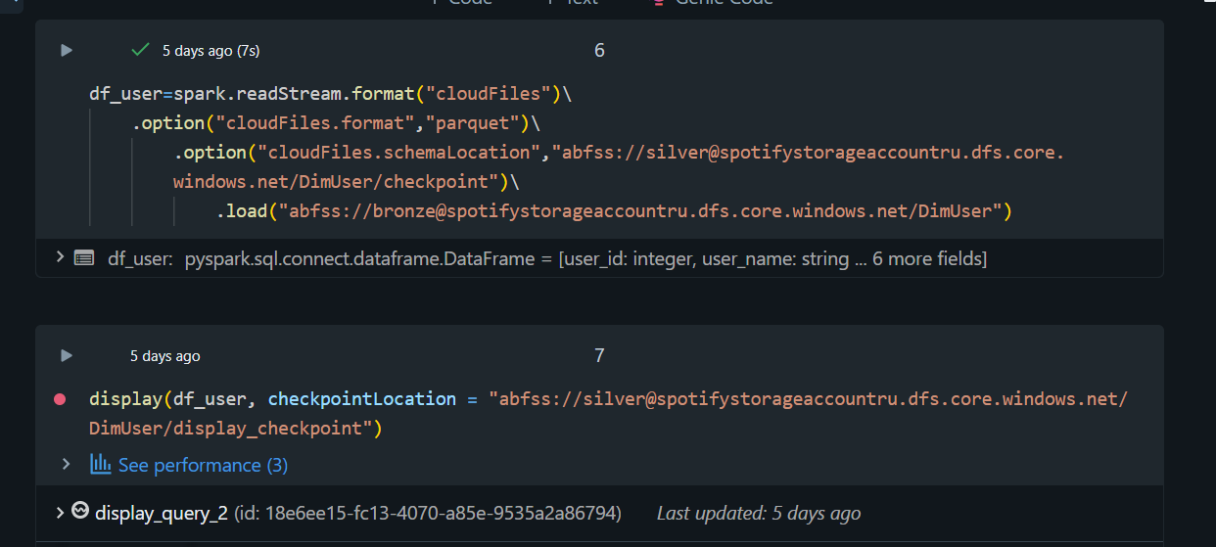
Databricks notebook cell: readStream with cloudFiles format, schemaLocation pointing to Silver checkpoint, loading from Bronze/DimUser. Note the inferred schema output.

The readStream call is where Autoloader is configured. Three options are critical: the format (cloudFiles), the source file format (parquet), and the schemaLocation (where Autoloader stores its checkpoint AND schema info). The .load() path is the Bronze table directory — Autoloader will watch this directory for new files.
# Autoloader readStream — DimUser table
df_user = spark.readStream.format("cloudFiles")\
.option("cloudFiles.format", "parquet")\
.option("cloudFiles.schemaLocation",
"abfss://silver@spotifystorageaccountru.dfs.core.windows.net/DimUser/checkpoint")\
.load("abfss://bronze@spotifystorageaccountru.dfs.core.windows.net/DimUser")
The result df_user is a streaming DataFrame. It's not materialized yet — Spark won't actually do anything until we call .writeStream() on it. The schema is inferred and shown in the cell output: user_id (integer), user_name (string), and 6 more fields.

Same pattern applied to DimArtist
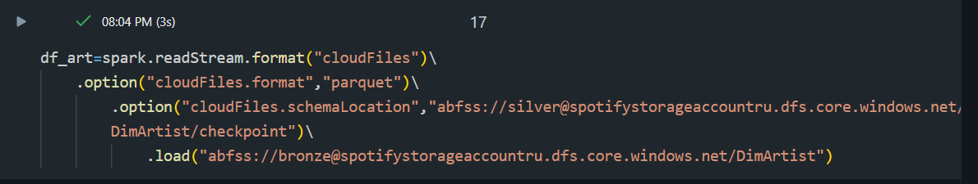
Same Autoloader pattern applied to DimArtist — exact same template, only the table name changes

Notice how the code is essentially identical between DimUser and DimArtist — just the table name changes. This is intentional. The repeatable template is what makes Autoloader so easy to scale: copy the pattern, swap the table name, done. In a more advanced setup, this would be parameterized so a single notebook handles all tables.

💻 Actual Code: writeStream with .toTable()
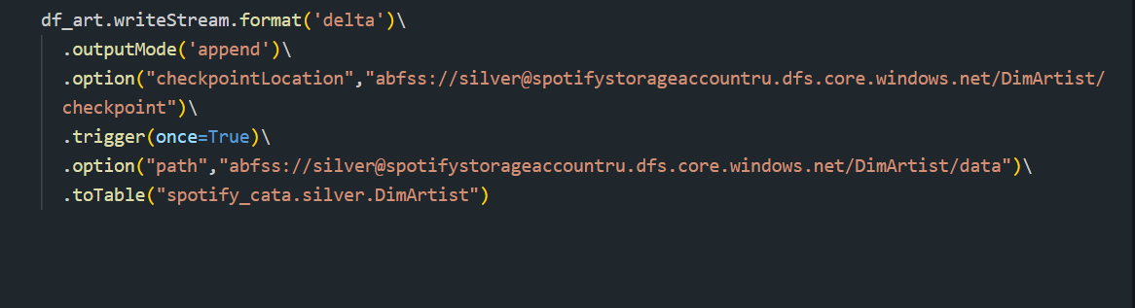
writeStream: delta format, append mode, checkpointLocation in Silver, trigger(once=True), and .toTable() registers the table in Unity Catalog as spotify_cata.silver.DimArtist

The writeStream call is where the streaming DataFrame actually becomes a stored table. Each option in this chain serves a specific purpose — none of them are decorative.
# writeStream — saves to ADLS Silver AND registers in Unity Catalog
df_art.writeStream.format('delta')\
.outputMode('append')\
.option('checkpointLocation', 'abfss://silver@.../DimArtist/checkpoint')\
.trigger(once=True)\
.option('path', 'abfss://silver@.../DimArtist/data')\
.toTable('spotify_cata.silver.DimArtist')

Option | What It Does
.format('delta') | Writes data in Delta Lake format — supports ACID transactions, time travel, schema enforcement
.outputMode('append') | Only appends new rows — doesn't update or delete existing rows. Other modes: complete, update.
.option('checkpointLocation', ...) | Where streaming progress is tracked. Without this, the stream cannot recover from crashes.
.trigger(once=True) | Process all available data and then STOP. This is micro-batch mode — runs once per pipeline execution.
.option('path', ...) | Where the actual Delta data files are stored in ADLS
.toTable('catalog.schema.table') | Registers the table in Unity Catalog so it can be queried by name from anywhere

Key insight: .toTable() does double duty — it WRITES the data to ADLS AND REGISTERS the table in Unity Catalog (spotify_cata.silver.DimArtist). No separate CREATE TABLE step needed. One line, two operations.

trigger(once=True) deserves special attention. This converts the streaming job from a continuously-running daemon into a one-shot batch job that processes all available files and exits. This is perfect for scheduled pipelines — you get all the benefits of streaming (checkpointing, schema evolution, idempotency) without the cost of running a 24/7 cluster.

🧰 utils/transformation.py — The Reusable Class Pattern
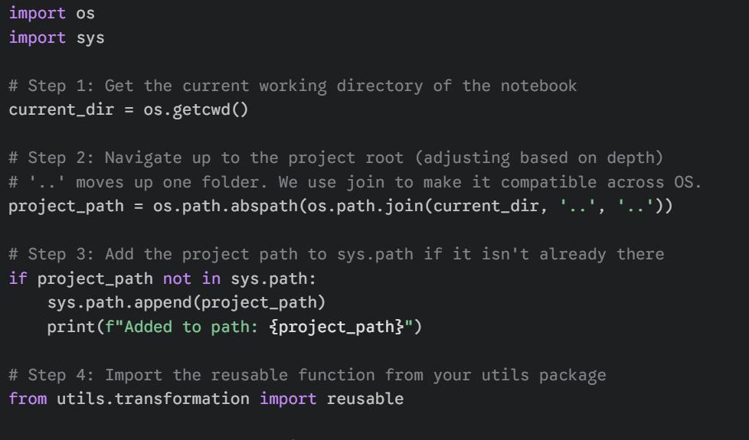
Utility import pattern: get current working directory, navigate up two folders to find project root, append to sys.path, then import the reusable transformation class

In a project with five tables, each having similar cleanup logic, there are two bad options and one good option. Bad option 1: copy-paste the transformation code into every notebook (5x maintenance burden). Bad option 2: write a Databricks Library and install it on the cluster (overkill for project-internal code). The good option: a utils package within the project that's importable from any notebook.
The transformation.py file contains a class called 'reusable' with methods like dropCol(). Any notebook can import and use it. The os.path / sys.path dance at the top of every notebook is what makes this work — it finds the project root by going up two directories from the current notebook location, then adds that to Python's import path.

# utils/transformation.py — Reusable transformation class
class reusable:
def dropCol(self, df, cols_to_drop):
"""Drop specified columns from a Spark DataFrame.

Args:
df: Spark DataFrame
cols_to_drop: list of column names to remove

Returns:
DataFrame with specified columns removed
"""
return df.drop(*cols_to_drop)

# In any silver notebook — import and use:
import os, sys
current_dir = os.getcwd()
project_path = os.path.abspath(os.path.join(current_dir, '..', '..'))
if project_path not in sys.path:
sys.path.append(project_path)

from utils.transformation import reusable

cleaner = reusable()
df_clean = cleaner.dropCol(df_user, ['_rescued_data', 'temp_col'])

This is exactly how production data engineering codebases are organized. The utils folder grows over time with more reusable methods — type casters, deduplicators, standardizers, etc. Every team eventually builds their own internal 'mini-framework' of reusable transformations.

📊 Tables Loaded in the Silver Layer
Five tables flow through the Silver layer. Four are dimension tables (relatively small, slowly-changing reference data) and one is a fact table (large, append-only, transactional).
Table | Description & Role
DimUser | User profile dimension — user_id, user_name, age, country, subscription_type, created_at, updated_at. Slowly changing data.
DimArtist | Artist dimension — artist_id, artist_name, genre, country, debut_year. Mostly static reference data.
DimTrack | Track dimension — track_id, track_name, artist_id, duration_ms, release_year, album. Static after release.
DimDate | Date dimension — date_id, date, day, month, year, quarter, is_weekend. Generated once, rarely updated.
FactStream | Fact table — stream_id, user_id, track_id, artist_id, streamed_at, duration_played_ms, device_type. Append-only, billions of rows over time.

🔗 Part 4: One Big Table — Jinja2 Metadata-Driven Joins

📖 Why Build an OBT in the First Place?
Once Silver tables are clean and queryable, an intermediate step is needed before the final Gold modelling: bringing all the relevant tables together into a single wide table called the OBT (One Big Table). The OBT joins FactStream with all the dimensions so that each row contains everything needed for analysis — user info, artist info, track info, date info, and the streaming event itself.
Building an OBT has trade-offs. The downside: it's wider and denormalized, which means more storage. The upside: downstream analytics queries don't need to do five-table joins for every report — they just query the OBT. For a streaming analytics workload like Spotify's, this is a worthwhile trade because read patterns dominate write patterns.

🎯 The Specific Problem Jinja2 Solves
Joining five tables in SQL is straightforward. The problem isn't writing one query — it's maintaining it over time. Imagine the data team adds DimDevice next month, then DimSubscription the month after, then DimGeography. Each new table means rewriting the join query, getting reviews, redeploying, and praying you didn't break anything. The repetitive structure of multi-table joins is begging to be templated.
Jinja2 is a Python templating engine — originally built for HTML templates in web frameworks like Flask. But it works perfectly for templating SQL too. The idea: write the join structure ONCE as a template, then describe each table as a config entry. The template renders the final SQL by iterating over the configs.

Without Jinja2 | With Jinja2
Write a new SQL JOIN for every new table added | Just add a new dict entry to jinja_config list
Risk of typos and inconsistencies in repeated SQL | Template renders the same pattern every time
Changing join logic = editing every query | Edit the template once — all joins update
Hard to review and audit all join conditions | Config file is a single source of truth
New team member must understand all SQL | New team member just learns the config format

⚙️ How the Jinja2 Template Works
The mechanism has two parts: a jinja_config list (the data) and a jinja_str template (the structure). The config describes WHAT to join; the template describes HOW to render it as SQL. Jinja2 then combines them to produce the final SQL query string, which Spark executes.

The jinja_config structure — one dict per table
Base table (first entry): {"table": "spotify_cata.silver.DimUser", "select": "DimUser.*", "where": "", "on": ""}
Joined table: {"table": "spotify_cata.silver.FactStream fs", "select": "fs.stream_id, fs.streamed_at",
"where": "", "on": "DimUser.user_id = fs.user_id"}
Another join: {"table": "spotify_cata.silver.DimArtist da", "select": "da.artist_name",
"where": "", "on": "fs.artist_id = da.artist_id"}
→ Template renders: SELECT DimUser.*, fs.stream_id, fs.streamed_at, da.artist_name
FROM DimUser
LEFT JOIN FactStream fs ON DimUser.user_id = fs.user_id
LEFT JOIN DimArtist da ON fs.artist_id = da.artist_id
→ Adding DimDate? Just add one more dict — template handles the rest. Zero SQL changes.

# jinja_str — the dynamic SQL template
jinja_str = """
select
{% for config in jinja_config %}
{{config.select}}
{% if not loop.last %} , {% endif %}
{% endfor %}
from
{% for config in jinja_config %}
{% if loop.first %}
{{config.table}}
{% else %}
left join {{config.table}} on {{config.on}}
{% endif %}
{% endfor %}
"""

# Render and execute
from jinja2 import Template
template = Template(jinja_str)
rendered_sql = template.render(jinja_config=jinja_config)
print(rendered_sql) # Debug — see what SQL was generated
df_obt = spark.sql(rendered_sql) # Execute the dynamically-built SQL

The template uses two Jinja2 control structures: {% for %} loops and {% if %} conditionals. Two special variables are key: loop.first (True only on the first iteration) and loop.last (True only on the last iteration). These are used to handle the special cases — no leading comma on the first SELECT, no LEFT JOIN on the first FROM table.

💡 This is the EXACT same principle as the ADF metadata-driven pipeline pattern from Part 1: write logic ONCE, extend through configuration. The same idea shows up in many forms across production data engineering — it's a fundamental design pattern.

Bonus: because rendered_sql is a printable string, you can run print(rendered_sql) during debugging to see exactly what SQL was generated. This makes Jinja2-based pipelines surprisingly easy to debug — much easier than complex DataFrame.join() chains in PySpark.

🥇 Part 5: Gold Layer — DLT Pipeline with SCD Type 2

📖 The Gold Layer's Purpose
By the time data reaches the Gold layer, it has been ingested incrementally (Bronze), streamed through Autoloader and cleaned (Silver), and joined into a wide intermediate format. The Gold layer's job is the final step: producing analytics-ready tables modelled as a Star Schema with proper history tracking. This is the layer that powers BI tools, dashboards, machine learning features, and any consumer-facing analytics product.
Crucially, the Gold layer uses Databricks DLT (Delta Live Tables) — a declarative framework that handles the heavy lifting of dependency management, retries, schema management, and incremental processing. The entire Gold layer runs inside a DLT pipeline named gold_pipeline.

⚡ Why DLT for Gold (and not for Silver)?
A subtle but important design choice in this project: Silver uses raw Autoloader, while Gold uses DLT. Why the split?
Layer | Choice
Silver | Raw Autoloader (no DLT)
Gold | DLT (Delta Live Tables)

In a production refactor, even Silver could move to DLT. The reason it's done with raw Autoloader here is partly for educational clarity — showing the underlying mechanisms — and partly because Silver has fairly straightforward append logic where DLT's overhead isn't worth it. Gold has complex SCD2 history tracking, which DLT handles brilliantly out of the box.

🖥️ gold_pipeline — Actual Databricks DLT Code
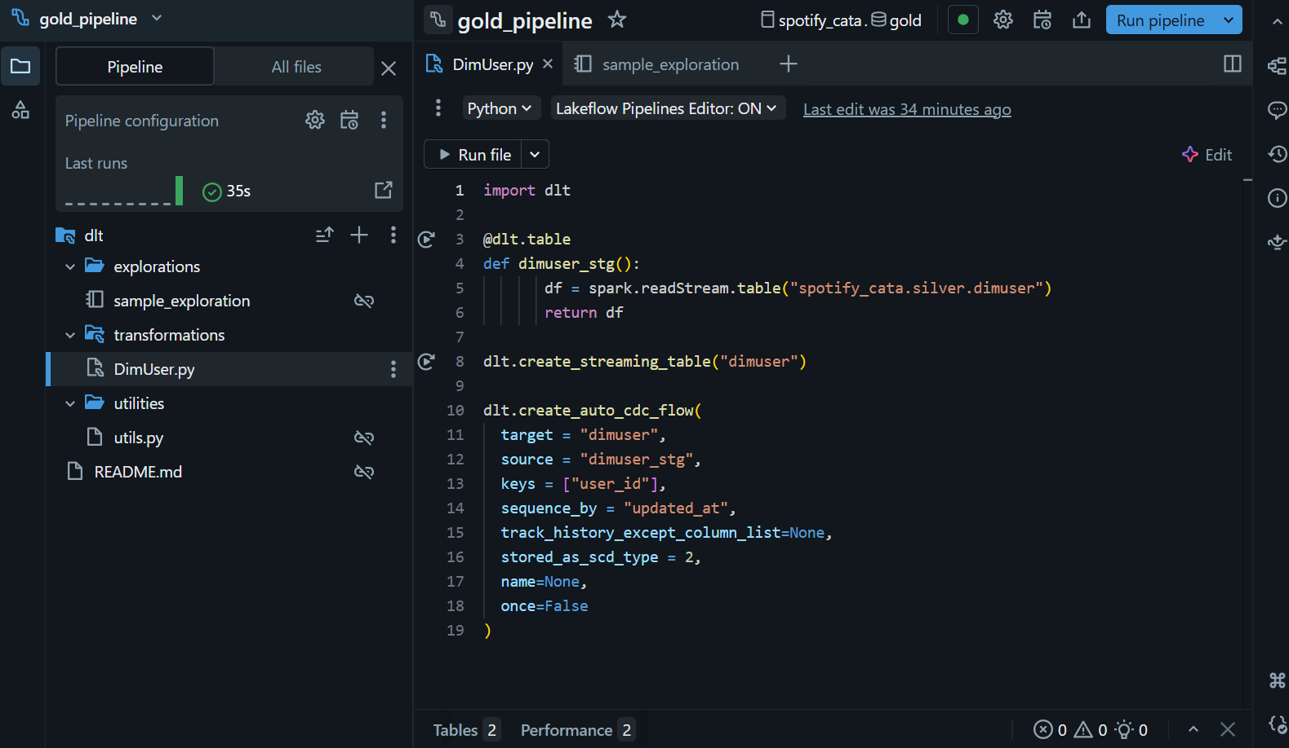
gold_pipeline in Databricks: DimUser.py showing @dlt.table decorator, readStream from silver.dimuser, dlt.create_streaming_table, and dlt.create_auto_cdc_flow with SCD Type 2 configuration

The screenshot shows the actual DimUser.py file inside the gold_pipeline. The structure is consistent for every Gold dimension table — and it's worth walking through each section because every line is doing something meaningful.
# gold/DimUser.py — Gold pipeline DLT table with SCD Type 2
import dlt

# Step 1: Define a staging streaming table from Silver
@dlt.table
def dimuser_stg():
df = spark.readStream.table("spotify_cata.silver.dimuser")
return df

# Step 2: Declare the target streaming table
dlt.create_streaming_table("dimuser")

# Step 3: Apply Auto CDC flow with SCD Type 2
dlt.create_auto_cdc_flow(
target = "dimuser",
source = "dimuser_stg",
keys = ["user_id"],
sequence_by = "updated_at",
track_history_except_column_list = None,
stored_as_scd_type = 2,
name = None,
once = False
)

Parameter | What It Means
target | The Gold dimension table name — where SCD history will be maintained
source | The staging table feeding the CDC flow — typically a streaming view of Silver
keys | Natural key columns identifying the same entity across changes (user_id here)
sequence_by | Column DLT uses to order changes (always pick a monotonic timestamp like updated_at)
track_history_except_column_list | If None: track changes on ALL columns. Otherwise: list columns to IGNORE for history.
stored_as_scd_type | 2 = full history (Type 2). 1 = overwrite only (Type 1, no history).
once | If True: run once and stop. If False: continue processing new changes (streaming).

🔄 SCD Type 2 — Deep Dive into How History Is Tracked
Slowly Changing Dimension Type 2 is the gold standard for tracking changes to dimension data over time. The naming is industry-standard: there are SCD Types 0 through 7, but Type 1 and Type 2 are by far the most common in practice.

SCD Type | Behaviour | When to use
SCD Type 0 | Never changes — fixed at insert. Reject all updates. | Truly immutable data (e.g., birth date, original signup date)
SCD Type 1 | Overwrites old value — no history kept | When history doesn't matter (e.g., fixing a typo)
SCD Type 2 | Adds new row with new value; old row marked closed | When full change history MUST be preserved ✅ Used here
SCD Type 3 | Adds a 'previous value' column | When you only need to track ONE level of change
SCD Type 4 | History stored in a separate table | Large dimensions where history is queried rarely

How SCD Type 2 works step-by-step in this project
Each dimension table has hidden columns added by DLT: __START_AT, __END_AT, __IS_CURRENT
When a NEW user_id arrives → row inserted with __START_AT=now, __END_AT=NULL, __IS_CURRENT=True
When an EXISTING user_id arrives with a change (e.g., user changes country from India to USA):
→ The old row gets UPDATED: __END_AT=now, __IS_CURRENT=False
→ A new row is INSERTED with new value, __START_AT=now, __END_AT=NULL, __IS_CURRENT=True
Result: The same user_id has multiple rows — one per state in time — and you can time-travel queries
The 'keys' parameter (user_id) tells DLT which column to use for identifying 'same entity'
The 'sequence_by' parameter (updated_at) tells DLT how to ORDER changes when multiple updates arrive together

Example Query — Time Travel with SCD Type 2
-- Example: Query the full history for user 12345
SELECT user_id, country, __START_AT, __END_AT, __IS_CURRENT
FROM spotify_cata.gold.dimuser
WHERE user_id = 12345
ORDER BY __START_AT;

-- Result:
-- user_id | country | __START_AT | __END_AT | __IS_CURRENT
-- 12345 | India | 2023-01-01 | 2024-03-15 | false ← historical
-- 12345 | USA | 2024-03-15 | NULL | true ← current

-- Now: 'What country was user 12345 in on Feb 1, 2024?'
SELECT country FROM spotify_cata.gold.dimuser
WHERE user_id = 12345
AND '2024-02-01' BETWEEN __START_AT AND COALESCE(__END_AT, '9999-12-31');
-- Answer: India (because Feb 1 falls between the start/end of the historical row)

This kind of time-travel query is impossible without SCD Type 2. If you had used SCD Type 1 (overwrite), the 'India' value would have been lost the moment the user changed to 'USA'. SCD Type 2 is what lets the analytics team answer 'point-in-time' questions about historical state — critical for fraud detection, attribution analysis, and audit reports.

⭐ Gold Layer — Final Tables (Star Schema)
The Gold layer produces five tables forming a classic Star Schema: four dimension tables (DimUser, DimArtist, DimTrack, DimDate) surrounding one central fact table (FactStream). The fact table holds the measurable events; the dimensions hold the descriptive context.

Table | Type / Description
dimUser | Dimension + SCD Type 2 — user profiles with full change history (country, subscription, etc.)
dimArtist | Dimension + SCD Type 2 — artist data with change tracking (genre changes, country moves)
dimTrack | Dimension — track metadata, mostly static after release
dimDate | Dimension — date calendar table, generated once with full year ranges
factStream | Fact table — every streaming event with FKs to all dimensions; this is where the volume lives

💡 Why Star Schema and not 3NF? Star Schema is denormalized — readable, joinable, BI-friendly. 3NF is normalized — minimizes redundancy but requires complex joins. Analytics workloads almost always prefer Star Schema because READ patterns dominate WRITE patterns at this stage.

✅ Part 6: DLT Expectations — Data Quality as Code

📖 The Data Quality Problem
Every data engineer eventually learns this painful lesson: bad data WILL flow through your pipeline. A NULL where one shouldn't be. A negative duration_ms when streams should always be positive. A user_id that doesn't exist in DimUser. The question isn't whether bad data will arrive — it's what your pipeline does when it arrives.
The naive answer is to write defensive .filter() logic everywhere: df.filter(col('user_id').isNotNull()) and df.filter(col('duration_ms') > 0). This works mechanically but has three big problems. First, you have no visibility into HOW MUCH data got filtered out. Second, the filter logic is scattered across many notebooks, making it hard to audit. Third, you can't easily change policy — what if you want to start FAILING the pipeline on bad data instead of silently dropping it?
DLT Expectations solves all three problems. Expectations are declarative data quality rules attached to DLT tables. They're observable (every violation is logged and counted), centralized (defined right next to the table), and policy-flexible (you can choose between WARN / DROP / FAIL on violation).

📊 How Expectations Work — The Flow
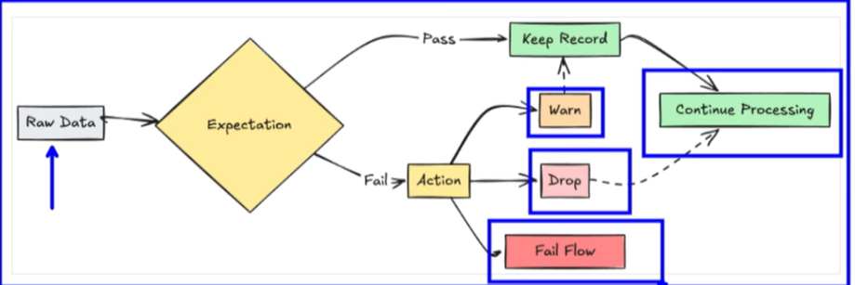
DLT Expectations flow: Raw Data → Expectation check → Pass: Keep Record | Fail → Action: Warn (continue), Drop (remove row), or Fail Flow (stop pipeline)

Every row arriving at a DLT table is evaluated against the expectations attached to that table. If the row passes, it's kept. If it fails, the configured Action determines what happens next. There are three possible actions, and choosing the right one is a real engineering decision.

Expectation Type | Behaviour on Failure | When to Use
@dlt.expect (WARN) | Logs violation in metrics, KEEPS the row, pipeline continues | Soft checks — you want to know about bad data but not block it
@dlt.expect_or_drop (DROP) | Removes the bad row from output, pipeline continues | Bad rows must be excluded but pipeline must still run (most common)
@dlt.expect_or_fail (FAIL) | Stops the entire pipeline immediately | Zero tolerance — any bad data means something is fundamentally wrong

# Example: Applying multiple DLT Expectations to a source table
import dlt

@dlt.table
@dlt.expect('valid_user_id', 'user_id IS NOT NULL') # WARN only
@dlt.expect_or_drop('valid_duration', 'duration_ms > 0') # DROP bad rows
@dlt.expect_or_fail('valid_track_id', 'track_id IS NOT NULL') # FAIL pipeline
def factstream_stg():
return spark.readStream.table("spotify_cata.silver.factstream")

💡 Why Expectations Beat Manual filter() Logic
The three big wins of Expectations over manual filtering
1. OBSERVABILITY: Every violation is recorded in the DLT event log with timestamp, rule name, count
→ You can query 'how many invalid rows did factstream see this week?' instantly
→ Manual filter() just silently drops rows — you have NO IDEA how much data you're losing
2. CENTRALIZED RULES: Expectations live as decorators on the table — easy to read, audit, update
→ A new team member sees ALL data quality rules in one place
→ Manual filters scattered across notebooks are nightmare to maintain
3. POLICY-FLEXIBLE: Change from WARN to DROP to FAIL by switching one decorator
→ No need to rewrite filter logic, no need to add throw-error blocks
→ A junior dev can flip the policy without touching the transformation code

Real-world tip: start every new pipeline with @dlt.expect (WARN-only) for all rules. Watch the metrics for a few days to understand the actual data quality. Then graduate the critical ones to @dlt.expect_or_drop or @dlt.expect_or_fail once you understand the patterns. Going straight to FAIL is a recipe for 3 AM pages.

🔍 What Gets Recorded in the Event Log
Behind the scenes, DLT writes an event log entry for every expectation violation. This event log is itself a queryable Delta table — you can run SQL queries against it to build data quality dashboards, alerts, and reports.
-- Query the DLT event log for expectation violations
SELECT
timestamp,
details:flow_progress.metrics.expectations.name AS expectation_name,
details:flow_progress.metrics.expectations.passed_records AS passed,
details:flow_progress.metrics.expectations.failed_records AS failed
FROM event_log(TABLE(spotify_cata.gold.dimuser))
WHERE event_type = 'flow_progress'
ORDER BY timestamp DESC;

🔄 End-to-End Data Flow Summary

📖 Putting It All Together
By now we've covered every component in isolation. This section ties them together — showing exactly how a single Spotify streaming event travels from the source database all the way to a queryable Gold table, and what happens at each step along the way.

🎯 Walkthrough: A Single Stream's Journey
Following one stream event end-to-end
T+0s: User 12345 plays a song. Application writes a row to Azure SQL DB's FactStream table.
→ updated_at = 2024-05-15 08:23:45
T+1h: ADF pipeline 'incremental_ingestion' triggers (hourly schedule).
→ Step 1 Lookup: reads CDC.json, finds Last_CDC_Date = 2024-05-15 07:00:00
→ Step 2 SetVariable: captures current time = 2024-05-15 09:23:00
→ Step 3 Copy: SELECT * FROM FactStream WHERE updated_at > '2024-05-15 07:00:00'
→ Our row IS included. Lands as Parquet in abfss://bronze/.../FactStream/
→ Step 4 True branch: updates CDC.json's Last_CDC_Date = 2024-05-15 09:23:00
→ Logic App fires: 'Pipeline succeeded' email sent
T+1h2m: Autoloader (running on a Databricks job) detects the new Parquet file.
→ readStream from bronze/FactStream picks up the new file via cloudFiles
→ Applies dropCol() to remove _rescued_data and any junk columns
→ writeStream appends to silver Delta table, registers as spotify_cata.silver.factstream
→ checkpoint folder updated to record this file as processed
T+1h5m: gold_pipeline (DLT) detects new rows in silver.factstream.
→ dimuser_stg() pulls latest user data; dlt.create_auto_cdc_flow applies SCD Type 2
→ If user 12345's country had changed since last run, a new SCD2 row is created
→ FactStream is joined/loaded into gold.factstream with FKs to gold.dimuser, gold.dimtrack
→ DLT Expectations validate: user_id NOT NULL ✓, duration_ms > 0 ✓, track_id NOT NULL ✓
T+1h6m: Stream event is now queryable in BI tool dashboards. Total latency: ~6 minutes.

This 6-minute end-to-end latency is achievable with this exact architecture in production. By tuning the ADF schedule (e.g., every 15 minutes) and making the Databricks job continuously triggered, this could be brought down to ~30 seconds. For tighter than that, you'd switch to true streaming with Event Hubs (like the Uber project).

📝 Quick Revision — Key Concepts

🎯 One-Liner Cheat Sheet
Concept | One-Line Summary
CDC (Change Data Capture) | Only fetch records newer than Last_CDC_Date — not the whole table on every run
ADF Lookup + SetVariable | Reads the checkpoint date, stores current run timestamp for next update
ForEach + Array Parameter | One pipeline handles ALL tables by iterating an array — add table → add to array
Logic Apps Alerting | Webhook triggers email on ADF pipeline pass/fail — no missed failures
Unity Catalog | Databricks governance layer: Metastore → Catalog → Schema → Tables
Managed Identity (Access Connector) | Zero-credential ADLS access — Azure handles auth, no secrets in code
External Locations | Maps abfss:// ADLS paths to Databricks-accessible endpoints
Databricks Asset Bundles | Structured project layout (src/silver, src/gold, utils) — CI/CD ready
Autoloader (cloudFiles) | Incrementally ingests new files from ADLS — idempotent, schema-aware
Checkpoint (RocksDB) | Tracks which files Autoloader has already processed — enables resume
Schema Evolution | Autoloader detects new columns and adds them to target schema automatically
Schema Rescue | Unmatched columns go to _rescued_data column — no data loss
.toTable() | writeStream method that both writes data to ADLS AND registers in Unity Catalog
trigger(once=True) | Process all available files then stop — micro-batch mode for scheduled pipelines
Jinja2 Template | Generates dynamic SQL joins from a config list — add tables without touching SQL
loop.first / loop.last | Jinja2 built-in variables for handling first/last iteration edge cases
SCD Type 2 | Keeps full history of dimension changes — old row closed, new row inserted
dlt.create_auto_cdc_flow | DLT method that automatically manages SCD Type 2 logic
keys parameter | Natural key for identifying same entity across changes (e.g., user_id)
sequence_by parameter | Column used to order changes chronologically (e.g., updated_at)
DLT Expectations | Built-in data quality rules: WARN / DROP / FAIL with observable metrics dashboard
@dlt.expect | Soft check — log violation, keep the row, pipeline continues
@dlt.expect_or_drop | Remove the bad row from output, pipeline continues
@dlt.expect_or_fail | Stop the entire pipeline on any violation — zero tolerance
Star Schema | Denormalized analytics model: central Fact table + surrounding Dimensions

🎤 Top Interview Questions — With Full Answers
Q1: What is CDC and why is it important?
CDC = Change Data Capture. Ingests ONLY new/changed records since last run — not full reload.
Saves compute cost, speeds up pipelines, avoids re-processing unchanged historical data.
Two main flavors: Log-based (reads DB transaction logs, e.g., Debezium) and Watermark-based (uses a date column).
This project uses watermark-based — simpler, works with any DB that has an updated_at column.

Q2: How does Autoloader differ from a regular spark.read?
spark.read is batch — reads ALL files matching the path every time you call it.
Autoloader (cloudFiles) is streaming — only processes NEW files since last checkpoint.
Autoloader also handles schema evolution, idempotency, and exactly-once semantics out of the box.
trigger(once=True) makes it behave like a smart batch read — best of both worlds.

Q3: What is Unity Catalog and why use it?
Centralised governance layer for Databricks. One place to manage all tables, permissions, lineage.
Hierarchy: Metastore → Catalog → Schema → Tables/Views.
Enables fine-grained access control, data lineage tracking, cross-workspace table sharing.
Required for proper enterprise Databricks — alternative is the deprecated 'hive_metastore'.

Q4: What's the difference between Managed and External Tables?
Managed: Data stored inside Databricks-managed storage. DROP TABLE removes both metadata AND data.
External: Data lives in ADLS Gen2. DROP TABLE removes only the catalog pointer — data stays safe.
Production recommendation: use External tables for raw/intermediate data, Managed for short-lived staging tables.
This project uses External tables for all Bronze/Silver/Gold — data lives in respective ADLS containers.

Q5: Why SCD Type 2 over Type 1?
SCD Type 1 overwrites — you lose history. Old value is permanently gone.
SCD Type 2 inserts a new row, marks old row closed with end-date.
Needed when historical state matters — e.g., 'what subscription did this user have when they made this stream?'
Trade-off: more storage (multiple rows per entity) but enables point-in-time analytics.

Q6: How does Managed Identity differ from SAS Token / Access Key?
Access Key: master credential, full control, must rotate manually, easy to leak. AVOID in production.
SAS Token: time-limited, scoped credential — better than Access Key but still a secret to manage.
Managed Identity: Azure-managed authentication — no secret stored anywhere. Auto-rotated by Azure.
Ranking: Access Key < SAS Token < Service Principal + Key Vault < Managed Identity. Always default to MI.

Q7: What is a Databricks Asset Bundle?
Structured project layout for Databricks code (src/, utils/, configs) — like a Python package or npm project.
Defines deployment via databricks.yml — describes jobs, clusters, target environments.
Supports CI/CD: 'databricks bundle deploy --target prod' pushes everything from Git to production workspace.
Replaces the old 'workspace-only' Databricks development model — brings software engineering best practices.

Q8: What's the difference between DLT and regular Spark Structured Streaming?
Regular SSS: imperative — you manage checkpoints, schema, retries, dependencies between tables.
DLT: declarative — you declare @dlt.table and the engine handles everything else.
DLT also adds: Expectations (data quality), automatic dependency DAG, visual lineage UI, auto-CDC flows.
Use raw SSS when you need full control. Use DLT when you have multi-table pipelines with quality rules.

Q9: Why use Jinja2 for SQL generation instead of just PySpark DataFrame joins?
PySpark joins work fine for 2-3 tables but become unreadable with 5+ tables and complex conditions.
Jinja2 lets you describe joins as config (data), then render to SQL. Easier to review and audit.
SQL is also faster — Catalyst optimizer can optimize the WHOLE query, vs DataFrame chains that may not fuse.
Bonus: print(rendered_sql) makes debugging trivial — you see exactly what SQL was generated.

Q10: What's the architecture difference between this project and the Uber project?
Uber project: real-time event-driven via Event Hubs. New rides arrive as events, processed immediately.
Spotify project: incremental batch via ADF CDC. New records picked up on schedule (hourly/daily).
Both end in Star Schema, but the ingestion paradigm is fundamentally different.
Uber: latency seconds, complexity high. Spotify: latency minutes-hours, complexity moderate.
In real-world, 80% of pipelines look like Spotify (batch CDC) — pure real-time is the exception.

