How can I run all the table at the same time in the data factory?
Logic apps in data factory it will create a trigger whenever there is a failure
web activity
ARM template for the whole code of ADF and parameters also which is used inside the ADF

DataBricks:
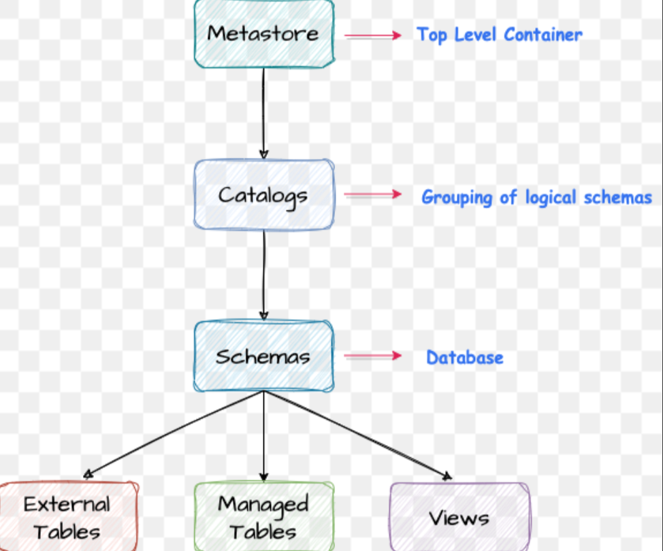
Question 1: "How does Unity Catalog simplify the management of multiple Databricks workspaces compared to the traditional Hive Metastore approach?"
Answer: Before Unity Catalog, each Databricks workspace was an "island." If you had three workspaces (Dev, Test, Prod), each had its own local Hive Metastore and its own Managed Storage Account (DBFS).
- The Problem: This created a "mess" of silos. To share data from Workspace A to Workspace B, you had to deal with complex mount points, service principals, and redundant storage accounts.
- The Unity Catalog Solution: Unity Catalog introduces a single, centralized Metastore that sits above the workspace level. Instead of every workspace having its own storage bucket, you create one Centralized Managed Storage location, assign it to the Unity Metastore, and then link all your workspaces to that one Metastore.

Question 2: "What is the concept of a 'Metastore' in Unity Catalog, and how does it relate to storage?"
Answer: In Unity Catalog, the Metastore is the top-level container for metadata. It represents the "brains" of your data governance.
- Centralization: You create only one Metastore per region.
- Storage Assignment: When you set up the Metastore, you define a Root Storage Location (an ADLS Gen2 container or S3 bucket).
- Managed Tables: Any "Managed Table" created in any workspace attached to this Metastore will automatically be stored in this centralized location.
- Result: This eliminates the need for "Workspace-Specific" storage accounts, making it easier to manage security and auditing from one single place.

Question 3: "In the context of the 'mess' mentioned, what are the primary benefits of moving to a Unity Catalog Managed Storage model?"
Answer: The "mess" refers to the administrative overhead of managing multiple storage accounts. The benefits of the Unity Catalog approach are:
- Unified Governance: You define permissions (GRANT/REVOKE) once in the Metastore, and they apply across all workspaces. You don't have to manage IAM roles or Service Principals for every single workspace.
- Simplified Data Sharing: Since all workspaces point to the same Metastore, "Workspace A" can see "Workspace B's" data instantly (if permitted) without moving files or re-mounting storage.
- Reduced Storage Proliferation: You don't end up with 10 different storage accounts for 10 different workspaces. You have one primary, governed "Source of Truth."
- Auditability: There is a single audit log for all data access across the entire organization, rather than fragmented logs in different workspaces.

Key Technical Terms to use in your Interview:
- Isolation: The old way (Workspace-local).
- Centralization: The Unity Catalog way.
- 3-Level Namespace: Mention that Unity Catalog uses catalog.schema.table instead of just schema.table.
- External vs. Managed: Explain that even with a central metastore, you can still have "External" locations, but Unity Catalog manages the "Managed" data in that one central bucket.

Process of creating the metastore in databricks
To set up a Unity Catalog Metastore, I first had to gain access to the Databricks Account Console (accounts.azuredatabricks.net). Here is the step-by-step workflow I followed:
1. Identifying the Admin Identity
I started by identifying the primary Administrator ID in the Microsoft Entra ID (formerly Azure Active Directory). By navigating to the Users section in the Azure Portal, I located the specific ID with Global Admin or Contributor rights to the Databricks resource.
2. Accessing the Account Console
Using that Admin identity, I logged into the Databricks Account Management portal. This portal is separate from individual workspaces and is used for organization-wide governance.
3. Implementing Group-Based Governance
Instead of managing users individually, I followed best practices by setting up a Group:
- Creating the 'Admin' Group: Inside the User Management tab of the Account Console, I created a new group named "Admin."
- Adding Users: I added my primary Entra ID user and my personal/real Gmail identity to this group.
4. Assigning the Account Admin Role
Simply being in a group isn't enough; the identity needs the specific "Account Admin" permission:
- I navigated to the User/Group Roles settings.
- I assigned the Account Admin role to my identity.
- Result: This enabled the "Manage Account" option in my Databricks environment, giving me the authority to create Catalogs, Metastores, and manage storage across the entire tenant.

You cannot create multiple metastore in the same region
And create the metastore in location where u made your databricks location while creating it
if u do not the path whenever we creating the catalog u have to provide the location while creating the catalog so ideally so should provide the location at the metastore level so even u can create your manage catalog and external catalogs
catalog is something like a database where we create the schema and table
Process: Linking Unity Catalog to Azure Data Lake (ADLS Gen2)
After setting up my Account Admin privileges, I followed these steps to establish a secure connection between my Databricks environment and my Azure storage containers:
1. Creating the Logical Hierarchy
I started by building the 3-level namespace in the Catalog Explorer:
- Catalog: I created a new Catalog to serve as the top-level container.
- Schema (Database): Inside that catalog, I created a schema named spotify. At this stage, the schema is just a logical folder; it doesn't have a physical "home" in the Data Lake yet.
2. Setting up the Security Bridge (Storage Credentials)
To allow Databricks to talk to Azure, I needed a "handshake."
- I navigated to External Data > Storage Credentials.
- I created a new credential by adding the Azure Access Connector ID (Managed Identity) that I created in the Azure Portal. This tells Databricks: "Use this identity to authenticate with Azure."
3. Defining the Physical Path (External Location) ishne mere folder ko connect kiya actually (jo bhi bronze,silver,gold the) and har folder ka alg external location banayi thi
Next, I had to point Databricks to the actual data:
- I went to External Locations and created a new entry.
- Connection: I linked it to the bronze container path in my Azure Data Lake.
- Authentication: I selected the Storage Credential (Access Connector) created in the previous step.
- Validation: Databricks verified that the Access Connector had the necessary Storage Blob Data Contributor permissions on that specific container.
4. Binding the Schema to the External Location (Managed Location)
Finally, to ensure any table I create in the spotify schema automatically goes to the bronze container:
- I went back to my spotify schema settings.
- I updated the Managed Location to point to the External Location I just defined.
- Result: Now, whenever I run a CREATE TABLE command in the spotify schema, the data is physically stored and governed within the specific Azure "Bronze" container.

Interview "Golden Nugget" (Why you did it this way):
If an interviewer asks why you used an Access Connector instead of a Service Principal/Key, you should say:
"I used an Azure Access Connector (Managed Identity) because it is more secure. There are no secrets or keys to manage or rotate. Unity Catalog handles the identity projection, ensuring that the connection is seamless and follows Azure's best security practices."
in databricks we have two options all compute(just like dedicated pool) and serverless
how to create a databricks init bundle
just write the command in terminal databricks init bundle
AUTOLOADER
1. What is Auto Loader?
Auto Loader is a Databricks-native feature that incrementally and efficiently processes new data files as they arrive in cloud storage (ADLS Gen2, S3, or GCS). It uses a Spark Structured Streaming source called cloudFiles.
The Core Problem it Solves:
Before Auto Loader, if you wanted to ingest data from a folder, you had two bad options:
- Batch Processing: Re-scanning the entire folder every time (very expensive as the folder grows).
- File Manifests: Manually keeping track of which files you already processed (very complex to code).

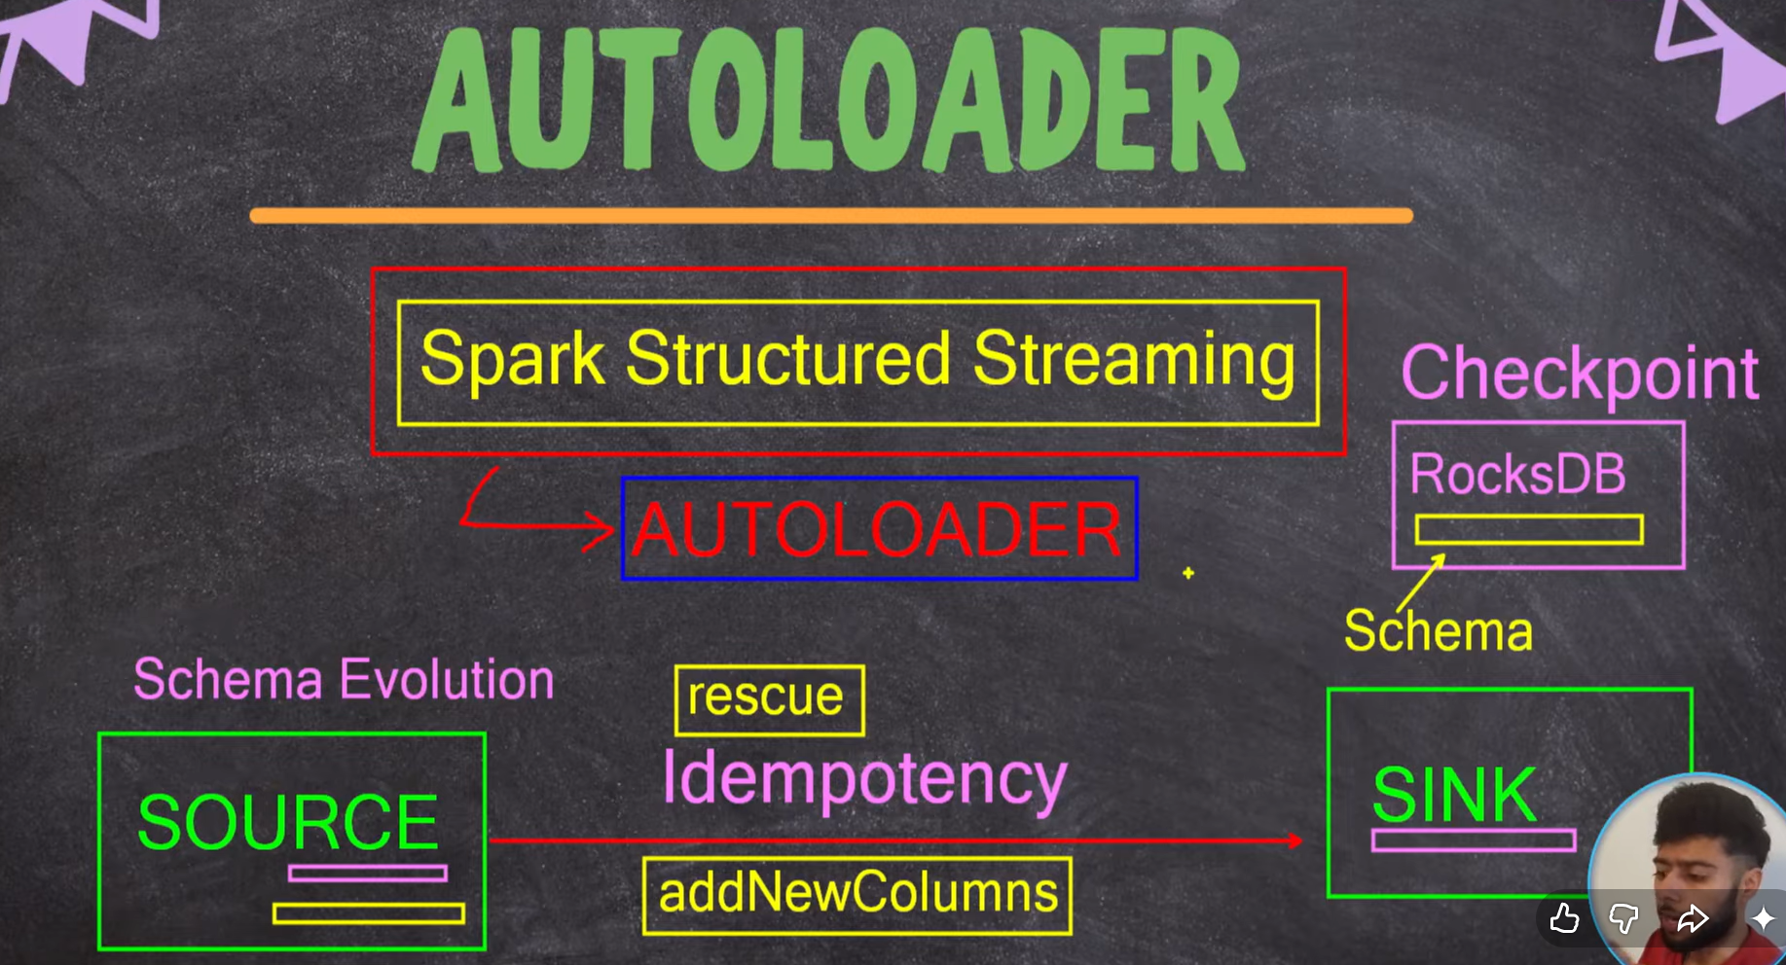
2. Key Features (Why is it famous?)
A. Scalability (File Discovery)
If your "Bronze" folder has millions of files, a regular Spark read will take forever just to list the files. Auto Loader can discover millions of files in seconds using two modes:
- Directory Listing: It scans the input directory and identifies new files based on their timestamp.
- File Notification (Advanced): It integrates with Azure Event Grid/Queue Storage to get a "ping" the moment a new file drops.
B. Schema Evolution (The "Magic" Part)
Usually, if a source file adds a new column, your pipeline crashes. Auto Loader handles this:
- Schema Inference: It looks at the files and guesses the data types for you.
- Schema Hinting: You can tell it, "Hey, treat this column as a Decimal, not a String."
- Schema Evolution: If a new column appears tomorrow, Auto Loader detects it, updates the schema, and restarts the stream without you touching the code.
C. Rescued Data Column
If a file has "corrupt" data (e.g., a String in an Integer column), Auto Loader doesn't fail the whole job. It puts the "bad" data into a hidden column called rescued_data so you can fix it later.
D. Idempotency: This is a fancy word for Accuracy. It ensures that even if the pipeline fails and restarts, the same data is never processed twice. You won't get duplicate rows in your Sink.
E. Checkpoint & RocksDB
This is the "Brain" or "Memory" of Auto Loader.
- Checkpoint: A folder where Databricks stores the "State." It records exactly which files have been processed.
- RocksDB: This is the underlying fast database used to store those states. It allows Auto Loader to scale to millions of files because it can quickly check the RocksDB index to see, "Have I read file_A.csv before?"

3. How to use it (The Code)
To use Auto Loader, you use the format cloudFiles. Here is a standard Python example:
4. The "Checkpoint" Concept
This is the most important part of Auto Loader. The Checkpoint is a folder where Auto Loader stores:
- A list of files it has already processed.
- The current schema.
- The state of the stream.
If your cluster restarts or your pipeline fails, Auto Loader looks at the checkpoint, sees where it left off, and starts processing only the new files.
I made the DimUser folder inside the silver container inside the dimuser I create the data and checkpoint folder where autoloader will store of its information to track the idempotency behaviour
Interviewer might ask: "Is deduplication the same as Idempotency?"
- Idempotency is a preventative measure. You design the system so it never creates duplicates (like using Auto Loader checkpoints).
- Deduplication is a curative measure. You assume duplicates might exist, so you write logic to clean them.

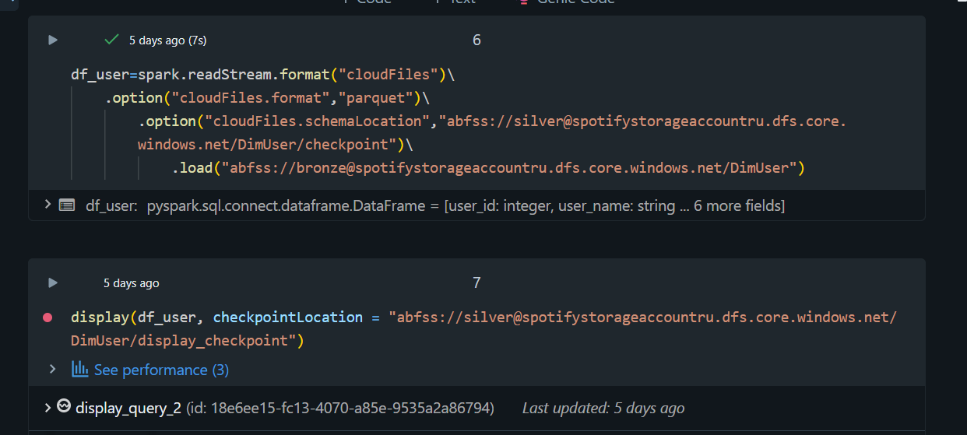

- Advantages of making the Utilities Folder:
Code Reusability & Maintenance: If you need to perform the same transformation (like cleaning data or dropping specific columns) in both the silver and gold layers, you can define it once in a util function. If the logic changes, you only need to update it in one place, not in every notebook.
- Cleaner Notebooks: By moving complex functions to a utility file, your main notebooks stay focused on the workflow rather than the low-level logic, making them easier to read and understand.
- Better Organization: It separates functional logic from execution logic, which is a best practice in software engineering and data engineering to ensure scalability and manageability.

Adding The spotify_dab into the system parameters
In large-scale data engineering projects (like the Spotify Data Pipeline), we often have logic that is used across multiple notebooks (e.g., date formatting, schema validation, or specific transformations). Instead of rewriting this code, we store it in a central directory called utils.
To use these functions in another notebook, we must inform the Python interpreter where to look for them by modifying the System Path (sys.path).
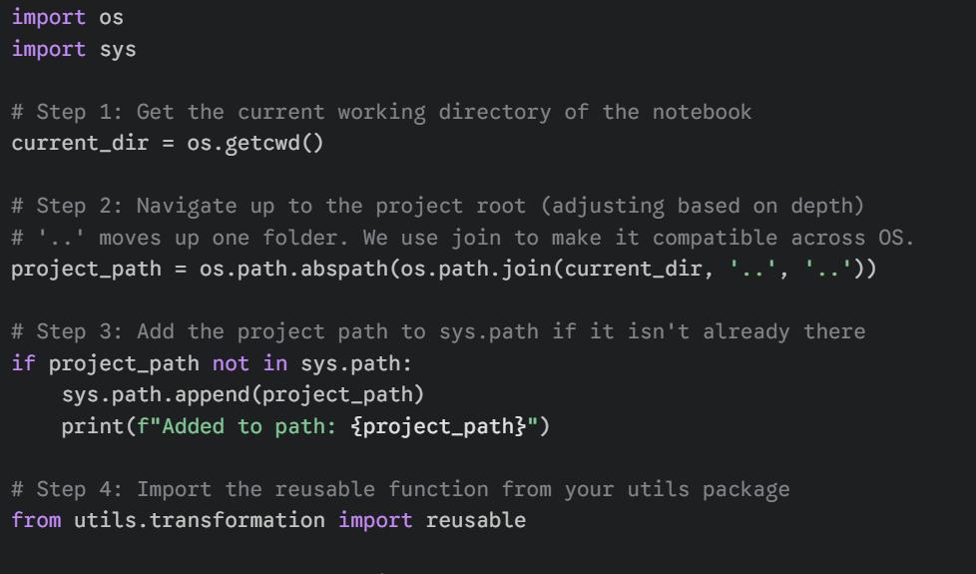
use df.drop(*columns_list),
- How it works: When you use df.drop(*columns_list), the * tells Python to take every element inside columns_list and pass them as separate, individual arguments to the drop function, instead of passing the entire list object as a single argument.
FOR READING THE TABLE
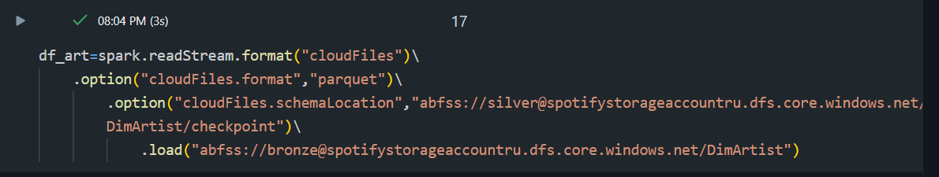
FOR WRITING INTO THE TABLE AND ALSO MAKE THE TABLE INSIDE THE CATALOG
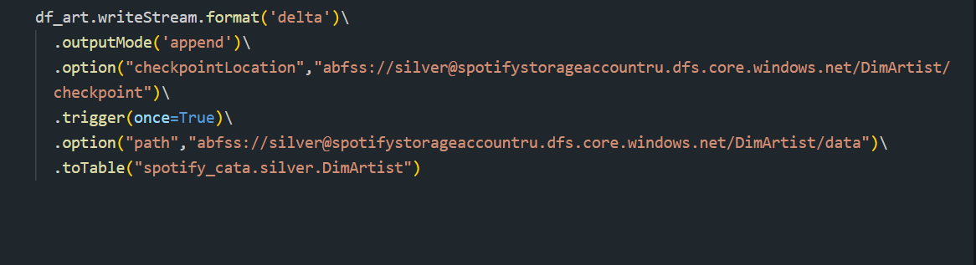
What is Jinja?
Jinja allows you to combine static text with dynamic Python logic.
Instead of writing 10 different SQL queries for 10 different dates, you write one query with a Jinja variable for the date. When you run it, Jinja "renders" the final SQL by plugging in the date you provide.
The Syntax:
- {{ ... }}: Used for Variables (printing something).
- {% ... %}: Used for Logic (if-statements, for-loops).
- {# ... #}: Used for Comments.
Mene metadata drviern notebook banayi jisme mene kuch ek parameter banaya jisme mene apne table ki information daali jese table name ,cols, condition ki kis condition pe mujhe join condition lagani hia fir mene jinja use kiya use template abanya uske baad isse kya hua ki agr mereko kabhi bhi kitni bhi table ME JOIN CONDITION LAGANI HIA MENE SIRF WO EK QUERY LIKHI JINA TEMPLATE KI MADAD SE uske baad me kitne bhi table ka join ka skti hu bss parameters me or tables ki info add krni hogi mtlb mene ishe dynamic bna diya banaye har join ke liye har ek nayi query likhna
simple means dynamic populate the sql queries
GOLD:gold me data daalne ke liye mene phele silver -> stagging area(view)->gold
ishme updated_at bhutt important hai kyuki usi se pta lagta ki change end date change krni ki nhi
SCD TYPES
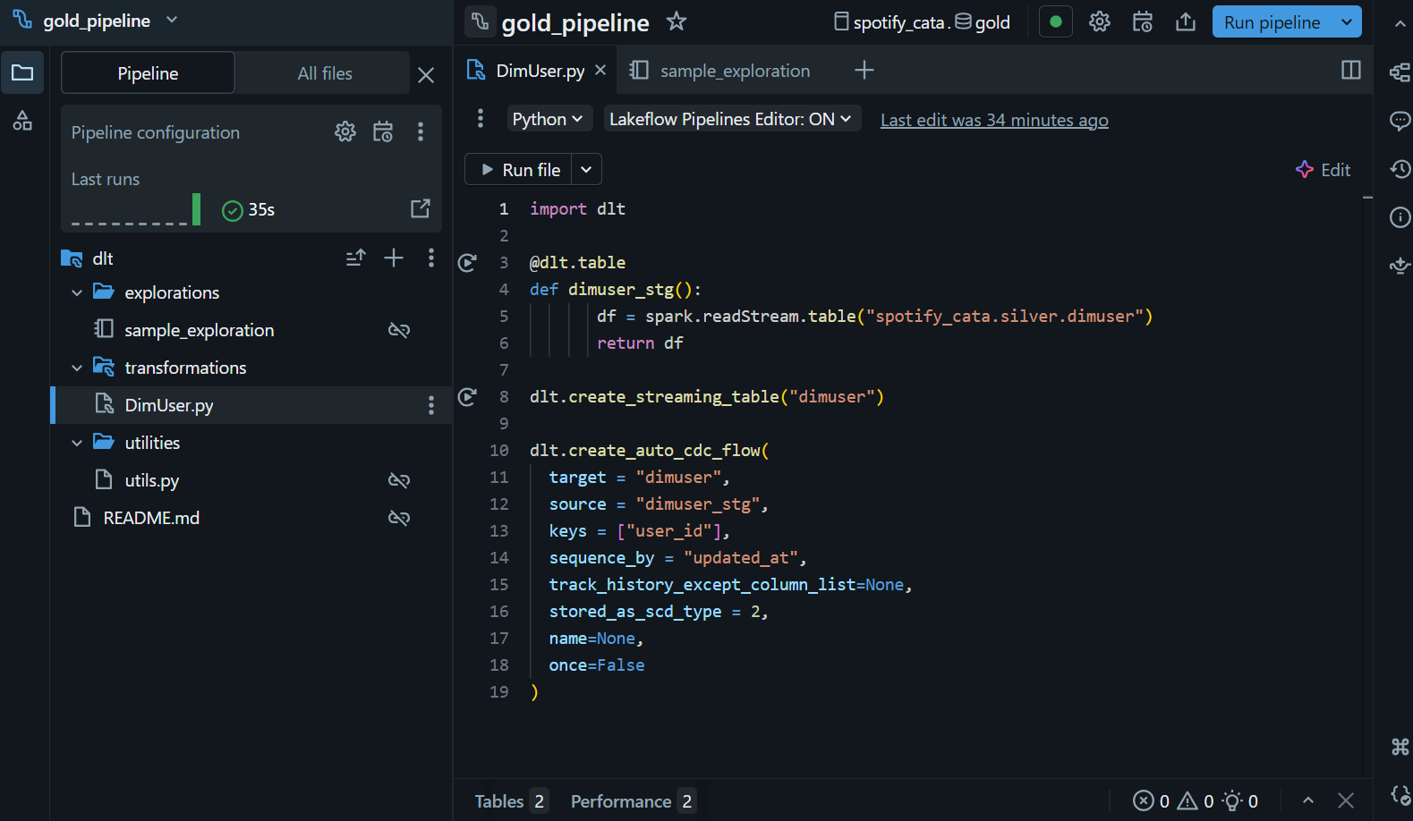
Canva for delta live tables
Exploration inside the delta live tables it is basically a scratch pad measn it not the part of the deployment and development this is just there to practice and to analyze the quick thing so no need to extensilvely create the notebook to test the small thing, it is just a scratch data to practice
Transformation: it is contain the source code anything which is inside this folder will be render and and it will create a dag and automatically track the
Utilities : as similar for reusability for the code

. DLT Kya Hai? (In Simple English)
DLT ek declarative framework hai.
- Declarative ka matlab: Tum Databricks ko bolte ho, "Mujhe ye table chahiye is source se," tum ye nahi batate ki "Cluster start karo, checkpoint folder banao, stream stop karo."
- Ye batch aur streaming dono data ko ek saath handle kar sakta hai.
Declarative pieplines
Auto cdc flow databricks
1. Ye dimuser_stg kya hai?
Python
@dlt.table
def dimuser_stg():
df = spark.readStream.table("spotify_cata.silver.dimuser")
return df
Ye tumhari Staging Table hai. Tum Silver layer se data utha rahi ho aur DLT ko bol rahi ho: "Ye mera kacha maal (raw material) hai, is par kaam shuru karo."
2. Ye create_auto_cdc_flow aur SCD Type 2 kya hai?
Ye sabse important part hai. Maan lo ek user hai "Rahul" jo pehle "Delhi" mein rehta tha, ab wo "Mumbai" move ho gaya.
- SCD Type 1: Purana data (Delhi) delete ho jayega, sirf Mumbai dikhega.
- SCD Type 2 (Jo tum kar rahi ho): Dono records rahenge! Ek purana record (Delhi) aur ek naya record (Mumbai). Isse humein pata chalta hai ki Rahul kab kahan tha.

3. Code ke parameters ka matlab:
- target = "dimuser": Ye tumhari final Gold table ka naam hai jo Analytics ke liye use hogi.
- keys = ["user_id"]: DLT ko kaise pata chalega ki ye wahi "Rahul" hai? user_id se. Agar same ID ka naya data aaya, toh DLT samajh jayega ki update hua hai.
- sequence_by = "updated_at": Agar ek hi user ke 2 updates ek saath aa jayein, toh kaunsa "Latest" hai? DLT updated_at column ka time dekh kar faisla karega.
- stored_as_scd_type = 2: Ye DLT ko bol raha hai ki: "Purana data delete mat karna, usse 'History' ki tarah save karke rakhna."

4. Tum ye Kyu kar rahi ho? (The Purpose)
Gold layer ka matlab hai Business Ready Data. Agar Spotify ka Manager pooche: "Pichle saal kitne log Premium user the jo ab Free par aa gaye?"—toh ye sawal tum tabhi solve kar paogi agar tumhare paas SCD Type 2 ki history hogi.
Agar tum normal append karti, toh sirf current status dikhta, history gayab ho jati.

Summary for your Project Notes:
"In the Gold Layer, I am using Delta Live Tables (DLT) to implement CDC (Change Data Capture) using the create_auto_cdc_flow function. This allows me to maintain a full history of user changes (SCD Type 2) in the dimuser table. I am using user_id as the primary key and updated_at to handle the sequence of updates, ensuring that our analytics reflect the most accurate and historical view of the data."
SCD type 2 using manual method and Delta live table method:
1. Bina DLT ke (The "Manual" Way)
Agar tum normal PySpark notebook use karti, toh tumhe MERGE INTO command likhni padti. Usme tumhe khud logic likhna padta:
- Pehle check karo ki user_id exist karta hai ya nahi.
- Agar karta hai aur data change hua hai, toh purane record ko "Expire" karo (End Date daalo).
- Naya record "Insert" karo (Start Date aur Current Flag ke saath).
- Ye code kam se kam 20-30 line ka hota aur handle karna mushkil hota.

2. DLT ke saath (The "Automatic" Way)
Tum jo code likh rahi ho, wo DLT ko sirf Command de raha hai. DLT yahan ek Engine ki tarah kaam kar raha hai.
DLT ka asli kaam yahan ye hai:
- Infrastructure Management: Tumhe writeStream ya checkpoint ki tension nahi leni, DLT backend mein khud files manage kar raha hai.
- Built-in CDC Logic: dlt.apply_changes (ya jo tumhara flow hai) ko pata hai ki SCD Type 2 kaise banta hai. Tumhe sirf keys aur sequence_by batana hai, baaki ka Merge, Update, aur History creation DLT khud kar deta hai.
- Automatic Start/End Dates: DLT khud se columns add kar deta hai (jaise __start_at, __end_at) ye track karne ke liye ki record kab valid tha.

3. DLT yahan kya kar rahi hai? (Main Points)
- State Management: DLT yaad rakhta hai ki pichli baar Rahul ka status kya tha.
- Handling Out-of-order Data: Agar Mumbai wala update pehle aa jaye aur Delhi wala baad mein (network delay ki wajah se), toh sequence_by="updated_at" ki wajah se DLT use sahi order mein set karega. Bina DLT ke ye code likhna bohot bada headache hai.
- Lineage: DLT UI mein tumhe ek saaf graph dikhega ki silver.dimuser se data nikal kar gold.dimuser mein kaise transform ho raha hai.

4. Interview Point of View (Why use DLT for SCD2?)
Interviewer poochega: "SCD Type 2 toh MERGE command se bhi ho jata hai, DLT kyu use kiya?"
Tera Answer: > "Sir, normal MERGE mein bohot saara boilerplate code likhna padta hai aur out-of-order data handle karna mushkil hota hai. Delta Live Tables use karne ka fayda ye hai ki ye ek Declarative Framework hai. Humein sirf business logic batana hota hai, aur DLT backend mein automatically history maintain karta hai, audit columns add karta hai, aur scaling/checkpoints khud manage karta hai. Isse pipeline production-ready aur low-maintenance banti hai."
Delta table also perform deduplication
Expectation: Data Quality check
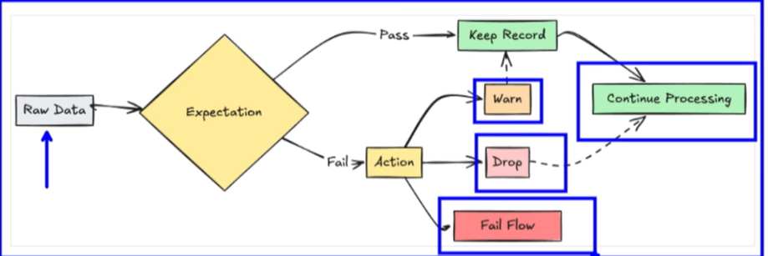
Asset bundles in Databricks

