SYNAPSE
Azure Synapse Analytics is an integrated analytics service that enables organizations to query, analyze, and visualize both structured (tables, databases) and unstructured (logs, files) data at scale. It merges SQL-based data warehousing with Apache Spark big data processing.
Dedicated SQL Pool
- Definition: A dedicated pool is a pre-reserved set of computing resources (like CPUs and memory) that you set up in advance for running large-scale data queries.
- • Retail chain: Every morning, the company needs to generate detailed sales reports across thousands of stores. Since this is a predictable, heavy workload, a dedicated pool ensures fast, consistent performance.
- You prefer dedicated pools when workloads are large, predictable, and performance guarantees are critical.
Serverless SQL Pool
- Definition: A serverless pool lets you query data on demand without reserving resources ahead of time. You only pay for the queries you run.
- • Marketing team: Analysts want to quickly explore campaign data stored in CSV files in Azure Data Lake. They don’t need a permanent warehouse, just quick insights.

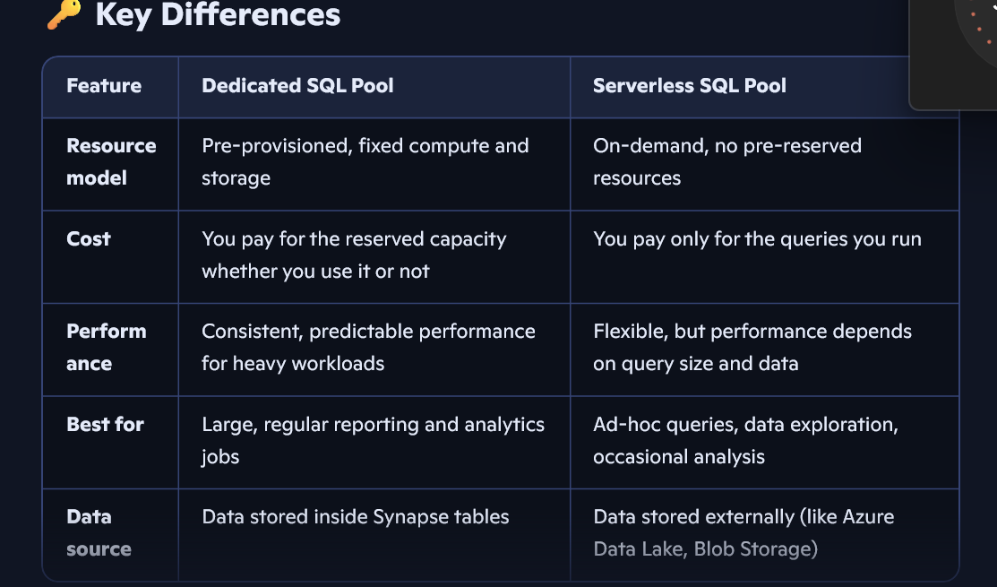sd
Spark Pool
In Azure Synapse, a Spark pool is a cluster of compute resources that runs Apache Spark jobs for big data processing, machine learning, and advanced analytics. It’s designed to handle large, complex datasets in parallel, making it ideal for scenarios where SQL alone isn’t enough.
Driver Node, Worker Node, Cluster Manager, Storage Integration
Why Spark ≠ Serverless/Dedicated
- Spark pools are different technology (Apache Spark engine vs SQL engine).
- Spark pools are used when you need parallel big data processing, ML, or handling unstructured data.
- SQL pools (serverless or dedicated) are used when you need structured queries, reporting, and BI dashboards.
Lake Database : Data stays in datalake
- What it is: A Lake Database is basically a structured view over files stored in Azure Data Lake (like CSV, JSON, Parquet).
- How it works: It doesn’t move the data into a warehouse. Instead, it creates a logical schema (tables, columns) so you can query raw files directly.
- Why use it: When you have huge amounts of raw or semi-structured data (logs, IoT sensor data, clickstream data) and you want to explore it quickly without loading it into a SQL warehouse.
SQL Database : Data stored inside synapse workspace
- What it is: A SQL Database in Synapse is a traditional relational data warehouse.
- How it works: You load cleaned, structured data into tables inside Synapse. It’s optimized with indexes, partitions, and dedicated compute power.
- Why use it: When you need fast, predictable performance for dashboards, reports, and business-critical queries.

In Synapse, a Lake Database is a logical layer over raw files in Azure Data Lake — it’s great for exploring big or semi-structured data without moving it. A SQL Database (Dedicated Pool) is a traditional warehouse where structured data is loaded and optimized for fast, reliable reporting. In practice, I’d use a Lake Database for logs or IoT data exploration, and a SQL Database for business-critical dashboards and reports.
Distributed Table
- In a dedicated SQL pool, Synapse doesn’t store all rows in one place.
- Instead, it splits the rows into 60 distributions (like 60 mini-partitions).
- When you run a query, Synapse breaks it into 60 smaller queries that run in parallel, then combines the results.
- This parallelism is what gives Synapse its massive performance boost for big data workloads.
Techniques:
1. Hash Distribution
- Mechanism: Data is distributed across 60 distributions based on the hash value of a chosen column.
- When to Use:
  - Large fact tables with a clear join key (e.g., CustomerID, ProductID).
  - Tables that participate in frequent joins with other large tables.
- Advantages:
  - Minimizes data movement during joins.
  - Scales well for big datasets.
- Risks:
- If the chosen column has skew (e.g., one value dominates), performance suffers.
- Requires careful selection of distribution column.
👉 Interview phrasing:
“Hash distribution is my go-to for large fact tables where I can pick a stable join key. It ensures rows are evenly spread and reduces data movement during joins, which is critical for query performance.”

2. Round-Robin Distribution
- Mechanism: Rows are evenly spread across distributions without considering column values.
- When to Use:
  - Staging tables for initial data loads.
  - Temporary or intermediate tables where performance is less critical.
- Advantages:
  - Simple to implement.
  - Ensures balanced distribution automatically.
- Risks:
- Joins often require data movement since rows aren’t aligned by keys.
- Not optimal for performance-critical queries.
👉 Interview phrasing:
“Round-robin is best for staging or intermediate tables. It’s simple and guarantees even distribution, but since it doesn’t align data by keys, joins usually involve extra shuffling.”
3. Replicated Tables
- Mechanism: The entire table is copied to all 60 distributions.
- When to Use:
  - Small dimension tables that are frequently joined with large fact tables.
- Advantages:
  - Eliminates data movement in joins.
  - Very fast lookups.
- Risks:
- Not suitable for large tables due to storage overhead.
- Updates can be expensive since every distribution must be updated.
👉 Interview phrasing:
“For small dimension tables, replication is ideal. Since the table exists on every distribution, joins with large fact tables are extremely fast. But replication only works well for small datasets.”
External Table
An External Table is a schema object that points to data stored outside the Synapse SQL pool storage. In Azure, this usually means data stored in Azure Data Lake Storage Gen2 (ADLS Gen2) or Azure Blob Storage.
- The Metadata: Synapse stores the table definition (column names, data types).
- The Data: Remains in its original location (Parquet, CSV, or ORC files in the data lake).
Interview Tip: "An external table provides a relational abstraction over file-based data. It allows us to use T-SQL to query 'data at rest' in the data lake without the overhead of importing it into managed storage."
. How it Works (The Architecture)
To create an external table, Synapse needs three specific "building blocks" to understand where the data is and how to read it:
- External Data Source: The "Where." This defines the location of the ADLS Gen2 container.
- External File Format: The "How." This tells Synapse if the file is Parquet, Delimited Text (CSV), or ORC.
- The External Table Definition: The "What." This maps the file's columns to SQL data types.
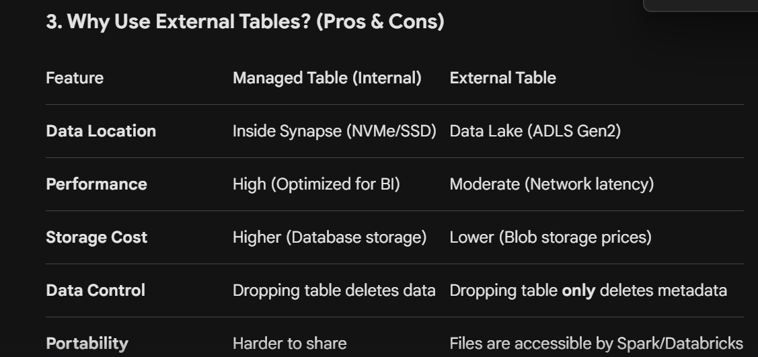

Q: What happens to the data if I drop an External Table?
- A: Only the metadata is deleted. The actual files in Azure Data Lake remain untouched. This is a key difference from internal (managed) tables.
Q: When would you choose an External Table over an Internal Table?
- A: Use External Tables when you need to share data with other engines (like Spark), when you have massive volumes of data that are queried infrequently (cost-saving), or for the initial "Staging" layer of your data pipeline.
Q: Which tool in Synapse uses External Tables most often?
- A: Both Serverless SQL Pools (for ad-hoc discovery) and Dedicated SQL Pools (for PolyBase loading) use them, but they are the primary way to interact with data in Serverless SQL.

6. SQL Syntax Example (For your notes)
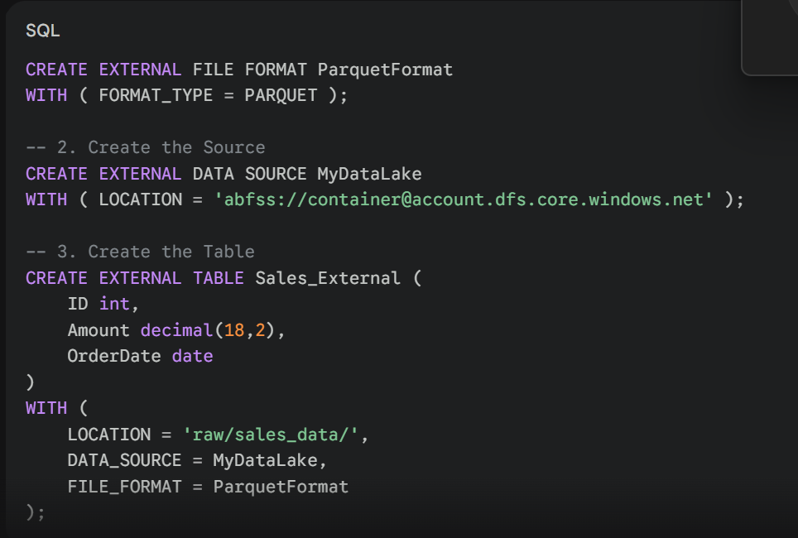

For creating the external table we need to use the 3 things:
1-Location(jo data lake me hai or jo di haii tumne phele se hi)
2-Data_source(iske andr hi to location di haii)
3-File_format(iska format niche hia kese banate hai):
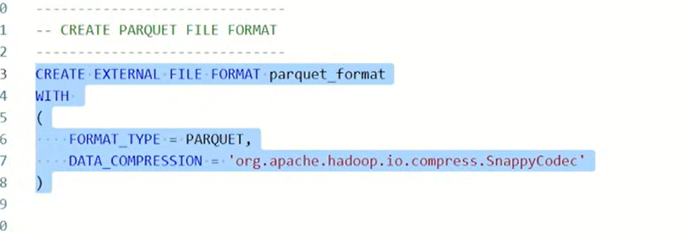
How is synapse secured for file access?
Azure Synapse Security Components
- Managed Identities: Synapse creates a system-assigned managed identity for the workspace. Instead of using hardcoded secrets, you grant this identity permissions (like Storage Blob Data Contributor) directly on the Data Lake storage
- Database Scoped Credentials: These are used to securely store authentication details, such as security tokens or managed identity references, within the Synapse database to access external data sources.
- External Data Sources: By defining these, you restrict access to specific containers within your ADLS Gen2 account, ensuring that queries only look at authorized locations.
- Access Connector: Used as a mediator for security, specifically when linking Synapse to ADLS Gen2 to facilitate secure communication.

The Real-Life Example how logical metadata layer working: "The Digital Kitchen"
1. Data Lake (ADLS Gen2) = The Huge Refrigerator (Storage)
Imagine you have a massive refrigerator where all your raw ingredients (Raw Data) are stored. One packet contains tomatoes (CSV file), another has onions (Parquet file), and another has milk. The refrigerator has no idea what is inside the packets; it simply "holds" them.
2. Serverless SQL Pool = The Chef (Compute Engine)
The Chef is very intelligent but has no refrigerator of his own. He only appears when an order is placed. He fetches the ingredients from the refrigerator, chops and prepares them (Processing), and delivers the final dish.
3. The Serverless Database = The Menu Card (Metadata Layer)
Now, imagine a customer arrives. They won’t reach into the refrigerator to grab a raw tomato; they will look at the Menu Card.
- The Menu says: "Tomato Soup."
- The Menu Card itself doesn't contain the soup! It is just Information.
- That information tells the Chef that to make "Tomato Soup," he must go to "Shelf No. 3" in the refrigerator and fetch the tomatoes.
The Workflow: How it works Step-by-Step
Step 1: The File in the Data Lake
Suppose a file named sales_2023.csv is sitting in your Data Lake. It has 3 columns: Date, Item, Price. At this stage, it is just a "file"—the SQL engine knows nothing about it.
Step 2: Creating the Serverless Database
You create an empty container (The Menu Card folder). This database takes up 0 GB on a hard drive because it contains no actual data.
Step 3: Creating the External Table (The Magic Step)
When you execute the command: CREATE EXTERNAL TABLE SalesTable (Date date, Item varchar(50), Price int) WITH (LOCATION = 'sales_2023.csv'...) Synapse makes an entry in its "Menu Card" (Database):
"If anyone asks for 'SalesTable', go directly to this specific folder in the Data Lake. Treat the first column as Date, the second as Item, and the third as Price."
Step 4: Running the Query: SELECT * FROM SalesTable
This is the Abstraction Layer in action:
- Request: The SQL engine receives your query.
- Lookup (Metadata): The engine checks the Database: "What is SalesTable?" The Database replies: "It’s a pointer; the data is located at Shelf No. 3 in the Data Lake."
- Action: The Engine (Chef) rushes to the Data Lake, reads the file, formats the columns into a SQL result, and displays the output on your screen.
Why create a Database? (Interview Points)
If the Database didn't exist, you would have to tell SQL every single time: "Open that folder, grab the 5th file, the format is CSV, and the first column is Name." That is inefficient.
The Benefits of the Database Layer:
- Easy Access: You only need to write SELECT * FROM TableName. The Database remembers the file path and format for you.
- BI Tool Compatibility: Tools like Power BI do not understand "Files"; they require "Tables." The Database provides that tabular view.
- Security: You can set permissions at the Database level (e.g., "User A can only see this specific Table"), even if there are thousands of other files in the Data Lake.
1. Creating the "Access Badge" (Database Scoped Credential)
SQL
CREATE DATABASE SCOPED CREDENTIAL anshcreds
WITH IDENTITY = 'Managed Identity'
- What it is: This is like giving the Chef (Synapse) a specific Access Badge (Credential).
- Why: Instead of typing a password or a secret key, you are saying, "Use the Workspace's own identity to open the fridge." It is the most secure way to authenticate.
2. Creating the "Shelf Pointer" (External Data Source)
SQL
CREATE EXTERNAL DATA SOURCE raw_ext_source
WITH (
LOCATION = 'https://anshdatalake.dfs.core.windows.net/raw',
CREDENTIAL = anshcreds
)
- What it is: This is the Menu Card entry that points to the exact shelf in the fridge.
- Location: This tells Synapse exactly which "folder" (/raw) in which "Data Lake" (anshdatalake) to look into.
- Credential: It tells Synapse: "When you go to this folder, show them the anshcreds badge we created above to get inside."
How do you securely connect a Synapse Serverless SQL pool to ADLS Gen2?
Answer: "To establish a secure connection, I follow a two-step process:
- First, I create a Database Scoped Credential using the Managed Identity of the Synapse Workspace. This avoids hardcoding keys.
- Second, I create an External Data Source. This defines the physical URL of the Data Lake and links it to the credential I created.
- Once this 'Source' is ready, I can create External Tables on top of it to query the data using standard T-SQL."
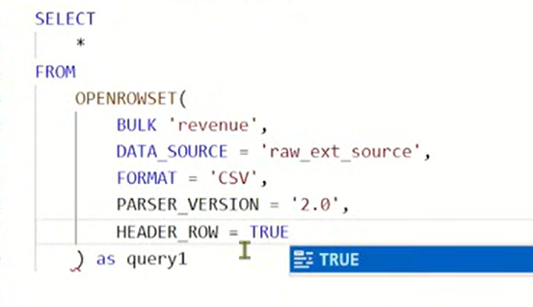 for selecting the data from the data lake
- What is OPENROWSET?
- OPENROWSET is a built-in function that allows you to read content from a file in the Data Lake directly, without even creating a table.
- Using our Digital Kitchen example:
- External Table = A fixed item on the Menu Card.
- OPENROWSET = The Chef just looking inside a random box in the fridge to see what's inside.

Breaking down the code in your image:
- BULK 'revenue': This is the folder or file name inside your container.
- DATASOURCE = 'raw_ext_source': This is the "Bridge" you created earlier (from your previous image). It tells Synapse where the lake is and what credentials to use.
- FORMAT = 'CSV': Telling the engine how to read the file.
- PARSER_VERSION = '2.0': This is the faster, more modern version of the CSV engine in Synapse.
- 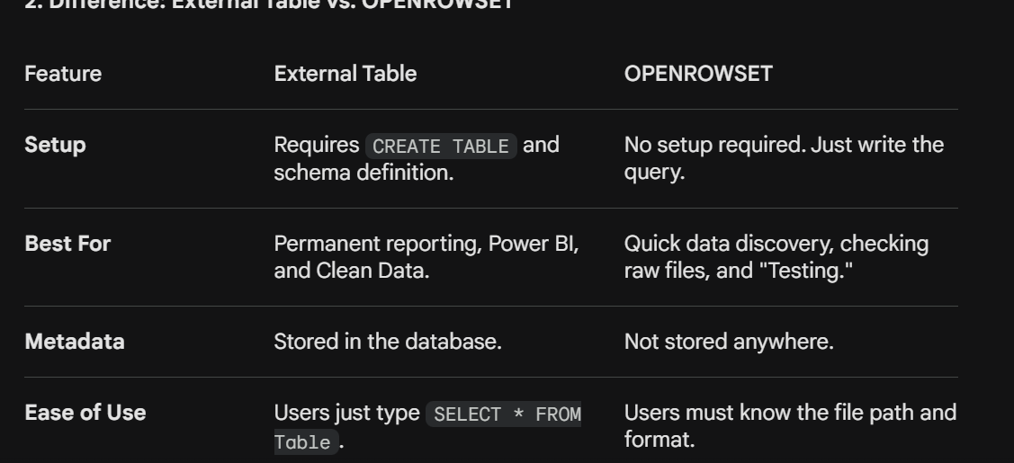
- Q When would you use OPENROWSET instead of an External Table?
- Q Can you use OPENROWSET to create a table?
- Bhai, here is the professional English translation of the explanation. I’ve structured it so you can directly copy it into your notes for interview preparation.

- Why use an External Table if OPENROWSET works?
- Your point is valid: If OPENROWSET can read the data directly, why go through the trouble of creating an External Table? The reason lies in Standardization, User Experience, and Production Readiness.
- 1. Convenience (The "Saved Address" Analogy)
- OPENROWSET: Every time you write a query, you must provide the full physical path (BULK 'revenue'), the DATA_SOURCE, the FORMAT, and the PARSER_VERSION. It’s like typing the exact GPS coordinates of your house every time you want to order food.
- External Table: Once you create the table, you only need to write SELECT * FROM SalesTable. The database "remembers" the file path and format for you. It’s like having a Saved Address.
- 2. Schema Enforcement (Data Quality)
- In OPENROWSET, columns often come out as C1, C2, C3 or rely entirely on the file header.
- External Table: You define strict Data Types (e.g., forcing Price to be an INT or JoinDate to be a DATE).
- This ensures data quality. If a text value like "ABC" accidentally enters the Price column in the file, the SQL Table can handle the error or flag it, whereas OPENROWSET might just read it as raw text and break your calculations later.
- 3. Compatibility with BI Tools (Power BI/Tableau)
- This is the most critical reason. Power BI and other reporting tools don't "understand" complex SQL functions like OPENROWSET.
- They expect to see a list of Tables.
- When you create an External Table, Power BI sees it as a standard SQL table. The Business Analyst can simply "Drag and Drop" it without knowing anything about the underlying Data Lake or file paths.
- 4. Security and Access Control
- To use OPENROWSET, a user usually needs permissions on the underlying storage account.
- With an External Table, you can grant a user access to only that specific table (GRANT SELECT ON SalesTable TO UserA). The user can query the data without ever knowing the name of your Storage Account or seeing the other sensitive files in the Data Lake.

Managed Identity in Azure,keyVault,Access Connector

Creation of External Table:
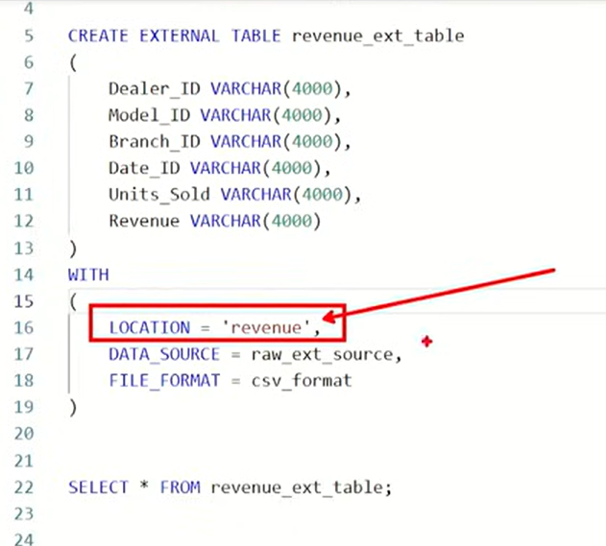
CETAS
Jab tu CETAS (Table on top of query) chalati hai, toh Synapse do kaam ek saath karta hai:
- Kaam 1 (Storage): Wo query ka result uthata hai aur Data Lake mein ek nayi file (Parquet/CSV) write kar deta hai.
- Kaam 2 (Metadata): Wo Serverless Database mein ek External Table bana deta hai jo us nayi file ko point karti hai.
- Definition: It is a process of creating an External Table based on the result set of a SELECT query.
- What happens? Synapse executes the query, exports the resulting data as new files into the Data Lake, and simultaneously registers a new External Table in the metadata layer.
- Real-Life Use Case: "I use this to transform raw, messy CSV files into cleaned, compressed Parquet files. This process is called Data Materialization or Data Transformation (the 'T' in ELT)."
Interview Answer:
"Creating a table on top of a query (CETAS) allows me to persist the results of a complex transformation. Instead of running a heavy OPENROWSET query every time, I run it once, save the output as a Parquet file in the Data Lake, and define an External Table over it for faster future access."
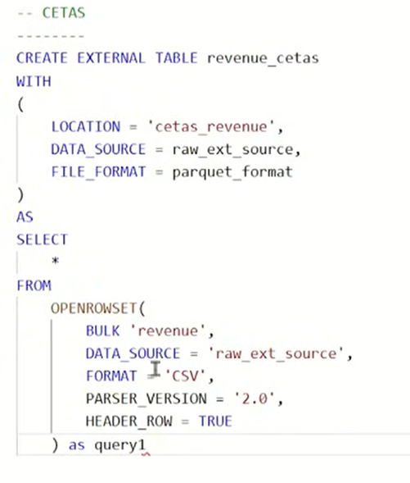so it will create a external table over this query as well as it store the data of this query in parquet format.
Q What will happen in that scenario if you try to create an external table on top of a folder location that does not actually exist yet?
- Metadata Registration: Synapse will successfully execute the SQL command to create the external table. It does not validate the existence of the physical folder at the time of creation. It simply registers the metadata (schema, file format, and the defined location) for that table in the database .
- Querying Behavior: When you later attempt to query (SELECT) from this table, Synapse will check that location. If the folder still does not exist, the query will not fail with a syntax error, but it will return zero rows because there is no data to read
- Future Data: The table is ready and waiting. As soon as a folder with the correct path, name, and file structure is placed in that location in the future, queries on that table will immediately start returning that data
Q How do I load data into dedicated pools?
- 1-COPY INTO Command: This is described as the recommended, scalable, and fast approach for bulk loading . It works by executing a COPY INTO SQL statement to move data from a specified storage location directly into a dedicated table
- 2-Using PolyBase (The Enterprise/Scale Way) PolyBase is the traditional "Powerhouse" for loading massive amounts of data. It breaks the file into pieces and uses all the compute nodes of your Dedicated SQL Pool to read them in parallel.
- The Workflow:
  - Create an External Data Source (The Bridge to ADLS).
  - Create an External File Format (Telling SQL if it's Parquet or CSV).
  - Create an External Table (The "Pointer" we discussed earlier).
  - Run a INSERT INTO ... SELECT * FROM query to move data from the External Table to the Internal (Managed) Table.
3. Using Azure Synapse Pipelines (The No-Code/GUI Way) If you prefer a visual interface, you use the Copy Activity within a Synapse Pipeline.
- How it works: You create a "Source" (Data Lake) and a "Sink" (Dedicated SQL Pool).
- Best for: Orchestrating complex loads, such as loading 50 tables at once or setting up a schedule (e.g., every night at 2 AM).
Q: What is the most efficient way to load data into a Dedicated SQL Pool?
Q: Why would you choose the COPY statement over PolyBase?
Q: What format should the data be in for the fastest load?

CSV vs. Parquet (The Difference)
- CSV (Row-Based): CSV data ko Rows mein likhta hai.
  - Agar tumhe sirf 100 logon ki "Age" chahiye, toh SQL ko poori file read karni padegi (Name, Address, Phone, Email sab kuch) sirf Age tak pahunchne ke liye. Ye slow hai.
- Parquet (Column-Based): Parquet data ko Columns mein store karta hai.
  - Agar tumhe "Age" chahiye, toh SQL engine baaki columns ko touch bhi nahi karega. Wo seedha "Age" wale column pe jayega aur data utha lega. Isse query Super Fast ho jati hai.
Parquet ke 3 Sabse Bade Fayde (Interview Points)
- Compression (Space Saving): Parquet data ko bahut zyada compress kar deta hai. Ek 1 GB ki CSV file Parquet mein convert hone ke baad mushkil se 200-300 MB ki reh jati hai.
  - Azure Fayda: Azure Storage mein kam jagah lagegi toh paisa bachega.
- Performance (Speed): Kyunki ye sirf zaroori columns read karta hai (ise Column Projection kehte hain), queries CSV ke muqable 10x-50x fast chalti hain.
- Schema Storage: Parquet file ke andar hi uski "Metadata" (Column names aur Data types) chhupi hoti hai. SQL ko batana nahi padta ki ye Column INT hai ya STRING, wo file read karke khud samajh jata hai.

