1.

print("Hello,",input(),'',input())

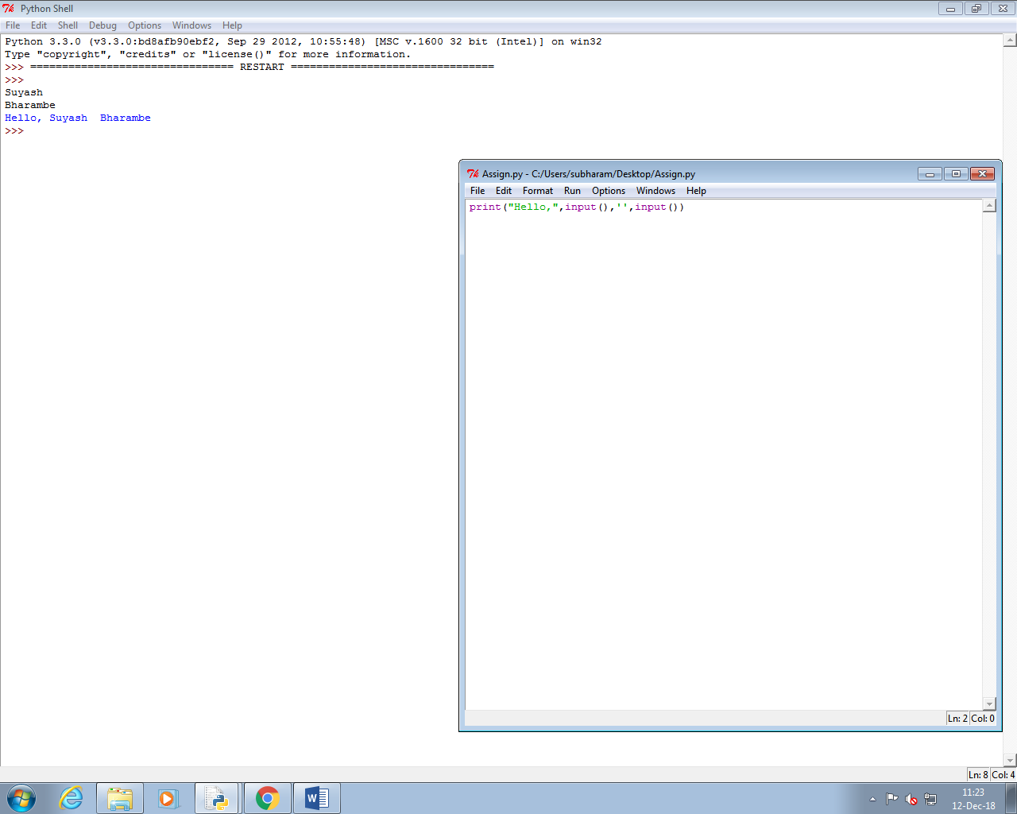

=====================================================================================

2.

a=int(input())

b=int(input())

sum=a+b

if sum>=0:

print("Number is positive")

else:

print("Number is negative")

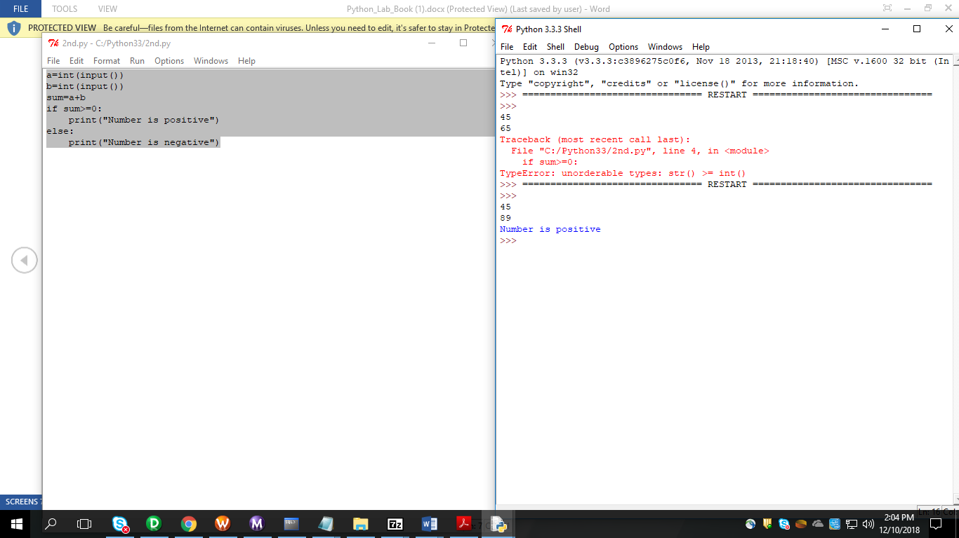  
=====================================================================================

3.

a=int(input())

i=0

while i == 0:

b = int(input())

if(a == b):

print("Correct")

break

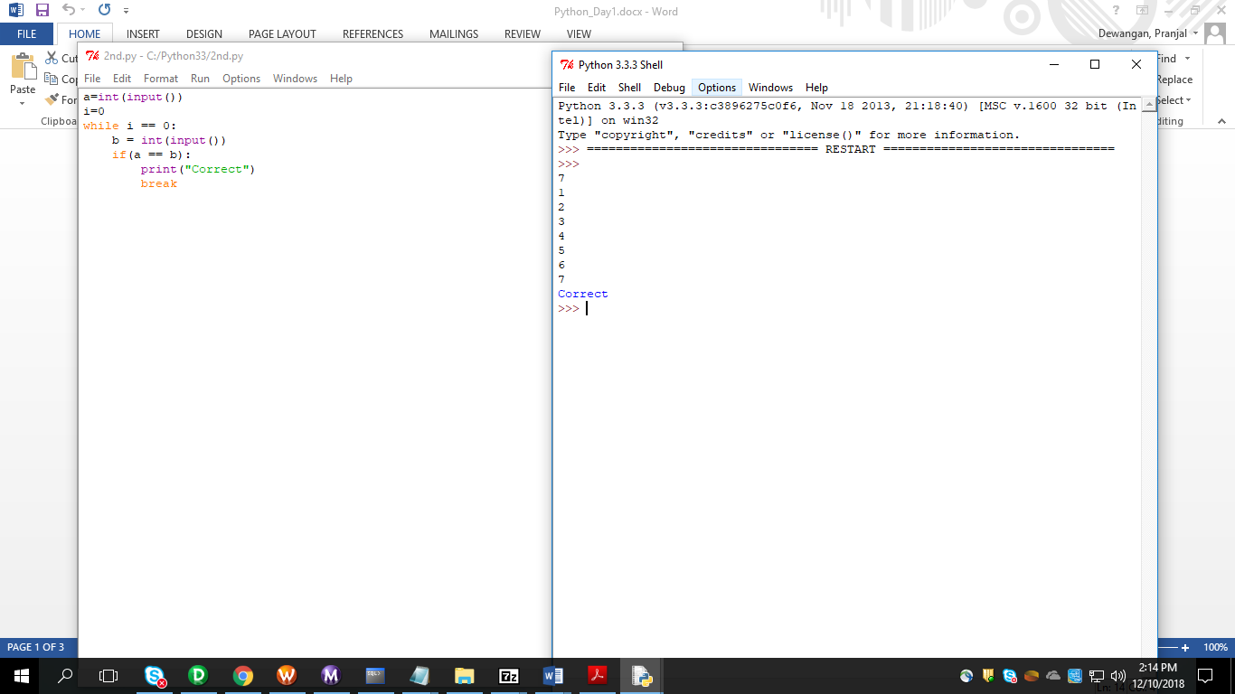

=====================================================================================

4.

firstname = str(input())

lastname = str(input())

wholename=firstname+"."+lastname

print(wholename)

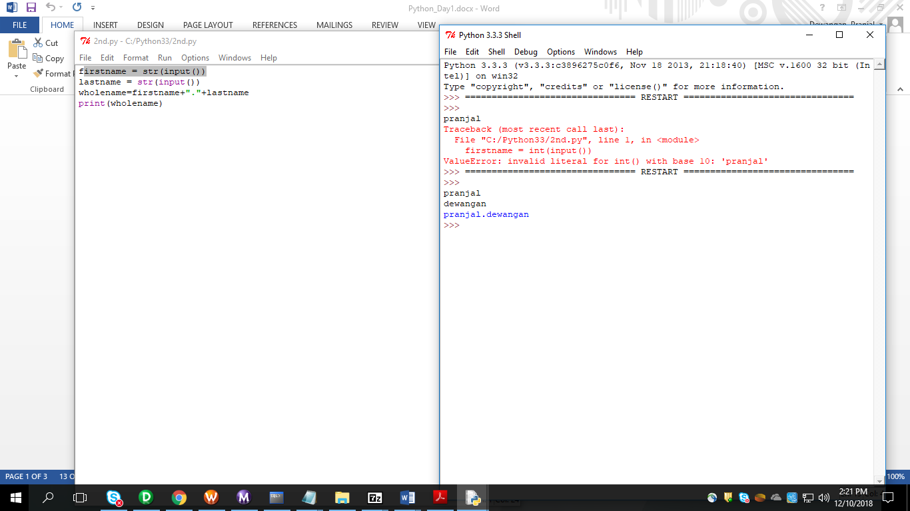

=====================================================================================

5.

str= str(input())

print(str.swapcase())

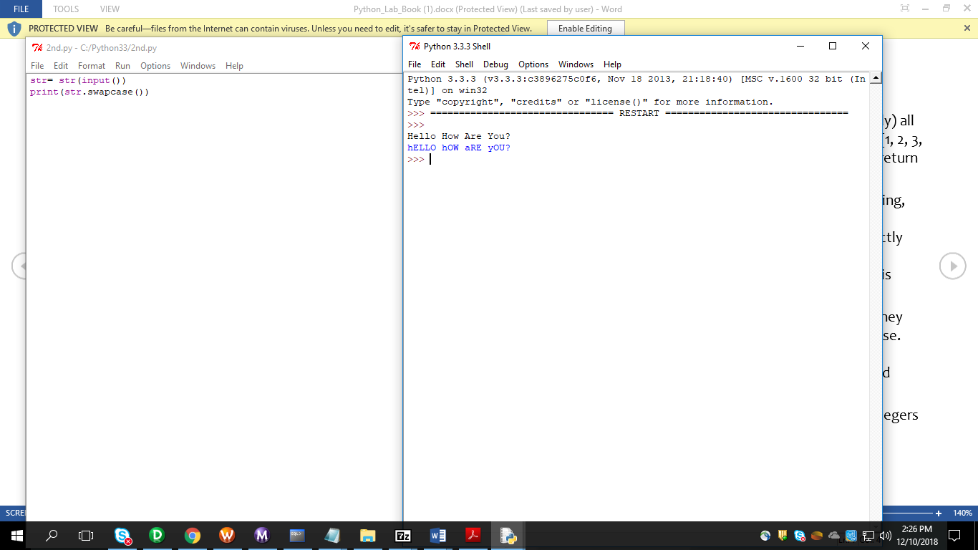

=====================================================================================

6.

a=int(input())

d=1

lst=[]

for i in range(a):

c=int(input())

lst.append(c)

d=c*d

print('multiply',d)

f=sum(lst)

print('sum',f)

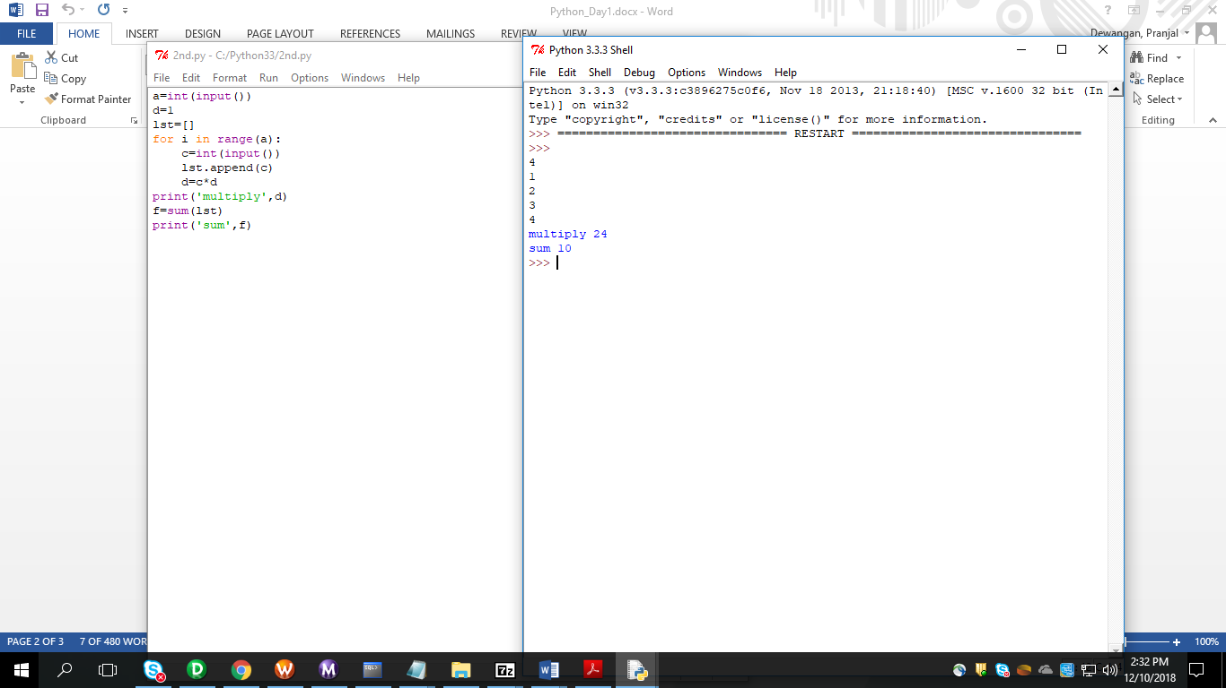

=====================================================================================

7.

a=int(input())

lst=[]

for i in range(a):

c=int(input())

lst.append(c)

x=int(input())

if x in lst:

print('True')

else:

print('False')

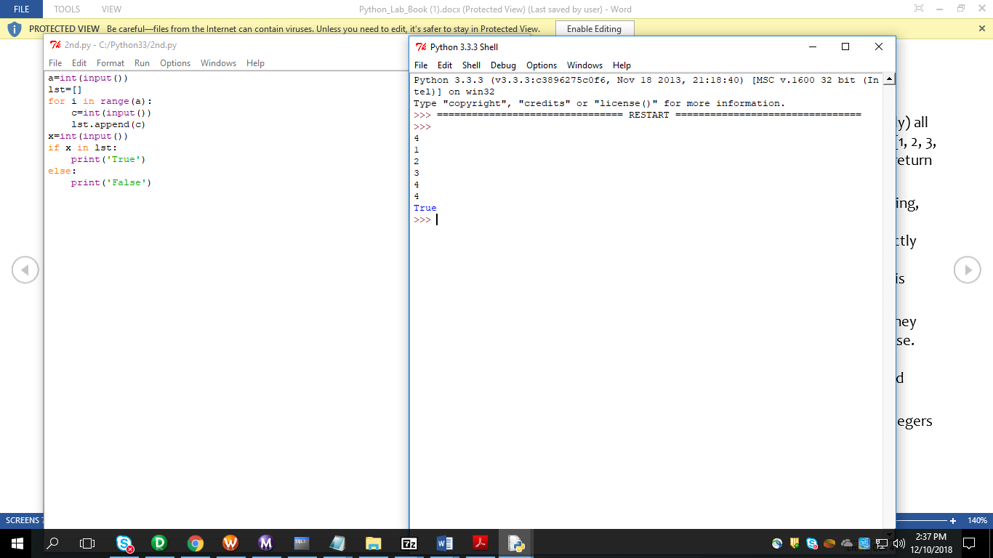

=====================================================================================

8.

a=int(input("Enter the no of elements in list1: "))

b=int(input("Enter the no of elements in list2: "))

x=[]

y=[]

flag=0

for i in range(a):

x.append(int(input("Enter the elements if list1: ")))

for i in range(b):

y.append(int(input("Enter the elements of list2: ")))

for i in range(a):

for j in range(b):

if(x[i]==y[j]):

print("True")

flag=1

break

if(flag==0):

print("False")

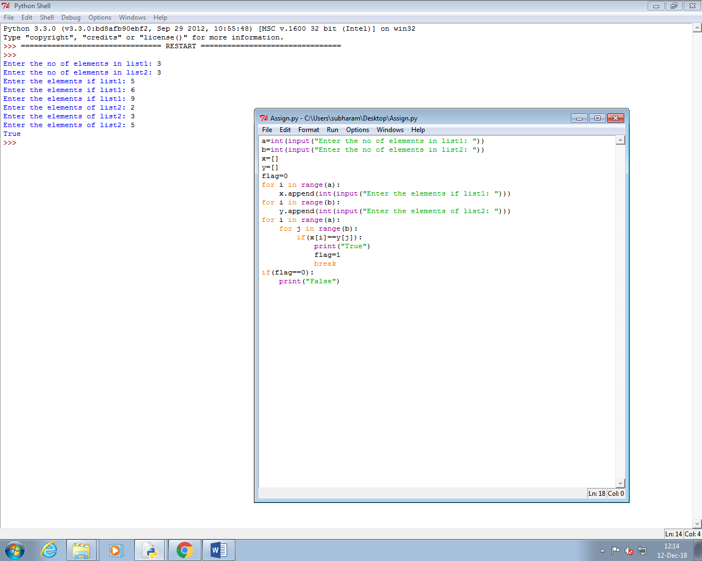

=====================================================================================

9.

N=int(input())

list=[]

output=""

for i in range(N):

elements=int(input())

list.append(elements)

for i in range(elements):

output=output+"*"

output=output+"\n"

print(output.strip())

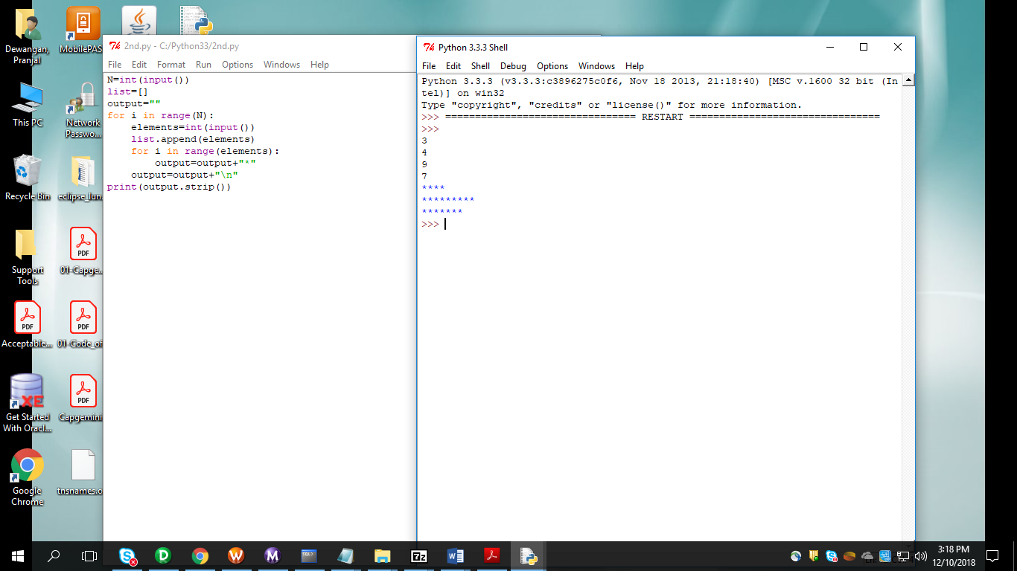

=====================================================================================

DAY_2

=====================================================================================

1.

def char_print():

    number=int(input("Enter number"))

    ch=input("Enter character")

    for i in range(number):

        print(ch ,end="")

    return;

char_print()

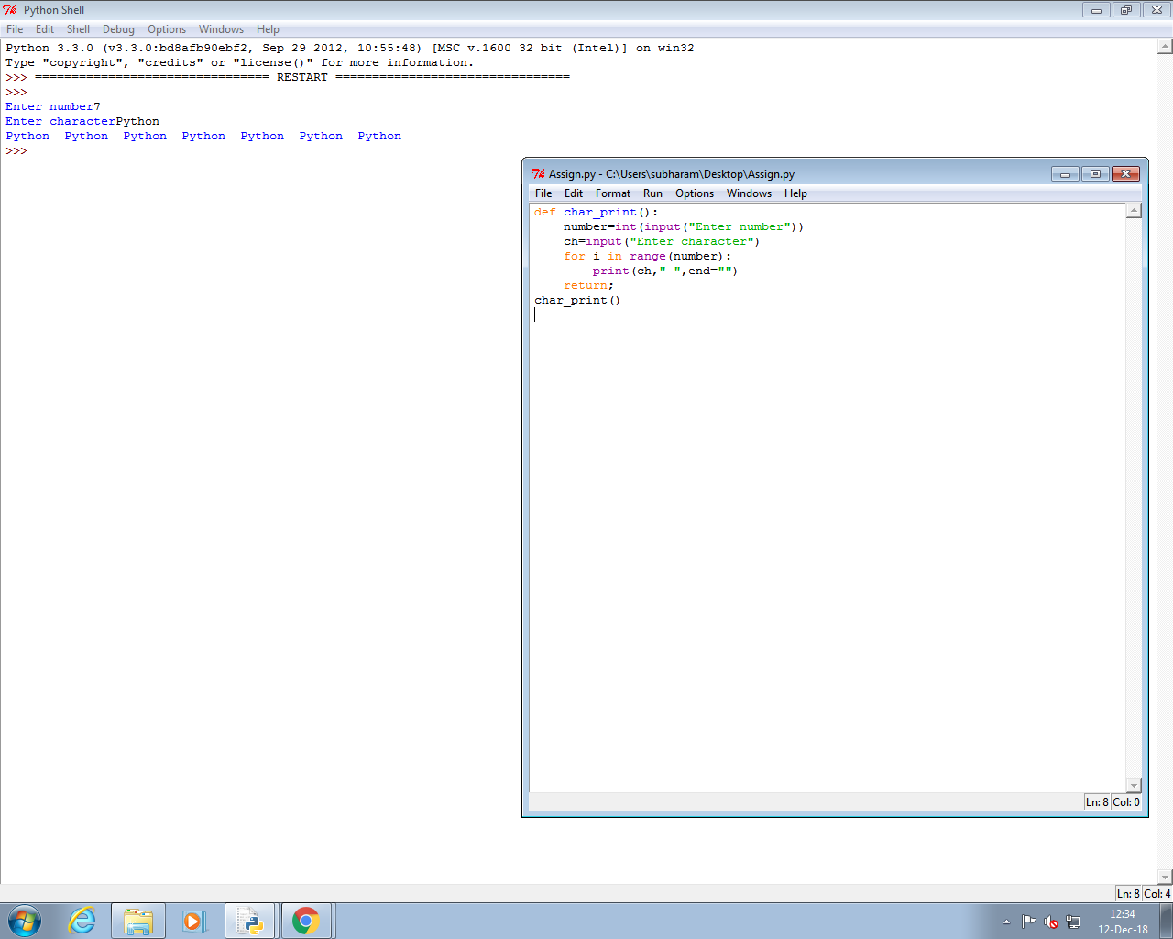

2.

def max_in_list():

list = []

for i in range(5):

w=int(input("Enter list"))

list.append(w)

max=list[0]

for i in range(1,5):

if(max<list[i]):

max=list[i]

else:

continue;

return (max)

print (max_in_list())

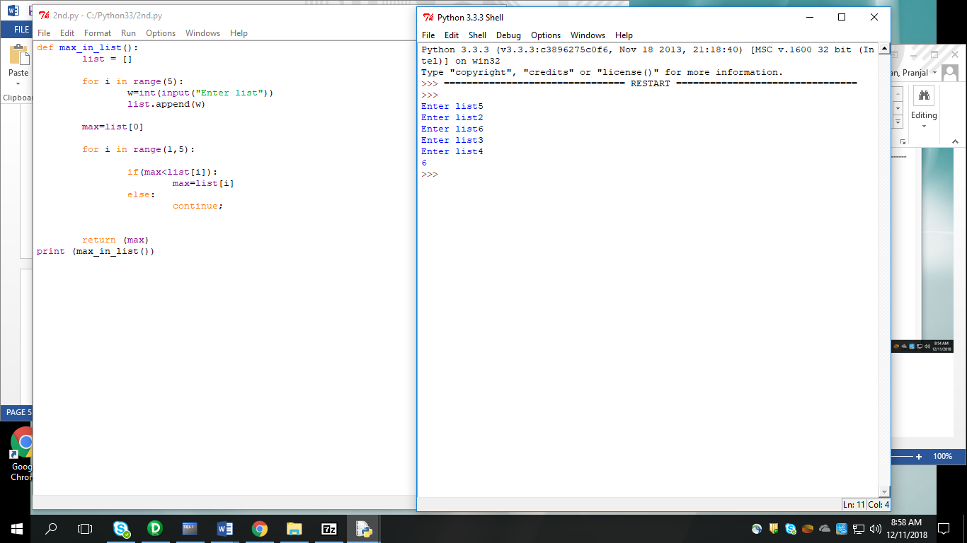

3.

word=[]

for i in range(3):

word.append(input("Enter words"))

list=[]

for i in range(3):

w=len(word[i])

list.append(int(w))

dictornary=dict(zip(word,list))

print (dictornary)

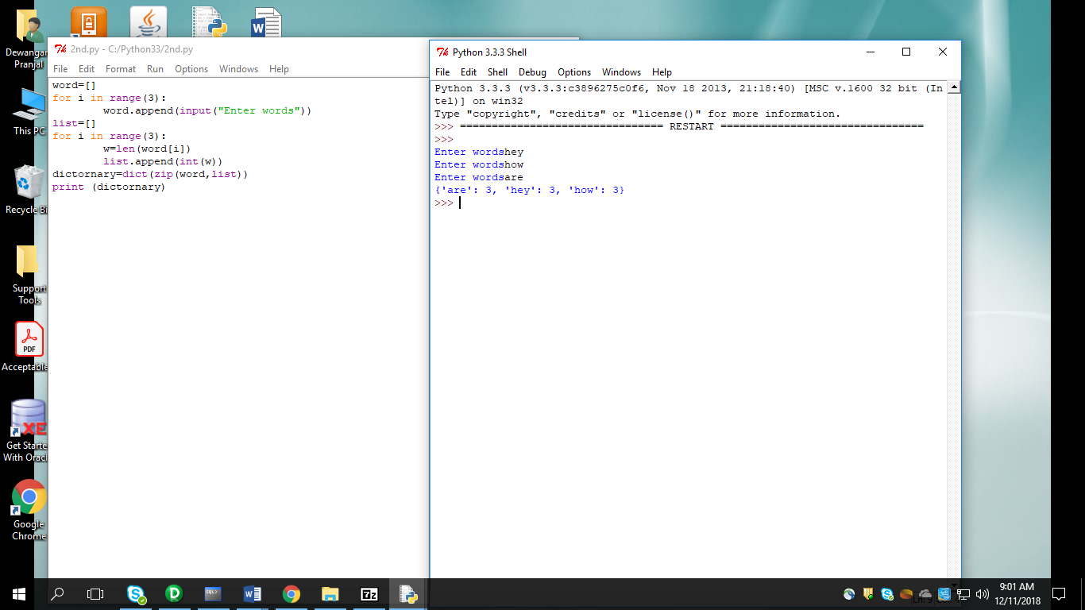

4.

leng=lambda list1 : max(list1)

def find_longest_word():

list=[]

list1=[]

for i in range(4):

x=input("Enter your list of words")

list.append(x)

list1.append(len(list[i]))

print(leng(list1))

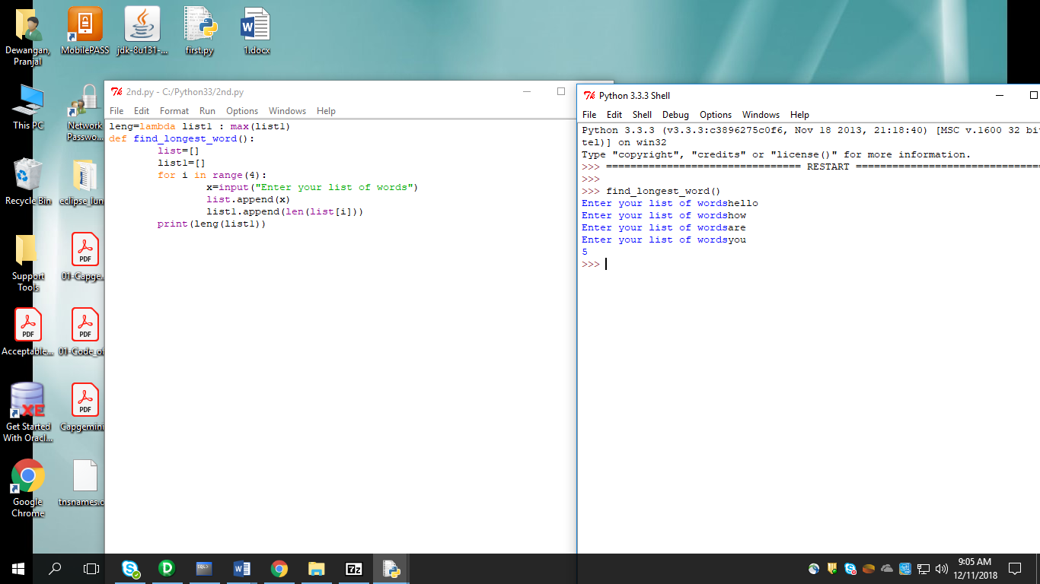

5.

6.

list2=[]

str1=input("enter the string")

list1=list(str1.strip(" "))

for i in list1:

if ((chr(ord(i))<='65') | (chr(ord(i))>='90')):

list1.remove(i)

print(list1)

for i in range(len(list1)-1,-1,-1):

list2.append(list1[i])

z=0

for i in range(0,len(list1)):

if list1[i]==list2[i]:

z=1

else:

z=0

if z==0:

print("False")

else:

print("True")

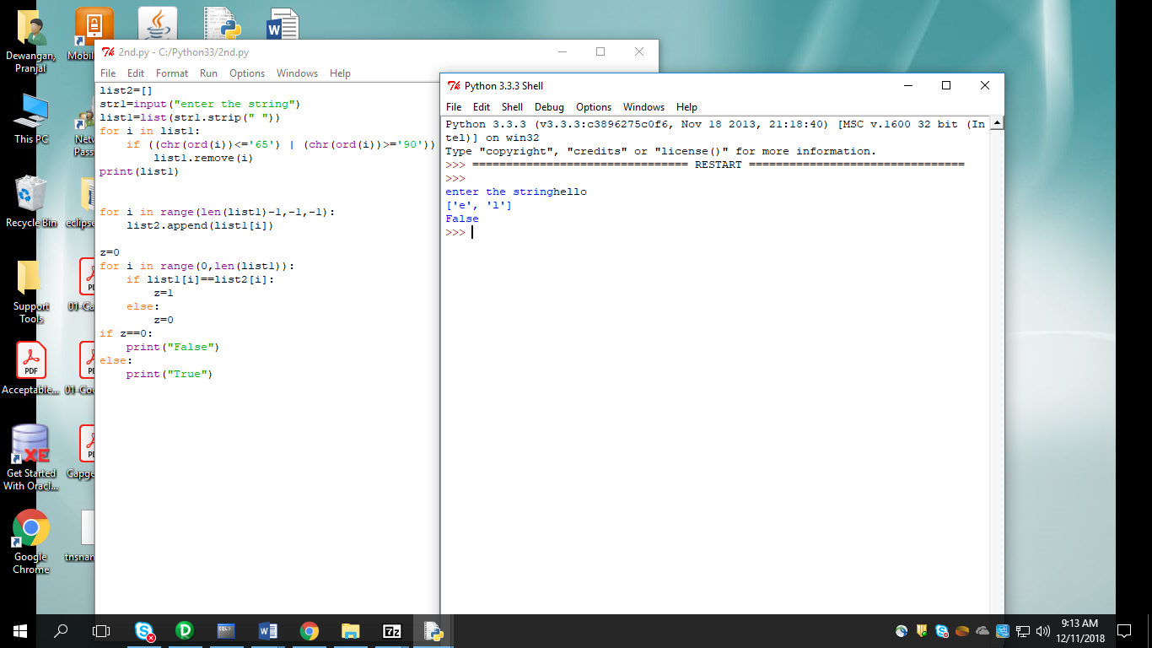

7.

def is_pangram(phrase):

alphabet = "abcdefghijklmnopqrstuvwxyz"

for char in alphabet:

if char not in phrase:

return False

return True

phrase=input("enter the string")

d=is_pangram(phrase)

print(d)

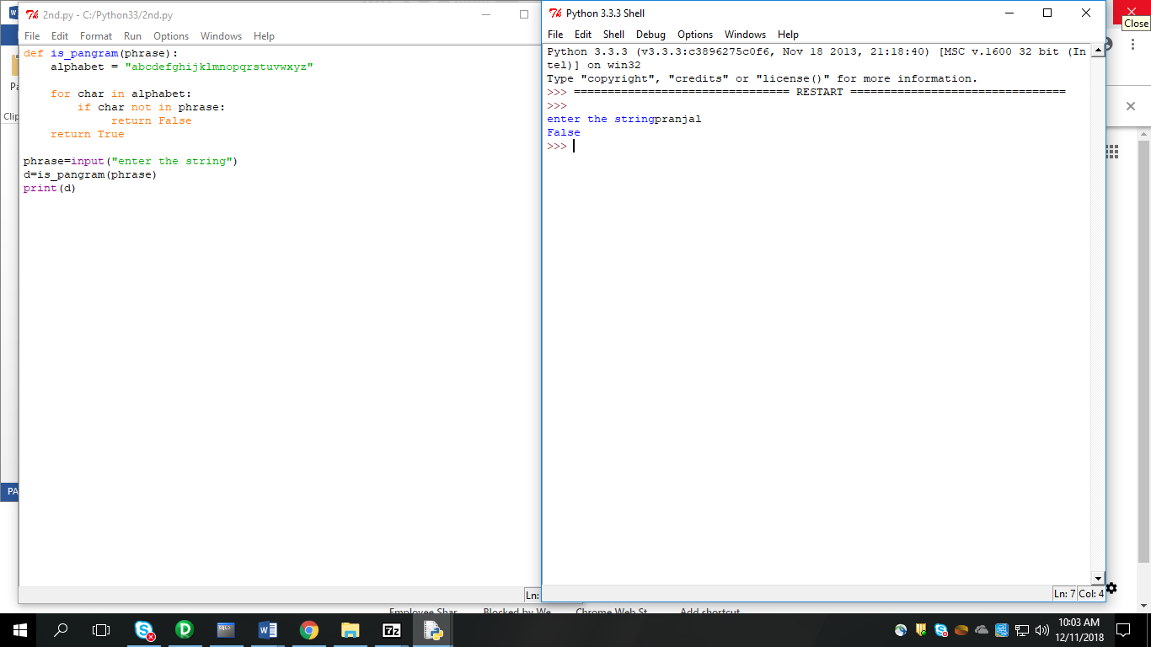

8.

dict1 ={"merry":"god", "christmas":"jul", "and":"och","happy":"gott","new":"nytt", "year":"ar"}

def translate(str1):

list1=str1.split(" ")

list2=[]

for i in list1:

list2.append(dict1[i])

print(list2)

str1=input("enter the english card words")

translate(str1)

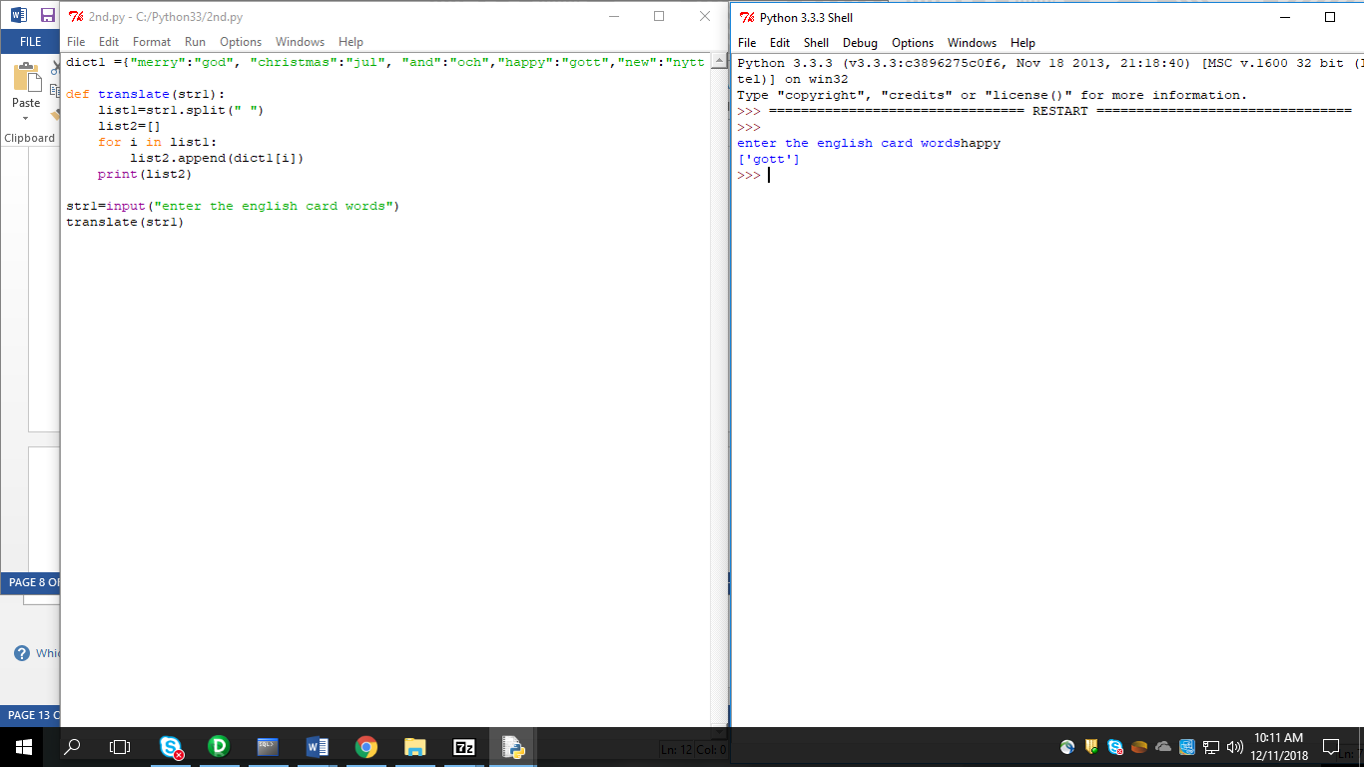

9.

def char_freq(str1):

dict = {}

for n in str1:

keys = dict.keys()

if n in keys:

dict[n] += 1

else:

dict[n] = 1

return dict

str1=input("enter the string")

d=char_freq(str1)

print(d)

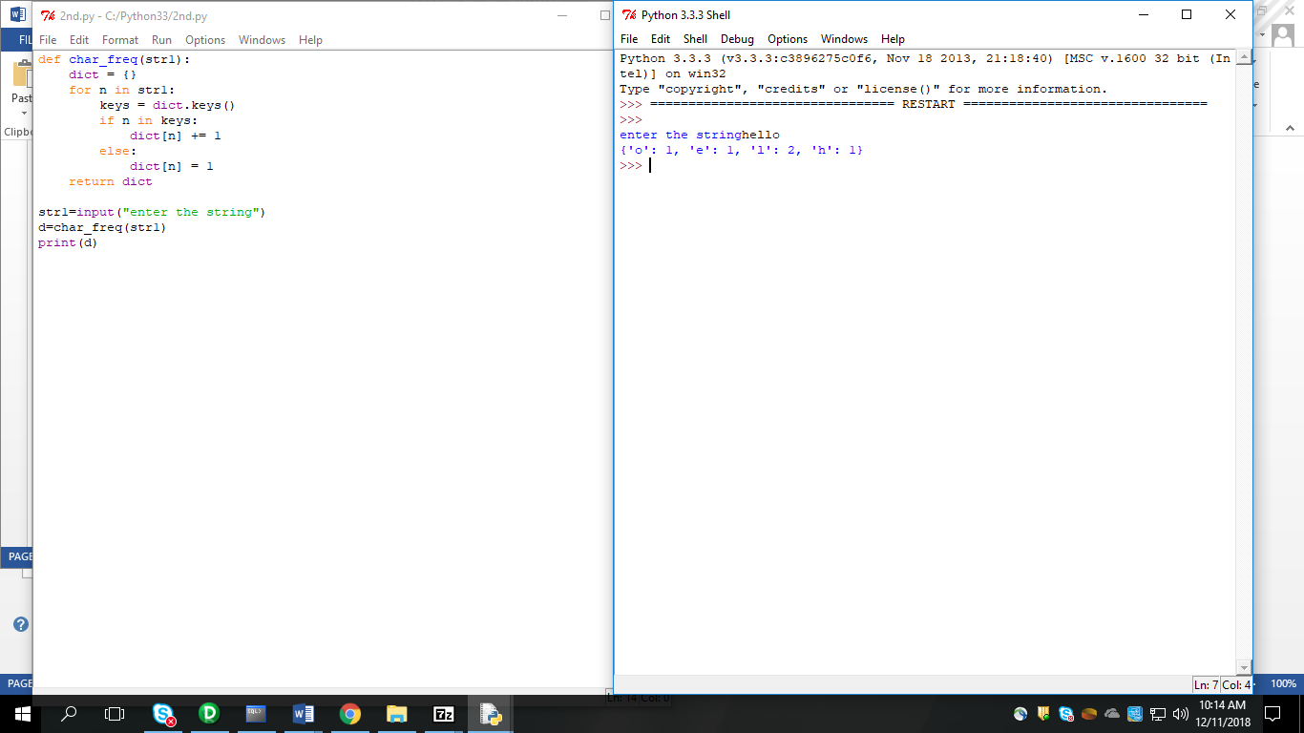

10.

11.

import mathematics

list1 = []

list2 = []

for i in range(int(input("Enter size of list"))):

list1.append(int(input("Enter list1 elements :")))

print("\n")

for i in range(len(list1)):

list2.append(int(input("Enter list2 elements :")))

c = mathematics.add(list1,list2)

d = mathematics.sub(list1,list2)

a = mathematics.Min(c)

b = mathematics.Max(c)

e = mathematics.sort(c)

print("\n")

print("Sum : ",c)

print("Sub : ",d)

print("Mininum : ",a)

print("Maximum : ",b)

print("Sort : ",e)

12. Create a Date class, which represents the Date with its attributes. Write a UseDate class, which makes use of the Date class to instantiate, and call methods on the object.

class Date:

def __init__(self):

self.day = 1

self.month= 1

self.year=1990

def __init__(self,day,month,year):

self.day=day

self.month=month

self.year=year

class UseDate:

def __init__(self):

self.p1=Date(1,1,1990)

def printData(self):

p1=Date(2,7,1996)

print('Date is:',p1.day,"-",p1.month,"-",p1.year)

q1=UseDate()

q1.printData();

13. WAP to read data from one file and writes in second file.

file1 = "one.txt"

file2 = "two.txt"

f1 = open(file1, 'r')

text=f1.read()

print(text)

f1.close()

f2 = open(file2, 'w')

text2 = f2.write(text)

f2.close()

13.

14.