Screenshots:

Movie ticket booking home page:

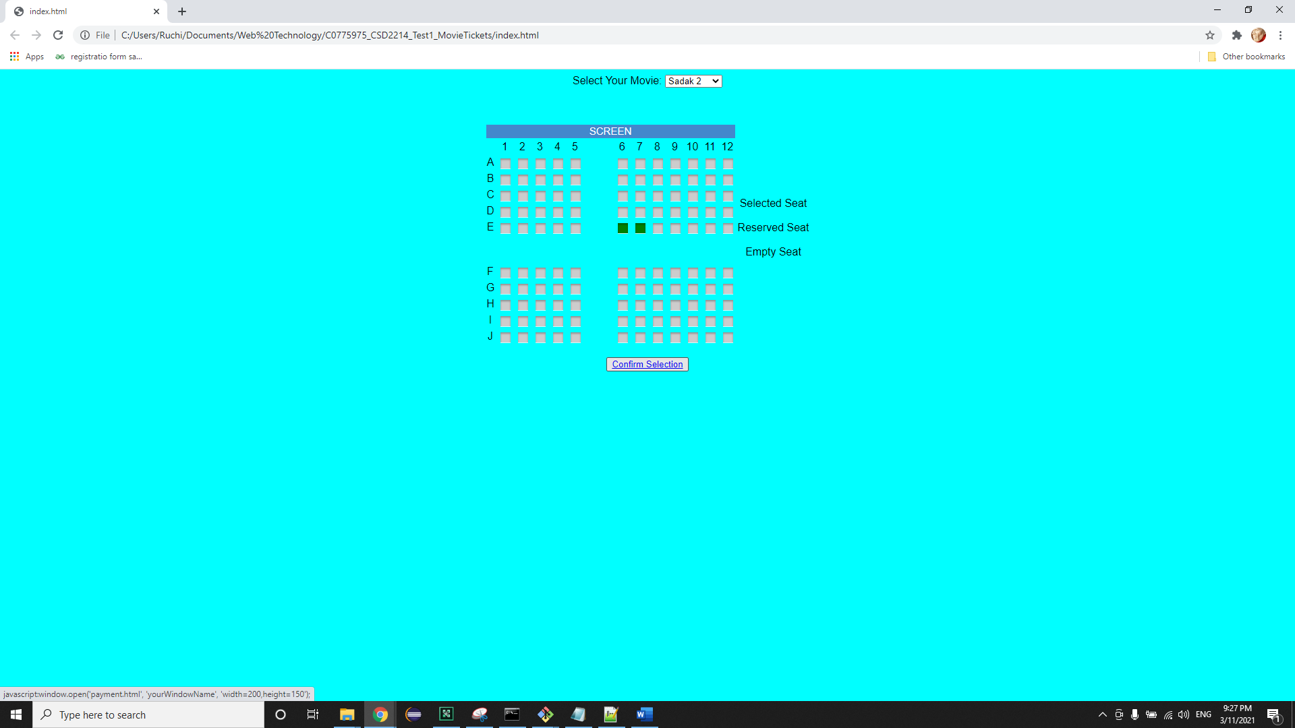

After clicking on Confirm button payment page will displayed the following screen:

