


Proposal
PIPO Production Cleanup and Migration to Integration Suite
for (Customer Name)
Client Name: (Customer Name) |  | Document No: POM/APJ25001CPA
Submission Date: 10-09-25 |  | Document Version: V1.0


Point of Contact:
Sharjeel Siddiqui
Contact: +966 56 585 6823
Email: sharjeel.siddiqui@craveinfotech.com
Vishal Verma
Contact: +49 160 908 19625
Email: vishal.verma@craveinfotech.com

Crave InfoTech
H.O.: 2035 Lincoln Highway Suite: 3008D Edison, NJ- 08817, USA

India office
STPI Building, Hinjewadi phase1, Pune 411057

Index
1. Executive Summary 4
2. About Crave InfoTech 5
3. About #CUSTNAME 6
3.1 About the Client – #CUSTNAME Plc: 6
3.2 Business Verticals & Operational Landscape 6
3.2.1 Convenience store operations (7-Eleven) 6
3.2.2 Wholesale and retail business (CP Axtra) 6
3.2.3 Financial and supporting services 7
3.2.4 Food manufacturing and supply 7
3.2.5 Corporate structure and ownership 8
3.3 Challenges & Project Objective 8
4. Project Scope 9
4.1 Introduction 9
4.2 Proposed Migration Approach Under Migration Factory Program 9
4.3 PIPO Assessment Results & Observation 10
4.3.1 Migration Assessment Analysis – ICOs with T-shirt Sizing 10
4.3.2 Migration Assessment Analysis – Adapter Summary 11
4.3.3 Key Considerations for Migration 11
4.4 Migration Project Realisation Scope 12
4.4.1 Solution Overview 12
4.4.2 Integration Suite Architecture 12
4.4.3 Pre-requisites & Key Assumptions 13
4.4.4 Out of Scope 13
4.4.5 Project Documents Deliverables 13
4.4.6 Bill of Material 14
4.4.7 RACI Matrix 14
5. Project Delivery Approach 15
5.1 Project Organization Structure: 15
5.2 Project Resource Planning (Staffing) 16
5.3 Product Implementation Methodology: 17
5.4 Communication Plan 17
5.5 Issue Resolution and Escalation Procedure 18
5.6 Change Management Process 20
6. Resource allocation, Timelines and Commercials 22
6.1 Resource Allocation 22
6.2 Project Delivery Timelines 22
6.3 Payment terms 24
7. Sign Off 25
8. Key Assumptions 26
8.1 Dependency on Client 26
8.1.1 IT and Infrastructure 26
8.1.2 Network and Connectivity 26
8.1.3 Customer responsibility during the implementation 26
8.2 Other Assumptions 26
8.3 Intellectual Property Rights 27
8.4 Limitation of Liability 27
8.5 General Provisions 27

Executive Summary
(Example) We are thankful to #CUSTNAME team for giving us the opportunity to submit our proposal for PI/PO interface clean-up and migration to Integration Suite on BTP. The primary objective of this document is to outline a comprehensive plan for migrating SAP Process Integration/Process Orchestration (PI/PO) interfaces from their current landscape to the SAP Integration Suite hosted on Cloud (BTP). Specifically focusing on cleaning the existing interfaces on PIPO production environment before migrating to Integration suite.

The proposal aims to detail a structured migration strategy that ensures a seamless transition, maintaining the integrity and functionality of these critical interfaces.
Crave Technologies proposes a comprehensive solution with:
- Implementation of SAP Integration Suite for PI/PO integration migration
- Solution Architecture of Integration Suite
- Cleaning on dummy or unused/inactive interfaces from PI/PO production environment
- Migration of the simple, medium and large complexity interfaces from PI/PO to IS
- Rigorous testing and validation

Crave Technologies boasts a rich history of delivering cutting-edge solutions on SAP BTP
Platform tailored to the unique needs of organizations. We through our domain understanding
and technical competencies have consistently delivered the projects which help organizations
maintain compliance, mitigate risks, and achieve operational excellence.

Being Migration Factory certified partner for Migration Assessment, we get engaged with
customers right from detailed assessments to plan the proper Migration journey. Having
competencies in all the BTP Pillars, we work with organizations to design the complete BTP
roadmap by identifying the right business use cases based on the pain areas and
complexities in their work environment.

We look forward to the opportunity to collaborate with you for this esteemed project execution.

About Crave InfoTech
We are an award-winning SAP PE build, PE-Sell & PE-Services partner who can successfully implement complete enterprise solutions, minimizing total cost of ownership, with rapid deployment and a lasting impact for efficiency and total audit-ready compliance.​


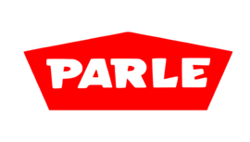

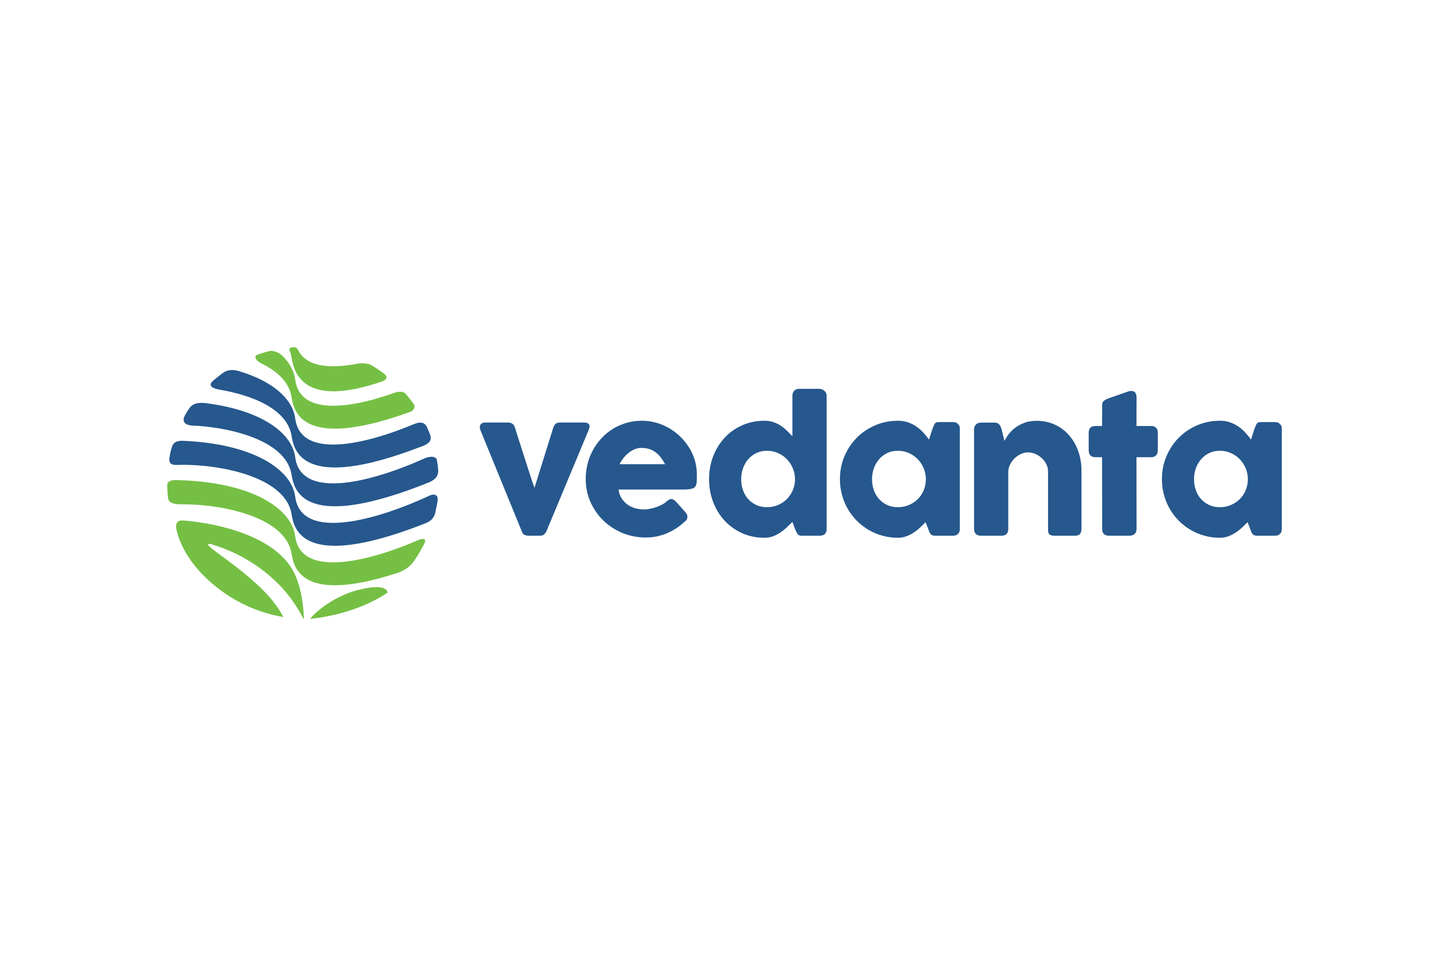





















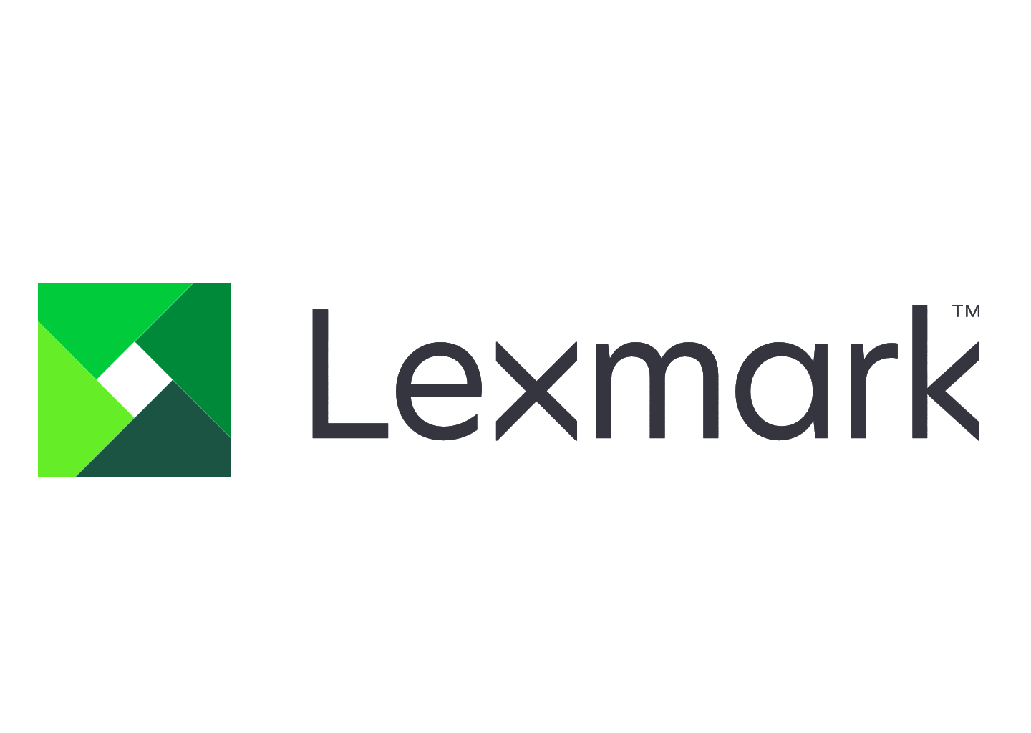





18+



INC. 5000 America’s Fastest Growing Pvt. Companies
NJBIZ Leaders in Digital Tech 2024
SAP BTP Most Valuable Partner Award
Fast 100 Asian American Business’24
SAP ACE Award 2023
Winner SAP ACE Award
SAP Pinnacle Award Finalist
SAP Hack2build Winner
APPs Validated
By ZEBRA
Awards
Certifications
Partners
50+
100+
55+
25+
Years of providing niche SAP consulting across industries
Pre-packed products specific to enterprise automation use cases
Enterprise customers served globally

SAP Business AI Use cases Built

SAP initiatives delivered globally

About #CUSTNAME

About the Client – #CUSTNAME Plc:
#CUSTNAME is one of the largest convenience store operators globally, holding the third-largest number of 7-Eleven stores after the United States.
#CUSTNAME is the largest convenience store operator in Thailand and a key subsidiary of the Charoen Pokphand Group. The company has diversified beyond its famous 7-Eleven stores into a wide range of retail, wholesale, and supporting businesses, making it a powerful and integrated retail leader in the Thai market and beyond.

Business Verticals & Operational Landscape

Convenience store operations (7-Eleven)

- Market dominance: #CUSTNAME is the exclusive operator of 7-Eleven stores in Thailand, a franchise it has held since 1989. It has built the country's most extensive retail network, with tens of thousands of locations across both urban and provincial areas.
- High footfall: The stores are ubiquitous and benefit from exceptionally high footfall. They have evolved into a one-stop-shop for many customers, offering a diverse product mix beyond typical convenience items.
- Product offering: The stores sell a vast array of food and non-food items, including ready-to-eat meals, bakery products, fresh food, beverages, cosmetics, and health products. The company also manufactures and distributes many of these products through its own subsidiaries.
- Digital integration: #CUSTNAME operates the 7-Eleven Delivery service and also engages in e-commerce through its subsidiary, 24 Shopping.

Wholesale and retail business (CP Axtra)

- Strategic acquisition: #CUSTNAME expanded into the wholesale and retail segments through strategic acquisitions. In 2013, it acquired Siam Makro, the leading cash-and-carry retailer in Thailand.
- Brand consolidation: In 2023, CP Axtra was formed through a merger of Siam Makro and Ek-Chai Distribution System (the operator of Tesco Lotus). This consolidation brought the Makro wholesale brand and the Lotus's retail hypermarket and supermarket brands under a single management entity.
- Diversified customer base: This division now serves a wide spectrum of customers. The Makro wholesale brand primarily caters to business-to-business (B2B) clients like small retailers, hotels, restaurants, and caterers, while the Lotus's retail stores serve a broader consumer base.

Financial and supporting services

#CUSTNAME has built an ecosystem of supporting businesses that enhance its core retail and wholesale operations.
- Bill payment and banking: Through its subsidiary, Counter Service, #CUSTNAME provides bill payment services and acts as a banking agent in its 7-Eleven stores.
- Financial technology: It operates Thai Smart Card Co., Ltd., a business focused on financial services.
- Logistics and distribution: To ensure a steady supply chain for its vast retail network, #CUSTNAME operates its own logistics management services.
- Equipment services: CP Retailink provides distribution and maintenance services for retail equipment.
- Educational services: The company's business extends into education through institutions like Panyapiwat Institute of Management (PIM) and related entities, which also serve as training platforms.

Food manufacturing and supply

To secure its supply chain and ensure quality, #CUSTNAME is directly involved in food production and distribution.
- Ready-to-eat food: The company manufactures and sells ready-to-eat and frozen foods that are sold in its retail outlets.
- Baked goods and beverages: It produces and distributes bakery and beverage products under brands like Bellinee's Bake & Brew, All Cafe, and Kudsan.

Corporate structure and ownership

- Parent company: #CUSTNAME is a public company listed on the Stock Exchange of Thailand (SET), but it is a key subsidiary of the Charoen Pokphand Group, one of Thailand's largest conglomerates.
- Strategic vision: This parentage provides #CUSTNAME with significant strategic resources and a vision for continued expansion in retail, technology, and other supporting sectors.

Challenges & Project Objective
Given its significant growth and expanding operational footprint, #CUSTNAME is dedicated to continuously modernizing and advancing its technology ecosystem to proactively support its diverse operational landscape. The company currently leverages a robust SAP ERP and associated application ecosystem. As part of its strategic technology roadmap, #CUSTNAME plans to upgrade its existing SAP Process Integration/Process Orchestration (PI/PO) system to SAP's next-generation offering, SAP Integration Suite. This initiative involves assessing the current PI/PO landscape and executing a migration to the modern cloud-based integration platform, SAP Integration Suite.

Project Scope

Introduction

We are thankful to #CUSTNAME Team for giving us opportunity to submit our SoW for PI/PO to Integration Suite Migration. The primary objective of this document is to outline a comprehensive plan for migrating SAP Process Integration/Process Orchestration (PI/PO) interfaces from their current landscape to the SAP Integration Suite hosted on Cloud. Specifically focusing on the interfaces facilitating integration between the SAP S/4 system. The proposal aims to detail a structured migration strategy that ensures a seamless transition, maintaining the integrity and functionality of these critical interfaces.

  - Crave InfoTech proposes a comprehensive solution with:
  - Implementation of SAP Integration Suite for PI/PO integration process.
  - Solution Architecture
  - Development of robust interfaces for various document exchanges
  - Rigorous testing and validation

Crave InfoTech boasts a rich history of delivering cutting-edge solutions on SAP BTP Platform tailored to the unique needs of organizations. We through our domain understanding and technical competencies have consistently delivered the projects which help organizations maintain compliance, mitigate risks, and achieve operational excellence. Being Migration Factory certified partner for Migration Assessment, we get engaged with customers right from detailed assessments to plan the proper Migration journey.

Having competencies in all the BTP Pillars, we work with organizations to design the complete BTP
roadmap by identifying the right business use cases based on the pain areas and complexities in their work environment. We look forward to the opportunity to collaborate with you for this esteemed project execution.

Proposed Migration Approach Under Migration Factory Program

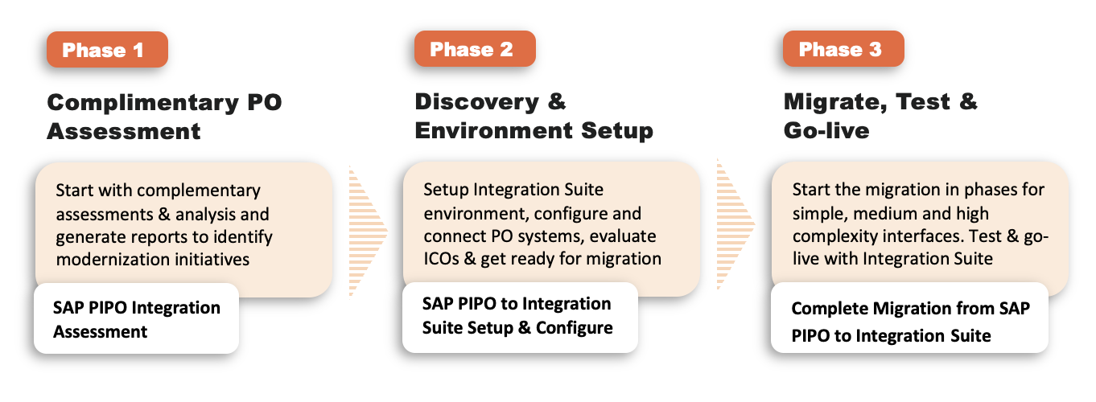

PIPO Assessment Results & Observation

#CUSTNAME’s PIPO Assessment was conducted under SAP Migration Factory team’s supervision, where we analysed the SAP PI/PO interfaces in the production environment for the purpose of migration to SAP Integration Suite in Cloud Foundry. The results of the migration are stated below –

Total Number of Interfaces in Production for Migration | 812

Migration Assessment Analysis – ICOs with T-shirt Sizing

Complexity  Level​ | Small​ | Medium​ | Large​ | Extra  Large​ | Total No. of  Interfaces​
Migrate​ | 221​ | 44​ | -​ | -​ | 265
Adapt​ | 397 | 106 | -​ | -​ | 503​
Evaluate​ | 7 | 35​ | 1​ | 1​ | 44
Total​ | 625 | 185 | 1​ | 1​ | 812

Based on our migration assessment:
- 32.64% of integration scenarios reviewed from your current SAP Process Orchestration system can be migrated presently to the SAP Integration Suite with very few changes needed.
- 61.95% of the integration scenarios reviewed from your SAP Process Orchestration system may be migrated after some adjustments have been made to be ready for usage in the SAP Integration Suite tenant.
- 5.42% of the interfaces should be further evaluated prior to the migration to gather additional information on the migration for those interfaces and their complexity.

Migration Assessment Analysis – Adapter Summary

Adapter | To-be | Sender | Receiver
SFTP | SFTP | 337 | 174
File | SFTP/FTP | 243 | 277
REST | HTTP | 117 | 56
XI | XI | 72 | 277
JMS | AMQP/Kafka | 23 | 49
FTP | SFTP/FTP | 12 | 11
SOAP | SOAP | 4 | 1
IDoc_AAE | IDOC | 4 | 32
Total | Total | 812 | 877

Key Considerations for Migration

Sr.No. | Key Consideration
1 | File adapter should be converted to SFTP (preferrable) / FTP Adapter or wait for file adapter availability on SAP roadmap Q4-2025. – SAP Roadmap
2 | JMS Sender needs to be repurposed with AMQP Adapter, Kafka or other message brokers.​
3 | Analysis is required for Adapter Modules in SAP PI/PO to achieve the same functionality in SAP Integration Suite Cloud Integration.
4 | User credentials/certificates are not migrated. Certificates can be exported from PO and imported to Integration Suite Cloud Integration but not user credentials.
5 | Java Mapping require further evaluation before migrating to Cloud Integration (PO Access is required) as they might change the interface complexity and necessary efforts to do the migration.
6 | OS commands are not supported by integration suite, further evaluation is required.​
7 | JDBC driver is not supported by Integration Suite. However, it is on SAP Roadmap 2025 Q4 to support Generic JDBC Drivers on the Integration Suite. – SAP Roadmap
8 | UDF Mapping require further evaluation before migrating to Cloud Integration (PO Access is required) as they might change the interface complexity and necessary efforts to do the migration.

Migration Project Realisation Scope

Following is the scope of Migration from SAP PI/PO to SAP Integration Suite for S/4 system. The scope also further covers the connection, verification and testing of interfaces in S/4 Hana once conversion to S/4 is completed. We have considered 812 interfaces which are in use.

Solution Overview

Being one of the esteemed SAP migration factory partners, Crave is happy to engage with #CustName in actual migration of 812 interfaces from current PIPO production system to Integration Suite on BTP tenant. Interfaces will be migrated based on complexity starting from ‘Migrate’ to migrate first followed by Adapt and Evaluate complexity interfaces as stipulated in the Project Plan.

Integration Suite Architecture

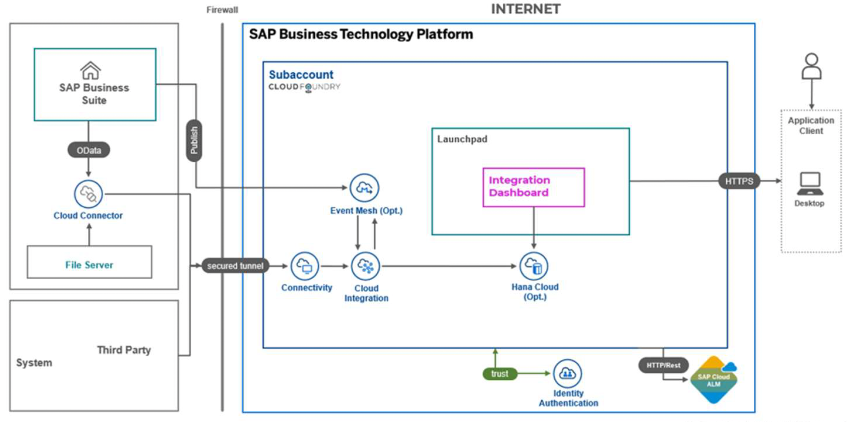

Pre-requisites & Key Assumptions

- SAP Cloud Connector must be setup, provisioned, sized and is made available by #CUSTNAME on day one of the project.
- SAP Integration Suite tenants are setup, available and configured by #CUSTNAME on day one of the project.
- Access to SAP PI/PO system and interfaces will be made available on day one of the project.
- #CUSTNAME needs to provide necessary VPN access to connect to on premise system.
- It is assumed that API already exists and no changes in API is required for API based integration. Any change in API will impact the duration and cost of the project.
- Functional Specifications and Technical specifications for PI/PO – documents to be provided by #CUSTNAME team before start of the project.
- FTP/SFTP file locations to be made available by #CUSTNAME as a part of prerequisite.
- Environments Considered: Dev/QA/Prod. Source and target systems to be made available for development and testing for S/4.
- #CUSTNAME Team shall identify SPOC for functional/technical clarifications who would be empowered to make decisions on behalf of the function they represent. SPOC would be made available as per the detailed project plan.
- Functional and technical specs will be provided by #CUSTNAME during the project Preparation phase.
- UAT is the responsibility of the #CUSTNAME team. All necessary personnel and resources to execute activities associated with testing will be the responsibility of the #CUSTNAME. Migration team will provide input during the development of the testing strategy.
- #CUSTNAME team should adhere to timeline of all phases including BRD and UAT, any more time in respective phases will increase the cost.
- ABAP work (If required) will be taken care by #CUSTNAME team, Crave team has not estimated ABAP resource.

Out of Scope

- New interface development/configuration of Interfaces
- Testing of new interfaces or pre-packaged content
- Enhancements on migrated interfaces
- Required changes to S/4HANA or systems other than SAP Integration Suite
- Custom error handling, alerts/logging
- Transport management approach / changes
- Changes in PIPO System

Project Documents Deliverables

- Technical Specifications for IS in Crave format
- Interface Testing Document in Crave format

Bill of Material
- SAP BTP Cloud Integration
- SAP BTP Cloud Foundry Run Time
- SAP BTP Launchpad
- SAP BTP Identity Authentication

RACI Matrix

Project Phases | #CUSTNAME | Migration Factory Team | Remarks
Requirement Gathering | C | R | -
Providing Access to system | R | C | #CUSTNAME to provide access to the systems and if needed, clarify open points
Configuration and Setup | C | R | #CUSTNAME to support in giving relevant access
Design | R | C | #CUSTNAME to review design artifacts
Development & Build | I | R | -
Migration and UT | R | R | To be reviewed by #CUSTNAME. Pre-requisites for UT (Payload/Files of the interfaces)
SIT | I | R | #CUSTNAME is responsible for Functional/technical team testing
UAT | R | A | Test scenarios & scripts to be prepared by#CUSTNAME
Go-Live | R | C | #CUSTNAME is responsible for Infrastructure support
Hypercare | R | C | -

R – Responsible | A – Accountable | C – Consulted | I - Informed

Project Delivery Approach
Crave InfoTech's Project Delivery methodology has evolved with multiple project delivery experience at various organizations. Our Project Methodology is based on lean principles and adaptive to implementation needs of individual projects and client organizations internal quality processes.

Project Organization Structure:
Below diagram shows the overall engagement team structure. The goal is to provide a single point of accountability between Crave InfoTech and #CUSTNAME for key project activities. Based on the project need, Crave will have the best blend of onsite and offshore resource model to deliver quality solution at optimized cost.

Onsite + Offshore Teams as per project needs
A detailed RACI matrix will also be defined during the Project Initiation phase and a sample is attached below (This is sample plan. The final activity list and the responsibility will depend upon the scope and the responsibility of Crave InfoTech)

Sr No | Activity | Responsibility
1 | Planning and Initiation
1.1 | Preparation Project Plan | Crave/#CUSTNAME
1.2 | Approve the Project Plan | #CUSTNAME
1.3 | Necessary Amendments | Crave/#CUSTNAME
1.3 | Infrastructure Readiness and System Access | #CUSTNAME
2 | PIPO Assessment
2.1 | PO Assessment Setup with Cloud Connector | Crave/#CUSTNAME
2.2 | Availability of user for Assessment Tool Run | Crave/#CUSTNAME
2.3 | Assessment of PIPO Production Environment | Crave/#CUSTNAME
2.4 | Generate and Share Assessment Report | Crave
3. | Baseline Configuration
3.1 | Configuration of SAP Integration Suite | Crave
3.2 | Configuration of Migration Connectors | Crave
3.3 | Approval of the baseline configuration | #CUSTNAME
4. | Project Realization
4.1 | Migration of Simple Complexity ICOs | Crave
4.2 | Migration of Medium Complexity ICOs | Crave
4.3 | Migration of High Complexity ICOs | Crave
4.4 | Connectors Integration testing | Crave / #CUSTNAME
5. | Training
5.1 | Facilities arrangement for training | #CUSTNAME
5.2 | Making user available for training | #CUSTNAME
5.3 | Conducting training for the Core team (train the trainer) | Crave
5.4 | End-User training | #CUSTNAME
6. | Testing – Unit, Integration and Regression
6.1 | Prepare test scenarios | #CUSTNAME/Crave
6.2 | Upload / preparation of standard test data. | #CUSTNAME
6.3 | Conducting test | Crave / #CUSTNAME
6.4 | Review test data | Crave / #CUSTNAME
6.5 | Approval of test results | #CUSTNAME
7. | Documentation
7.1 | Prepare System Documentation | Crave
7.2 | Review and approve documentation | #CUSTNAME
7.3 | End User documentation | Crave / #CUSTNAME
8. | Go Live Run
8.1 | Carry out live run | Crave / #CUSTNAME
8.2 | Review results of live run | #CUSTNAME
8.3 | Approve and sign off | #CUSTNAME
9. | Post Go-Live Support
9.1 | Post go-live support | Crave

Project Resource Planning (Staffing)
During the initiation of the project Crave InfoTech Project/Program manager identifies the resource needs for the entire duration of the project. The offshore Delivery Manager then blocks the resources as per the staffing plan to ensure there is no resource crunch during the project execution, which helps to ensure the project deliveries are on track.
Below table provides the indicative staffing requirements for different project phases that includes execution/implementation activities. During project initiation/planning phase this list will be revisited for any changes.

Project Phase | Functional Consultant | Technical Consultant | Other (Developer, Tester, PM, UI5.ABAP etc.)
Project Preparation | Yes | No | PM (Crave and #CUSTNAME)
PO Migration Assessment | Yes | Yes | PM, Integration Developer
Realization- Migration | No | Yes | PM, Integration Developer
Unit and integration testing | Yes | Yes | PM, Integration Developer & QA
Documentation and user training | Yes |  | QA/Trainer
Cut Over and Go Live | Yes | Yes | PM, Integration Developer & QA
Post Go Live Support | Yes | Yes | PM, QA, Technical Support

Product Implementation Methodology:
Crave InfoTech's implementation methodology has been incorporated with multiple implementation experiences. Our methodology is based on lean principles and adapts to implementation needs.
This section describes our 6 phase implementation methodology covering the activities to be performed in each phase and the deliverables to be produced in those phases.

Communication Plan
Following table represents different reports that will be generated periodically and circulated to various stakeholders.
Exhibit: Daily Interaction
Activity | Communication Mode | Report Recipient/s | Frequency | Comments
Daily Status Report | Email/Telephone | Crave InfoTech and #CUSTNAME Project Manager | Daily | Daily Status Reports informs the project tasks executed on a daily basis
Weekly Status Reports | Email | Crave InfoTech and #CUSTNAME Project Manager | Weekly | Summarize the tasks delivered & issues from the previous week(s), activities planned for the next week & specific events.  Project Effort and Schedule Variance
Additional meetings will be decided during project planning phase as necessary.

Issue Resolution and Escalation Procedure
Crave InfoTech’s Project Manager will identify and capture project related issues that adversely impact the project, launch relevant actions to resolve them, and track and monitor the issues to closure. The Crave InfoTech’s Project Manager will also decide on the appropriate escalations for any critical/unresolved issues.
The responsibilities / timescales for executing these procedures are:

Issue Management
Task | Timescale | Responsibility
Raise Issue Report | As they occur | Any person working on or related to the project
Assessment/ Management of issues | Weekly/periodically | Crave InfoTech Onsite Project Manager
Reporting | Periodically | Crave InfoTech Onsite Project Manager

Following guidelines will be followed for reporting the issues:
- Develop issue report containing problem description and suggested solution. Report to Crave InfoTech Project Manager
- Issues will be documented in issue reports and in the project’s issue log.
- The Crave InfoTech Project Manager is responsible for problem classification together with the issue reporter
- The Crave InfoTech Project Manager will convey the issue to the issue owner and define actions. If the problem is serious or critical, an issue report will be sent with an meeting invite
- The Crave InfoTech Project Manager assign the action to the issue owner or/and action owner
- The Crave InfoTech Project Manager will monitor and follow up the action plan
- The Crave InfoTech Project Manager will terminate the problem handling process when the problem is solved or decided closed
Following exhibit explains the process of issue classification:
Issue Classification
Problem Type | Definition | Reporting process | Solution Responsible
Low | Implies none or low project delay and/or cost increase. | Report to Crave InfoTech Project Manager. Issue handled within the project. | - Crave InfoTech Project Manager
Serious | Implies serious project delay and/or cost increase or influence on working relation. | Report to Crave InfoTech Project Manager and Crave InfoTech Delivery Manager. Inform #CUSTNAME Project manager responsible | - Crave InfoTech Project Manager  - #CUSTNAME Project Manager
Critical | Implies critical treat against the project or working relation. | Immediately report to Crave InfoTech Project Manager, Crave InfoTech Delivery Manager and the member of the Project Core Committee including #CUSTNAME representative | - Crave InfoTech Project Manager  - #CUSTNAME Project Manager
Following escalation process will be followed as part of the issue management:
Exhibit : Escalation Process
Issue Type | Escalation Point | Escalation Criteria | Governance Role (Project Core Group)
Project Delivery | Crave InfoTech Project Manager | If plan to resolve the issue is not outlined within 48 hrs (24 hrs in case of urgent issues) | Weekly checkpoints (or depending on the urgency)  Issue resolution  Quality issues
- Contract  - Unresolved delivery issue  - Program Management issue within specified timeframe | Crave InfoTech Delivery Manager | If plan to resolve issue is not outlined within 48 hrs (24 hrs in case of urgent issues) | Monthly Review  As needed in case of urgent issues
** The Project Workgroup will be comprised of representatives from Crave InfoTech and #CUSTNAME key project stakeholder.

Change Management Process
Crave InfoTech defines Change as “a state different from a previously defined condition”. The goal of Crave InfoTech’s change management process is to ensure that standardised methods and procedures are used for efficient and prompt handling of all changes, in order to minimise the impact of change-related incidents upon service quality, and consequently to improve the day-to-day operations of the in the scope of the project.
Crave InfoTech proposes the following Configuration and Change Management process:
- #CUSTNAME will submit all change requests (Addition, modification, deletion requests related to project scope, environment changes etc.) to Crave InfoTech Project Manager
- Crave InfoTech Project Manager will analyse the impact of the change from implementation perspective.
- In case where the change requested has significant impact and risks to overall success of the project, Crave InfoTech Project Manager will put the request on ‘Hold’ and discuss the impact and the risks involved with #CUSTNAME Project Manager.
- Crave InfoTech Project Manager will plan the implementation timeline to ensure minimal impact to the overall Project timelines.
- Crave InfoTech Project Manager will keep all the stakeholders informed about the changes to project timelines.
- Crave InfoTech Project Manager will keep a change log of all changes that have been made.
- Crave InfoTech Project Manager will ensure that version control is managed
Change Management process will primarily cover the following areas:
- Project Requirements (Project Scope)
- Implementation Environment
- Third party dependencies

Resource allocation, Timelines and Commercials

Resource Allocation
Crave Infotech will deploy following team for this project execution –
Crave Resources | Location | Allocation | Resource Count
Project Manager/Governance | Remote | Partial | 1
Integration Consultants | Remote | Full Time | 2
QA/Business Analyst | Remote | Partial | 1
Basis | Remote | Partial | 1
#CUSTNAME will deploy following team for this project execution –
Crave Resources | Location | Allocation | Resource Count
#CUSTNAME Project Manager | On-site | Partial | 1
Integration Developers | On-site | Full Time | 2
QA/Business Analyst | On-site | Partial | 1
#CUSTNAME will assign their respective required project team during the project. On request from #CUSTNAME we have reduced the number of integration developers enabling #CUSTNAME team to have their integration developers collaborate with Crave team. They will have to adhere to the project timeline during all phases for needful accesses, approvals, availability of resources and testing. Any delay in timeline due to non-availability of resources form #CUSTNAME, will increase the project cost for the additional number of days for Crave resources.

Project Delivery Timelines
Considering the fact that #CUSTNAME’s production have some inactive ICOs which needs to be cleaned before migrating to Integration Suite, Crave suggests phases in project delivery, mainly–

Phase 1: Setup, configure and clean-up of inactive interfaces
Phase 2: Migrate interfaces as per the standard migration protocol under migration factory program.

These phases are combined in one project delivery plan listed below -

Following will be the commercials of this project –
Sr. | Particulars | Total Cost in SGD
1 | Migration from PIPO to Integration Suite with Shared Resources (Including PO Clean-up) | USD. XXXX /-
Total Project Cost |  | USD. XXXX /-
In words: XXXX Dollars Only

Terms / Notes:
- This price is inclusive of inactive or redundant ICO cleaning from #CUSTNAME’s PIPO system. The cleaning phase is for around a month and both #CUSTNAME and Crave teams would work together.
- The quoted price is considering collaborative effort estimation. #CUSTNAME team is liable to provide 2 integration developers/consultant throughout the project. The Integration developers/consultant must meet Crave’s quality standards for the project to be executed in the promised timeline.
- Prices are exclusive of VAT or any local taxes.
- Crave’s team will handle the project remotely, if the client wants any resource to travel on-site, the cost to fulfil such request will be calculated at actual on FTA basis and shall be charged separately.
- Any delay due to #CUSTNAME Approval process / UAT process or Delay in dependent activity will impact the implementation timeline.

Payment terms

Sr. No. | Payment milestones | % of total payment
1 | Advance with PO | 30%
2 | After Simple Complexity Interfaces Migrated to Integration Suite | 20%
3 | After Medium Complexity Interfaces Migrated to Integration Suite | 20%
4 | After Large Complexity Interfaces Migrated to Integration Suite | 20%
5 | After UAT, Verification & Testing & Go Live is Complete | 10%
- Pyment to be released in Net 30 days from the date of invoice

Sign Off
IN WITNESS WHEREOF, Crave InfoTech and #CUSTNAME have each caused this Project SoW to be executed by their respective duly authorized officers as of the Effective Date.
The undersigned agree to the terms of this proposal on behalf of his or her organization or business.

#CUSTNAME Crave InfoTech
By: By:
Authorized Signature Authorized Signature
Name Name - Vrushali Nistane

Date: Date: 10th September, 2025

Key Assumptions

Dependency on Client

IT and Infrastructure
- Provider team will require necessary development and testing access to the Development and QA landscape.
- Provider team might need access to existing Client landscape with appropriate authorization during the post go live support phase to troubleshoot any potential issues.
- During the timeline of this project if Provider team members are on-site then the Client will make adequate seating arrangements in their office.

Network and Connectivity
- Proper VPN network is required for system connectivity in an office environment.
- For providing remote support as well as trouble-shooting purpose we need a secured internet medium to access the server.

Customer responsibility during the implementation
- Provider team will train the Customer ‘train the trainer’ to perform the end-user training.
- Customer functional team will provide the details about existing user exits, and functions applicable for this process area to the Provider team as we have not built a buffer for learning the Customer system
- Resourcing structure is designed to implement the solution from a remote location.

Other Assumptions
- All data required for implementation will be collated and provided by the Client within 2 business days after the request or as per the project schedule.
- All sign-offs required for milestones or project stages (e.g. project preparation approval, Realization approval etc.) are required within 2 business days as long as said milestones or project stages are completed.
- Any delays in sign offs could have an adverse impact on the implementation schedule and may lead to additional cost.
- Logical access to the customer’s data centre including current source files, documentation, databases and remote access connection to the staging server with similar configuration that of the production server will be provided to Provider resources.
- Facilities for Provider staff in case working from the customer premises including but not restricted to, Desktop, connectivity & Telephone lines will be provided by the Client.
- The Client will provide supporting documentation for the Provider project team members as necessary.
- Change Management will be handled by Customer

Intellectual Property Rights
- Crave InfoTech has built reusable mobility components to be leveraged during new application development. This reusable suite of mobility objects is the Intellectual Property of Crave InfoTech and will remain as IP of Crave InfoTech.
- Crave InfoTech uses this reusable library to fast track the client project development and implementation to leverage the benefits to client business team on a short time frame.
- The reusable mobility components used in the proposed Project App shall have to be shared in a reusable form with usage rights and usage guide to #CUSTNAME to avoid future support issues. #CUSTNAME shall use it only for proposed application extensions/ redevelopments
- Any Custom development is done by Crave InfoTech for #CUSTNAME as per the specific requirements given by them only will be the IP of #CUSTNAME and shall not be replicated/ reused without written permission of #CUSTNAME.

Limitation of Liability
In no event shall either party be liable to the other party hereto for any indirect, incidental, collateral, special, punitive, unforeseen, exemplary or consequential damages, including lost profits, lost savings, loss of use, lost revenue or lost goodwill, regardless of the form of action or theory of recovery, even if such party has been advised of the possibility of such damages. Neither party’s liability under this Agreement shall exceed the total fees due or paid under this Agreement.

General Provisions
During the term of this Agreement and for Two years after termination (the “Prohibition Period”), neither party shall solicit any of the other party’s personnel involved in the Services to consider alternative employment. Nor shall either party hire or obtain the services of such personnel directly or indirectly for the Prohibition Period. For the avoidance of doubt, the preceding sentence does not forbid a solicitation to the general public.

