


AI Proposal for (Customer Name)
Client Name: (Customer Name) |  | Document No: <DOCUMENT_NO>
Submission Date: <SUBMISSION_DATE> |  | Document Version: V1.0

Point of Contact:
Sharjeel Siddiqui
Contact: +966 56 585 6823
Email: sharjeel.siddiqui@craveinfotech.com
Vishal Verma
Contact: +49 160 908 19625
Email: vishal.verma@craveinfotech.com

Crave InfoTech
H.O.: 2035 Lincoln Highway Suite: 3008D Edison, NJ- 08817, USA

India office
STPI Building, Hinjewadi phase1, Pune 411057

Index
1. Executive Summary 4
2. About Crave InfoTech 5
3. About #CUSTNAME 6
4. Project Scope 7
4.1 Introduction 7
4.2 Proposed Migration Approach Under Migration Factory Program 7
4.3 PIPO Assessment Results & Observation 8
4.3.1 Migration Assessment Analysis – ICOs with T-shirt Sizing 8
4.3.2 Migration Assessment Analysis – Adapter Summary 8
4.3.3 Key Considerations for Migration 8
4.4 Migration Project Realisation Scope 9
4.4.1 Solution Overview 9
4.4.2 Integration Suite Architecture 9
4.4.3 Pre-requisites & Key Assumptions 10
4.4.4 Out of Scope 10
4.4.5 Project Documents Deliverables 10
4.4.6 Bill of Material 11
4.4.7 RACI Matrix 11
5. Project Delivery Approach 12
5.1 Project Organization Structure: 12
5.2 Project Resource Planning (Staffing) 13
5.3 Product Implementation Methodology: 14
5.4 Communication Plan 14
5.5 Issue Resolution and Escalation Procedure 15
5.6 Change Management Process 17
6. Resource allocation, Timelines and Commercials 19
6.1 Resource Allocation 19
6.2 Project Delivery Timelines 19
6.3 Payment terms 20
7. Sign Off 21
8. Key Assumptions 22
8.1 Dependency on Client 22
8.1.1 IT and Infrastructure 22
8.1.2 Network and Connectivity 22
8.1.3 Customer responsibility during the implementation 22
8.2 Other Assumptions 22
8.3 Intellectual Property Rights 23
8.4 Limitation of Liability 23
8.5 General Provisions 23

Executive Summary
<EXEC_SUMMARY>

About Crave InfoTech
<ABOUT_CRAVE>


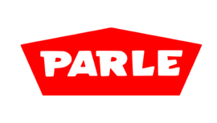

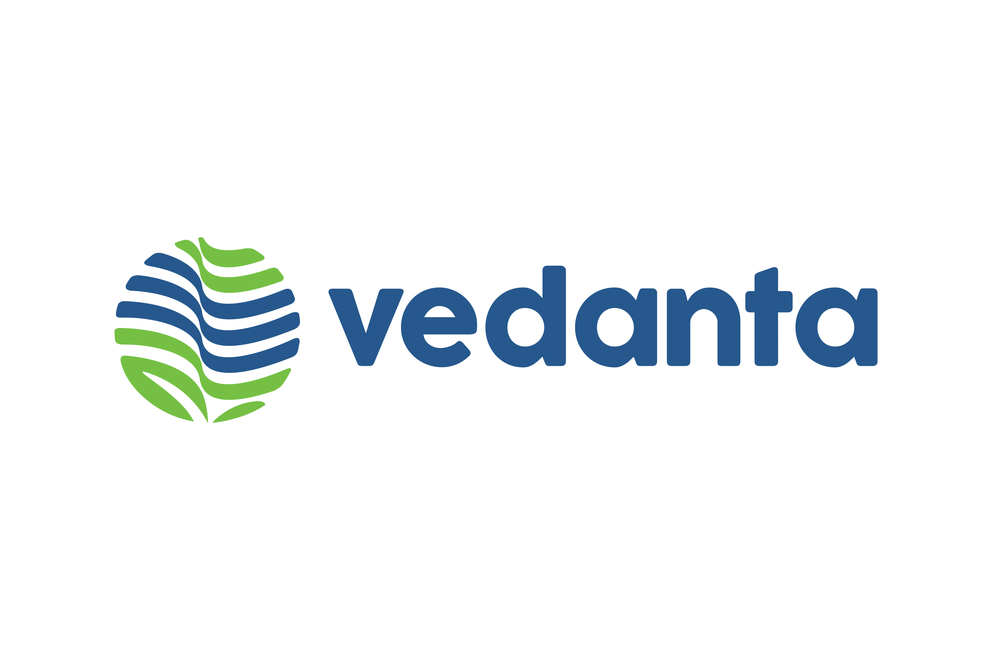
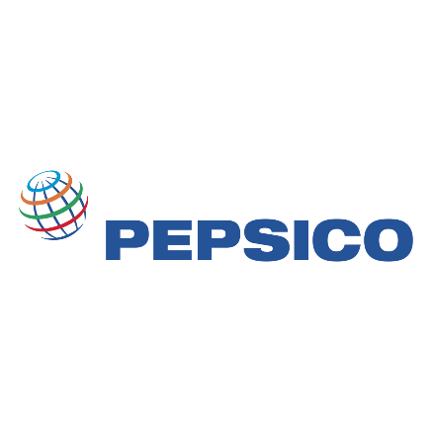


























18+



INC. 5000 America’s Fastest Growing Pvt. Companies
NJBIZ Leaders in Digital Tech 2024
SAP BTP Most Valuable Partner Award
Fast 100 Asian American Business’24
SAP ACE Award 2023
Winner SAP ACE Award
SAP Pinnacle Award Finalist
SAP Hack2build Winner
APPs Validated
By ZEBRA
Awards
Certifications
Partners
50+
100+
55+
25+
Years of providing niche SAP consulting across industries
Pre-packed products specific to enterprise automation use cases
Enterprise customers served globally

SAP Business AI Use cases Built

SAP initiatives delivered globally

Our Understanding & Solution
<OUR_SOL>

Project Scope
<PROJECT_SCOPE>

Project Approach
<DELIVERY_APPROACH>

Project Phase | Functional Consultant | Technical Consultant | Other (Developer, Tester, PM, UI5.ABAP etc.)
Project Preparation | Yes | No | PM (Crave and #CUSTNAME)
Business Blueprint/Detailed Design | Yes | Yes | PM, Developer, Functional (Crave (Customer Name))
Realization- Development | Yes | Yes | PM, Developer, and Functional (Crave and (Customer Name))
Unit and integration testing | Yes | Yes | PM, Developer, and Functional (Crave and (Customer Name))
Documentation and user training | Yes |  | QA/Trainer (Crave and (Customer Name))

Resource Allocation

Project Organization Structure:
Below diagram shows the overall engagement team structure. The goal is to provide a single point of accountability between Crave InfoTech and #CUSTNAME for key project activities. Based on the project need, Crave will have the best blend of onsite and offshore resource model to deliver quality solution at optimized cost.

Resources for Implementation

Sr | Resources | Location | Hours
1 | Project Manager | Onshore
2 | SAP Functional Consultant (IM/WM) | Onshore
3 | SAP Technical Consultant | Offshore
4 | UI/UX Consultant | Offshore
5 | BASIS Consultant | Offshore
6 | Hardware Consultant | Onshore

Timelines
<TIMELINES>

Commercials & Payment Terms

.
Sr. | Particulars | Total Cost in SGD
1 | Migration from PIPO to Integration Suite with Shared Resources (Including PO Clean-up) | USD. XXXX /-
Total Project Cost |  | USD. XXXX /-
In words: XXXX Dollars Only
<PAYMENT_TERMS>

Sign Off
IN WITNESS WHEREOF, Crave InfoTech and #CUSTNAME have each caused this Project SoW to be executed by their respective duly authorized officers as of the Effective Date.
The undersigned agree to the terms of this proposal on behalf of his or her organization or business.

#CUSTNAME Crave InfoTech
By: By:
Authorized Signature Authorized Signature
Name Name - Vrushali Nistane

Date: Date: <SUBMISSION_DATE>

Key Assumptions
<KEY_ASSUMPTIONS>

