


Proposal Clean Core Assessment with Crave’s CoreAssess.AI for (Customer Name)
Client Name: (Customer Name) |  | Document No: <DOCUMENT_NO>
Submission Date: <SUBMISSION_DATE> |  | Document Version: V1.0

Point of Contact:
Sharjeel Siddiqui
Contact: +966 56 585 6823
Email: sharjeel.siddiqui@craveinfotech.com
Vishal Verma
Contact: +49 160 908 19625
Email: vishal.verma@craveinfotech.com

Crave InfoTech
H.O.: 2035 Lincoln Highway Suite: 3008D Edison, NJ- 08817, USA

India office
STPI Building, Hinjewadi phase1, Pune 411057

Index
1. Executive Summary 3
2. About Crave InfoTech 4
3. Our Understanding 5
4. Project Scope 6
5. Proposed Solution Approach 7
5.1 Proposed Approach 7
6. Team Structure 8
6.1 Project Organization Structure: 8
6.2 Resource Allocation 8
7. Timelines 10
Project Delivery Timelines 10
8. Commercials & Payment Terms 11
8.1 Commercials - 11
8.2 Payment terms 11
9. Sign Off 12
10. Key Assumptions 13
11. Appendix 14

Executive Summary
<EXEC_SUMMARY>

About Crave InfoTech
<ABOUT_CRAVE>


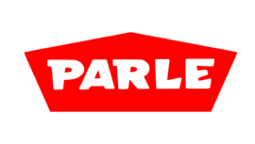





























18+



INC. 5000 America’s Fastest Growing Pvt. Companies
NJBIZ Leaders in Digital Tech 2024
SAP BTP Most Valuable Partner Award
Fast 100 Asian American Business’24
SAP ACE Award 2023
Winner SAP ACE Award
SAP Pinnacle Award Finalist
SAP Hack2build Winner
APPs Validated
By ZEBRA
Awards
Certifications
Partners
50+
100+
55+
25+
Years of providing niche SAP consulting across industries
Pre-packed products specific to enterprise automation use cases
Enterprise customers served globally

SAP Business AI Use cases Built

SAP initiatives delivered globally

Our Understanding
<OUR_SOL>

Project Scope
<PROJECT_SCOPE>

Proposed Solution Approach

Proposed Approach

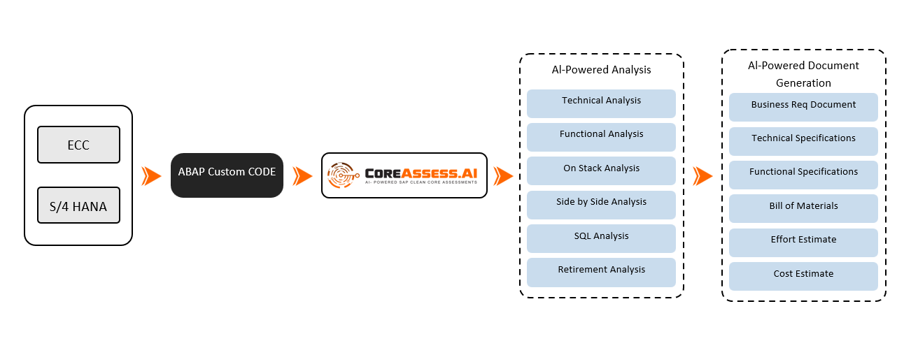
<DELIVERY_APPROACH>

Team Structure

Project Organization Structure:
Below diagram shows the overall engagement team structure. The goal is to provide a single point of accountability between Crave InfoTech and #CUSTNAME for key project activities. Based on the project need, Crave will have the best blend of onsite and offshore resource model to deliver quality solution at optimized cost.

<TEAM_STRUCTURE>

Resource Allocation
Crave Infotech will deploy following team for this POC execution –

Crave Resources | Activity | Type | Effort
ABAP Dev | Extract ABAP Objects | One-time
 | Perform Automated Assessment with Crave Team | One-time
 | Assessments Review & Validation | One-time
Tech Architecture | Architecture Analysis | One-time
 | Assessment Dashboard Review | Ongoing
 | Final Recommendation & Reporting Analysis | Ongoing
Functional Expert | Business Requirements Validation | Ongoing

#CUSTNAME will deploy following team for this project execution –

#CUSTNAME Resources | Activity | Type | Effort
ABAP Dev | Extract ABAP Objects | One-time
 | Perform Automated Assessment with Crave Team | One-time
 | Assessments Review & Validation | One-time
Tech Architecture | Architecture Analysis | One-time
 | Assessment Dashboard Review | Ongoing
 | Final Recommendation & Reporting Analysis | Ongoing
Functional Expert | Business Requirements Validation | Ongoing

#CUSTNAME will assign their respective required project team during the POC for smooth execution and co-ordination. Crave will ensure #CUSTNAME’s team will not spend significant time and bandwidth on the POC.

Timelines

Project Delivery Timelines
For this POC, Crave follows a phase wise approach, mainly–
- Phase 1 - Assessment Kick-off: Initial meeting to define scope and objectives.
- Phase 2 - Discovery & Object Extraction: Automated and manual extraction of ABAP objects.
- Phase 3 - Assessment & Categorization: Running CoreAssess.AI and categorizing objects.
- Phase 4 - Insights & Recommendation: Reviewing findings and providing recommendations.
- Phase 5 - Report Preparation & Review: Compiling and reviewing the final report.
- Phase 6 - Presentation & Sign-off: Presenting findings and obtaining client sign-off.

Commercials & Payment Terms

Commercials -

Sr. | Particulars | Total Cost
1 | CoreAssess.AI – Complimentary Clean Core Assessment of Custom ABAP Objects/Programs | USD. 0 /-
Total Project Cost |  | USD. 0 /-
In words: Zero Dollars Only

Terms / Notes:
- For the purpose of complimentary assessment, we are sharing a zero dollar commercial contract
- This contract is mainly for legal purpose of complimentary POC.

Payment terms
<PAYMENT TERMS>

Sign Off
IN WITNESS WHEREOF, Crave InfoTech and #CUSTNAME have each caused this Project SoW to be executed by their respective duly authorized officers as of the Effective Date.
The undersigned agree to the terms of this proposal on behalf of his or her organization or business.

#CUSTNAME Crave InfoTech
By: By:
Authorized Signature Authorized Signature
Name Name - Vrushali Nistane

Date: Date: <SUBMISSION_DATE>

Key Assumptions
<KEY_ASSUMPTIONS>

Appendix
<APPENDIX>

