
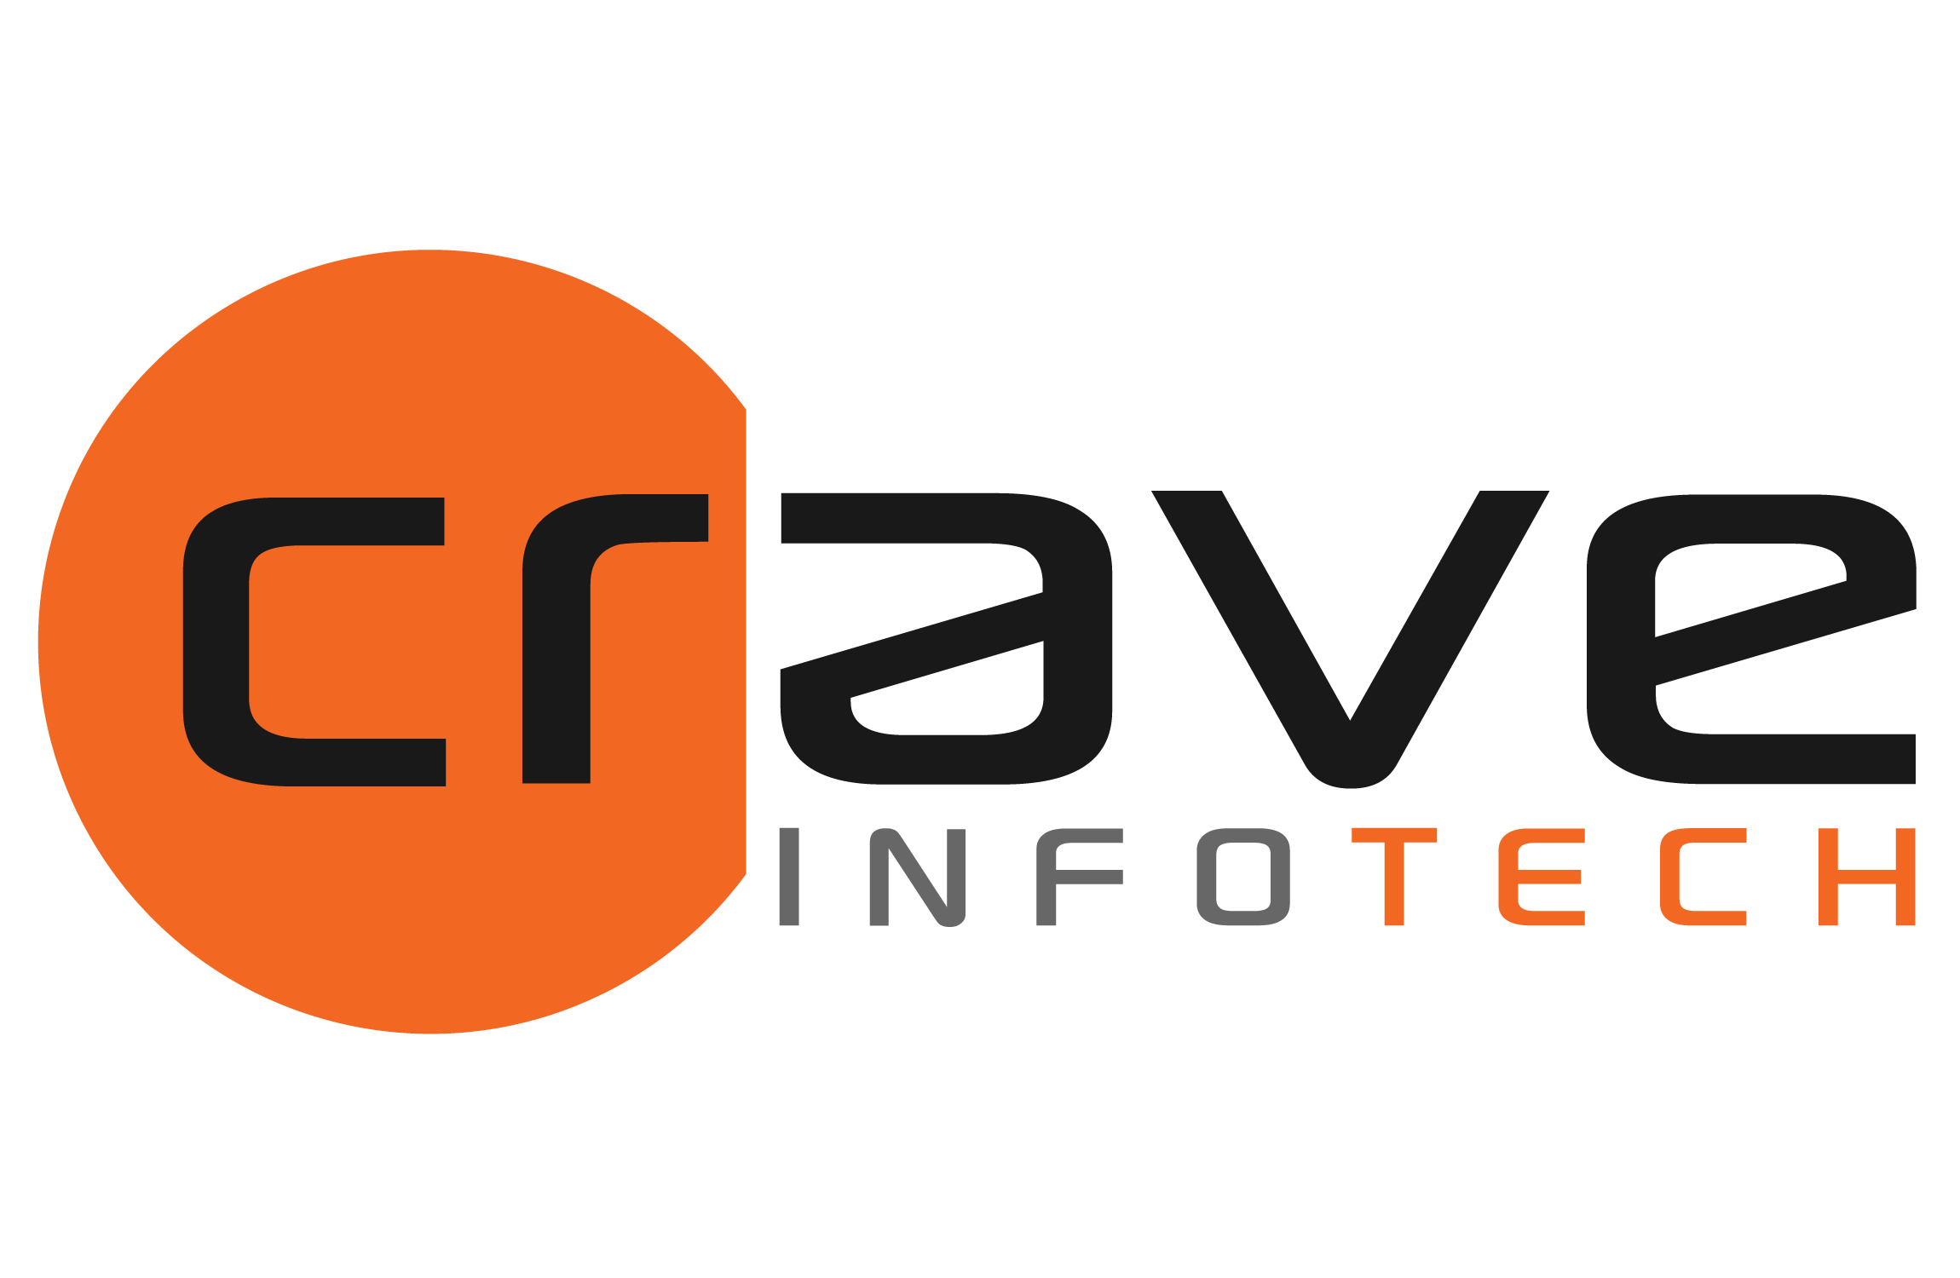

SOW
for
CoreAssess.AI
for
<Client Name>

Submitted on:
Version: 1.0

By:
Crave InfoTech
2035 Lincoln Highway, Suite3008D, Edison NJ 08817

Point of Contact:
Shrikant Nistane
Contact: +1 253 241 6704
Email: Shrikant@craveinfotech.com

Kalpana Parekh
Contact: +1 416 688 0297
Email: Kalpana@craveinfotech.com

Table of Contents
1. Executive Summary 3
2. Features of CoreAssess.AI 4
3. CoreAssess.AI – Assessment Findings 5
4. Key Findings & Recommendations Summary 6
5. Benefits Over Traditional Assessment 7
6. Working Together 8
Sign Off Working Together - ABAP Objects 8
7. Working Together – ABAP Objects 9
8. Annexure 10

<<CONTENT START>>

