**Proteus simulation output**

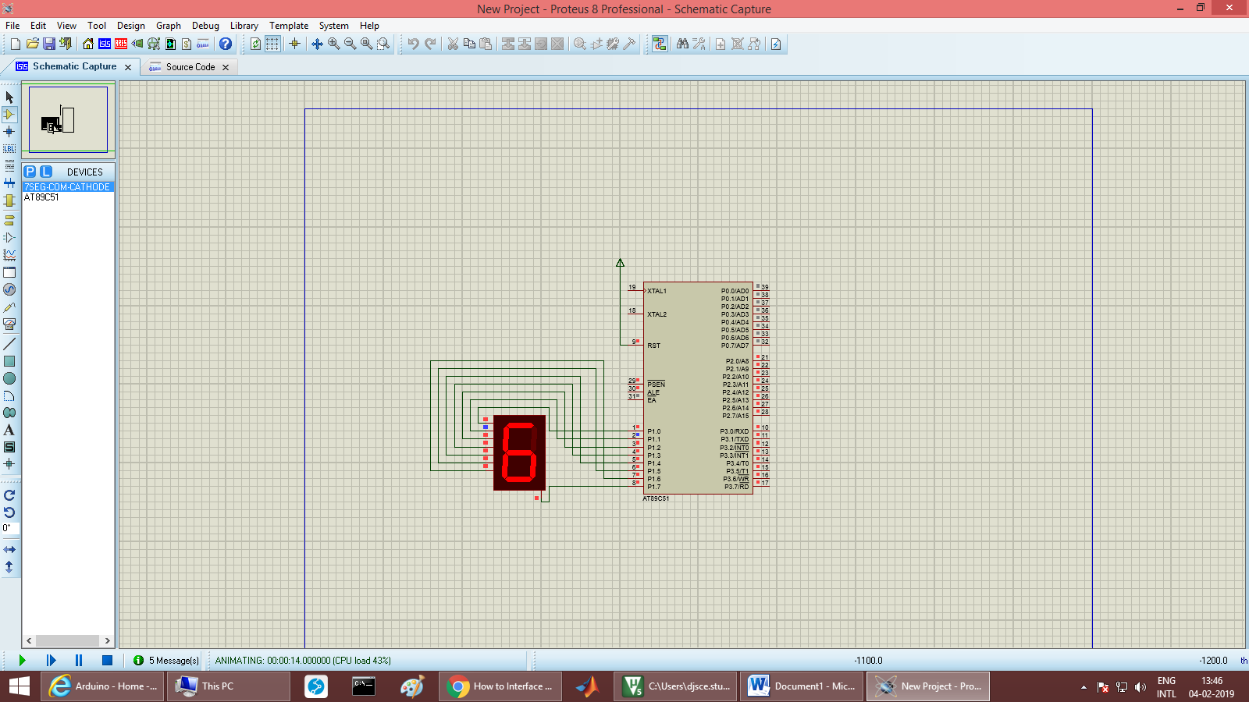

Keil project window:

org 0000H

start: mov DPTR,#0100H

mov r2, #0aH

mov r3, #00H

up1: mov a,r3

movc a, @a+DPTR

mov p1,a

moov r5,#0ffH

up:nop

nop

nop

nop

djnz r5,up

inc r3

djnz r2,up1

ljmp start

org 100H

db 3fH,06H,5bH,4fH,66H,6dH,7dH,07H,7fH,6fH

end