Code

area add,code,readonly

entry

mov r0,#0x0

mov r1,#0x0a

mov r4,#0

adr r2,data

loop ldr r3,[r2,r4]

add r0,r3,r0

add r4,r4,#4

subs r1,r1,#1

bne loop

stop b stop

align

data dcd 1,1,1,3,1,1,1,1,1,1

end

output

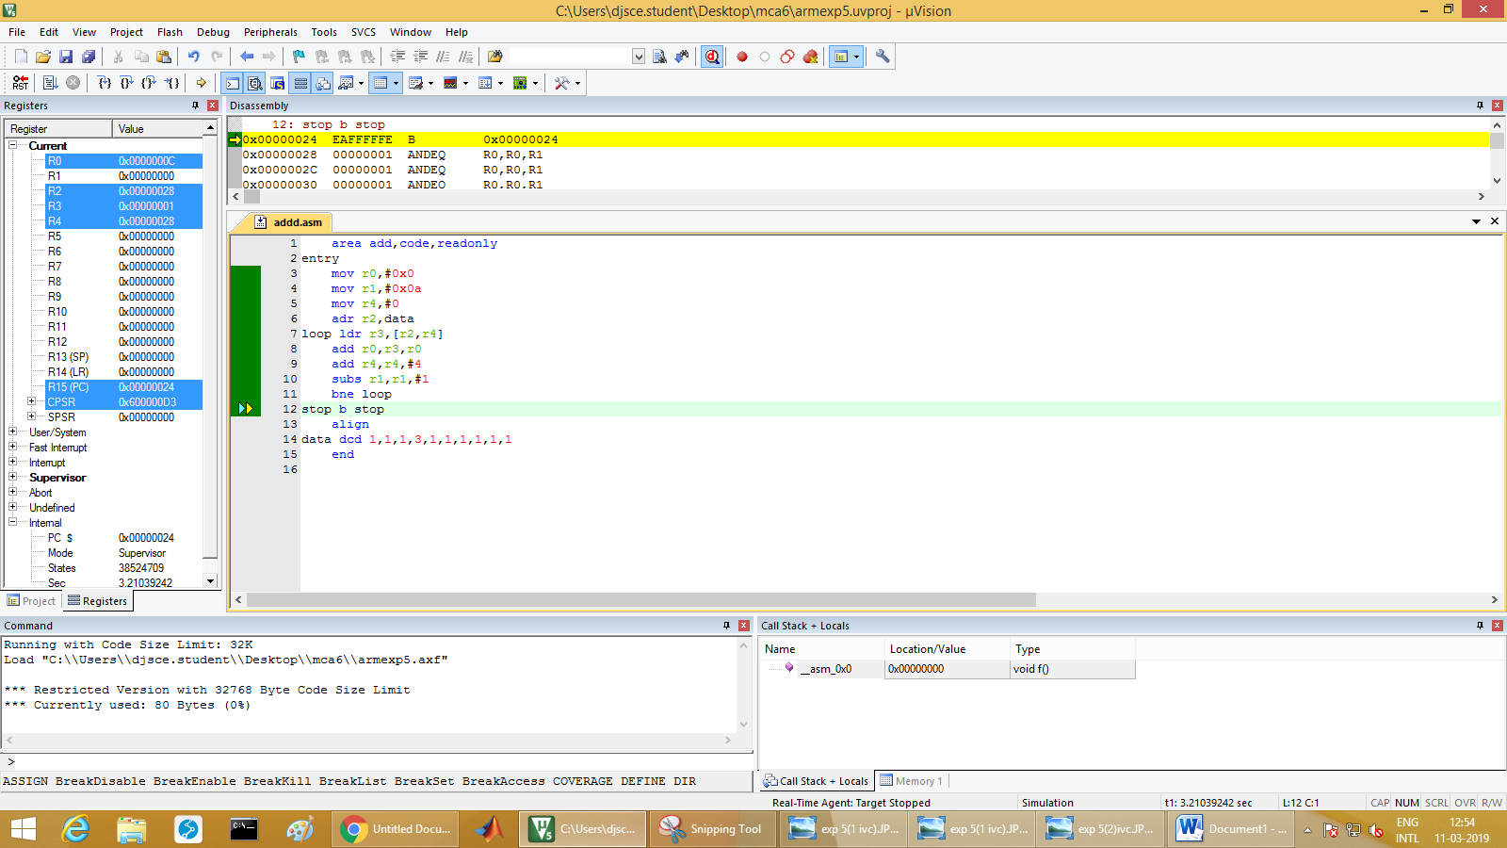

Code:

areamaths,code,readonly

entry

mov r7,#0x40000000

mov r8,#0x40000004

ldr r0,[r7]

ldr r1,[r8]

add r2,r1,r0

str r2,[r7,#8]

sub r2,r1,r0

str r2,[r7,#12]

umull r3,r2,r1,r0

str r3,[r7,#16]

str r2,[r7,#20]

exit b exit

end

Output:

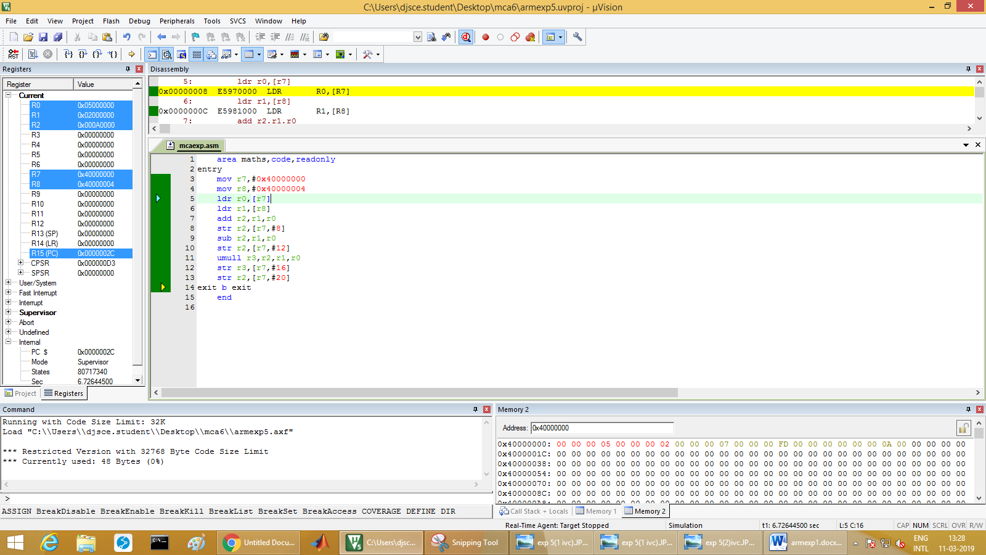

Code largest

arealargest,code,readonly

entry

mov r0,#00

mov r1,#0x0a

adr r2,array

mov r3,#0

loopldr r4,[r2,r3]

cmp r0,r4

bcc carry

carr2 add r3,r3,#4

subs r1,r1,#1

bne loop

stop b stop

carrymov r0,r4

b carr2

align

arraydcd 2,4,9,8,4,7,3,2,1,0

end

output

