CODE

clc;

closeall;

clearall;

a=imread('C:\Users\djsce.student\Desktop\pri2.jpg');

a=imresize(a,[256 256]);

subplot(3,3,1);

imshow(a);

title('original image');

a=rgb2gray(a);

psf=fspecial('motion',21,11);

c=imfilter(a,psf,'conv','circular');

subplot(3,3,2);

imshow(c);

title('filter image');

d=deconvwnr(c,psf,0.2);

subplot(3,3,3);

imshow(d);

title('deconvolution image');

e=imnoise(c,'salt& pepper',0.1);

subplot(3,3,4);

imshow(e);

title('salt & pepper noise image');

f=imnoise(c,'gaussian',0.1);

subplot(3,3,5);

imshow(f);

title('gaussian noise image');

g=deconvwnr(e,psf,0.1);

subplot(3,3,6);

imshow(g);

title('deconvolution of salt&pepper image');

h=deconvwnr(f,psf,0.1);

subplot(3,3,7);

imshow(h);

title('deconvolution of gaussian noise image');

i=medfilt2(e);

subplot(3,3,8);

imshow(h);

title('salt n pepper by median filter')

j=medfilt2(f);

subplot(3,3,9);

imshow(h);

title('gaussian by median filter')

figure

imshow(300\*psf);

title('motion image');

Output:

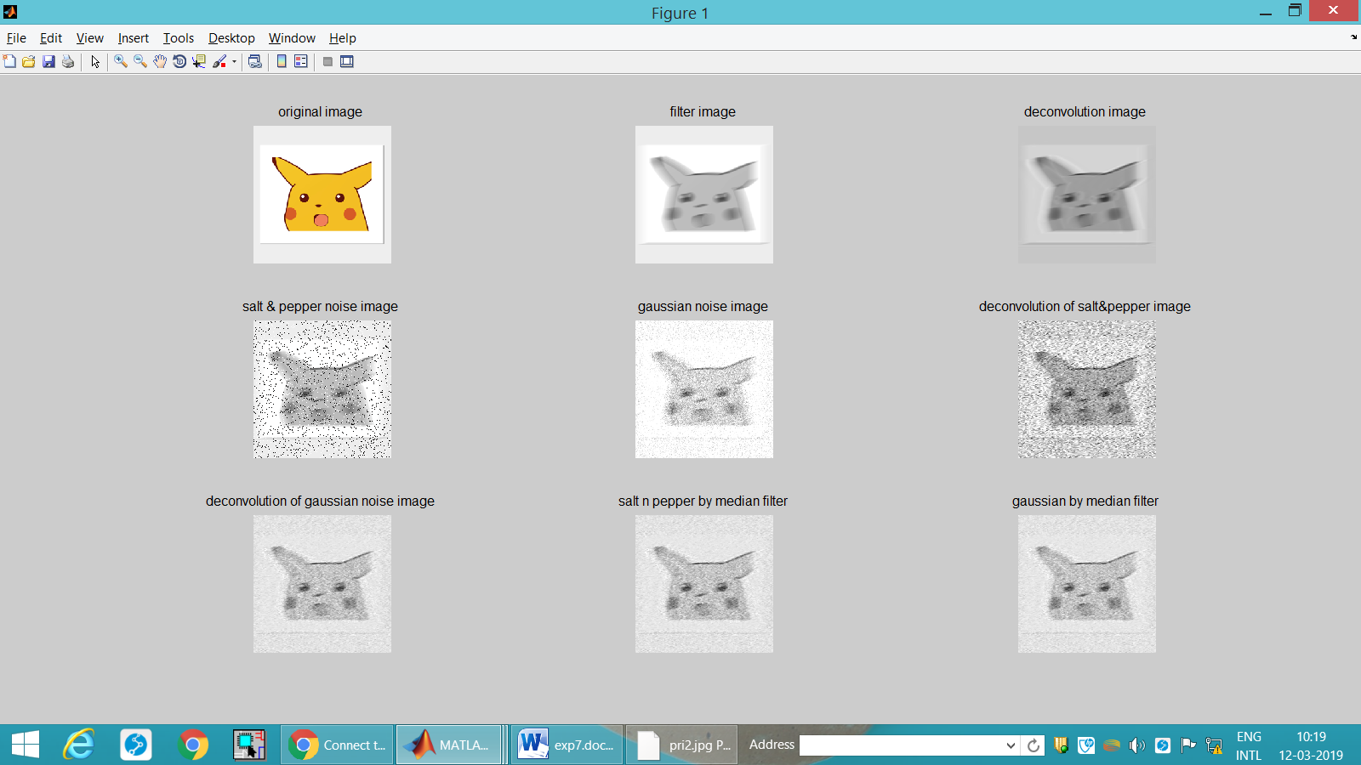

Motion Image:

