**Code:**

clc;

closeall;

clearall;

a=imread('cameraman.tif');

subplot(3,2,1)

imshow(a);

title('original image');

a=double(a);

lpf1=a;

lpf2=a;

lpf3=a;

hpf=a;

hbf=a;

fori=2:255

for j=2:255

lpf3(i,j)=0;

for u=(i-1):(i+1)

for v=(j-1):(j+1)

lpf3(i,j)=lpf3(i,j)+a(u,v);

end

end

lpf3(i,j)=lpf3(i,j)/9;

end

end

subplot(3,2,2)

imshow(uint8(lpf3));

title('lpf 3x3 image');

fori=3:254

for j=3:254

lpf1(i,j)=0;

for u=(i-2):(i+2)

for v=(j-2):(j+2)

lpf1(i,j)=lpf1(i,j)+a(u,v);

end

end

lpf1(i,j)=lpf1(i,j)/25;

end

end

subplot(3,2,3)

imshow(uint8(lpf1));

title('lpf 5x5 image');

fori=2:255

for j=2:255

lpf2(i,j)=(a(i-1,j-1)+2*a(i-1,j)+a(i-1,j+1)+2*a(i,j-1)+4*a(i,j)+2*a(i,j+1)+a(i+1,j-1)+2*a(i+1,j)+a(i+1,j+1) )/16 ;

end

end

subplot(3,2,4)

imshow(uint8(lpf2));

title('lpf weighted image');

fori=2:255

for j=2:255

hpf(i,j)=-(a(i-1,j-1)+a(i-1,j)+a(i-1,j+1)+a(i,j-1)-8*a(i,j)+a(i,j+1)+a(i+1,j-1)+a(i+1,j)+a(i+1,j+1) );

end

end

subplot(3,2,5)

imshow((hpf));

title('High Pass Filtered image');

fori=2:255

for j=2:255

hbf(i,j)=-(a(i-1,j-1)+a(i-1,j)+a(i-1,j+1)+a(i,j-1)-8.9*a(i,j)+a(i,j+1)+a(i+1,j-1)+a(i+1,j)+a(i+1,j+1) );

end

end

subplot(3,2,6)

imshow((hbf));

title('High boost filtered image');

Output of Filters:

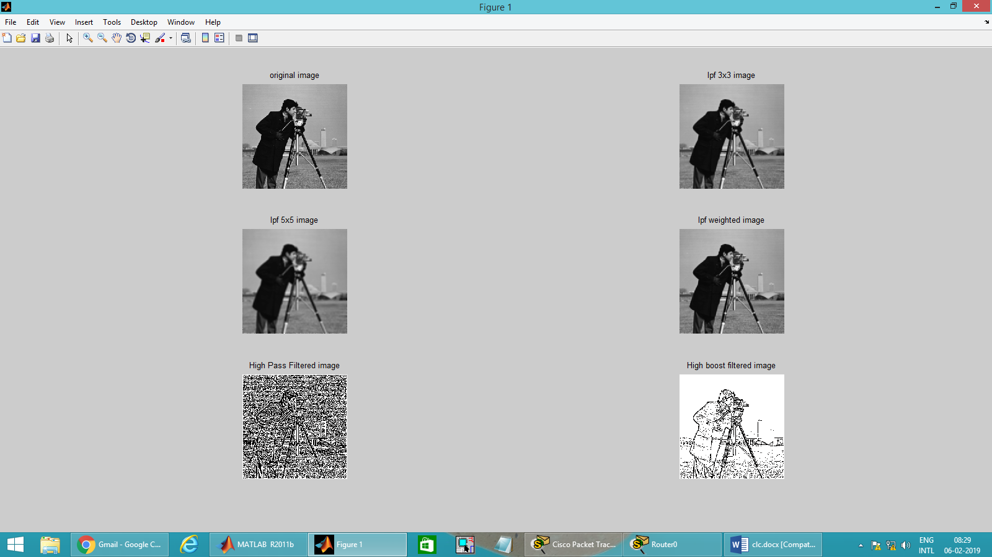

Code for median filter:

clc;

closeall;

clearall;

i=imread('cameraman.tif');

J = imnoise(i,'salt & pepper');

subplot(2,1,1)

imshow(J);

for a=2:255

for b=2:255

M(a,b)=median(median(i(a-1:a+1,b-1:b+1)));

end

end

subplot(2,1,2)

imshow(M);

output of median filtering

