Code

clc;

clearall;

closeall;

a=xlsread('C:\Users\djsce.student\Desktop\irisdataset.xlsx');

%meas=xlsread('C:\Users\djsce.student\Desktop\meas.xlsx');

species=xlsread('C:\Users\djsce.student\Desktop\species_num.xlsx');

X=a(1:100,:);

Y=species(1:100);

rand_num=randperm(100);

X_train=X(rand_num(1:80),:);

Y_train=Y(rand_num(1:80),:);

X_test=X(rand_num(81:end),:);

Y_test=Y(rand_num(81:end),:);

SVMModel=fitcsvm(X_train,Y_train);

[labels]=predict(SVMModel,X_test);

sv=SVMModel.SupportVectors;

figure

gscatter(X(:,1),X(:,2),Y)

holdon

plot(sv(:,1),sv(:,2),'ko','MarkerSize',10)

legend('setosa','versicolor','Support Vector')

holdoff

idx=(Y_test()==1);

idx1=(Y_test()==2);

p=length(Y_test(idx));

n=length(Y_test(idx1));

N=n+p;

tp=sum(Y_test(idx)==labels(idx));

tn=sum(Y_test(idx1)==labels(idx1));

fp=n-tn;

fn=p-tp;

tp_rate=tp/p;

tn_rate=tn/n;

accuracy=(tp+tn)/N;

C=confusionmat(Y_test,labels);

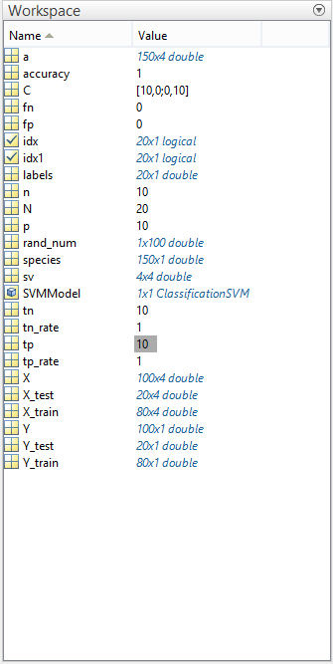



C =

10 0

1. 10

