**CODE 1**

clc;

clear all;

close all;

a=imread('C:\Users\djsce.student\Desktop\pri2.jpg');

subplot(3,3,1)

imshow(a)

title('Original image');

a=rgb2gray(a);

b1=imresize(a,[256 256]);

subplot(3,3,2)

imshow(b1);

a=double(b1);

title('GRAY SCALED IMAGE');

m1=[1 1;-1 -1]

for i=2:255

for j=2:255

c(i,j)=sum(sum(a(i-1:i,j-1:j).*m1));

end

end

subplot(3,3,3)

imshow(uint8(c));

title('Robert H&V MASK');

m2=[-1 -1 -1;0 0 0;1 1 1]

for i=2:255

for j=2:255

x(i,j)=sum(sum(a(i-1:i+1,j-1:j+1).*m2));

end

end

subplot(3,3,4)

imshow(uint8(x));

title('Prewitts H MASK');

m3=[-1 0 1;-1 0 1;-1 0 1]

for i=2:255

for j=2:255

y(i,j)=sum(sum(a(i-1:i+1,j-1:j+1).*m3));

end

end

subplot(3,3,5)

imshow(uint8(y));

title('Prewitts V MASK');

m4=[-2 -1 0;-1 0 1;0 1 2]

for i=2:255

for j=2:255

xy(i,j)=sum(sum(a(i-1:i+1,j-1:j+1).*m4));

end

end

subplot(3,3,6)

imshow(uint8(xy));

title('Prewitts H&V MASK');

m5=[-2 -2 0;-2 0 2;0 2 2]

for i=2:255

for j=2:255

xy1(i,j)=sum(sum(a(i-1:i+1,j-1:j+1).*m5));

end

end

subplot(3,3,7)

imshow(uint8(xy1));

title('SOBEL H&V MASK');

m6=[0 1 0;1 -4 1;0 1 0]

for i=2:255

for j=2:255

xy2(i,j)=sum(sum(a(i-1:i+1,j-1:j+1).*m6));

end

end

subplot(3,3,8)

imshow(uint8(xy2));

title('LAPLACIAN H&V MASK');

**Code 2**

clc;

clear all;

close all;

a=imread('C:\Users\djsce.student\Desktop\pri2.jpg');

subplot(3,3,1)

imshow(a)

title('Original image');

a=rgb2gray(a);

b1=imresize(a,[256 256]);

subplot(3,3,2)

imshow(b1);

title('GRAY SCALED IMAGE');

subplot(3,3,3)

BW1 = edge(b1,'roberts')

imshow(BW1);

title('Robert H&V MASK');

subplot(3,3,5)

BW2 = edge(b1,'sobel')

imshow(BW2);

title('SOBEL H&V MASK');

subplot(3,3,4)

BW3 = edge(b1,'prewitt')

imshow(BW3);

title('PREWITTS H&V MASK');

subplot(3,3,7)

BW4 = edge(b1,'canny')

imshow(BW4);

title('CANNY EDGE H&V MASK');

subplot(3,3,6)

BW5 = edge(b1,'log')

imshow(BW5);

title('LAPLACIAN H&V MASK');

**OUTPUT 1**

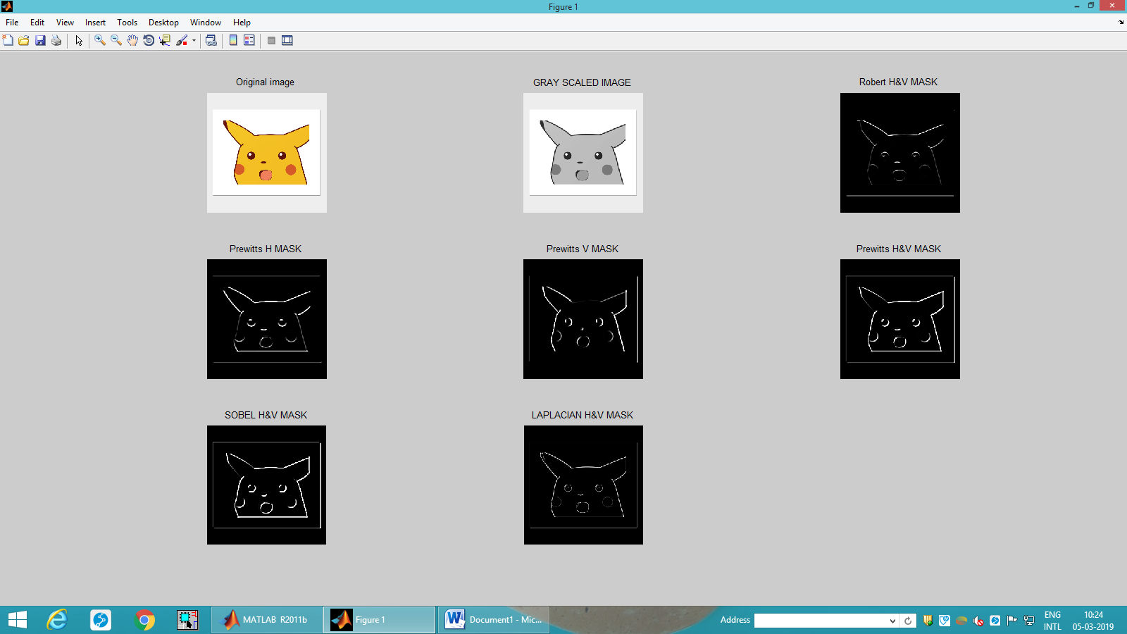

**OUTPUT 2:**

