**ADVANCED DATABASE TOPICS – (COMP-8207)**

**ASSIGNMENT 2**

**Name: Ruchi Nakum**

**Student Id: 110122972**

**Section: 3**

1. **Database Schema Design**
2. **`program` (programID, name)**



1. **`depCourse` (courseID, deptName, programID)**



1. **`users` (userID, programID)**



1. **`courseSiteVisit` (visitID, courseID, userID, date)**



1. **Data Population**
2. **Inserting data into the ‘program’ table.**

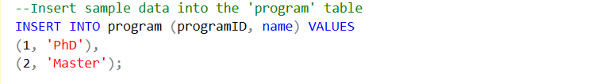

**Output:**



1. **Inserting data into the ‘depCourse’ table.**

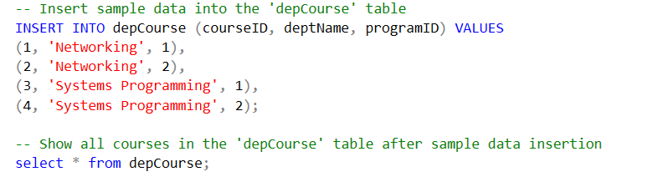

**Output:**

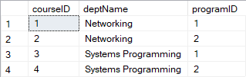

1. **Inserting data into the ‘users’ table.**

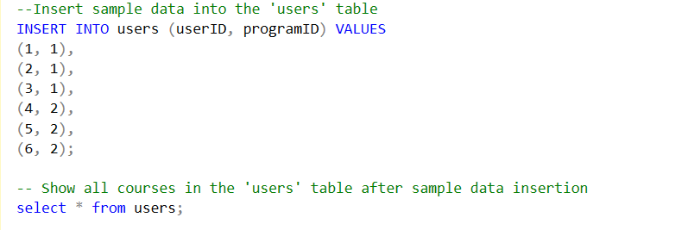

**Output:**

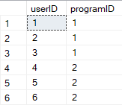

1. **Inserting data into ‘courseSiteVisit’ table.**

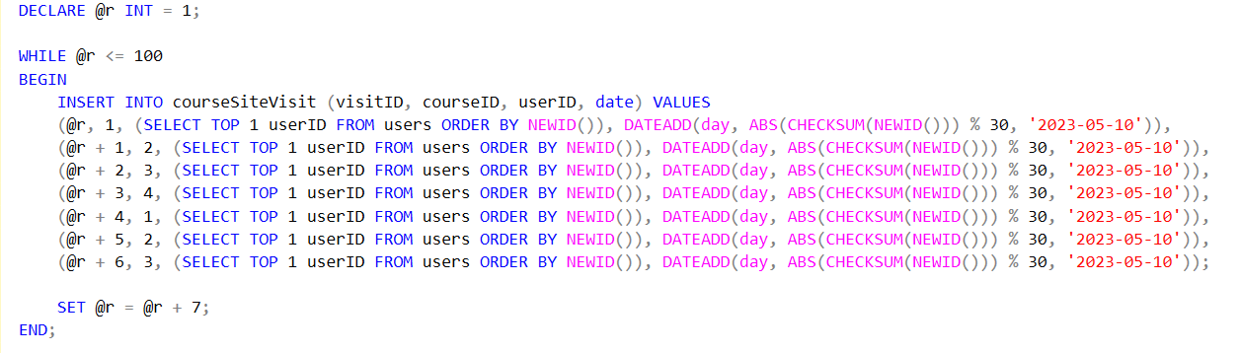

**Output:**

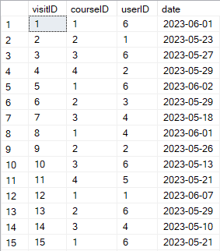

1. **Data Analysis and Visualization**
2. **The total number of times a course has been visited or accessed by all users**

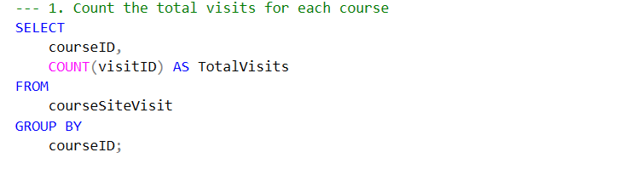

**Output:**

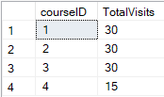

**Visualization:**

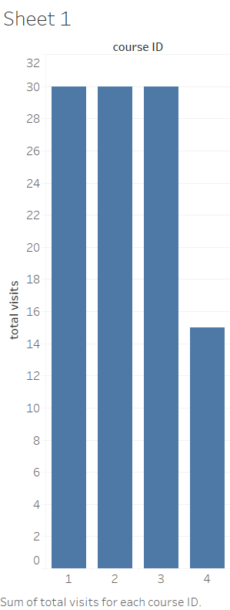

1. **The total number of visits for each course, categorized by program**

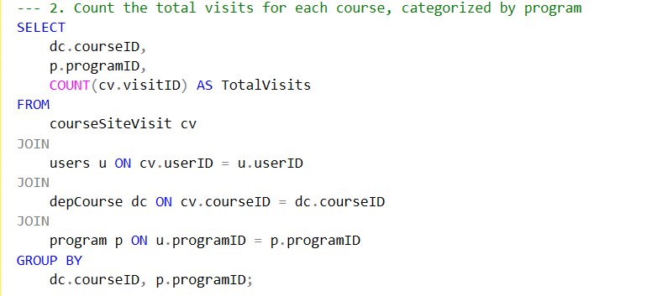

**Output:**

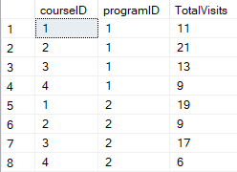

**Visualization:**

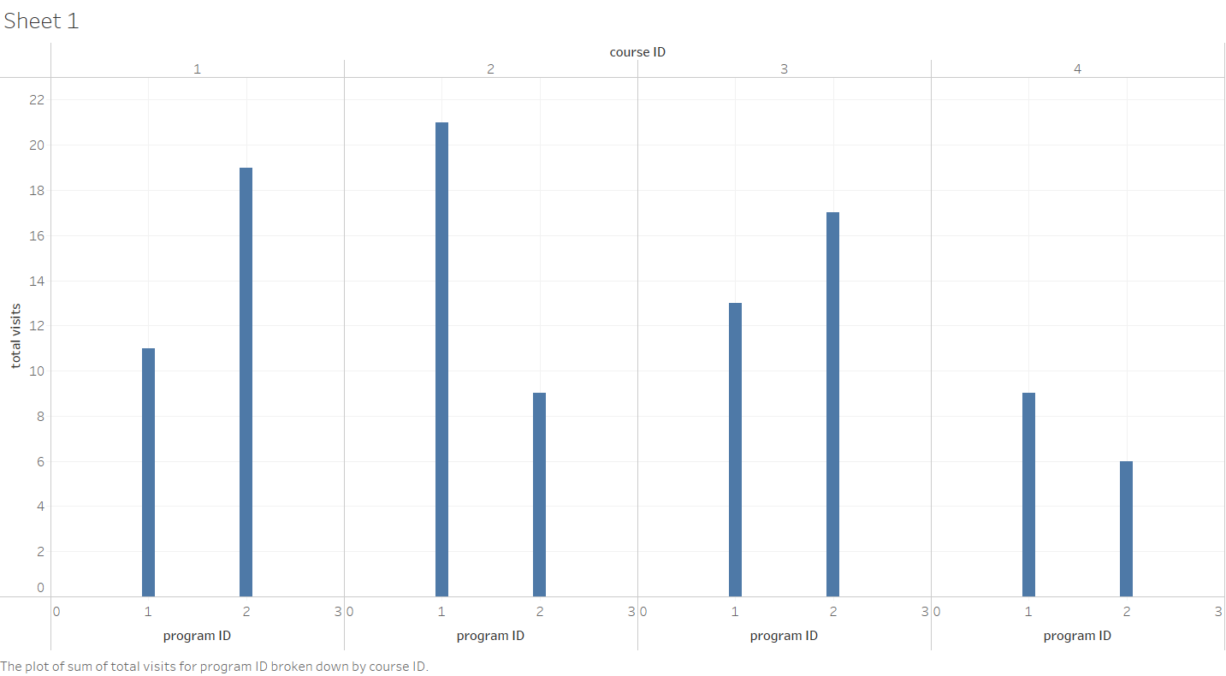

1. **The total number of students or users enrolled in each program**

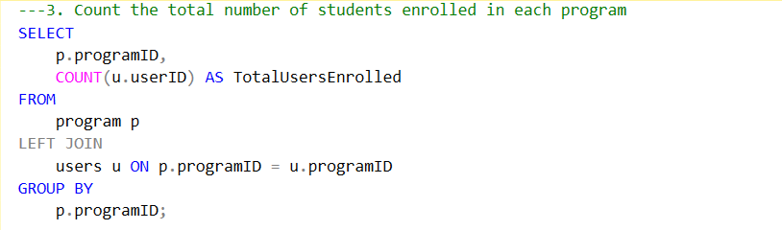

**Output:**

**Visualization:**

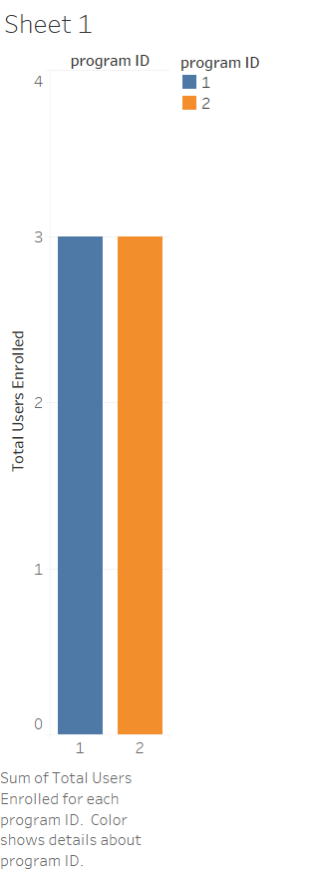

1. **The total number of unique visitors per department by program**

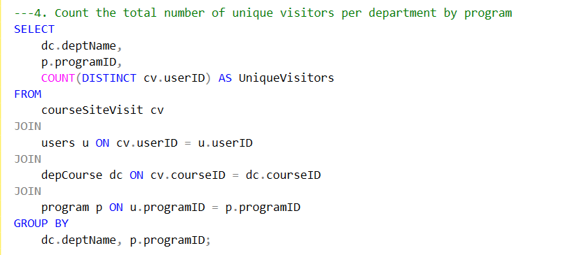

**Output:**

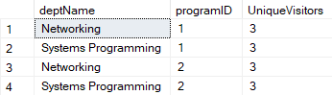

**Visualization:**

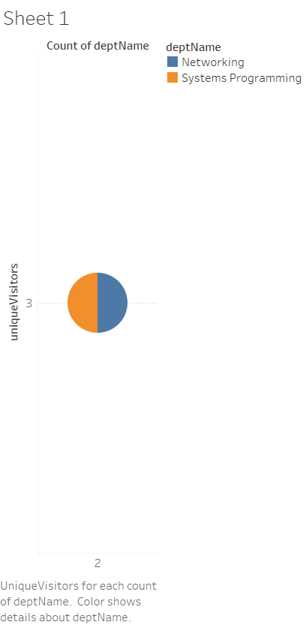

1. **The most recent date (or last date) on which a user visited each course**

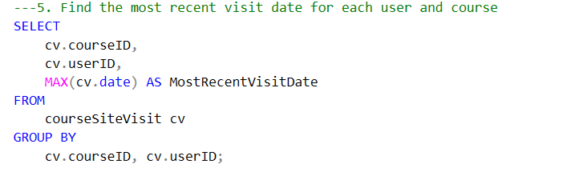

**Output:**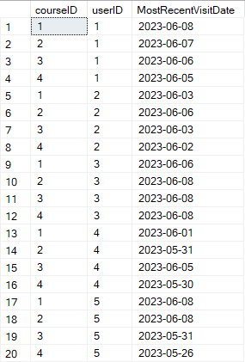

**Visualization:**

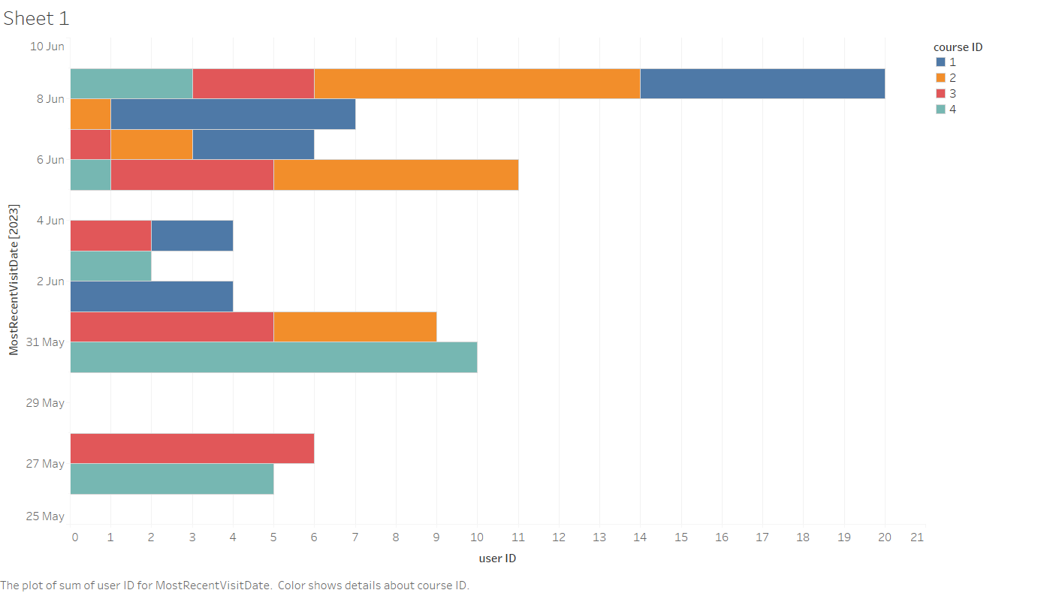

1. **The number of times a user has visited each course**

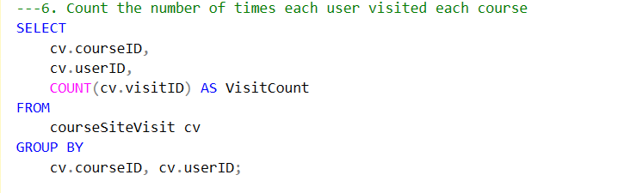

**Output:**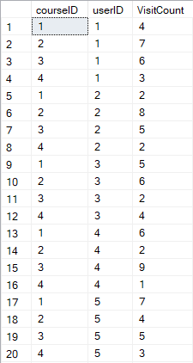

**Visualization:**

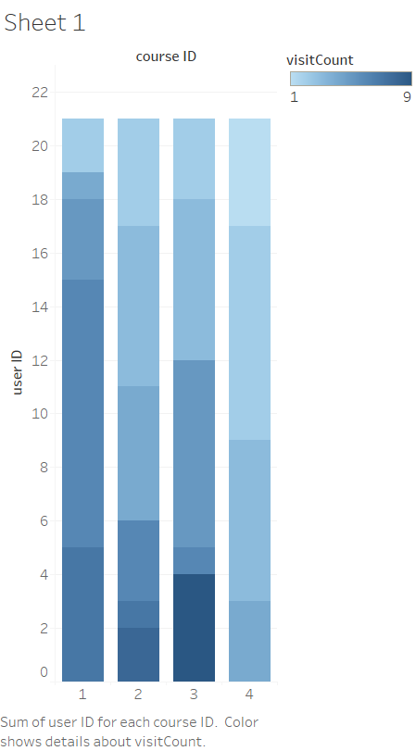

1. **The user who has visited a course the most (i.e., most frequent visitor per course), along with the visit count**

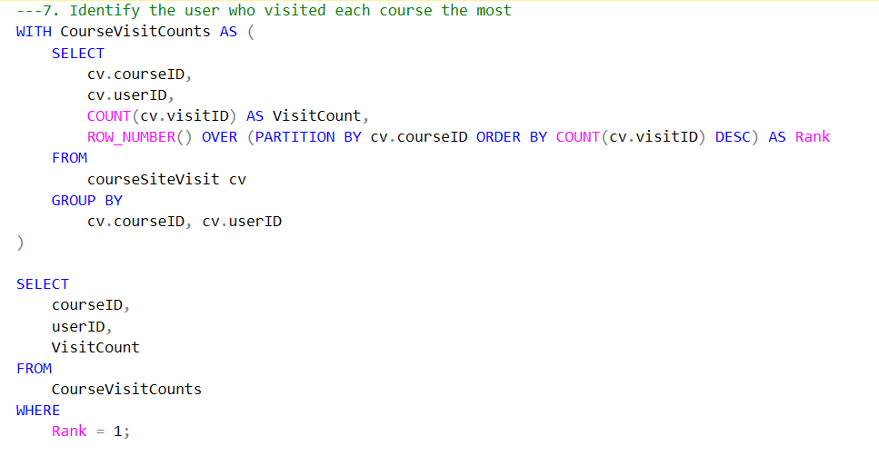

**Output:**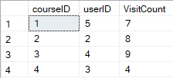

**Visualization:**

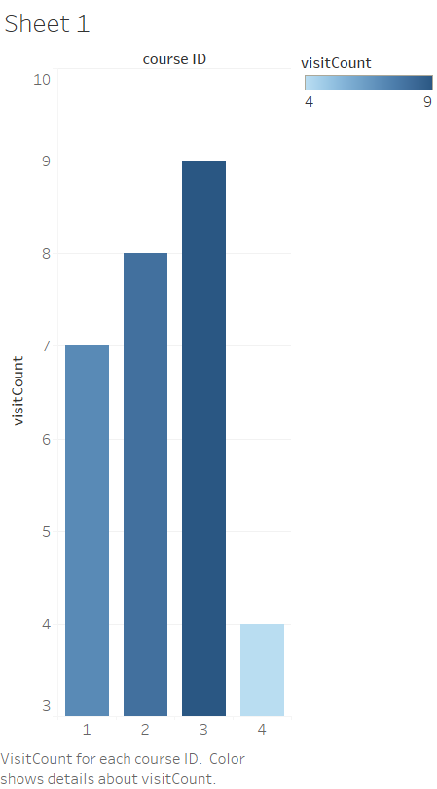

1. **The user who visited a course the most times in a single day. (i.e., most frequent visited user in single day per course)**

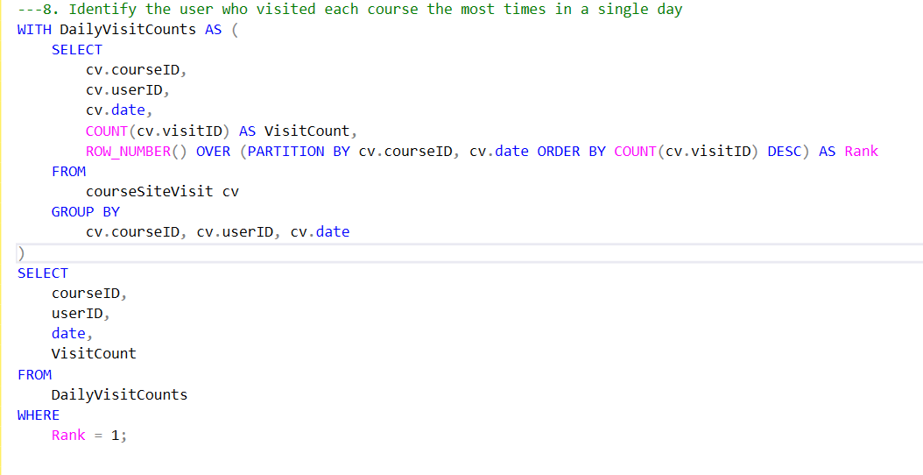

**Output:**

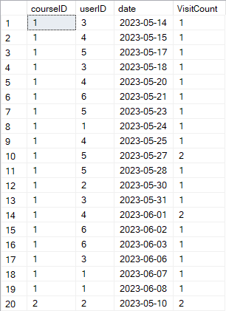

**Visualization:**

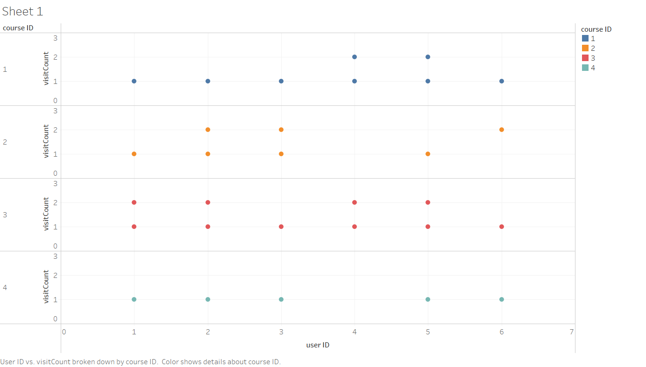

1. **Longest visit streak days per user per course (i.e., the maximum number of days in a row that a user has accessed or engaged with the course site)**

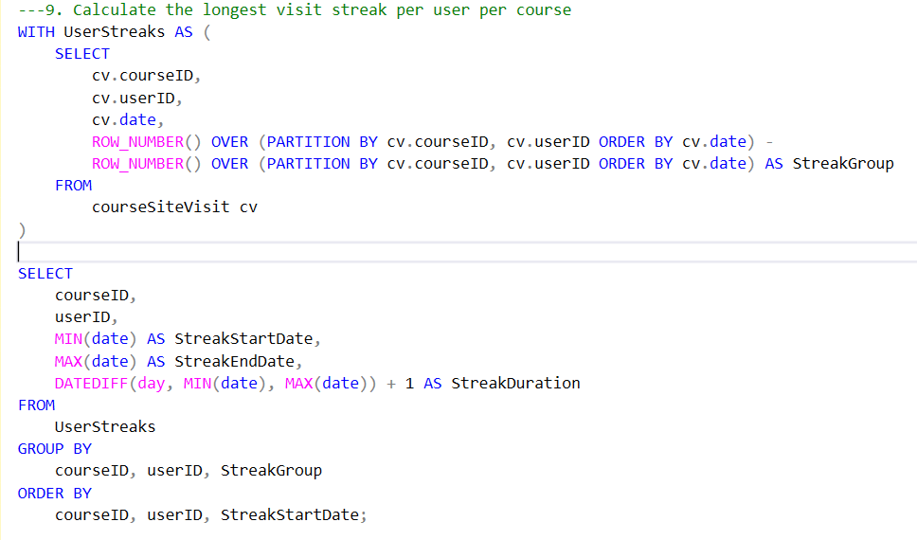

**Output:**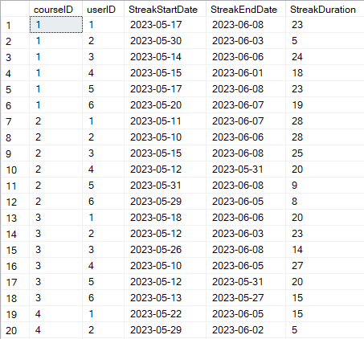

**Visualization:**

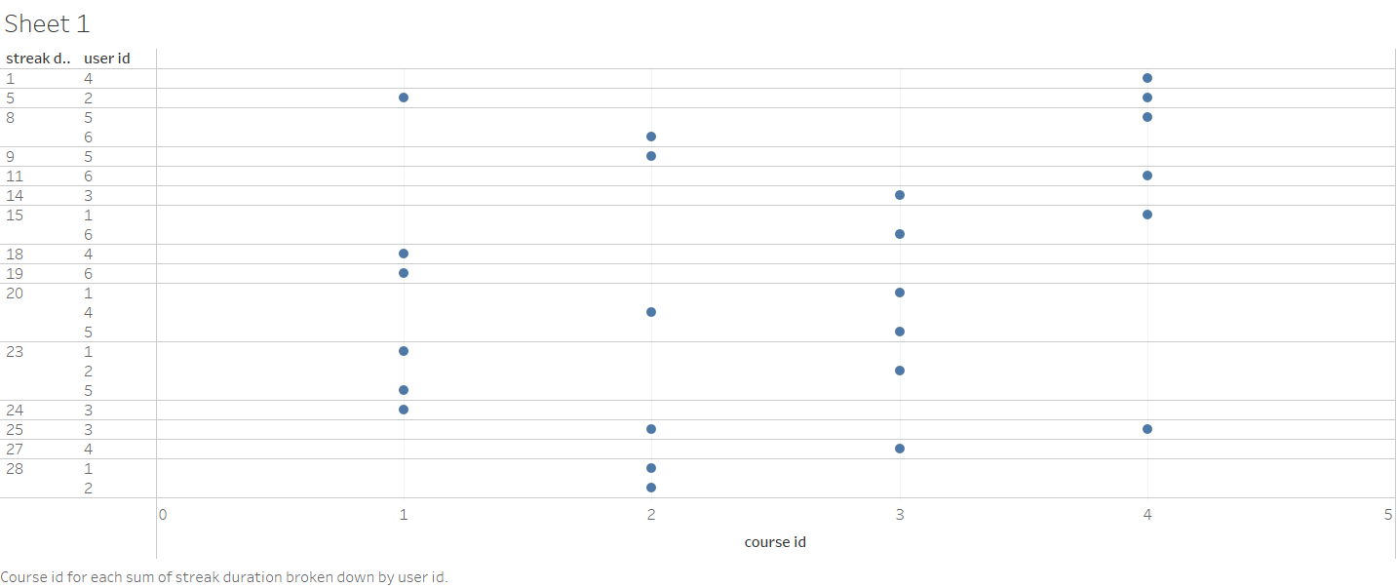

1. **Longest gap between visit per user and number of days in single course**

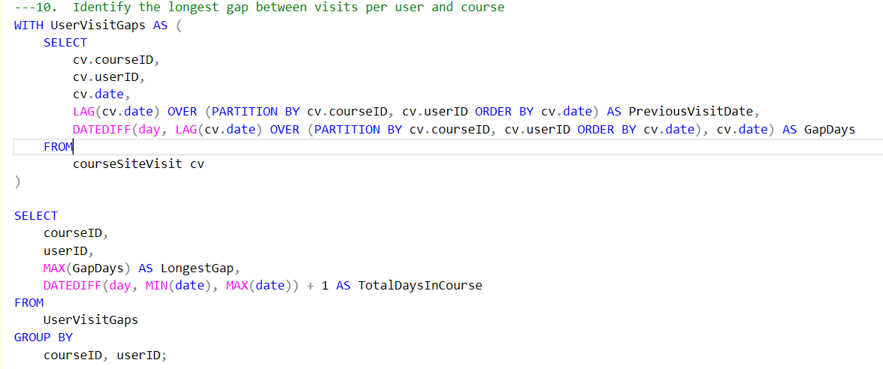

**Output:**

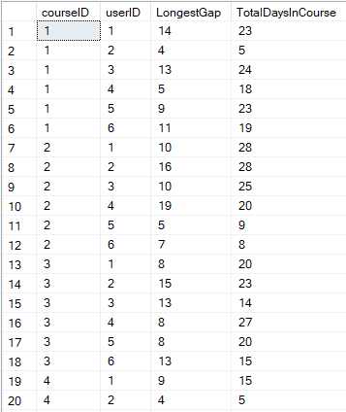

**Visualization:**

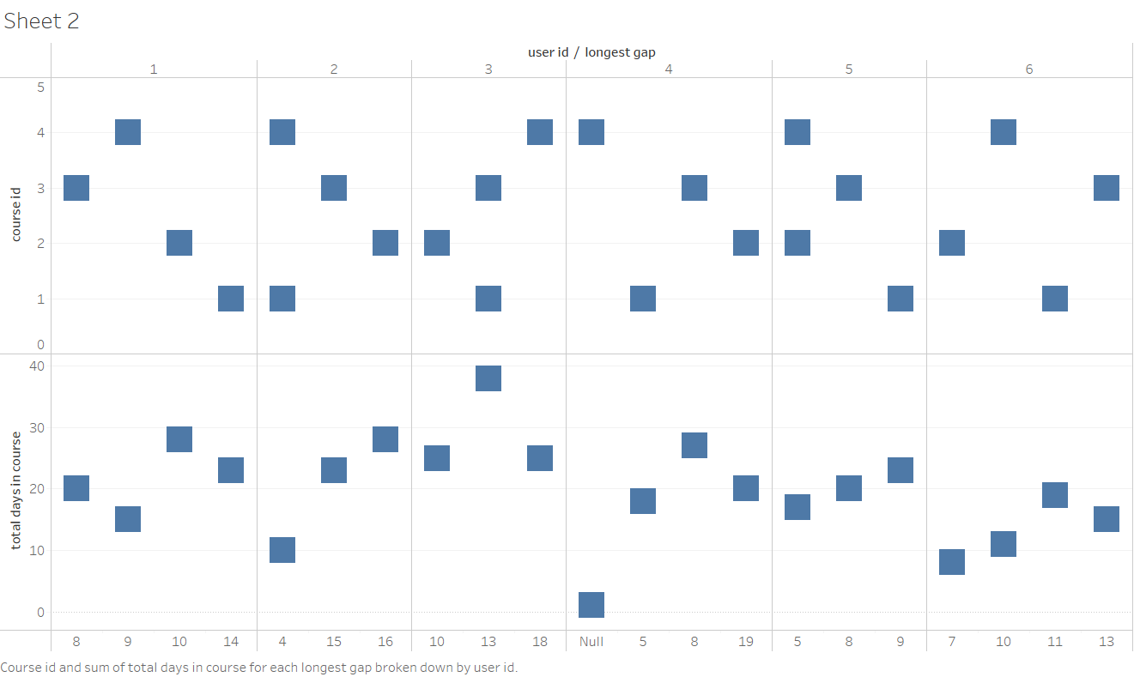

1. **The user who visited the most courses within a short duration**

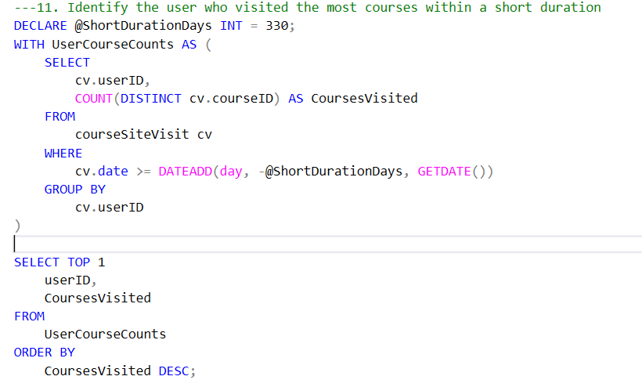

**Output:**

