# find command

* The **find** command in UNIX is a command line utility for walking a file hierarchy.
* It can be used to find files and directories and perform subsequent operations on them.

**1. Search a file with specific name.**

$ find ./GFG -name sample.txt

**2. Search a file with pattern.**

$ find ./GFG -name *.txt

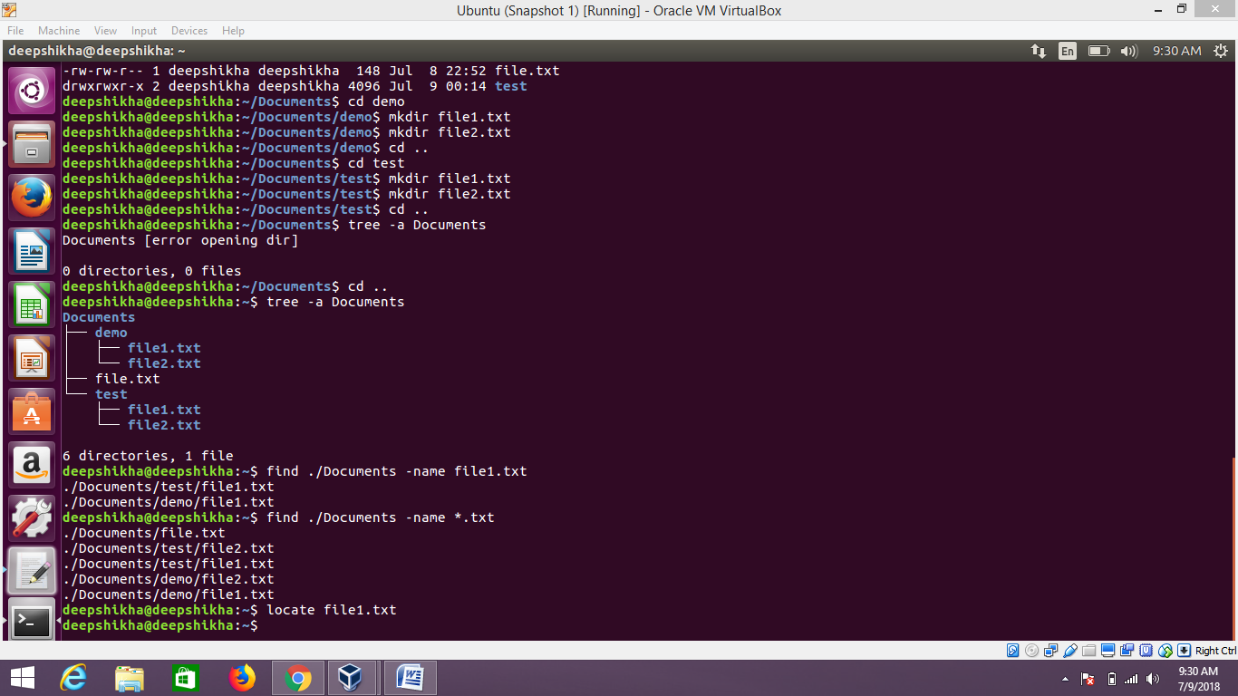

# ‘diff’ command

This command is used to display the differences in the files by comparing the files line by line.

**Syntax :**

**diff [options] File1 File2**

* **-c (context) :** To view differences in context mode, use the **-c** option.
* **-u (unified) :** To view differences in unified mode, use the **-u** option. It is similar to context mode but it **doesn’t display any redundant information** or it shows the information in concise form.

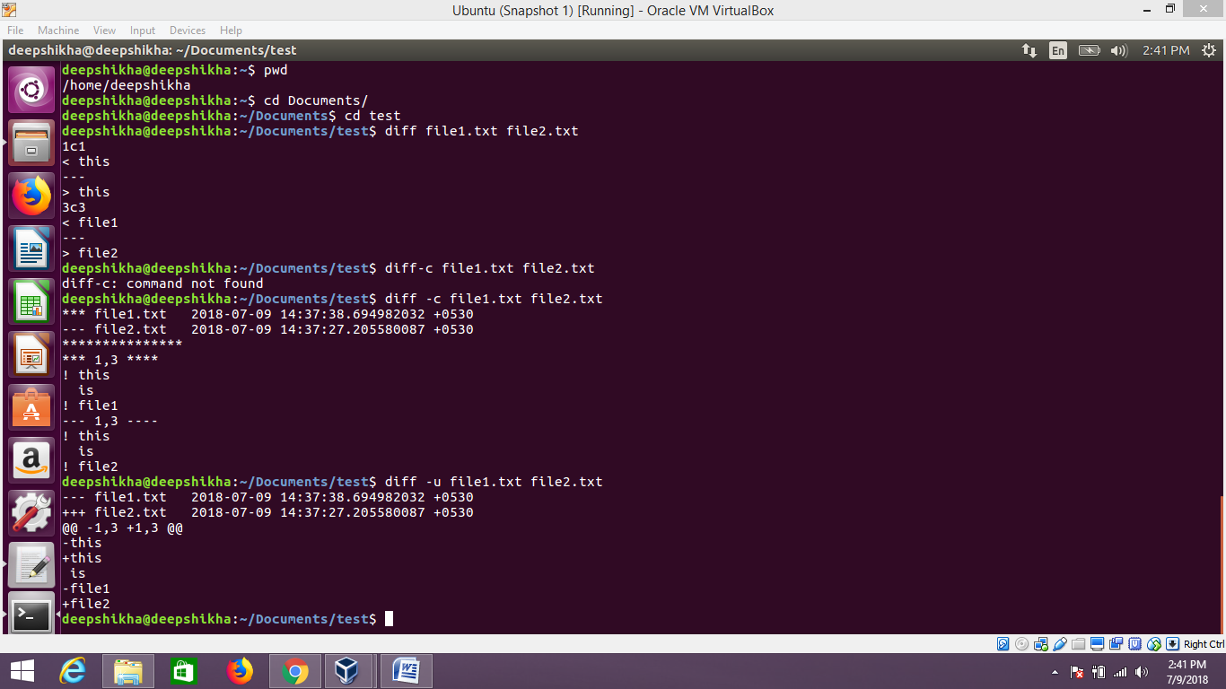

# ‘Tail’ command

# The tail command, as the name implies, print the last N number of data of the given input.

# By default it prints the last 10 lines of the specified files.

**Syntax:**

tail [OPTION]... [FILE]...

# ****-n num:**** Prints the last ‘num’ lines instead of last 10 lines. ****num**** is mandatory to be specified in command otherwise it displays an error. This command can also be written as without symbolizing ‘n’ character but ‘-‘ sign is mandatory.

# **-c num:** Prints the last ‘num’ bytes from the file specified.

# 

# ‘Less’ command

# Less command is linux utility which can be used to read contents of text file one page(one screen) per time.

**syntax :**

less filename

# 

# Soft and Hard links

# A link in UNIX is a pointer to a file. Like pointers in any programming languages, links in UNIX are pointers pointing to a file or a directory.

**1. Hard Links**

$ ln [original filename] [link name]

**2. Soft Links**

$ ln -s [original filename] [link name]

For example, if we have a file a.txt. If we create a hard link to the file and then delete the file, we can still access the file using hard link. But if we create a soft link of the file and then delete the file, we can’t access the file through soft link and soft link becomes dangling.

