**UNIX COMMANDS**

1. TAR COMMAND

* The name tar stands for tape archive
* Originally designed as a program to let people backup their files to magnetic tapes
* c - you are creating a new archive
* V –verbose
* f- I want a file as output(followed by the file name)
* C-un archive in a different directory
* tar –cvf file.tar file1 file2
* X for extract tar –cvf file.tar. extracts all the files
* The size of tar> size of files

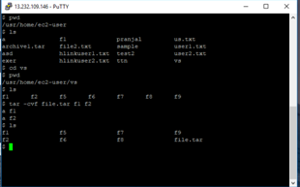

1. FIND COMMAND

* It can be used to find files and directories and perform subsequent operations on them.
* It supports searching by file, folder, name, creation date, modification date, owner and permissions.
* $ find [where to start searching from]

[expression determines what to find] [-options] [what to find]

* Find(.) it search in the same director y or its sub directories

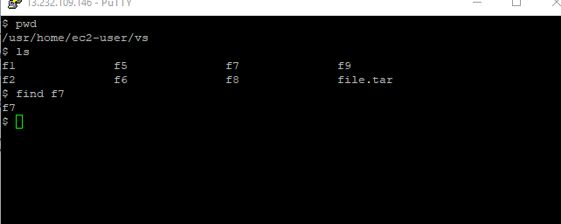

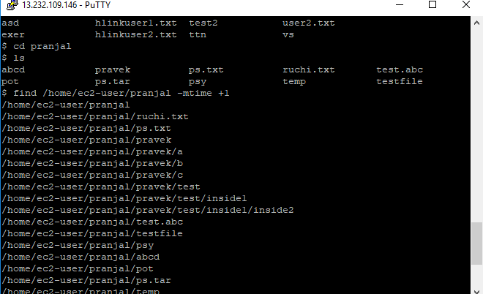

Find add –mtime +1

* It returns the file in the location which has been modified more than 1 day ago
* To use restricted directories use $ before the name of the directory.

1. Locate COMMAND

* It locates the file in the system
* Locate file in all the path

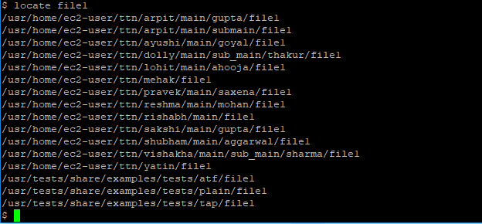

1. DIFF COMMAND

* It tells the difference in two files
* Syntax diff <file1> <file2>

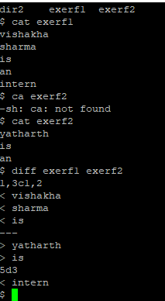

* line contains 1,3c1,2 which means from line from first file needs to be changed to match line in the second file.

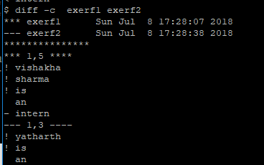

-c context mode

1. Tail COMMAND

* It prints last lines of data of the given file
* By default it is 10 in length

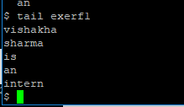

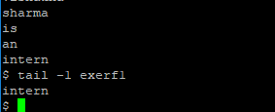

* -n for specifying custom number of last lines

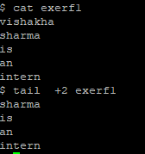

1. less COMMAND

* It is used for looking at the files instead of opening it
* + used to start the file from given number of line

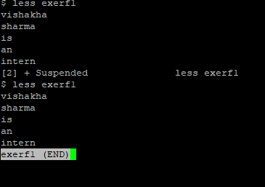

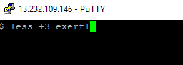

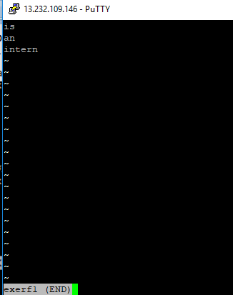

1. Ln COMMAND

* Used for creating links

