|  |  |
| --- | --- |
| **Course code and Title : BCSE101E – Computer Programming: Python**  **Lab student exercise – 6 (Solutions)** | |
| **Student Name : Ruchir Patel** | **Given Date : 14.08.2024** |
| **Register no: 24BAI0042** | **Submitted Date : 15/8/2024** |
| Topic :   1. CONTROL STRUCTURES : Decision Making | |

1. Printing Numbers from 1 to 10

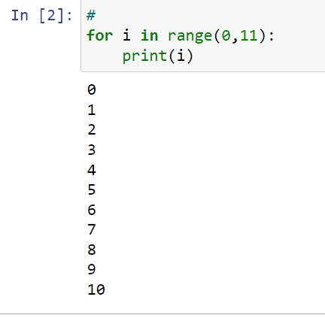

1. Printing Numbers from 10 to 1

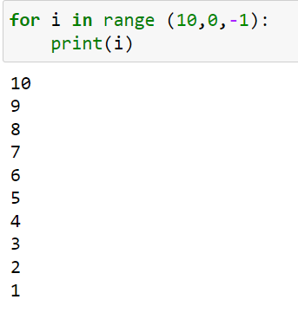

1. 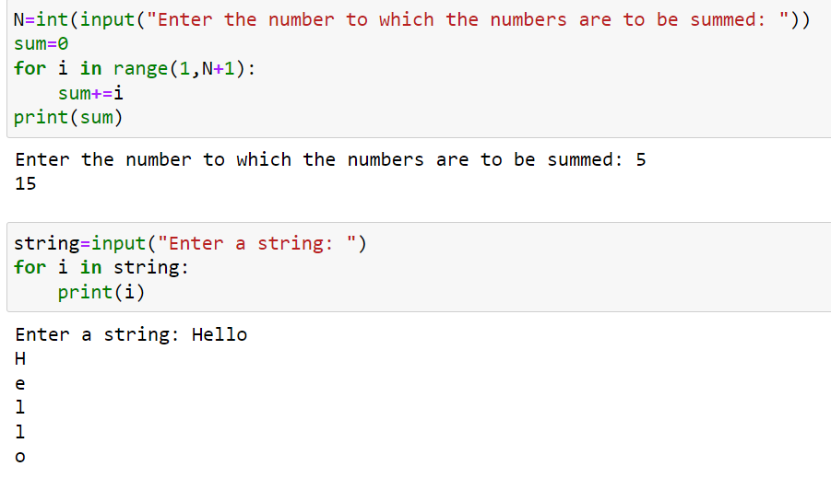and 4. Sum of first N Natural Numbers and Printing Each Character of a string

5. Printing Even Numbers Between 2 ranges

a) Test case 1 :

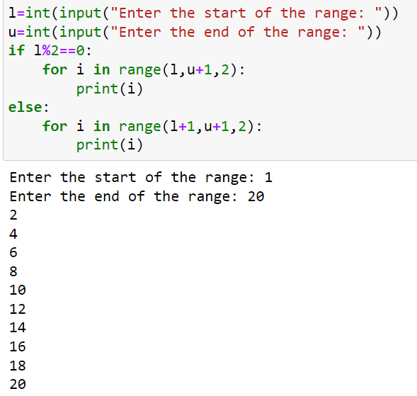

b) Test case 2:

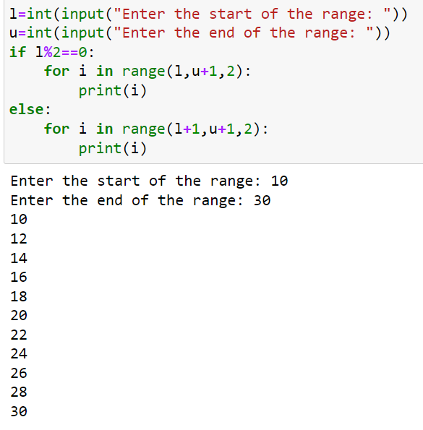

6. REVERSE THE DIGITS OF A NUMBER

a) Test case 1

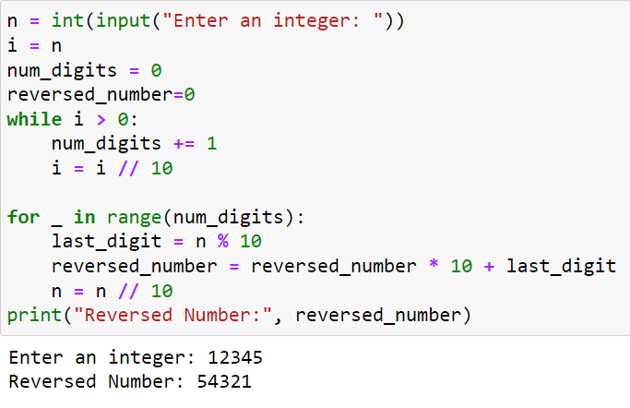

b)Test case 2 :

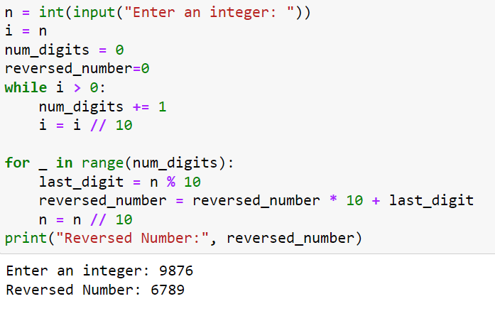

c) Test case 3 :

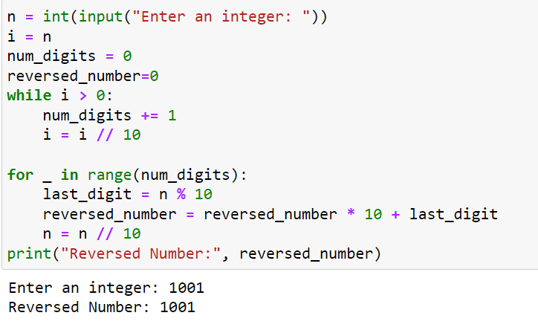

7. FINDING THE LARGEST DIGIT IN A NUMBER

1. 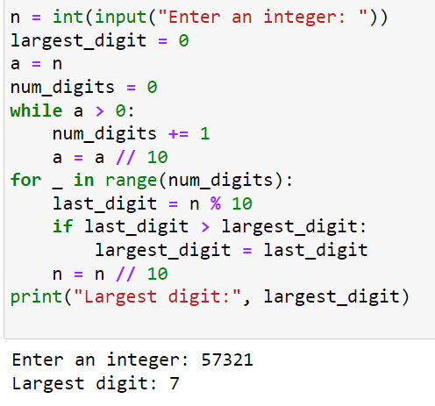Test case 1 :
2. Test case 2 :

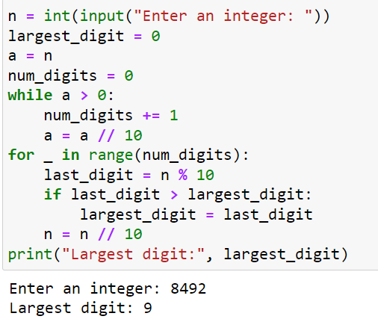

1. Test case 3 ;

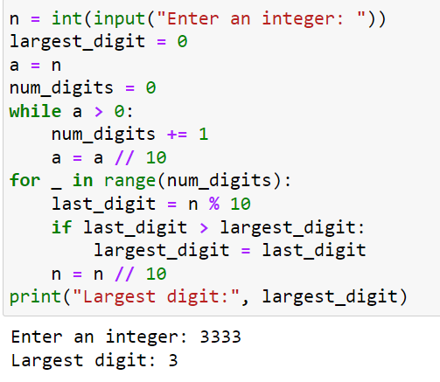

8. CHECK IF A NUMBER IS PRIME

1. Test case 1:

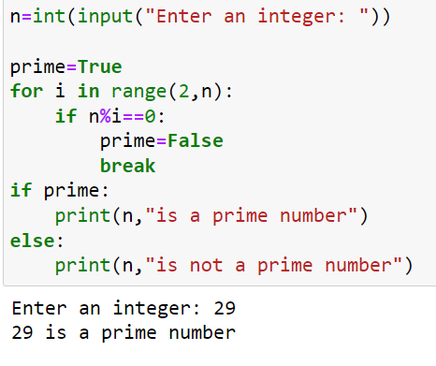

1. Test case 2:

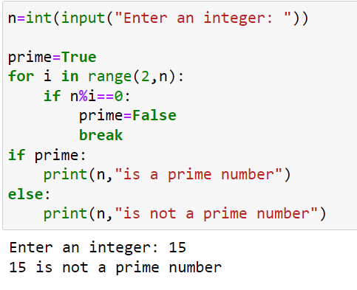

1. Test case 3:

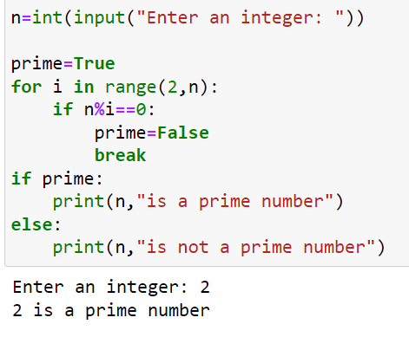

9. SIMPLE LIST ITERATION

