Experiment No: 4
Aim: Implementation of association mining using Apriori algorithm in Weka tool.

Theory:
Association Rules: Association rules are if/then statements that help uncover relationships between seemingly unrelated data in a transactional database, relational database or other information repository.

Step 1: Start->All Programs->Weka3.6.2->Enter
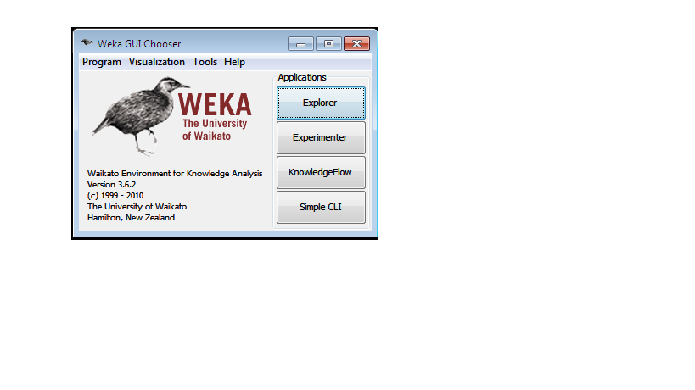
Figure-4.1 Weka Explorer(a)
Step 2: Click on “Explorer”

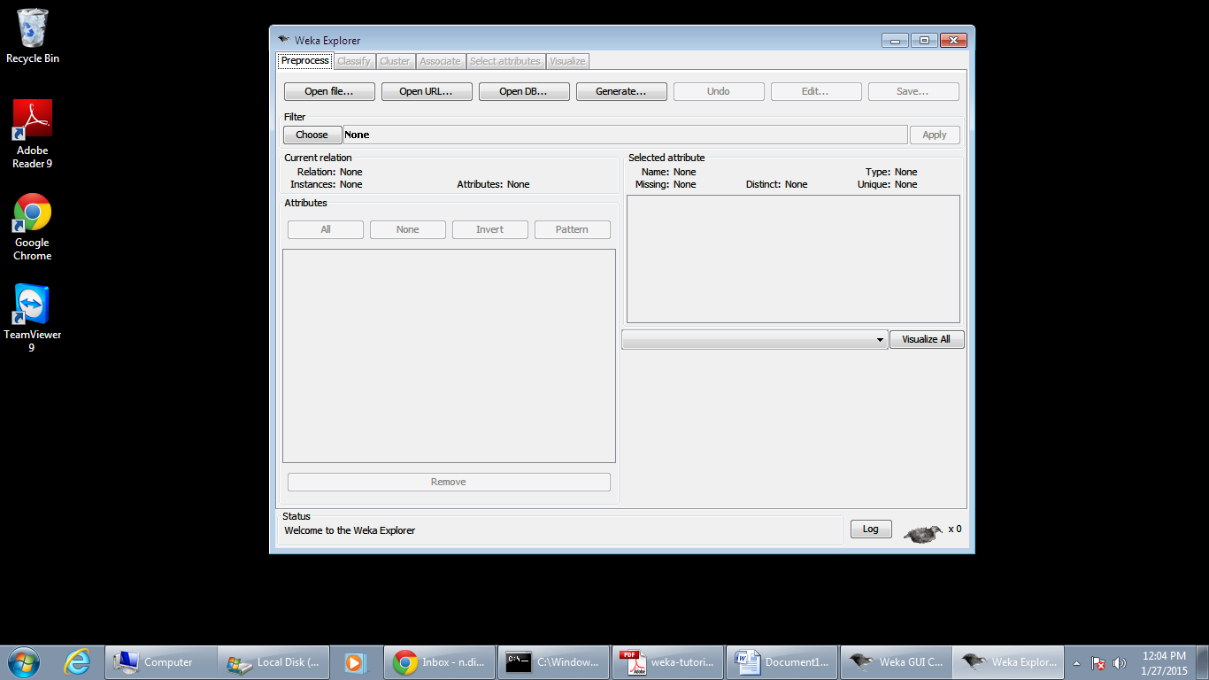
Figure-4.2 Weka Explorer(b)

Step 3: Click on “Open File”. Go to C:\Program Files\Weka-3-6\data\weather.nominal and open it.
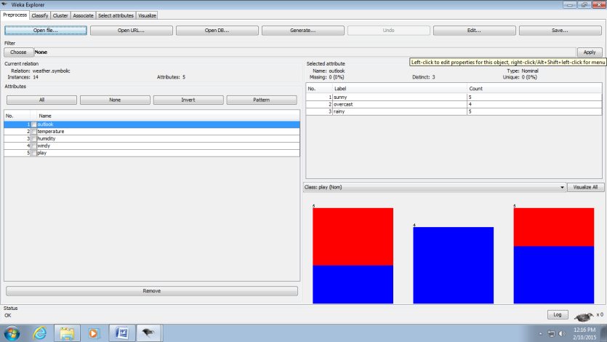
Figure-4.3 Weather-nominal Dataset
Step 4: Click on “Edit”
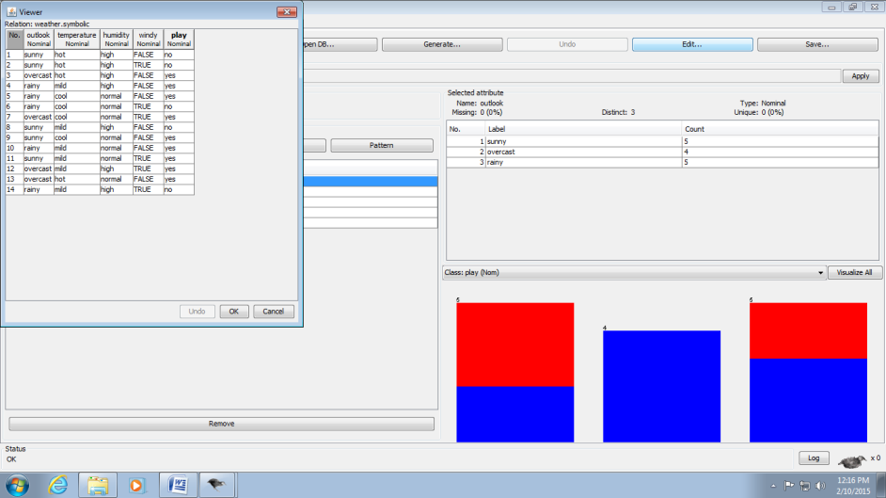
Figure 4.4 Edit Window
Step 5: Now click on “Associate” and “Choose Apriori algorithm”.
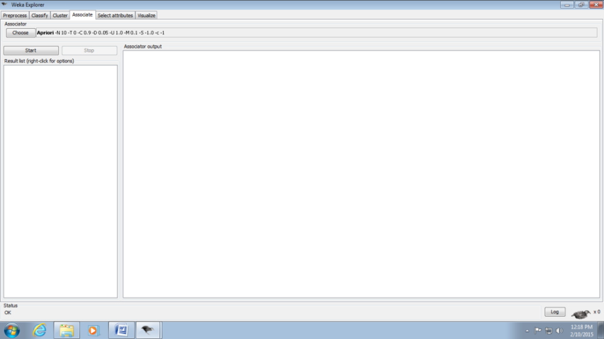 Figure 4.5 Associate

Step 6: Now click on “Start”.
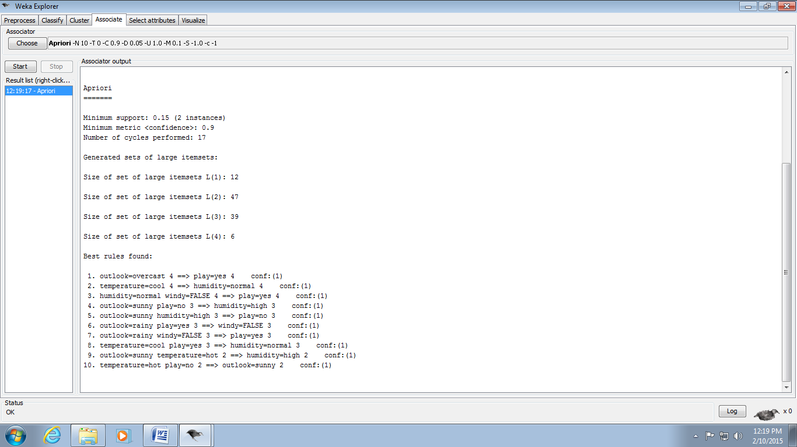
Figure 4.6 Start

Conclusion:

