average_face.png template gives better result as there are more True Positives and giving accurate result than the average_face_cropped.png. Therefore, it proves that first template in the given table below is better than the later one as it will detect more faces correctly.
template = average_face.png | template = average_face_cropped.png
detection_accuracy(ground_truth_file,template,scales,0.6,0.5); | detection_accuracy(ground_truth_file,template,scales,0.6,0.5);
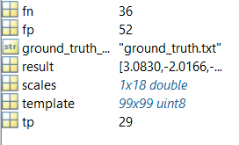 | 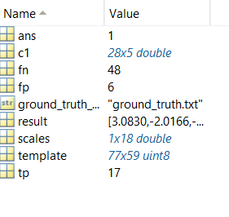
detection_accuracy(ground_truth_file,template,scales,0.7,0.5); | detection_accuracy(ground_truth_file,template,scales,0.7,0.5);
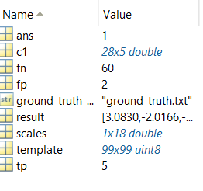 | 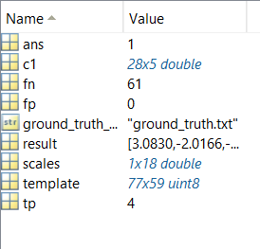
detection_accuracy(ground_truth_file,template,scales,0.8,0.5); | detection_accuracy(ground_truth_file,template,scales,0.8,0.5);
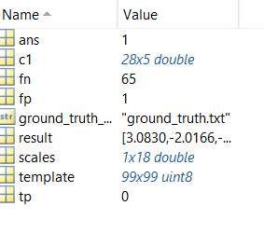 | 