# CSP554—Big Data Technologies

## Assignment #13

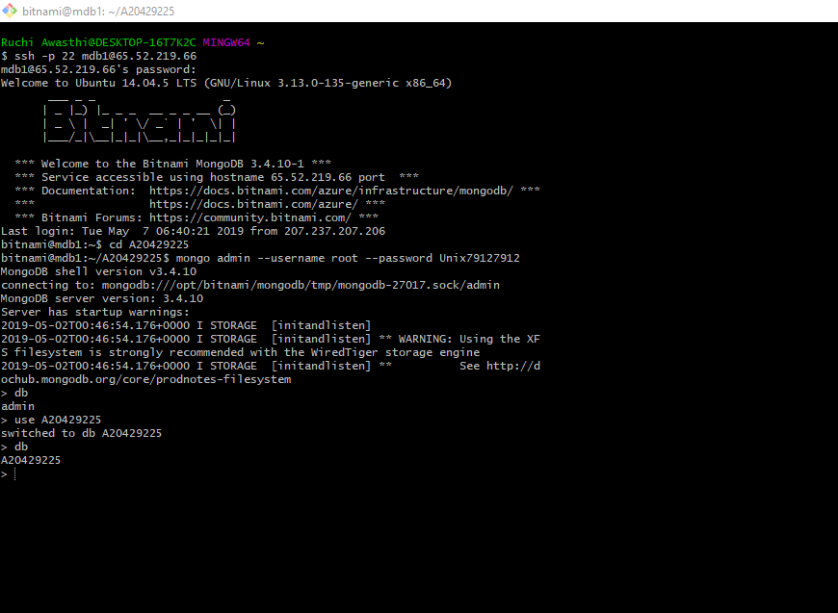

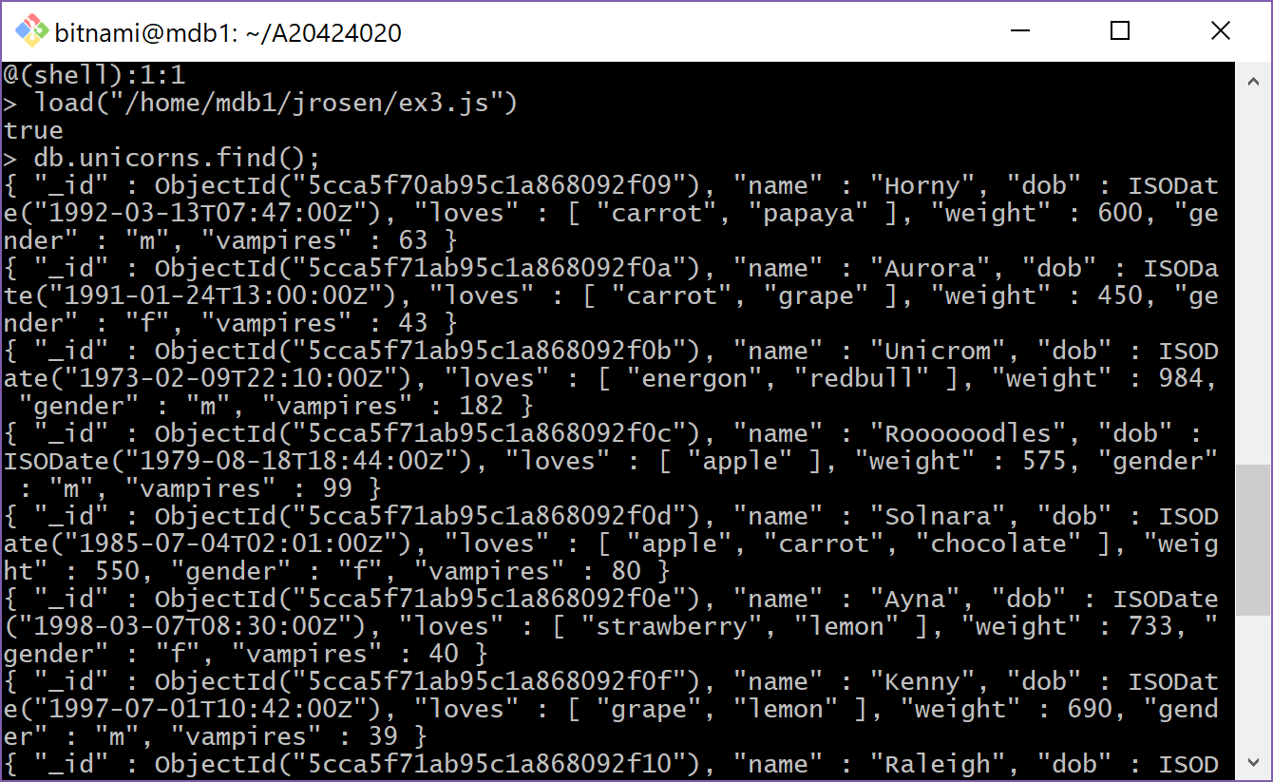

**Exercise 1) (2 points)**

**Write a command that finds all unicorns having weight less than 500 pounds. Include the code you executed and some sample output as the result of this exercise.**

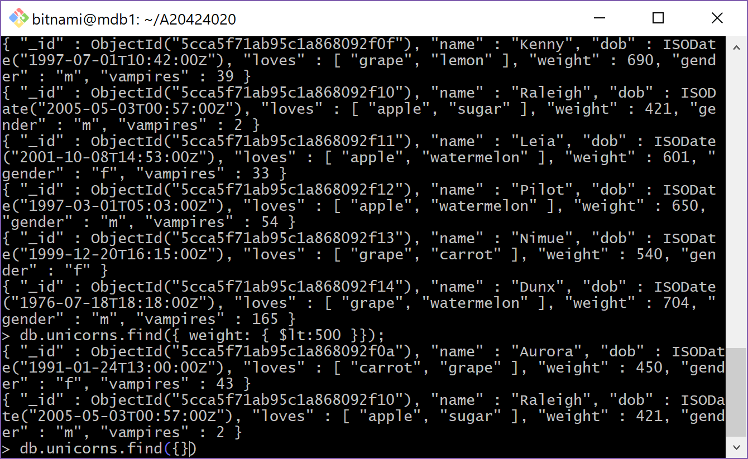

**Command:**

db.unicorns.find({ weight: { $lt: 500 }});

**Exercise 2) (2 points)**

**Write a command that finds all unicorns who love apples. Hint, search for “apple”. Include the code you executed and some sample output as the result of this exercise.**

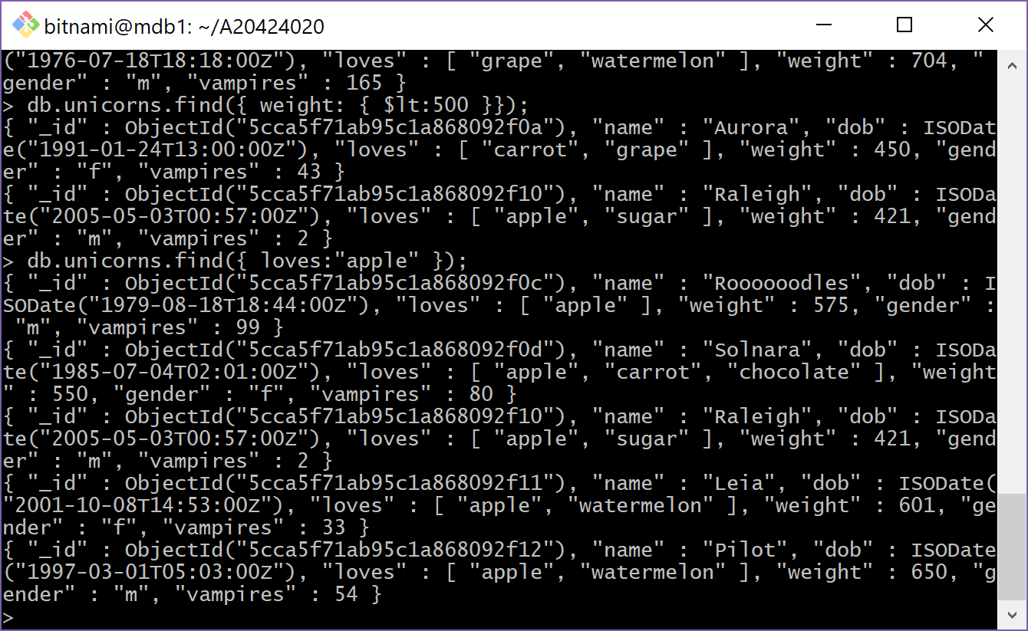

**Command:**

db.unicorns.find({ loves: "apple"});

**Exercise 3) (2 points)**

**Write a command that adds a unicorn with the following attributes to the collection. Note dob means “Date of Birth.”**

|  |  |
| --- | --- |
| Attribute | Value(s) |
| name | **Malini** |
| dob | **11/03/2008** |
| loves | **Pears and grapes** |
| weight | **450** |
| gender | **F** |
| vampires | **23** |
| horns | **1** |

**Include the code you executed to insert this unicorn into the collection along with the output of a find command showing it is in the collection.**

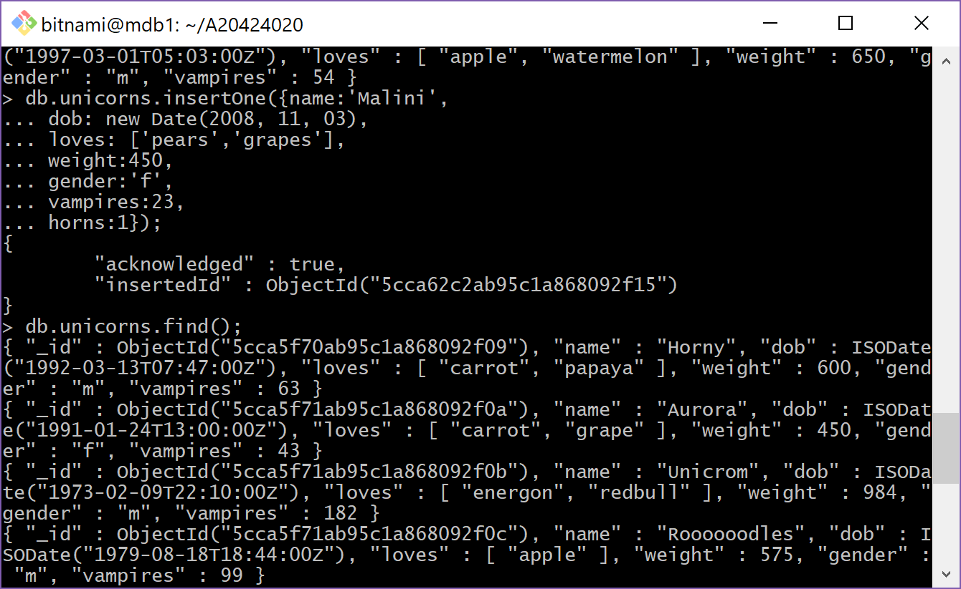

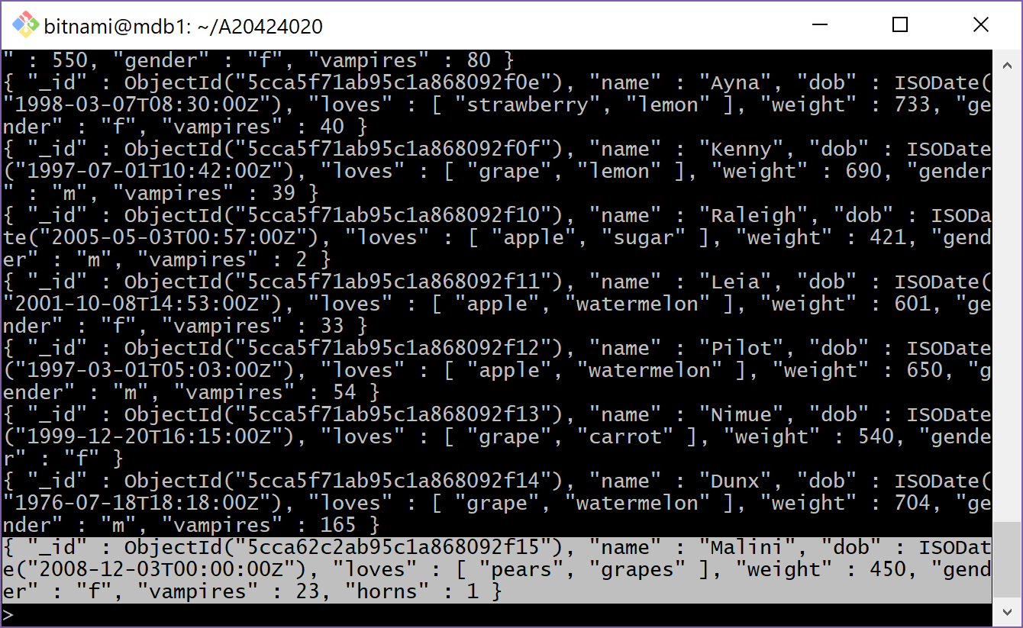

**Command:**

db.unicorns.insertOne({name: 'Malini',

dob: new Date(2008, 11, 03),

loves: ['pears', 'grapes'],

weight: 450,

gender: 'f',

vampires: 23,

horns: 1});

db.unicorns.find();

**Exercise 4) (4 points)**

**Write a command that updates the above record to add apricots to the list of things Malini loves. Include the code you executed and some sample output showing the addition.**

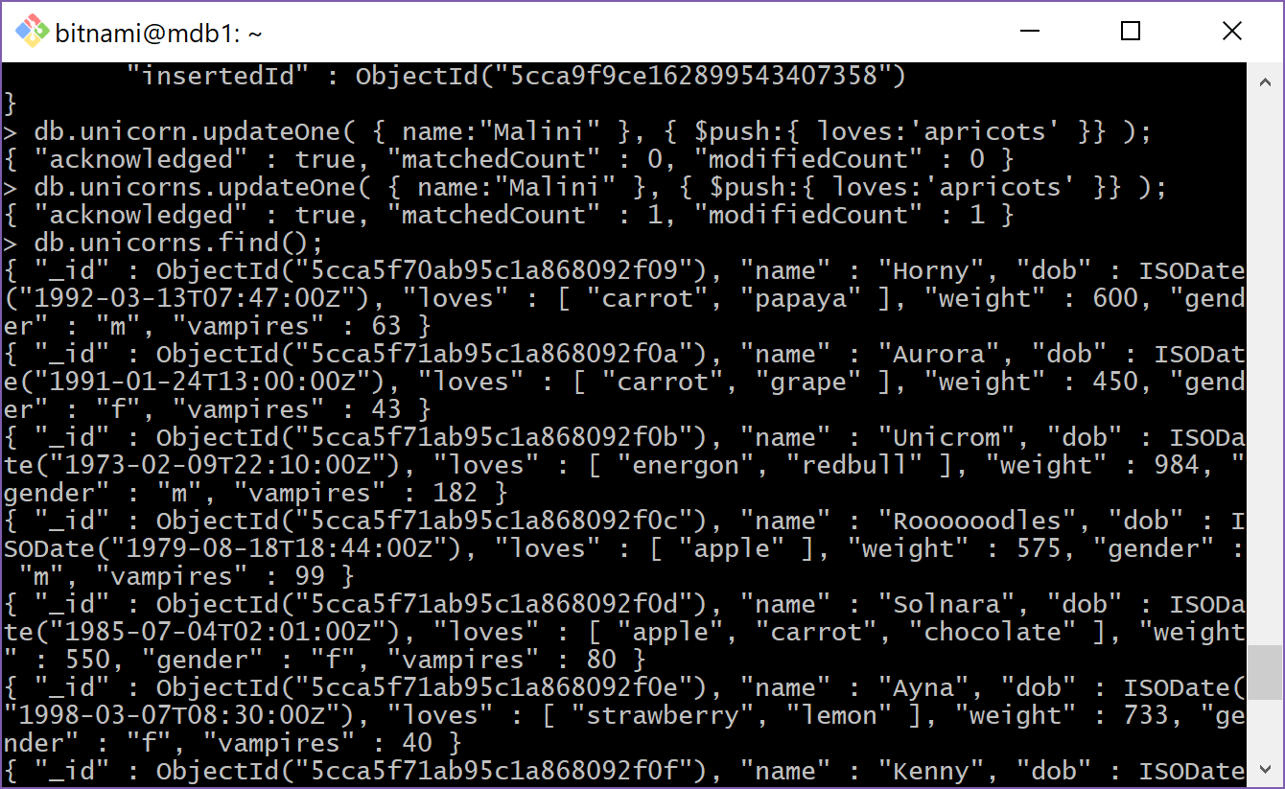

**Command:**

db.unicorns.updateOne(

{ name: "Malini" },

{ $push: { loves: 'apricots' } }

);

db.unicorns.find({ name: "Malini" });

**Exercise 5) (2 points)**

**Write a command that deletes all unicorns with weight more than 600 pounds. Include the code you executed and some sample output as the result of this exercise.**

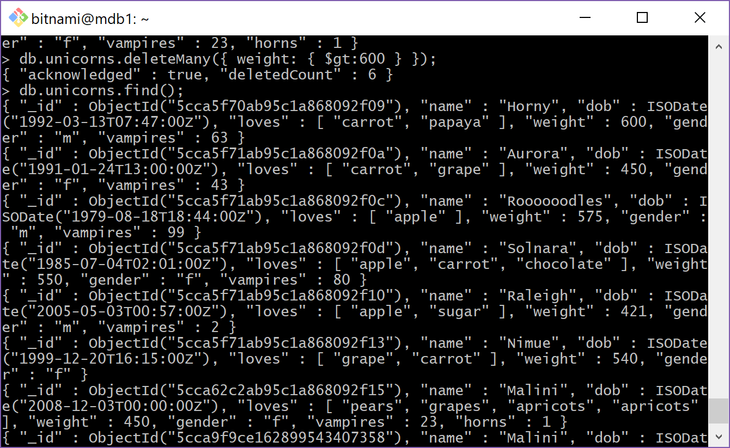

**Command:**

db.unicorns.deleteMany({ weight: { $gt: 600 }});

db.unicorns.find();