1. Install anaconda

<https://www.geeksforgeeks.org/how-to-install-anaconda-on-windows/>

**How to use Jupyter Notebook**

Short-cut to access jupyter notebook from prompt ( Windows)

(base) C:\Users\admin>**jupyter notebook**

* You will be navigating to <http://localhost:8888/tree> - here you can see all files in your current directory
* Create a folder to keep all session related file in one place ([ipynb](http://localhost:8888/notebooks/Data%20Science%20-%20Python%2C%20ML/Python/Python%20Basics.ipynb)) - Suggested

To create a new notebook, Go to New and select Python 3

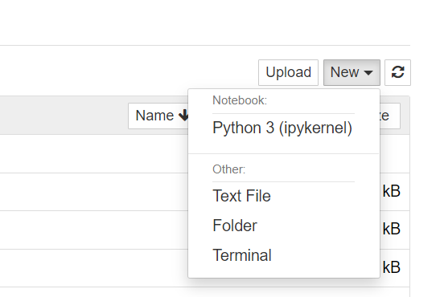

1. Install intellij

<https://www.jetbrains.com/idea/download/?fromIDE=#section=windows>

Add python plugin (youtube)

1. Install github

<https://git-scm.com/downloads>

1. Install github desktop

<https://desktop.github.com/>

1. Create your github account (similar to creating a social media account)
2. Open jupyter notebook
   1. Interactive platform
   2. Testing
   3. Quick line by line code
3. Read csv file in python
4. Read csv file in intellij IDE
5. Create git hub

Aws: Ruchi ji

Sagemaker for ml, deploy jupyter notebook