**Install anaconda**

<https://www.geeksforgeeks.org/how-to-install-anaconda-on-windows/>

**How to use Jupyter Notebook**

Short-cut to access jupyter notebook from prompt ( Windows)

(base) C:\Users\admin>**jupyter notebook**

* You will be navigating to <http://localhost:8888/tree> - here you can see all files in your current directory
* Create a folder to keep all session related file in one place ([ipynb](http://localhost:8888/notebooks/Data%20Science%20-%20Python%2C%20ML/Python/Python%20Basics.ipynb)) - Suggested

To create a new notebook, Go to New and select Python 3

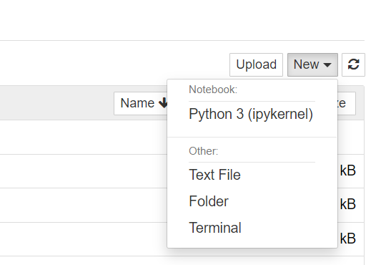

1. Install intellij

<https://www.jetbrains.com/idea/download/?fromIDE=#section=windows>

Add python plugin (youtube)

1. Install github

<https://git-scm.com/downloads>

1. Install github desktop

<https://desktop.github.com/>

**How to add a local repository?**

* Go to Git Bash (Terminal)
* Check your current directory using command: Pwd
* Go to desired location where your local folder is saved
* Enter command to Initialize : $ git init
* Check the status : $ git status
* To include the changes: $ git add .
* To commit the changes: $ git commit -m “Remarks”
* $ git push origin master ( It can be done directly to Git Desktop using Publish Repository)
* Now you check the uploaded local folder into your github account.

1. Create your github account (similar to creating a social media account)
2. Open jupyter notebook
   1. Interactive platform
   2. Testing
   3. Quick line by line code
3. Read csv file in python
4. Read csv file in intellij IDE
5. Create git hub

Aws: Ruchi ji

Sagemaker for ml, deploy jupyter notebook