ASP .Net Core MVC
CLR basics- https://www.csharp.com/UploadFile/puranindia/interview-question-on-net-framework-or-clr/

MVC - https://www.csharp.com/UploadFile/puranindia/ASP-NET-MVC-Interview-Questions/

Entity framework - https://www.c-sharpcorner.com/article/10-common-entity-framework-interview-questions-and-answers/

Rest API - https://www.causelabs.com/post/what-you-need-to-know-about-rest/
https://medium.com/stories-from-the-lab/advanced-rest-api-design-754d1f254e87

WPF - https://medium.com/wpf-windows-presentation-foundations-by-peculia/wpf-overview-introduction-5cf415121464
https://medium.com/mesciusinc/the-definitive-guide-to-wpf-controls-2f032eb1737d

Grpc - https://medium.com/swlh/grpc-fundamental-and-concept-93414d7956df

- Cross-platform, high performance, open source.
Adv
- Cross platform
- Improve performance
- Side by side versioning
- New APIs
- Open source

ASP.NET Core | ASP.NET 4.x
Build for Windows, macOS, or Linux | Build for Windows
Razor Pages is the recommended approach to create a Web UI as of ASP.NET Core 2.x. See also MVC, Web API, and SignalR. | Use Web Forms, SignalR, MVC, Web API, WebHooks, or Web Pages
Multiple versions per machine | One version per machine
Develop with Visual Studio, Visual Studio for Mac, or Visual Studio Code using C# or F# | Develop with Visual Studio using C#, VB, or F#
Higher performance than ASP.NET 4.x | Good performance
Use .NET Core runtime | Use .NET Framework runtime

ASP.NET Core Blazor
- Full stack web ui framework
Adv :
- Reusable component model
- Flexibly render components from server or client via web assembly
- Rich UI interface in c#
- Server randered component for smoother navigation form handling and to enable streaming rendering
- Shared code for common logic
- Interop with javaScript
- Integrate components with existing MVC, Razor pages, Ts libraries

RazorPages
Page based model for builing server rendered WebUI.

Pages folder
Contains Razor pages and supporting files. Each Razor page is a pair of files:
- A .cshtml file that has HTML markup with C# code using Razor syntax.
- A .cshtml.cs file that has C# code that handles page events.

Supporting files have names that begin with an underscore. For example, the _Layout.cshtml

wwwroot folder
Contains static assets, like HTML files, JavaScript files, and CSS files. For more information, see Static files in ASP.NET Core.
appsettings.json
Contains configuration data, like connection strings. For more information, see Configuration in ASP.NET Core.
The following code enables various Middleware:
- app.UseHttpsRedirection(); : Redirects HTTP requests to HTTPS.
- app.UseRouting(); : Adds route matching to the middleware pipeline. For more information, see Routing in ASP.NET Core.
- app.UseAuthorization(); : Authorizes a user to access secure resources. This app doesn't use authorization, therefore this line could be removed.
- app.MapRazorPages();: Configures endpoint routing for Razor Pages.
- app.MapStaticAssets(); : Optimize the delivery of static assets in an app such as such as HTML, CSS, images, and JavaScript to be served. For more information, see What's new in ASP.NET Core 9.0.
- app.Run(); : Runs the app.

Data Context
- Like database configuration
DbSet
- inmemory multiple set of table class

MVC
- Model view controller pattern :
- Seperates code in 3 main components:
- Model
- View
- Controller : user request are routed to a controller.
  - Responsible for working with a model to perform user actions or retrieve results of queries.
  - Chooses view to display to user and provides it with any model data it requires

What is Middleware?
It intercepts incoming requests and outgoing responses and allows you to modify them.
Middleware can be used to perform a wide range of tasks such as authentication, logging, compression, and caching.

Middleware works by using a pipeline model. When a request comes in, it is passed through a series of middleware components before it reaches the application. Each middleware component can modify the request before passing it on to the next component. Once the request has passed through all the middleware components, it reaches the application. Similarly, when a response is sent back to the client, it is passed through a series of middleware components before it is sent back to the client.

Types of Middleware
There are two types of middleware in .NET Core:

terminal - final middleware component in the pipeline.
Ex: - Static file middleware

non-terminal middleware - not the final component
Ex: Authentication, authorization, Request logging, Routing

Custom Middleware
you need to create a class that implements the IMiddleware interface. The IMiddleware interface has a single method called InvokeAsync that is called when the middleware component is invoked.

public class CustomHeaderMiddleware : IMiddleware
{
public async Task InvokeAsync(HttpContext context, Func<Task> next)
{
context.Response.Headers.Add("X-Custom-Header", "Hello World");
await next();
}
}

The InvokeAsync method takes two parameters: the HttpContext and a Func<Task> delegate that represents the next middleware component in the pipeline.

Here is an example of how to add the CustomHeaderMiddleware component to the middleware pipeline:

public void Configure(IApplicationBuilder app, IWebHostEnvironment env)
{
app.UseMiddleware<CustomHeaderMiddleware>();
app.UseRouting();
app.UseEndpoints(endpoints =>
{
endpoints.MapControllers();
});
}

Run() : it adds a terminal middleware delegate to the application's request pipeline. Can not call next after this
: will end the request,
application.Run(async (context) => { await context.Response.WriteAsync("Beginning to Middleware…"); });

Use() : it adds a middleware delegate to the application's request pipeline.
will pass the request to next middleware.
app.Use(async (context, next) =>
{
//action before next delegate
await next.Invoke(); //call next middleware
//action after called middleware
});

App.UseEndpoints: it is app.Use with EndpointMiddleware.

Dependency Injection
is a design pattern that facilitates the decoupling of components in a system. Instead of a class creating its own dependencies, these dependencies are injected into the class from an external source.
This inversion of control enhances modularity, testability, and maintainability.

Key Terms:
- Dependency: An object that another object relies on.
- Injection: The process of providing dependencies to a class.
- Inversion of Control (IoC): A principle where the control of object creation and binding is transferred from the object itself to an external entity.

Benifits:
Loose coupling - Components are less dependent on each other, making it easier to modify or replace them without affecting others.,
Maintainability - Clear separation of concerns makes the codebase easier to manage and extend.,
Flexibility - Easily swap out implementations without changing the consuming code.

Types of Dependency Injection
- Constructor Injection - most common
- Define dependencies as parameters in the constructor.

Use Case:
Use constructor injection when:
- The dependency is mandatory for the class to function.
- You want to ensure that the dependency is available and initialized before the class
is used.
- When you have multiple dependencies, promoting immutability.

Advantages:
- Clear declaration of dependencies.
- Ensures dependencies are not null.
- Promotes immutability and thread-safety.

Limitations:
- Can lead to constructor overload if there are too many dependencies.
- Not suitable for optional dependencies.
- Property Injection :
- Define a public property for the dependency.
- Dependency is optional.
- Method Injection -
Method Injection involves passing dependencies directly through method parameters.

private readonly ILoggerService _loggerService;

public OrderController(ILoggerService loggerService)
{
_loggerService = loggerService;
}

Understanding Service Lifetimes
The three primary service lifetimes are:
- Transient : A new instance of the service is created every time it’s requested.
Lightweight, stateless services.
Services that do not hold any shared state.
services.AddTransient<IMyService, MyService>();
- Scoped : A new instance is created once per request.
- Services that should maintain state within a single request but not across requests.
— Database contexts, unit of work patterns.
services.AddScoped<IMyService, MyService>();
- Singleton : A single instance is created once and shared throughout the application’s lifetime.
— Services that maintain shared state or configuration.
— Caching, logging, and other cross-cutting concerns.
services.AddSingleton<IMyService, MyService>();

Transient objects are always different; a new instance is provided to every controller and every service.
Scoped objects are the same within a request, but different across different requests.
Singleton objects are the same for every object and every request.

Choosing the Right Lifetime
- Transient: When services are lightweight and stateless.
- Scoped: When services need to maintain state within a single request.
- Singleton: When services need to maintain state across the entire application lifecycle.

Differences between JWT, OAuth, and OpenID Connect.

- JWT (JSON Web Token): A compact, URL-safe means of representing claims to be transferred between two parties. It’s a token format used in authentication and information exchange.
- OAuth: An authorization framework that enables a third-party application to obtain limited access to an HTTP service. It’s about delegation of authorization.
- OpenID Connect: A simple identity layer on top of OAuth 2.0, which allows clients to verify the identity of the end-user and to obtain basic profile information in an interoperable and REST-like manner.

How do you configure authorization policies?
Authorization policies in ASP.NET Core are configured using the ConfigureServices method of the Startup class by using the AddAuthorization method. You can define policies that incorporate various requirements, such as user roles, claims, or custom requirements. These policies are then applied to controllers or actions within your application through attributes (like [Authorize]) or by using the policy name directly if more complex rules are needed.

Entity Framework Core?
Entity Framework Core (EF Core) is an open-source object-relational mapping (ORM) framework developed by Microsoft. It is a lightweight and cross-platform version of Entity Framework (EF).

Main Components
- DbContext:
Represents the database session and provides a way to query and interact with the database.
- DbSet:
Represents a collection of entities in the database.
- Entity Classes:
POCO classes that map to database tables.
- Configuration:
Fluent API or Data Annotations to configure entity properties and relationships.
- Migrations:
Used for creating and applying database schema changes.
- LINQ (Language Integrated Query):
Used for querying data in a type-safe manner.

Change Tracking
Change tracking in EF Core is a mechanism that keeps track of changes made to entities. It enables EF Core to detect which entities have been modified and need to be updated in the database when SaveChanges is called. Change tracking is essential for maintaining data consistency between the application and the database.

Lazy Loading
Lazy loading is a technique to defer the loading of related entities until they are explicitly accessed. It helps optimize database queries by loading related data only when it’s needed, reducing unnecessary data retrieval. Let’s go through an example of lazy loading using EF Core:

Eager Loading
Eager loading is a technique used to load related entities along with the main entity in a single database query. It is the opposite of lazy loading
var authorWithBooks = context.Authors
.Include(a => a.Books) // Specify the related entity to load

How to handle Concurrency conflicts
Concurrency conflicts in EF Core occur when multiple users or processes attempt to modify the same entity simultaneously. EF Core provides mechanisms to handle these conflicts, such as optimistic concurrency control using timestamps or row version columns.

As No Tracking
This is a feature that allows you to query data from a database without keeping track of the retrieved entities’ changes. The purpose of using “NoTracking” is primarily for read-only scenarios or when you don’t intend to update or persist changes to the database for the entities you retrieve.
The main benefits of using “NoTracking” are:
- Performance:
Since EF Core doesn’t keep track of changes, it can be more efficient when querying a large amount of data.
- Reduced memory usage:
Without change tracking, EF Core consumes less memory because it doesn’t store information about the original state and changes of each entity.
- Avoiding unintentional updates:
By using “NoTracking,” you prevent accidental updates to entities that you didn’t intend to modify. Any changes made to “NoTracking” entities won’t be persisted in the database unless you explicitly attach them to the DbContext in a tracking state

How do you handle database migrations?
Database migrations in EF Core are handled through the dotnet ef migrations command-line tool or the Package Manager Console in Visual Studio. To handle migrations, you typically:
- Create a migration using the Add-Migration command, providing a name for the migration.
- Apply the migration to the database using the Update-Database command, which updates the database schema to match the current model by applying the necessary changes.

What are some deployment options available for ASP.NET Core?
- IIS (Internet Information Services): A flexible, secure, and manageable Web server for hosting anything on the Web.
- Kestrel: A cross-platform web server for ASP.NET Core.
- Docker Containers: Package applications with all of their dependencies and services.
- Cloud Services: Azure App Service, AWS Elastic Beanstalk, and Google Cloud App Engine are popular cloud hosting options.
- Linux or Windows Virtual Machines: For full control over the hosting environment.

What are microservices?
- Definition: An architectural style that structures an application as a collection of loosely coupled, independently deployable services.
- Design in ASP.NET Core: Use ASP.NET Core’s lightweight, modular nature to develop individual microservices. Leverage APIs for communication between services and Docker containers for isolation and deployment.

Explain the role of messaging queues and service buses in distributed systems.
- Messaging Queues (e.g., RabbitMQ, Azure Queue Storage): Enable asynchronous communication between services, enhancing decoupling and scalability.
- Service Buses (e.g., Azure Service Bus, MassTransit): Provide more complex routing, message sequencing, and transaction management, facilitating sophisticated integration patterns across services.

Explain caching strategies in ASP.NET Core.
- In-Memory Caching: Stores data in the memory of the web server for quick access. Suitable for single-server or ephemeral data.
- Distributed Caching: Distributed cache systems like Redis or Memcached can be used to share cache data across multiple servers, which is beneficial for scalable applications.
- Response Caching: Cache the entire response or parts of it to serve repeated requests quickly.

What are the different types of tests you can write for ASP.NET Core applications?
In ASP.NET Core applications, we can write unit tests, integration tests, and functional tests. Unit tests focus on testing individual components or methods for correctness. Integration tests verify the interaction between components or systems, such as database access and API calls. Functional tests, or end-to-end tests, validate the application as a whole, ensuring that the user experience is as expected.

How do you unit test controllers and services?
To unit test controllers and services, I use a testing framework like xUnit, along with a mocking library like Moq. For controllers, I mock the services they depend on to isolate the controller logic. For services, I mock external dependencies like database contexts or external APIs. This approach allows me to test the behavior of my code in isolation from its dependencies.

Explain integration testing in ASP.NET Core.
Integration testing in ASP.NET Core involves testing the application’s components as a whole, ensuring they work together as expected. This includes testing interactions with databases, file systems, and external services. I use the ASP.NET Core TestHost package to run the application in a test environment, allowing me to send requests to the application and assert the responses and side effects.

How do you handle routing and versioning in Web APIs?
For routing, I use attribute routing in ASP.NET Core to define routes directly on controllers and actions, providing clear and customizable URL patterns.
For versioning, I implement URL path, query string, or header-based versioning strategies using built-in services or third-party libraries. This approach allows me to maintain multiple versions of the API, ensuring backward compatibility while introducing new features.

Describe the role of the Startup class.
- The Startup class in ASP.NET Core is your application's control center, controlling its setup and behavior.
- It defines how your app interacts with databases, middleware, and external services through the ConfigureServices and Configure methods.
- It also enables dependency injection for modularity and testability.

Explain strategies for handling errors and exceptions in ASP.NET Core applications.
Error and exception handling are crucial for building robust and reliable ASP.NET Core applications. Here are some key strategies to consider:
- Middleware: Global error handling with specific responses, logging, and custom error pages.
- Try/Catch: Localized error handling for specific scenarios and resource cleanup.
- Exception Filters: Intercept and handle exceptions before reaching the middleware.
- Descriptive Errors: Throw specific exceptions with clear messages for better debugging.
- Logging: Capture all exceptions for analysis and later troubleshooting.

Explain how to enable Cross-Origin Requests (CORS) in ASP.NET Core for API access from different domains.
- Install Microsoft.AspNetCore.Cors NuGet package.
- Register CORS middleware in ConfigureServices of Startup.cs.
- Define CORS policy with allowed origins, methods, and headers.
- Use the [EnableCors] attribute on controllers or apply globally.
- Optionally, set exposed response headers for client access.

Web API

What is ASP.Net Web API?
A: ASP.Net Web API is a framework that helps in creating http based services. Different clients like, mobile applications or web browsers can consume this data

What are the differences between Web API and WCF REST API?
A: Web API is suitable for HTTP-based services, while WCF REST API is ideal for Message queues, one-way messaging, and duplex communication. WEB API supports any media format, even XML and JSON, while WCF supports SOAP and XML formats. ASP.Net Web API is ideal for building HTTP services, while WCF is perfect for developing service-oriented applications. To run Web API, there is no configuration required, while in the case of WCF, a lot of configuration is required to run it.

WCF.
https://docs.google.com/presentation/d/1kYK0kbo8Kb3dJJ_erHFECHUgqxw1faEkH5aPxW8qFdM/edit
WCF stands for windows communication foundation
- Microsoft platform for building distributed and interoperable application

Distributed - parts run on different computer nodes
Interoperable - application that can be communicate to any other application that is built on any platform

- WCF is interoperable because it uses Soap, HTTP and rest message format, that can be undertsand by other application
WCF is based on the notion of message-based communication, and anything that can be modeled as a message (for example, an HTTP request or a MSMQ)
Client - which are applications that initiate communication
Server - which are applications that wait for clients to communicate with them
Endpoint - Messages are sent between endpoints.
An endpoint describes in a standard-based way where messages should be sent, how they should be sent, and what the messages should look like.
<endpoint address="" binding="wsHttpBinding" contract="Microsoft.ServiceModel.Samples.ICalculator" />

SQL
- Explain the meaning of ‘index’.

Indexes help retrieve information from the database faster and with higher efficiency. In other words, it’s a method that enhances performance and there are 3 types of indexes: Moreover, a table can have multiple non-cluster indexes, but only 1 single clustered one.

Clustered – reorders the table and searches for information with the use of key values

Non-clustered – maintains the order of the table

Unique – forbids fields to have duplicated values

Using an existing table, make an empty one.
Select * into employeecopy from employee where 1=2

Get alternative odd records from the table.
Select employeeId from (Select rowno, employeetId from employee) where mod(rowno, 2)=1

What command would select a unique record from the table?
Select DISTINCT employeeID from Employee

What is a ‘datawarehouse’ and what it does?
A “datawarehouse” is a system used for data analysis and reporting. Basically, it’s a warehouse of data. Data in DWs can be stored from various areas and sources and thus makes them central repositories of integrated data that is ready for usage.

For what ‘recursive stored procedure’ is mainly used ?
A recursive stored procedure is a procedure that will make the code calls itself until specific boundary condition is reached. This is a productivity type of thing, that allows programmers to use the same code a number of times.

Retrieve the first 3 characters from a character string.
Select SUBSTRING(EmployeeSurname, 1, 3) as employeesurname from employee

How would you retrieve common records from two tables ?
Select employeeID from employee. INTERSECT Select EmployeeID from WorkShift
‘
What are Scalar subqueries and Correlated subqueries?
A Scalar subquery is when a query returns just one row and one column of data. A Correlated subquery occurs when a query cannot process without information from an outer query.
List the type of SQL statements or subsets.
- DDL (Data Definition Language) - It is used to define and structure tables. Users can CREATE, ALTER, and Truncate the database tables.
- DCL (Data Control Language) - Administrators use it to give users privileges to GRANT or REVOKE permissions to the database.
- DML (Data Manipulation Language) - It allows users to either UPDATE, INSERT, RETRIEVE, or DELETE information from the database.

What is the difference between TRUNCATE and DELETE?
The truncate command is used when you want to delete all rows and values from a table. It is a DDL type of command which is faster. While the DELETE command is used when you want to delete a specific row in a table. It is a DML command type and less efficient than the truncate statement.
What is a cursor?
A cursor is a temporary memory allocated by the server when performing any DML queries. They are used to store Database Tables. Basically a cursor in sql is an object in database code that allows processes to process rows one by one. While in other programming languages sets of data is processed individually through a loop, in SQL, data is processed in a set through a cursor.
Two types of cursors are Implicit cursors and Explicit cursors.
Implicit Cursors:
They are Default Cursors of SQL SERVER. Allocated when the user performs DML operations.
Explicit Cursors:
They are created by users in need. They are used for Fetching data from Tables in Row-By-Row Manner.

What is ACID?
ACID in SQL refers to a set of properties that guarantee the reliable and consistent processing of database transactions. It is an acronym where each letter stands for one of the properties:
Atomicity: Ensures that a transaction is either fully completed or not executed at all. If any part of a transaction fails, the entire transaction is rolled back, and the database remains unchanged.
Consistency: Guarantees that the database transitions from one consistent state to another upon the completion of a transaction. All data must adhere to predefined rules and constraints.
Isolation: Provides a degree of separation between concurrent transactions, ensuring that they do not interfere with one other. It helps maintain data integrity by controlling the visibility of changes made by one transaction to another.
Durability: Guarantees that after a transaction has been committed, the modifications made to the database become permanent, even if a system failure or crash occurs.
ACID properties are vital in maintaining data integrity and consistency in relational database management systems (RDBMS) and ensuring the robustness of transactions.

What are triggers in SQL?
Triggers are special stored procedures that run when there's an event in the database server, such as changing data in a table. A trigger is different from a regular stored procedure as it cannot be directly called like a regular stored procedure.

Explain Database mirroring.
Database mirroring is a disaster recovery technique used in SQL Server to provide redundancy and failover capabilities for critical databases. It involves maintaining two copies of a database, known as the principal database and the mirror database, on two separate servers. Database mirroring provides a highly reliable and robust solution for critical databases, with the ability to maintain high availability, reduce downtime, and provide a quick recovery in case of a failure.
Update with join:

UPDATE pSET p.category = c.categoryFROM products p
INNER JOIN prodductcatagories pg
ON p.productid = pg.productid
INNER JOIN categories c
ON pg.categoryid = c.cateogryidWHERE c.categories LIKE 'whole%'

Partitions and Shards
Both for distributed database.
Both helps - Managing and quering the vast volume of data generated by modern applications.

- Partitioning
- Sub diving database entities(Table/Index etc) into smaller entities within same physical machine.
- Subentity = Partition.
- Each partition can be accessed and managed seperatly.
Why
- Manageability
- Performance
- Availability
- Sharding
- Same divide entities into subparts but not on single physical machine. But in multiple server instances

-> Client side
Client application is responsible for directing queries to the approriate database.
-> Server side
Across multiple database on server side. Server infrastructure is responsible for directing queries to the appropriate database.

Advantage:
- Ease maintenance
- Performance and scalability
- Simplified query logic
-May lead to complex architecture.

Strategies
- Range base sharding -
  - Partitioned based on predefined range of values, such as range of dates or IDs
- Hash based sharding
  - Based on any attribute of data, such as customer ID.
  - Evenly distributes
- Directory based sharding
  - Lookup table/Directory is used to map data to specific shard
- Round robin sharding
  - In round robin fashion
  - Each piece of data is assigned to the next available shard in a sequence. This strategy is simple to implement and works well when the data is evenly distributed.

Entity Framework

View Models
: POCO without relations.
DBSet : table, if no primary key then it’s like Dbquery, no database change??
DBContext : database
DBQuery : was there, will not update database, just for query

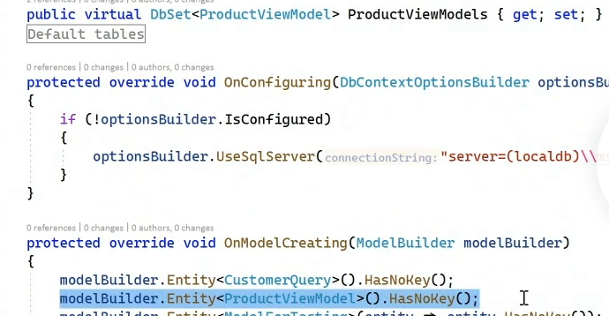

Like view in SQL. - it’s not database table.

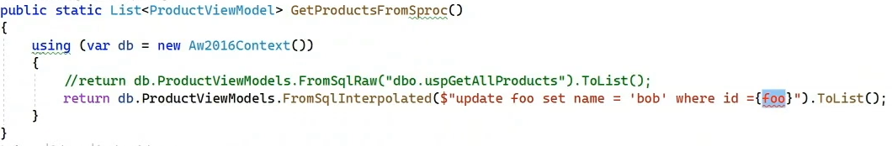
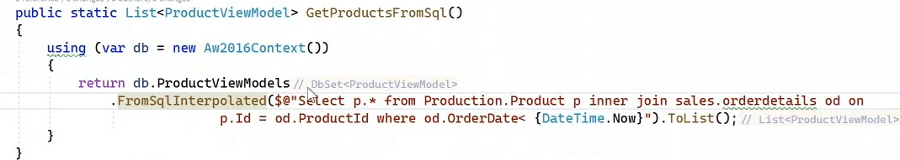

Configuration - by using design time db context factory,this will never run in production
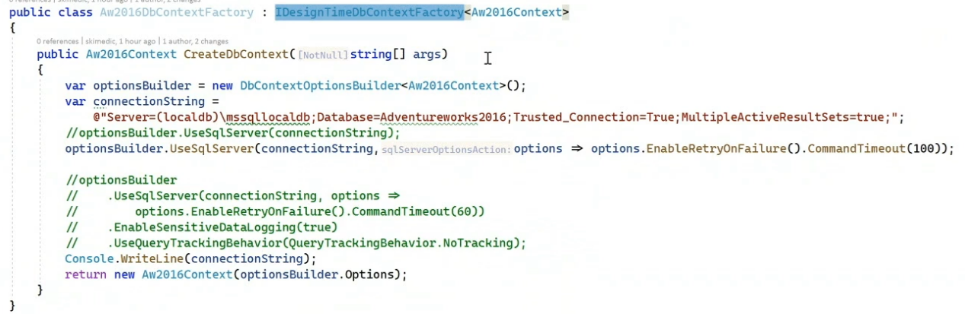
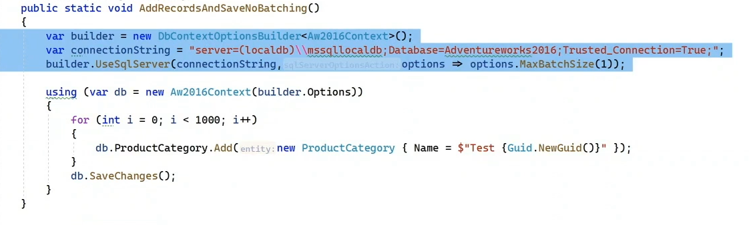
Migrations:

Id : if any column have id as name, EF Core creates it as primary key

Some decorators for POCO
- required
- displayName
- StringLength
- NotMapped - property that does not goes to database
-Key
- ForeignKey
- Column - can change name of column or type of column

Table / POCO decorator
- Owned : owned by some other entity, like json
By below, you can change name of that json column

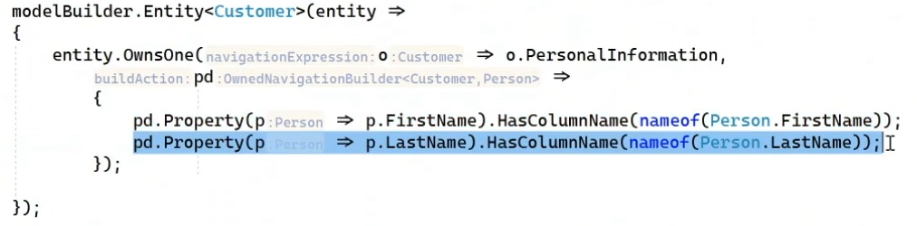

Global Query Filters:
- You can add a query filter to any entity and it will use that query filter whenever that entity is used
- either logging query or main target query anything

- Example, we uses isDeleted boolean for deleted entity, so we can apply global filter to give only which is has isDeleted false.

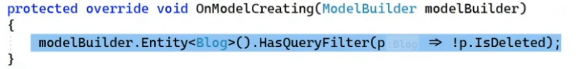

IgnoreQueryFilter() - This will give all entities including isDeleted

Concurrency Resiliency:
If multi users do changes parallel then it could overwrite someone’s changes

Timestamp : [Timestamp] : this is updated by sql server when any column is modified.

EF core handles change tracking,
- if EF core change row and row affected by database lets say SQL is different then EF core will return DBUpdateConcurrencyException
(If number of expected changes and num of actual changes are different - this is because of Timestamp column so sql can track that data)

Good to read: nice way to handle concurrency and rollback to database’s data

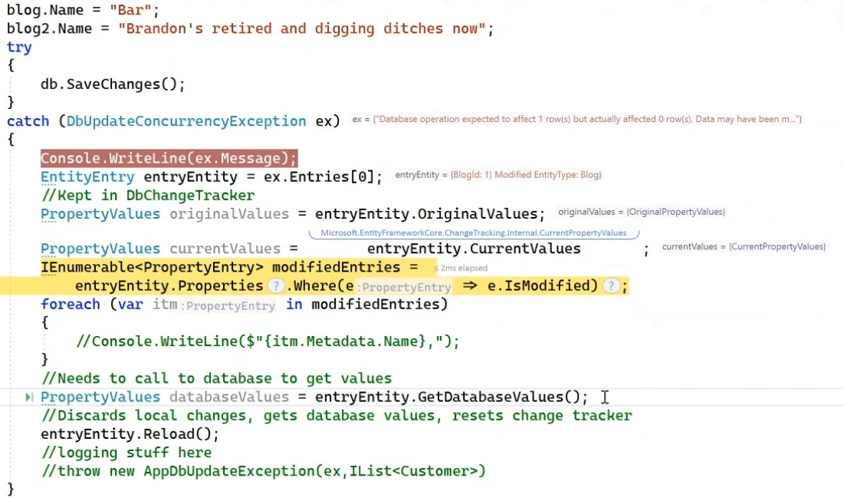

EntryEntity.Reload() - Discard all local changes and get database’s value back and reset change track

Computed columns
Be careful to using functions in SQL, which can be give performance issue.
Example of this function:

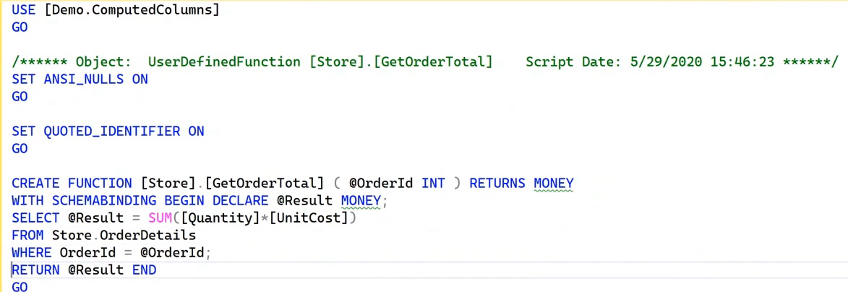
Example with EF:

- Inline computed column

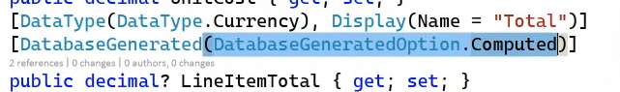
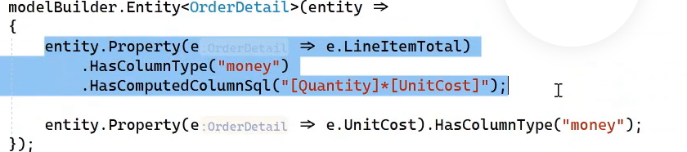

- Using function
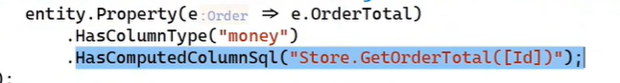
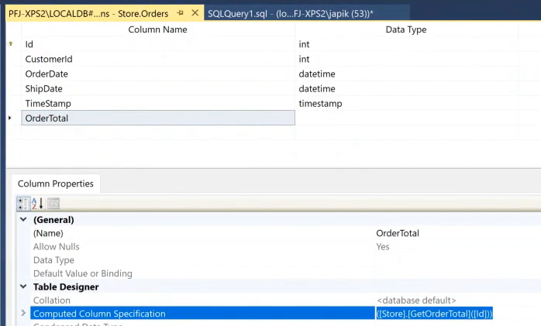

Can map C# function of SQL function in DBContext too

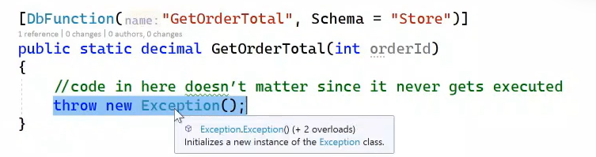

Benefit - can use it in LINQ in dotnet core. But it will look like C# function but it’s calling SQL function

Track changing events:
Two things-
- Raise event when state is changed
- When something is added to change tracker

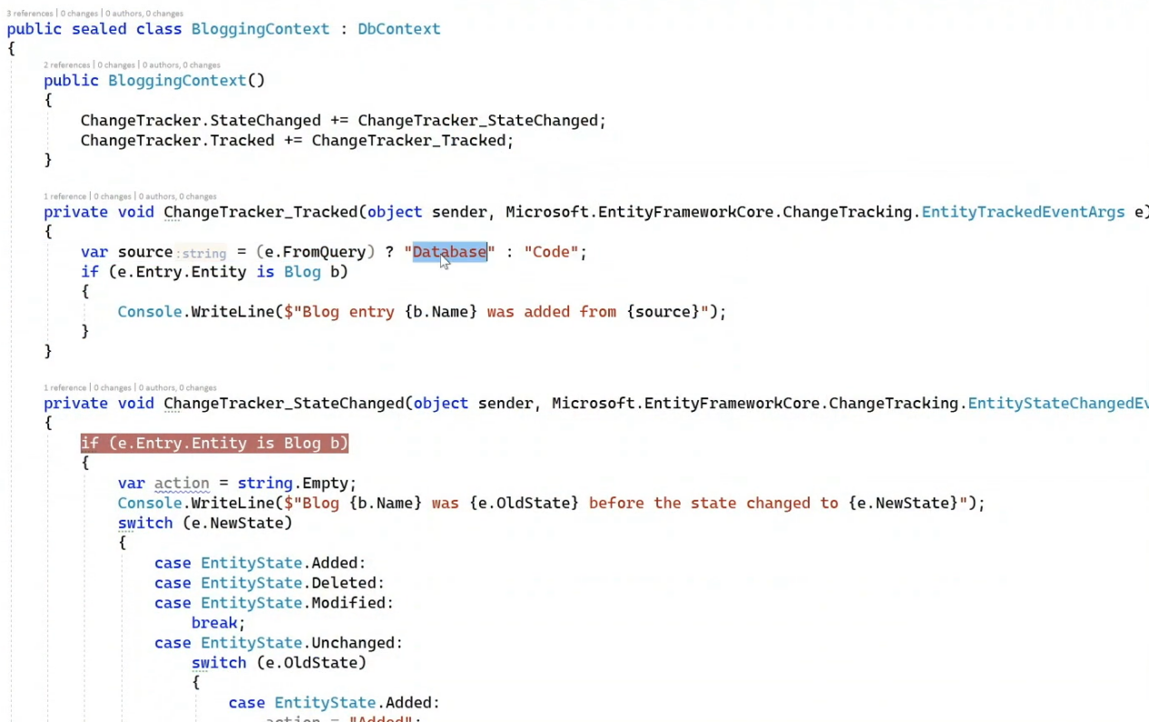
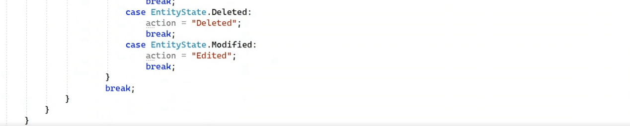

After state change, before save change - at changeTracker_statechanged
When you saved it, it’s unchanged.

Interceptor in EF : running between your code and EF code
Can add like below, in on confige when initializing conneciton string
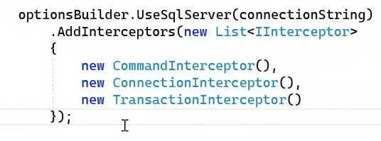

Multi tenancy
In Entity Framework Core (EF Core), "multi-tenancy" refers to the ability of a single application to serve multiple customers (tenants) by isolating their data within the database, while "single-tenancy" means a single application only manages data for one customer, using a single database connection and structure for all data access

MongoDB Query Basics & Syntax
MongoDB is a NoSQL document database that stores data in JSON-like documents (BSON). Instead of tables, rows, and columns, you work with collections and documents.

1. Find Documents
db.collection.find(query, projection)
query: filter criteria (like WHERE in SQL)
projection: fields to return (like SELECT columns)
Example: Find all documents where age > 25
db.users.find({ age: { $gt: 25 } })

2. Find One Document
js
CopyEdit
db.collection.findOne(query)
Example: Find one user with name "Alice"
js
CopyEdit
db.users.findOne({ name: "Alice" })

3. Insert Documents
db.collection.insertOne(document)
db.collection.insertMany([document1, document2, ...])
Example:
db.users.insertOne({ name: "Bob", age: 30 })

4. Update Documents
db.collection.updateOne(filter, update, options)
db.collection.updateMany(filter, update, options)
Example: Increment age by 1 for user with name "Bob"
db.users.updateOne({ name: "Bob" }, { $inc: { age: 1 } })

5. Delete Documents
db.collection.deleteOne(filter)
db.collection.deleteMany(filter)
Example: Delete users with age less than 20
db.users.deleteMany({ age: { $lt: 20 } })

6. Query Operators
Operator | Meaning | Example
$eq | Equal | { age: { $eq: 25 } }
$ne | Not equal | { age: { $ne: 30 } }
$gt | Greater than | { age: { $gt: 25 } }
$gte | Greater than or equal | { age: { $gte: 25 } }
$lt | Less than | { age: { $lt: 40 } }
$lte | Less than or equal | { age: { $lte: 40 } }
$in | In array of values | { status: { $in: ["A", "B"] } }
$nin | Not in array | { status: { $nin: ["D"] } }

7. Logical Operators
Operator | Meaning | Example
$and | AND condition | { $and: [ { age: { $gt: 25 } }, { status: "A" } ] }
$or | OR condition | { $or: [ { age: { $lt: 20 } }, { status: "B" } ] }
$not | NOT condition | { age: { $not: { $gt: 25 } } }
$nor | NOR (NOT OR) | { $nor: [ { age: 25 }, { status: "A" } ] }

8. Projection
Limit fields returned:
db.users.find({}, { name: 1, age: 1 }) // return only name and age fields

9. Sort
Sort results by fields:
db.users.find().sort({ age: -1 }) // descending order by age

10. Limit and Skip
db.users.find().limit(5) // first 5 documents
db.users.find().skip(10) // skip first 10 documents

11. Aggregation
More complex queries (like GROUP BY in SQL):
db.orders.aggregate([
{ $match: { status: "A" } },
{ $group: { _id: "$cust_id", total: { $sum: "$amount" } } },
{ $sort: { total: -1 } }
])

