- What is angular / why angular
Angular is javascript binding framework which binds HTML UI and Javascript modal.
This helps you to reduce your efforts writing those lengthy lines of code for binding
It’s an MVW => w= whatever => MVVm, mvc
Single page application => with routing
Has lots of features like HTTP, DI, input output etc
Angular is a front-end web application framework developed by Google that allows you to build single-page applications (SPAs) using a component-based architecture. It's known for features like dependency injection, powerful routing, two-way data binding, and built-in support for forms and HTTP.
Angular uses TypeScript because it's a superset of JavaScript that adds strong typing and object-oriented features. TypeScript helps catch errors during development rather than runtime, improves code readability, and supports better tooling (like autocompletion and refactoring).

- Angular Js vs Angular
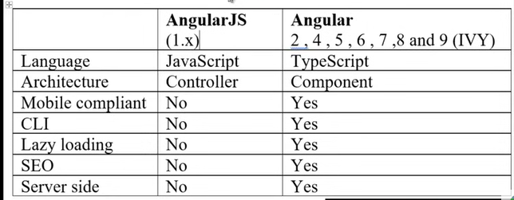
- angular with ionic - can create mobile compliant
- angular - can load data in small bundle

- What are directives
It helps to attach behaviour to HTML dom, in simple words or
Angular syntax which you write inside html to expend behaviour of html

Exm - ngModel, hidden, type, value or {{variable}}
Just angular syntax in html

- Kinds of directives
- S : structure directive
- it actually change structure of html /dom
- For, if, switch
- A : attribute directive
- change look and behavior of element
- disabled , ngclass, ngstyle
- C : component directive
- inputs of component

What are the building blocks of Angular?
- Modules: Container for a group of components, services, etc.
- Components: Control the view and logic (HTML + TS).
- Templates: HTML views with Angular syntax.
- Services: Reusable business logic (like HTTP calls).
- Directives: Change behavior or appearance of DOM.
- Pipes: Transform data in templates.
- Routing: Navigation between views.
Real-world analogy: Think of a component like a LEGO brick (UI unit), a module as a box of LEGO bricks (feature), and services as shared tools or instructions.

- What is NPM

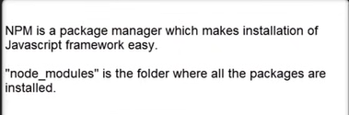

- Packages.json
It has all java-script references needed for a project
So rather than installing one package at a time, we an install packages in one go.

@angular/material
@angular/router
@angular/jquery
@rxjs
- What is typescripts
- adds type to javascript
- super set of java-script
- converts code to javascript
- gives nice oop environment which converts to java-script
- class, extent class

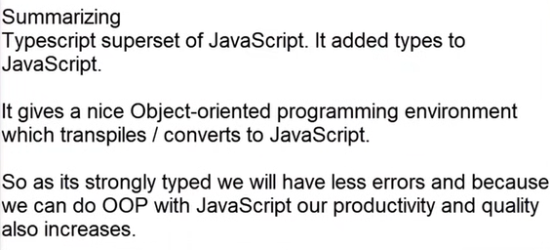

- Let vs var
Var has global scope inside function
Let keyword scope is limited to the block only from where it is declared

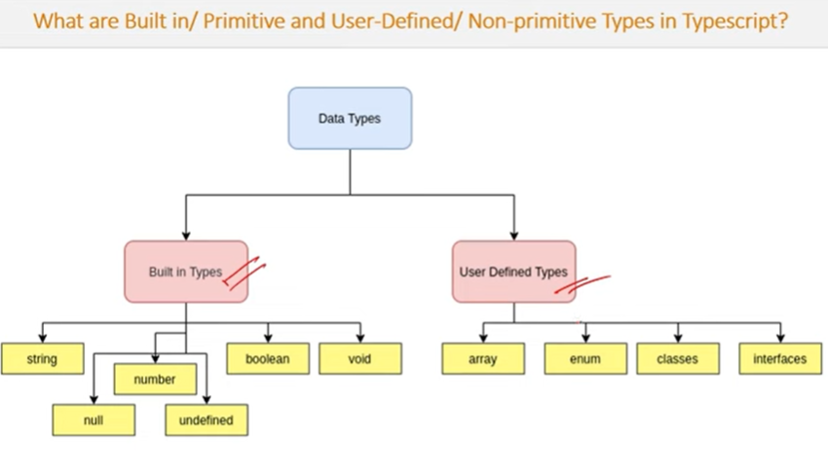
ANY:
Type of variable will be managed at runtime
- no type checking
- can use any type
ENUM:
Allows to define a set of named constants

TYPE ASSERTION
Technique that informs compiler about type of the variable
- Explain importance of angular CLI
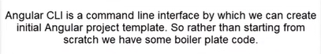

- ng new ‘project’ : it will create project template
- helps to create scarfold project

- can install from npm
Npm I @angular/cli

- What is component and module
Component is where you write your binding code
V - C - M
|
Css
Module : logically group component, so we can divide our application logic to small chunks
MVVM architecture consists of three parts:
- Model
- View
- ViewModel
- Model contains the structure of an entity. In simple terms it contains data of an object.
- View is the visual layer of the application. It displays the data contained inside the Model. In angular terms, this will be the HTML template of a component.
- ViewModel is an abstract layer of the application. A viewmodel handles the logic of the application. It manages the data of a model and displays it in the view.
View and ViewModel are connected with data-binding (two-way data-binding in this case). Any change in the view, the viewmodel takes a note and changes the appropriate data inside the model.
https://stackoverflow.com/questions/1890878/whats-the-difference-between-a-viewmodel-and-controller

- Decorator / Metadata / Anotations / Data anotations
What kind of class it is
@component, @ngmodule
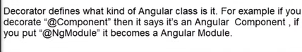

Types of Decorators:
- Class decorators like @Component, @NgModule
- Property decorators like @Input and @Output
- Method decorators like @HostListener
- Parameter decorators like @Injectable

- Templates
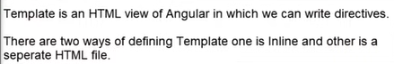
TemplateUrl
Template : inline html
- Data binding
How view and component communicate which each-other
- Expression / interpolation / string interpolation
Get mix with html
{{variable}}
- Property binding - square bracket
Data flows from component to the view
[ngmodel]
- Event binding - (click) : goes from view to component
- Two way binding
Data or event can flow to and fro from the view to the component and from c to v
[(ngModel)]

- Architecture
- Template : html view
- Components
- Group of components : modules
- Bindings - [], ()
- Directives
- Service - share common logic
- DI - helps to inject instance across component
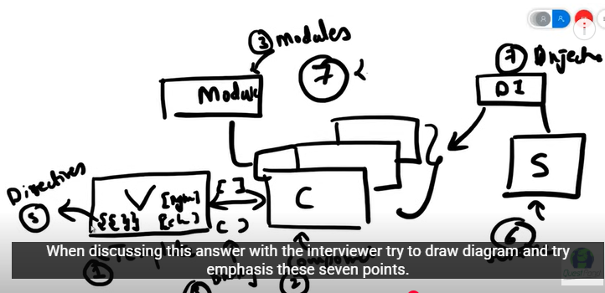

- SPA - single page application
Where main UI gets loaded once and then the needed UI is loaded on demand
How - routing
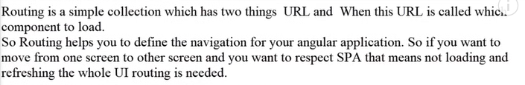

- Create collection
- <router-outlet></router-outlet>
- [routerLink]=”[‘Home’]”
- Router.navigate if wants to navigate with component

- Lazy loading
Load on demand. Loading only necessary HTML, CSS and JS files so tht you have better performance
How -
- ng new customer-app --no-standalone
- separate module
- loadChildren in route collection
const routes: Routes = [
{
path: 'items',
loadChildren: () => import('./items/items.module').then(m => m.ItemsModule)
}
];
angular-v17-cli-default-to-standalone-does-lazy-loading-still-require-ngmodule
- Services
Common functionality across angular projects

- Dependancy injection
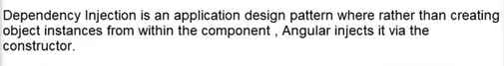

Dependency Injection (DI) is a design pattern. DI is heavily used in Angular. DI is a design pattern that aims to manage component dependencies by injecting them from external sources rather than creating them within the component itself. It is use to improved testability, make Components loose coupling.

By default, Angular’s DI system creates singleton instances of services and shares them throughout the application. In AngularJs, function params are used for DI, From Angular 2, constructor param is used for DI.

- How to implement dependacy injection
Use Provider in ngModule
standalone-application-dependency-injection-4d40fdcc64ea
- Benefit of DI
Decouple class dependancies. So when you add a new dependencies you do not have to change everywhere

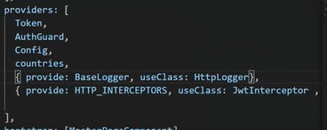

- Ng server and ng build
- ng s : for dev, ng build - need to do when prod


- Ng build --prod
Creates most compressed build

- Change detection method
- Default change detection strategy
- angular checks for changes in all components and their child whenever an event occurs or a data is updated
- On push
- optimized approach, only checks for components data
changeDetection: changeDetectionStategy.push

- Authentication and authorization
- Use a back-end service or identity provider to handle authentication and provide a access tokens
- Store it in a secure way using http only cookie or local storage
localStorage.setItem(‘access_token’, token);
- Create an angular http interceptor that automatically adds the access token to outgoing request.
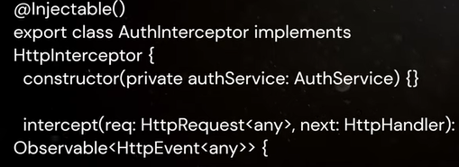
- Creates an authentication service that provides methods for login,logout, and checking current user’s Auth status. This service should also handle refreshing access token when it expires.
- Use angular route guards to control access to protected routes based on the users authentication status and permissions.
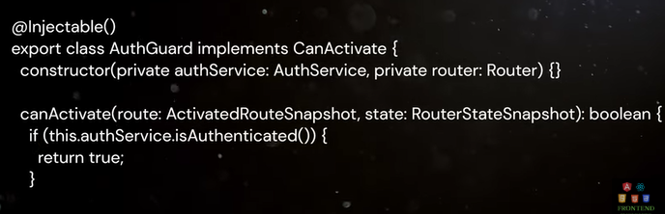

- NgModule
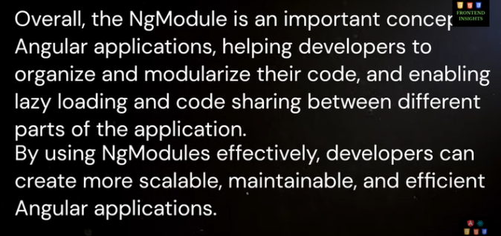

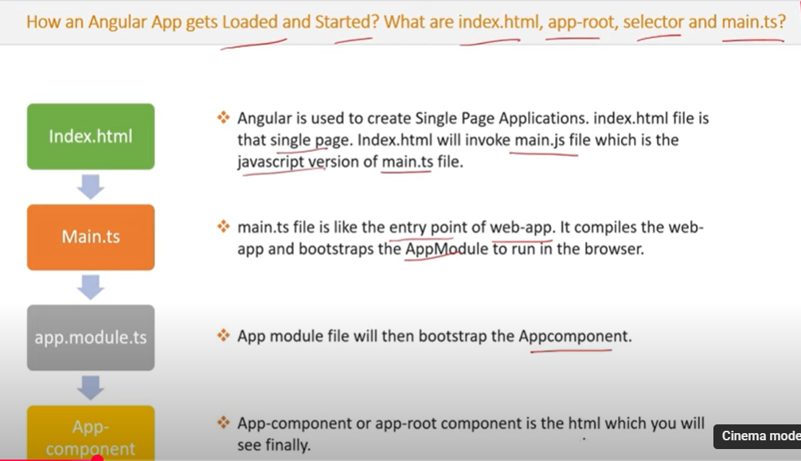

Selector of app component - app-root

https://medium.com/@tehseen_ullah786/what-is-bootstrapping-an-application-in-angular-4df27d80bede

- What are pipes

In Angular, the term "filters" has been replaced with pipes. They help in transforming data in the template.
Types:
- Built-in Pipes: date, uppercase, lowercase, currency, json, async
- Custom Pipes: Defined by developers for custom transformation.

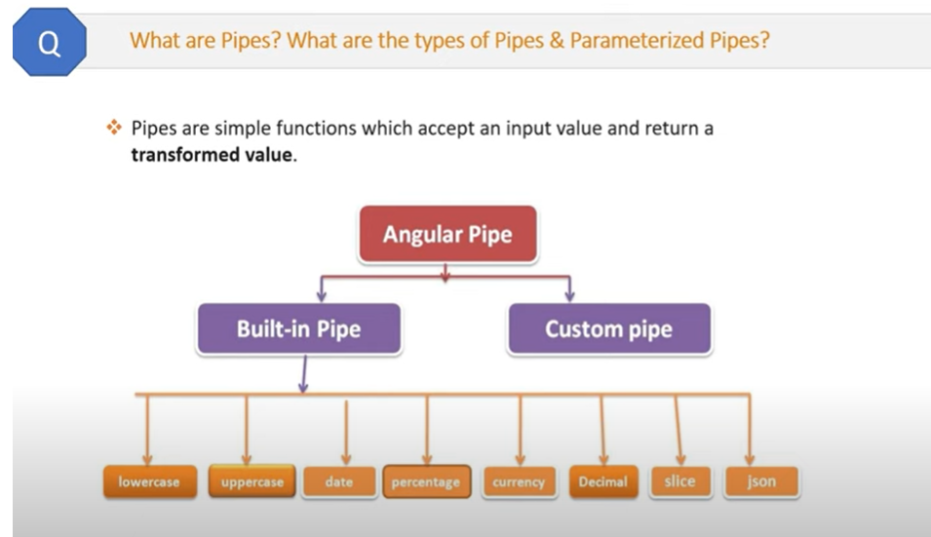

- Chaining pipes
Multiple pipes on data input
{{ dob | date | uppercase }}

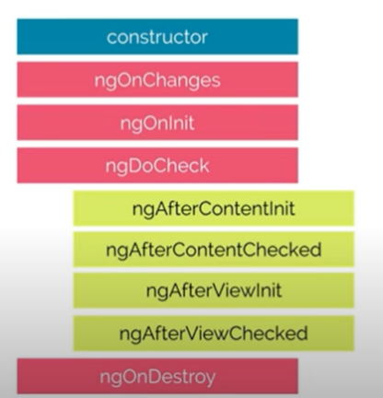

- Promise and observable
- both for async operation
- Promise : when whole data is ready then only it returns
- Observable: steaming data, continuously process chunks of data

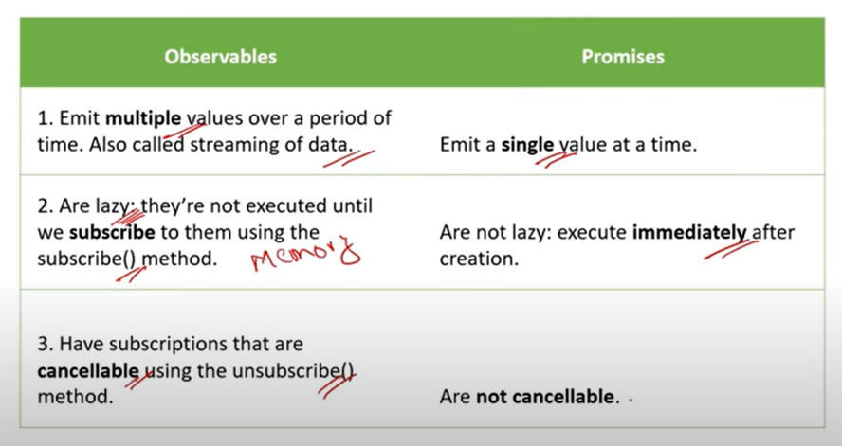

- RxJS
- Stands for reactive extension for javascript
-library for composing async and event-base programming
: event -based : continous data
- javascript library that allow us to work with async data stream with help of observables
- observables introduced by RxJS

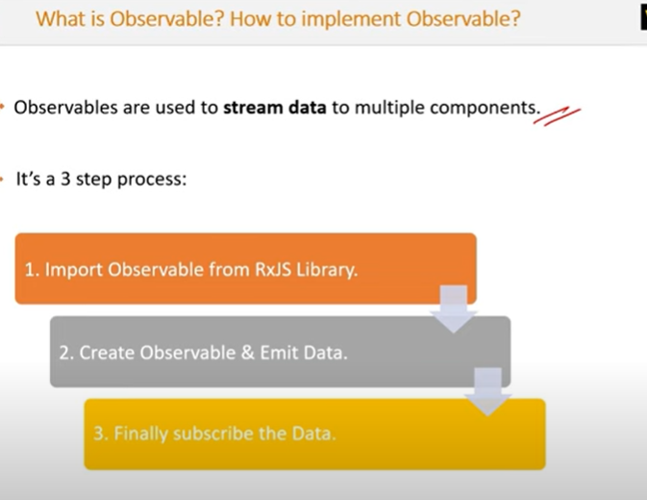

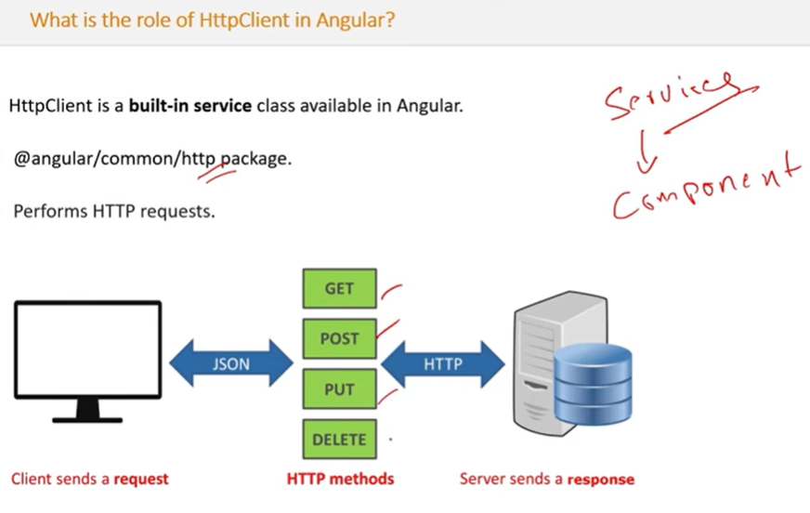

What is Angular Material?
Angular Material is a UI component library that implements Google’s Material Design using Angular. It provides ready-to-use components like buttons, modals, tables, and form fields with accessibility and responsiveness baked in.
Use Case: If you're building an admin dashboard, Angular Material gives you components like mat-table, mat-sidenav, mat-toolbar, and mat-form-field to help you quickly build a consistent UI.

What is ViewEncapsulation, and how many ways can it be implemented in Angular?
ViewEncapsulation controls whether the styles defined in a component affect only that component or leak out globally.
Types:
- Emulated (default): Styles are scoped to the component using attributes.
- ShadowDOM: Uses native Shadow DOM. Not widely used.
- None: Styles are global.
Example:
@Component({
selector: 'app-test',
templateUrl: './test.component.html',
styleUrls: ['./test.component.css'],
encapsulation: ViewEncapsulation.None
})
Use None when you want global styling (e.g., shared button styles across app).

- Why prioritize TypeScript over JavaScript in Angular?

TypeScript offers several advantages over JavaScript, especially for large-scale applications like those built with Angular:

  - Type Safety: TypeScript enforces type checking, which helps catch errors at compile time.

  - Intellisense & IDE Support: Strong tooling support in editors like VS Code makes development smoother.

  - OOP Features: TypeScript supports interfaces, inheritance, access modifiers, etc.

  - Maintainability: Makes large codebases easier to understand, refactor, and maintain.

  - Future JavaScript Features: TypeScript allows developers to use modern JavaScript features that may not yet be fully supported in all browsers.

- What do you understand by RouterOutlet and RouterLink?
RouterOutlet is a directive used as a placeholder where the routed component gets rendered.
RouterLink is used to define navigation paths in templates.
Example:

<nav>
<a routerLink="/home">Home</a>
<a routerLink="/about">About</a>
</nav>
<router-outlet></router-outlet>

What happens when you use the script tag within a template?
Using <script> tags inside Angular component templates is not recommended and generally ignored. Angular sanitizes templates for security (e.g., to prevent XSS). So if you add a <script> tag, Angular will strip it out or throw a warning.
Correct Practice: Include scripts in angular.json or dynamically load via services.

What is ViewChild and when would you use { static: false }?
ViewChild lets you access a DOM element, directive, or component instance from your template in your component class.
Syntax:
@ViewChild('myInput', { static: false }) inputEl!: ElementRef;
- Use { static: false } when the element is rendered after ngOnInit, typically inside an *ngIf or similar condition.
- Use { static: true } if you want access before ngOnInit.

How many ways can we share data between components?
- @Input() / @Output() - For parent-child communication.
- Services with Observable/Subject - For sibling and distant components.
- Local Storage / Session Storage - For sharing across unrelated components.
- Router Params - Passing data via routes.
- ngRx / State Management - For large-scale apps.

Angular Lifecycle Hooks
#### Angular Lifecycle Hooks (One-liners)

- `ngOnChanges()` – Called when any data-bound input property changes.
- `ngOnInit()` – Called once after the first `ngOnChanges()`, used for initialization.
- `ngDoCheck()` – Detect and act upon changes not handled by default change detection.
- `ngAfterContentInit()` – Called once after content (ng-content) is projected into the component.
- `ngAfterContentChecked()` – Called after every check of projected content.
- `ngAfterViewInit()` – Called once after the component's view (and child views) has been initialized.
- `ngAfterViewChecked()` – Called after every check of the component's view (and child views).
- `ngOnDestroy()` – Called just before the component is destroyed; used for cleanup.

There are 8 life cycle hooks in Angular. I have heavily used ngOnInit and ngOnDestroy in my previous work environment. ngOnInit is called when component initialize. It is called once. Mostly, I used for variable initialize and API call. ngOnDestroy is called before detroying the component. I heavily used for unsubscribe the subscription to prevent the memory leak.
Several times I have used ngOnChanges, ngAfterContentInit, ngAfterViewInit in my career. ngOnChanges method is called once on component’s creation and then every time changes are detected in one of the component’s input properties. It receives a SimpleChanges object as a parameter. ngAfterViewInit is called after the component view and its child views has been initialized. ngAfterContentInit is called after components external content (or from parent ) has been initialized.
There are other hooks like ngDoCheck, ngAfterContentChecked, ngAfterViewChecked, I did not use them too much.
- What is SimpleChanges in Angular?
Simply in the ngOnChange is fire when declared property values are changed. So in that method, we can set this as a param to store the data. like this In this way we can check these details using SimpleChanges : Previous value : any Current value: any FirstChange : boolean

What is AOT compilation? What are the advantages of AOT?
AOT (Ahead-Of-Time) compilation compiles your Angular HTML and TypeScript code into efficient JavaScript during the build time.
Advantages:
- Faster rendering (no runtime compilation)
- Smaller bundles
- Early error detection
- Improved security

What is "sourceMap": true in Angular?
In angular.json, setting "sourceMap": true includes mapping files in the build.
Benefit: Helps in debugging. Even though the browser runs minified JS, you can debug using original TypeScript files in DevTools

What are Template and Reactive forms?
In Angular, we use forms to collect user inputs. There are two main approaches: Template-driven forms and Reactive forms.
Template-driven forms are more HTML-based. We write most of the logic in the HTML using directives like ngModel. These forms are good for simple scenarios, like a contact form or login form, where validation and structure are straightforward.
<input [(ngModel)]="user.name" name="name" required />
Reactive forms are more code-driven. We define form controls in the TypeScript file using FormControl, FormGroup, and FormBuilder. It gives us more control and is better for complex forms like dynamic forms or forms that need custom validation logic or conditional rendering.
Example:
this.userForm = new FormGroup({
name: new FormControl('', Validators.required),
email: new FormControl('', [Validators.required, Validators.email])
});

What are forRoot() and forChild() in Angular?

These are methods used in Angular when setting up feature modules and routing.
forRoot() is used in the AppModule. It sets up singleton services and the root router configuration. Think of it as initializing the app-wide dependencies.
forChild() is used in feature modules. It allows us to define routes and configurations specific to that module without duplicating services or causing re-initialization.
https://dev.to/chintanonweb/achieve-clean-routing-in-angular-17-refactoring-tips-techniques-24bm
https://medium.com/@piyalidas.it/forroot-and-forchild-of-angular-lazy-loading-module-209252a15c5e
Example:
ts
CopyEdit
RouterModule.forRoot(appRoutes) // in AppModuleRouterModule.forChild(childRoutes) // in FeatureModule
Scenario: I once faced an issue where using forRoot() in a feature module caused my guards and resolvers to reinitialize unexpectedly. Changing it to forChild() fixed it.

49. How to handle multiple HTTP requests in Angular?
Answer:
We can handle multiple requests using RxJS operators like forkJoin, combineLatest, or switchMap.
- forkJoin: Waits for all observables to complete and gives final values. Good for independent calls.
- combineLatest: Emits values when any of the observables emit.
- switchMap: Good when one call depends on the result of another.
- concatMap: Executes observables sequentially.
- mergeMap: Executes in parallel, doesn't wait for one to finish.
Example:

forkJoin({
user: this.http.get('/api/user'),
orders: this.http.get('/api/orders')
}).subscribe(data => {
console.log(data.user, data.orders);
});

50. map vs mergeMap vs switchMap vs concatMap
Answer:
These are RxJS operators used when working with Observables, especially in HTTP calls.
map: Just transforms data.
observable.pipe(map(data => data.value))
MergeMap: Flattens Observables and runs in parallel.
Useful when you want to call multiple APIs simultaneously.

of(userIds).pipe(
mergeMap(id => this.getUser(id))
)
concatMap: Runs requests one after another (sequentially).
from([1, 2, 3]).pipe(
concatMap(id => this.getUser(id))
)
switchMap: Cancels previous requests if a new one comes in. Best for search/autocomplete.
searchInput.pipe(
switchMap(term => this.search(term))
)
Scenario: In a search bar, I used switchMap so that if the user kept typing quickly, old HTTP requests would be canceled, avoiding race conditions.

What is the purpose of angular.json?
Answer:
angular.json is the workspace configuration file for Angular CLI. It defines how your app is built, tested, served, and more.
Contains:
Build options (like optimization, budgets)
- File paths (styles, scripts)
- Environments
- Output folders
Scenario: Once, we had to load Bootstrap globally. Instead of importing in every component, we added it in angular.json under styles and scripts.
10. Angular 17 New Features
Answer:
Angular 17 brought several modern improvements. Here are key features:
- Deferred Loading (Deferrable Views)
Helps improve performance by delaying the rendering of parts of the UI until needed (like after a button click or visibility).
@defer (on viewport) {
<expensive-widget />
}
- Control Flow Syntax (@if, @for)
New template syntax similar to JavaScript:
@if (user) {
<p>Welcome {{ user.name }}</p>
}
- Standalone APIs Are Default
Now, we don’t have to use NgModules unless needed. Components and routes are all standalone by default.
- Faster Builds with esbuild
Angular 17 uses esbuild under the hood for significantly faster dev builds.
- Hydration Improvements for SSR
Helps with SEO and performance for server-side rendered apps.
Scenario: In a recent POC, we used @defer to load a large analytics chart only when it came into view. It reduced the initial load time and made the page faster.

11. Differences Between Standard and Standalone Component
Answer:
Standard Component:
Part of a module, declared in declarations of @NgModule.
Standalone Component:
Declares its own dependencies and can be used without an NgModule. Introduced to simplify app structure.
Standard Example:
@NgModule({
declarations: [MyComponent],
})
Standalone Example:
@Component({
standalone: true,
imports: [CommonModule],
...
})
Scenario: When working on a micro frontend, standalone components helped us isolate and test features without tight coupling to a module.

12. What is bootstrapModule in Angular?
Answer:
bootstrapModule is a method used to launch an Angular application manually by specifying which module to start with.
Example (main.ts):
platformBrowserDynamic()
.bootstrapModule(AppModule)
With standalone components:
bootstrapApplication(AppComponent)
Scenario: With Angular 17, if you're using a fully standalone app, you use bootstrapApplication() to start the app without a traditional AppModule.

13. Angular Testing Framework
Answer:
Angular uses Jasmine for writing unit tests and Karma as a test runner.
You write tests in .spec.ts files using:
describe() to group tests
it() to define a test case
beforeEach() for setup
TestBed to create and configure components and services

Example:
describe('MyComponent', () => {
beforeEach(() => {
TestBed.configureTestingModule({
declarations: [MyComponent]
}).compileComponents();
});

it('should create the component', () => {
const fixture = TestBed.createComponent(MyComponent);
expect(fixture.componentInstance).toBeTruthy();
});
});
Scenario: I wrote unit tests for a critical form to ensure the required validations always trigger properly. It helped us catch issues during refactors.

14. Pre-fetch Data Using Resolvers
Answer:
Resolvers in Angular fetch data before a route is activated. This is helpful when you don’t want to show the page until the required data is ready.
How?
- Create a resolver that implements Resolve<T>.
- Add it to the route.
{
path: 'profile',
component: ProfileComponent,
resolve: { user: UserResolver }
}
Scenario: For a user profile page, I used a resolver to get the user’s data before the component loaded. It prevented the UI from showing "loading" spinners unnecessarily.

15. Guards in Angular
Answer:
Guards are used to control access to routes. Types include:
- CanActivate: Block or allow access
- CanActivateChild: For child routes
- CanDeactivate: Ask before leaving
- Resolve: Preload data
- CanLoad: Control lazy-loaded modules
Example:
{ path: 'admin', canActivate: [AuthGuard] }
Scenario: I used CanActivate in an app to prevent unauthorized users from accessing the admin dashboard. It redirected them to login.

16. What is @HostBinding and @HostListener in Angular?
Answer:
- @HostBinding: Binds a property of the host element (like a class, style, or attribute).
- @HostListener: Listens to DOM events on the host element.
Example:
@HostBinding('class.active') isActive = false;
@HostListener('click')onClick() {
this.isActive = !this.isActive;
}
Scenario: I used @HostBinding to toggle a CSS class on a custom directive when clicked, making a dropdown open/close by changing class dynamically.

17. Polyfills in Angular
Answer:
Polyfills are JavaScript code used to add support for newer features on older browsers (like IE11).
Angular includes polyfills in polyfills.ts, like:
core-js (for ES6+ features)
zone.js (for change detection)
Scenario: We had to support older browsers. I enabled the classList and es6 polyfills to make ngFor work correctly in IE11.

18. RouterOutlet vs RouterLink vs RouterModule
Answer:
Term | Purpose
RouterModule | Angular module that sets up routing
RouterLink | Directive for navigation (like <a [routerLink]="'/home'")
RouterOutlet | Placeholder where routed components are loaded
Scenario: In our layout, <router-outlet> was inside a <div class="content">, and all routes loaded there. Sidebar links used [routerLink] to navigate without reloading the page.

19. Difference Between Pure and Impure Pipes
Answer:
Pipe Type | Triggers | When to Use
Pure (default) | Only when input changes (by reference) | Best for performance
Impure | On every change detection cycle | Use when data changes frequently without changing reference
ts
CopyEdit
@Pipe({ name: 'myPipe', pure: false })
Scenario: I made a custom impure pipe to filter an array when an internal property changed (not the array itself). Pure pipe didn’t detect the change because the reference stayed the

What are SOLID principles?
Answer (simplified):
They are like rules for writing clean code.
- S: One class should do one thing.
- O: Code should be open to add features, but not break existing stuff.
- L: Child classes should work wherever parent class is used.
- I: Don't force classes to implement unused methods.
- D: Depend on interfaces, not concrete classes.
I follow these to make code easy to change and test.

https://tusharghosh09006.medium.com/advanced-angular-interview-questions-d1573f1b350b

https://medium.com/@jemimaosoro/mastering-form-handling-unraveling-the-power-of-forms-in-angular-c7768adc3bae

https://sithummeegahapola.medium.com/what-is-angular-simplechanges-in-ngonchange-method-2e6b8e7f411d

https://medium.com/@shairez/a-super-ninja-trick-to-learn-rxjss-switchmap-mergemap-concatmap-and-exhaustmap-forever-88e178a75f1b

https://medium.com/@greennolgaa/understanding-object-oriented-programming-concepts-in-angular-7549547c3f68

https://medium.com/@sonikkapadia20/angular-architectural-patterns-flexible-scalable-1de1aa1ec519

https://medium.com/@ShantKhayalian/state-management-in-angular-ngrx-vs-akita-e31d81a2ec87

