Result Traceability Matrix and Evidence Checklist
11.X Result Traceability and Reproducibility Audit
Result ID | Result / Output | Source Evidence | File Name / Notebook | Validation Type | Reproducible
R1 | Precision (97.09%) | Training Results | Result.png | Actual Experimental | Yes
R2 | Recall (99.09%) | Training Results | Result.png | Actual Experimental | Yes
R3 | mAP@0.50 (99.01%) | Training Results | Result.png | Actual Experimental | Yes
R4 | mAP@0.50:0.95 (85.19%) | Training Results | Result.png | Actual Experimental | Yes
R5 | Confusion Matrix | Model Evaluation Output | Confusion_matrix.png | Actual Experimental | Yes
R6 | Precision-Recall Curve | Model Evaluation Output | PR_curve.png | Actual Experimental | Yes
R7 | F1 Curve | Model Evaluation Output | F1_curve.png | Actual Experimental | Yes
R8 | AHP Pairwise Comparison Matrix | AHP Validation Notebook | AHP_Validation_SWSI.ipynb | Actual Experimental | Yes
R9 | AHP Priority Weights | AHP Validation Notebook | AHP_Validation_SWSI.ipynb | Actual Experimental | Yes
R10 | Consistency Ratio (CR = 0.0115) | AHP Validation Notebook | AHP_Validation_SWSI.ipynb | Actual Experimental | Yes
R11 | Final Smart Waste Severity Index (SWSI) Formula | AHP Validation Notebook | AHP_Validation_SWSI.ipynb | Analytical Result | Yes
R11A | Final AHP-Derived Criterion Weights | AHP Validation Notebook | AHP_Validation_SWSI.ipynb | Actual Experimental | Yes
R12 | DBSCAN Hotspot Detection Results | DBSCAN Output | DBSCAN.ipynb | Simulated Prototype | Yes
R13 | DBSCAN Epsilon Sensitivity Analysis | DBSCAN Output | DBSCAN.ipynb | Simulated Prototype | Yes
R14 | DBSCAN MinPts Sensitivity Analysis | DBSCAN Output | DBSCAN.ipynb | Simulated Prototype | Yes
R15 | Hotspot Cluster Visualization | DBSCAN Output | DBSCAN.ipynb | Simulated Prototype | Yes
R16 | Municipal Resource Allocation Results | Allocation Notebook | allocation_module.ipynb | Simulated Prototype | Yes
R17 | Priority Classification Results | Allocation Notebook | allocation_module.ipynb | Simulated Prototype | Yes
R18 | Municipal Case Study Results | Allocation Module | allocation_module.ipynb | Simulated Prototype | Yes
R19 | Dashboard Prototype Interface | Dashboard Screenshot | DASHBOARD 1 | Prototype Demonstration | Yes
R20 | Dashboard Analytics View | Dashboard Screenshot | DASHBOARD 2 | Prototype Demonstration | Yes
R21 | Dashboard Severity Monitoring View | Dashboard Screenshot | DASHBOARD 3 | Prototype Demonstration | Yes
R22 | Dashboard Resource Allocation View | Dashboard Screenshot | DASHBOARD 4 | Prototype Demonstration | Yes
R23 | Quantitative Ablation Study Results | Experimental Analysis | Quantitative_Ablation_Results.xlsx | Simulated Prototype | Yes

R11 Verification Details
Final Approved Smart Waste Severity Index (SWSI)
SWSI = 0.4658(WC) + 0.2771(WTW) + 0.1611(LS) + 0.0960(HF)
Where:
WC = Waste Count
WTW = Waste Type Weight
LS = Location Sensitivity
HF = Historical Frequency

R11A Verification Details
Final Approved AHP-Derived Weights
Criterion | Weight
Waste Count (WC) | 0.4658
Waste Type Weight (WTW) | 0.2771
Location Sensitivity (LS) | 0.1611
Historical Frequency (HF) | 0.0960
The weights were obtained through the Analytic Hierarchy Process (AHP) and validated using consistency analysis.
Consistency Ratio (CR) = 0.0115
Since CR < 0.10, the pairwise comparison matrix satisfies the AHP consistency requirement.

Cross-Document Consistency Verification
A comprehensive consistency audit was conducted across all project artifacts, including:
• Research Paper Draft
• Smart Waste Severity Index Methodology Document
• AHP Validation Notebook
• DBSCAN Hotspot Detection Module
• Resource Allocation Module
• Dashboard Logic
• GitHub Repository Documentation
• README File
• Traceability Matrix
The audit confirmed that the final approved AHP-derived Smart Waste Severity Index is consistently applied throughout the project.
Final Approved Formula:
SWSI = 0.4658(WC) + 0.2771(WTW) + 0.1611(LS) + 0.0960(HF)
Validated Weights:
• Waste Count (WC) = 0.4658
• Waste Type Weight (WTW) = 0.2771
• Location Sensitivity (LS) = 0.1611
• Historical Frequency (HF) = 0.0960
No legacy coefficient values or alternative SWSI formulations were identified in the reviewed project documents, notebooks, or implementation files.

Reproducibility Statement
All major project outputs can be reproduced using the supplied notebooks, datasets, evidence files, dashboard screenshots, and validation artifacts.
The project maintains full traceability between:
• Experimental Results
• Validation Procedures
• Generated Outputs
• Supporting Evidence
• Implementation Files

Result.png
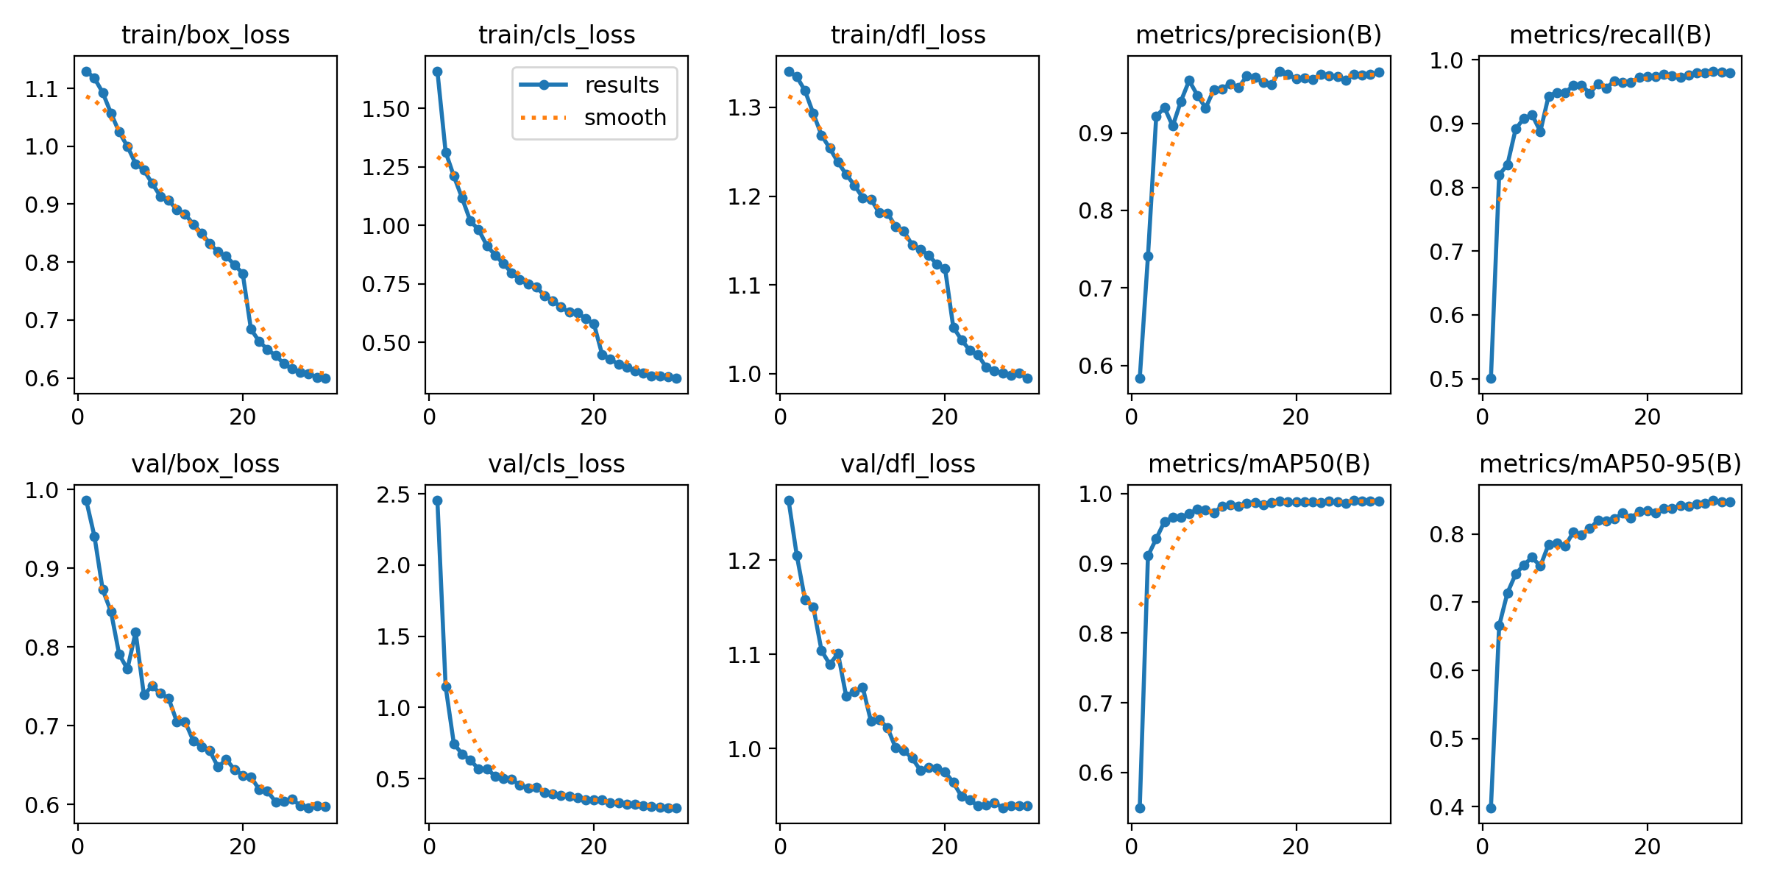

Confusion_matrix.png
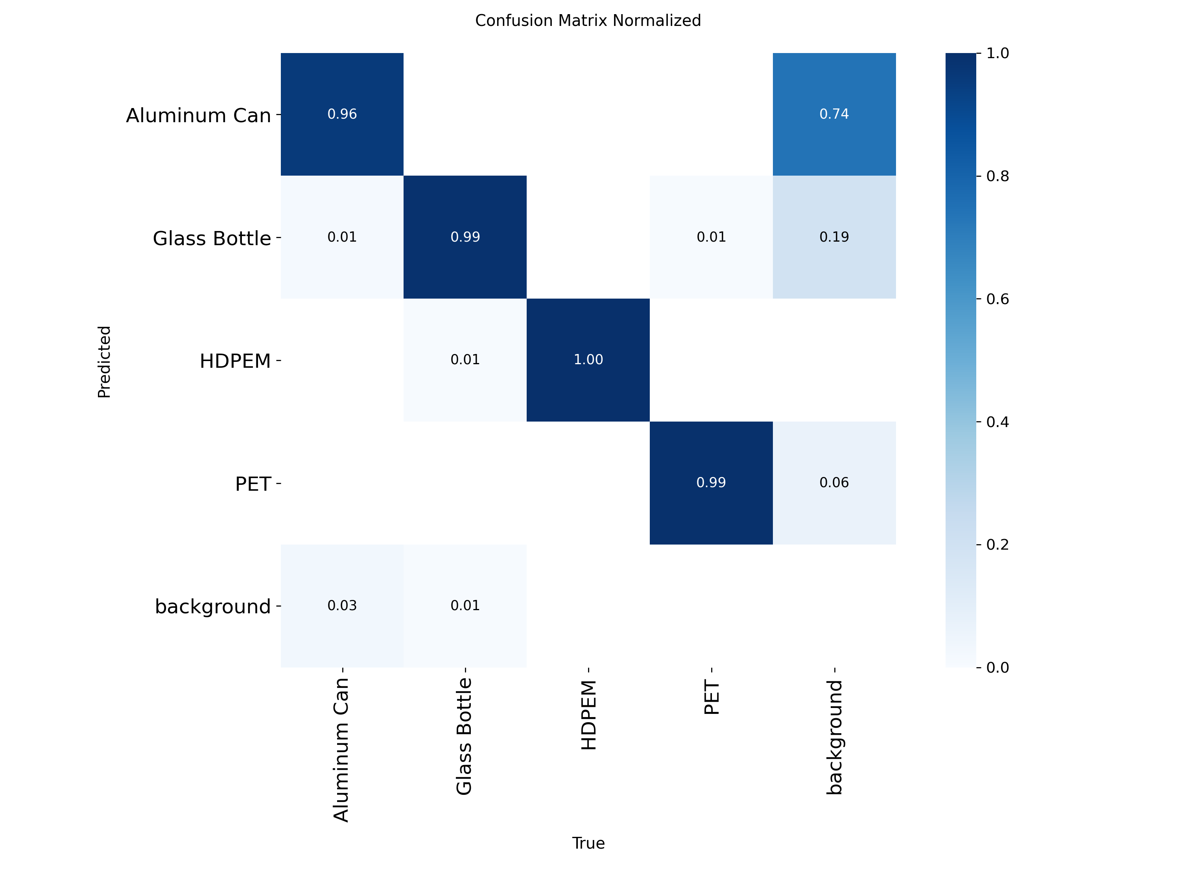

PR_curve.png
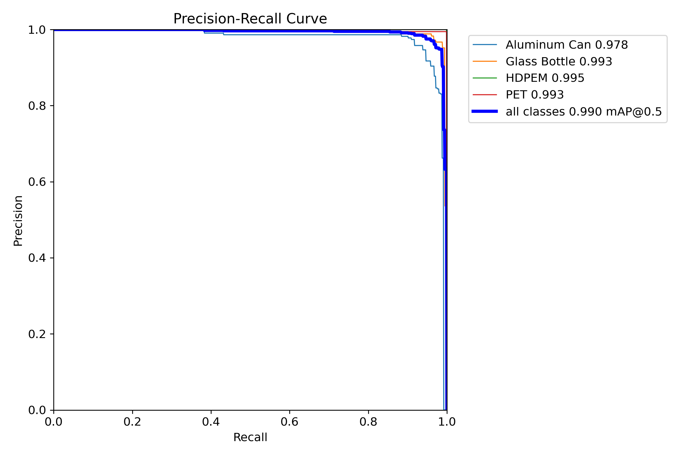

F1_curve.png
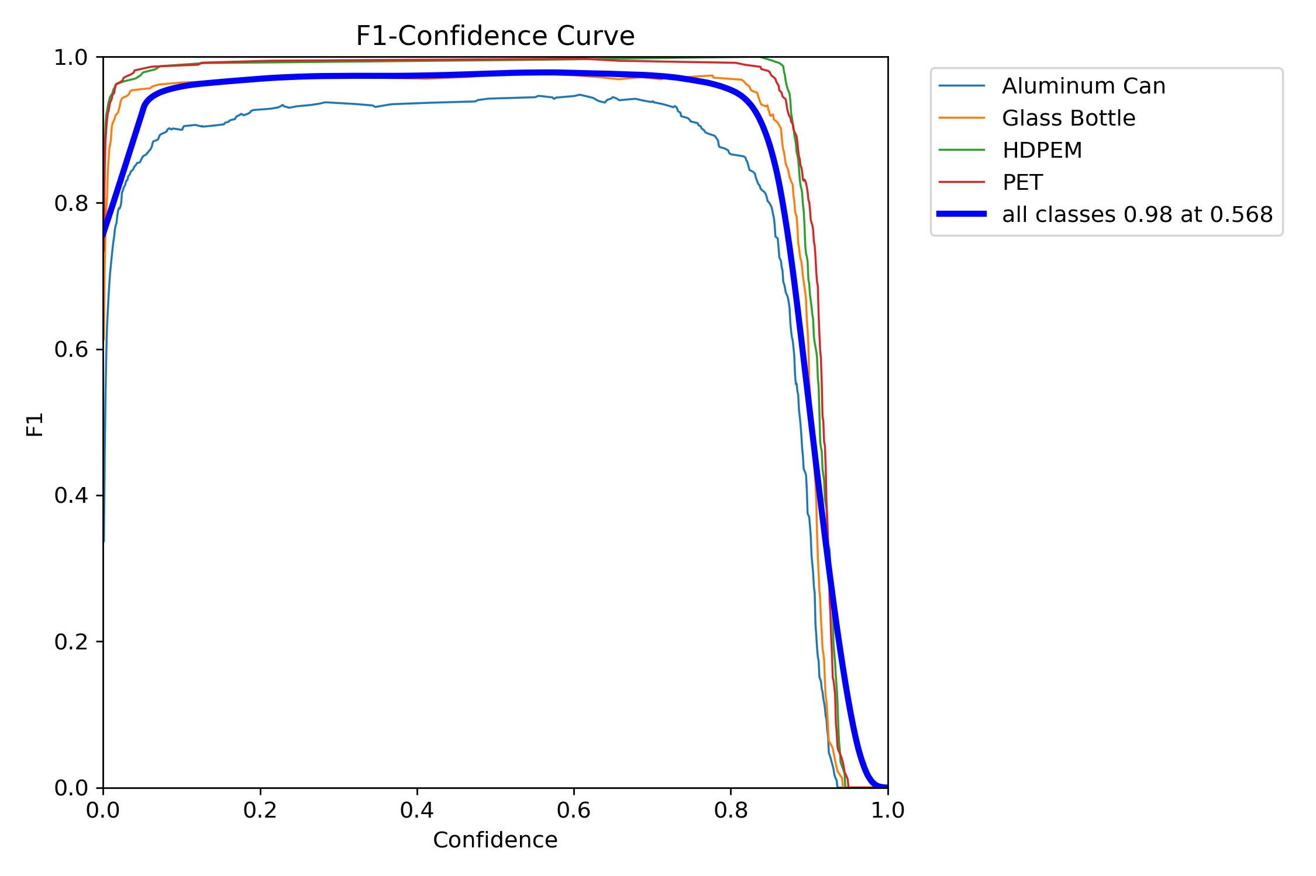

AHP_VALIDATION_SWSI

DBSCAN

QUANTITATIVE ABLATION RESULTS

ALLOCATION_MODULE

DASHOBOARD 1
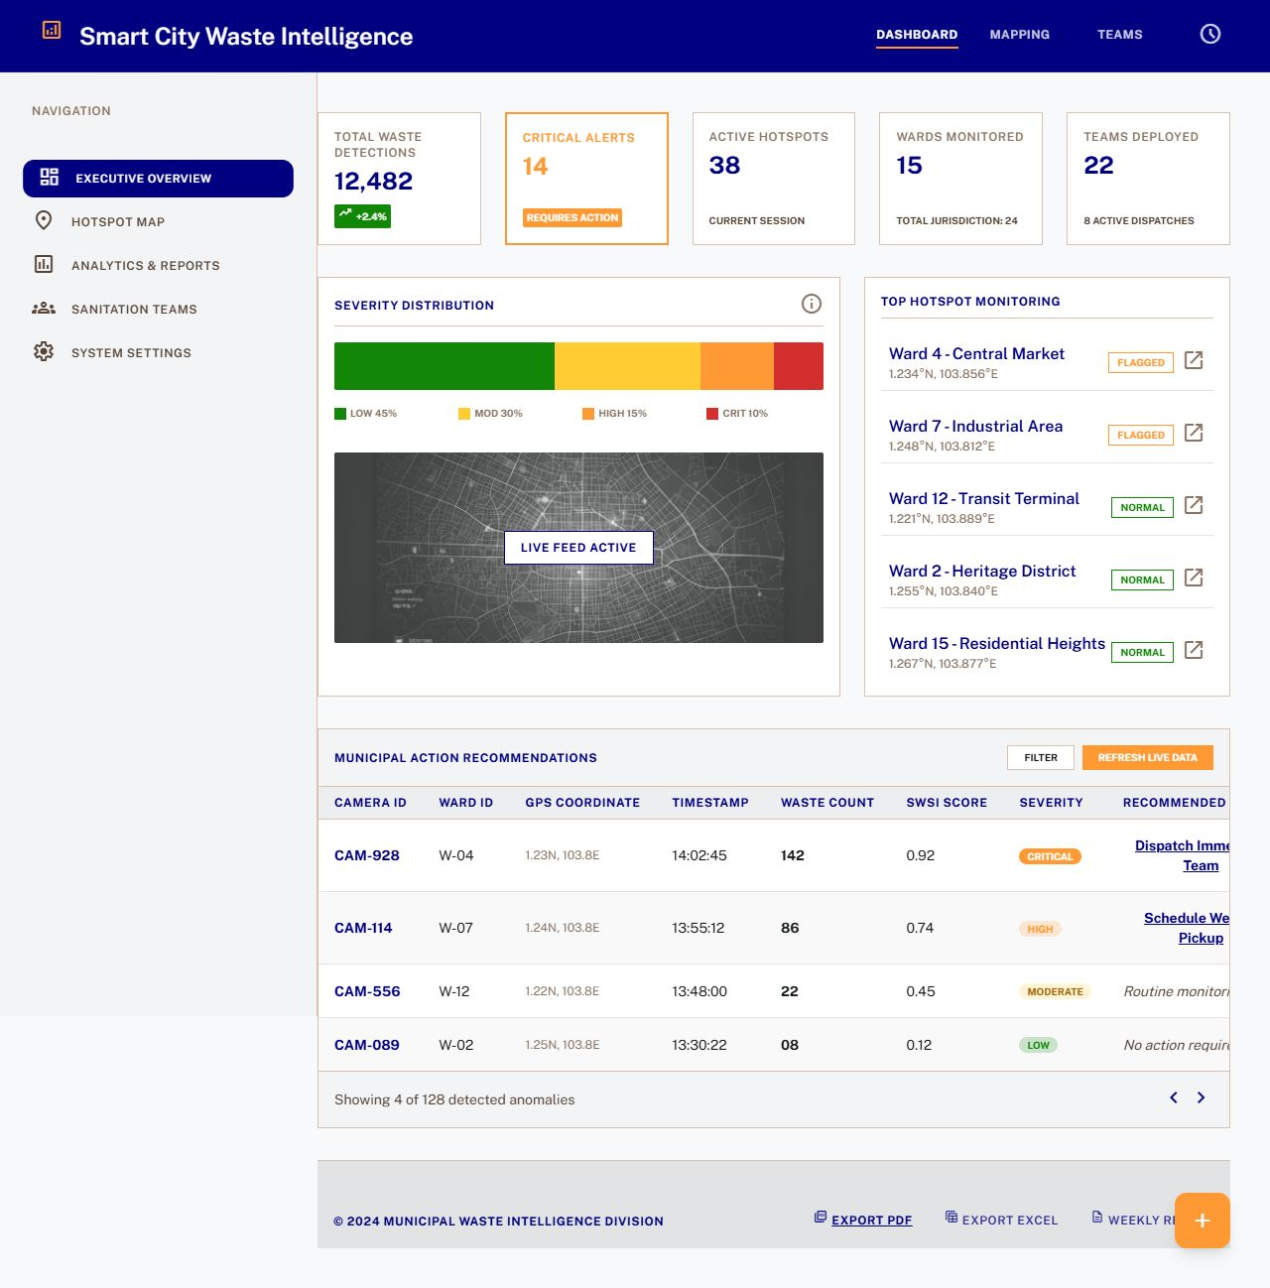

DASHBOARD 2
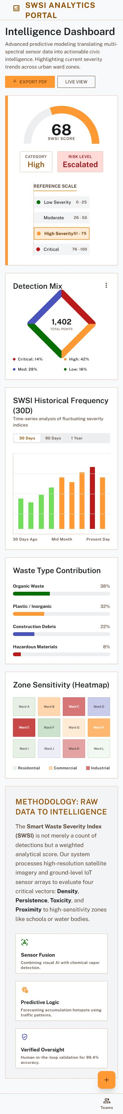

DASHBOARD 3


DASHBOARD 4



