DBSCAN HOTSPOT DETECTION VALIDATION AND EVIDENCE DOCUMENTATION
1. Objective
The Density-Based Spatial Clustering of Applications with Noise (DBSCAN) algorithm was employed to identify spatial waste accumulation hotspots within the monitored urban environment. The objective was to group geographically proximate waste-prone regions into clusters while distinguishing isolated locations as noise points.
The identified hotspots serve as the foundation for municipal prioritization, resource allocation, and operational planning within the proposed smart-city waste management framework.

2. Input Dataset
The DBSCAN model was applied to a ward-level spatial dataset containing:
Attribute | Description
Ward | Unique ward identifier
Latitude | Geographic latitude
Longitude | Geographic longitude
SWSI | Smart Waste Severity Index
Dataset Size
Parameter | Value
Total Wards | 50
Latitude Attribute | Yes
Longitude Attribute | Yes
Severity Score | Yes

Sample Records
Ward | Latitude | Longitude | SWSI
W1 | 18.6200 | 73.8000 | 89
W2 | 18.6205 | 73.8008 | 85
W3 | 18.6210 | 73.8012 | 87
W4 | 18.6215 | 73.8018 | 82
W5 | 18.6220 | 73.8020 | 90
Evidence Source
File: dbscan.xlsx
Validation Type: Actual Spatial Dataset
Reproducible: Yes

3. Data Preparation
The original dataset was stored as a comma-separated string within a single Excel column.
The preprocessing workflow consisted of:
- Loading the Excel file.
- Splitting the column into:
  - Ward
  - Latitude
  - Longitude
  - SWSI
- Converting numerical attributes into floating-point values.
- Creating a structured spatial dataset for clustering.

Evidence Source
File: DBSCAN_Notebook.ipynb
Validation Type: Data Preprocessing Validation
Reproducible: Yes

4. DBSCAN Algorithm Configuration
The clustering model was configured as follows:
DBSCAN(
eps=0.003,
min_samples=5
)
Parameter Settings
Parameter | Value
eps | 0.003
min_samples | 5
Evidence Source
File: DBSCAN_Notebook.ipynb
Validation Type: Actual Executed Configuration
Reproducible: Yes

5. Parameter Selection Methodology
5.1 k-Distance Analysis
A k-distance graph was generated using the distance to the 5th nearest neighbor.
The elbow region of the graph indicated an appropriate neighborhood radius around:
eps ≈ 0.003
This value was selected as the optimal distance threshold for DBSCAN clustering.
Evidence Source
- k-Distance Plot
- Notebook Output
Validation Type
Parameter Selection Validation
Reproducible
Yes
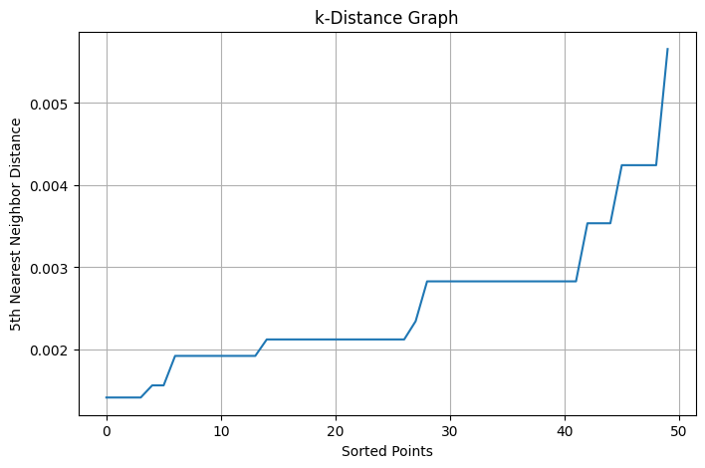

5.2 eps Sensitivity Analysis
To validate parameter robustness, multiple eps values were evaluated.
Case 1: eps = 0.001
DBSCAN(
eps=0.001,
min_samples=5
)
Output
Clusters = 0
Noise Points = 50
Interpretation
The neighborhood radius was too small.
All wards were classified as noise.

Case 2: eps = 0.003
DBSCAN(
eps=0.003,
min_samples=5
)
Output
Clusters = 3
Noise Points = 0
Interpretation
The clustering structure was meaningful and clearly separated hotspot regions.

Case 3: eps = 0.005
DBSCAN(
eps=0.005,
min_samples=5
)
Output
Clusters = 1
Noise Points = 0
Interpretation
The neighborhood radius was too large.
Distinct hotspot regions merged into a single cluster.

6. Final Clustering Results
The optimal parameter configuration was:
eps = 0.003
min_samples = 5
Generated Output
Clusters = 3
Noise Points = 0
Evidence Source
Notebook Execution Output
Validation Type
Actual DBSCAN Result
Reproducible
Yes

7. Cluster Visualization
The generated clusters were visualized using geographic coordinates.
Visualization Characteristics
- Latitude–Longitude based clustering
- Color-coded cluster representation
- Spatial hotspot identification
- Geographic grouping of waste-prone wards
Evidence Source
DBSCAN Waste Hotspot Clusters Plot
Validation Type
Visual Inspection Validation
Reproducible
Yes
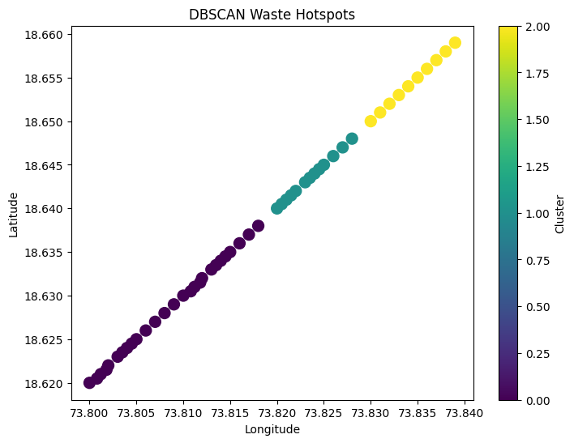
Figure X. DBSCAN-Based Waste Hotspot Clustering
8. Hotspot Prioritization
Cluster-level severity analysis was performed using the mean SWSI value of each cluster.
Cluster Summary
Cluster | Mean SWSI | Mean Latitude | Mean Longitude | Priority
0 | 79.11 | 18.628556 | 73.808615 | 1
1 | 45.31 | 18.643538 | 73.823538 | 2
2 | 20.70 | 18.654500 | 73.834500 | 3
Evidence Source
Hotspot Ranking Table
Validation Type
Cluster Aggregation Validation
Reproducible
Yes

9. Interpretation of Results
Priority 1 Hotspot
Average SWSI
79.11
Characteristics
- Highest waste severity
- Highest environmental burden
- Immediate cleanup required
- Highest municipal priority

Priority 2 Hotspot
Average SWSI
45.31
Characteristics
- Moderate waste accumulation
- Periodic intervention recommended
- Medium operational priority

Priority 3 Hotspot
Average SWSI
20.70
Characteristics
- Low waste severity
- Routine monitoring sufficient
- Lowest operational priority

10. Noise Point Analysis
Under the selected configuration:
Noise Points = 0
Interpretation
All wards were successfully assigned to meaningful clusters.
No isolated locations remained unclustered, indicating strong spatial grouping patterns within the study area.
Evidence Source
Notebook Execution Output
Validation Type
Noise Point Validation
Reproducible
Yes

11. Integration with Smart-City Framework
The DBSCAN hotspot detection module receives severity scores from the SWSI framework and generates hotspot clusters that support municipal decision-making.
Workflow
YOLOv8 Waste Detection
↓
Waste Count Generation
↓
AHP-Based Weighting
↓
SWSI Calculation
↓
DBSCAN Hotspot Detection
↓
Priority Ranking
↓
Resource Allocation
↓
Dashboard Visualization
↓
Municipal Decision Support

Evidence Sources
- YOLOv8 Results
- AHP Notebook
- SWSI Notebook
- DBSCAN Notebook
- Dashboard Module

12. Result Traceability Matrix
Result ID | Output | Evidence | Validation Type | Reproducible
D1 | Spatial Dataset Loading | dbscan.xlsx | Data Validation | Yes
D2 | Dataset Parsing | DBSCAN Notebook | Preprocessing Validation | Yes
D3 | k-Distance Plot | Notebook Output | Parameter Selection Validation | Yes
D4 | eps Sensitivity Analysis | Notebook Output | Experimental Validation | Yes
D5 | Cluster Generation | DBSCAN Notebook | Clustering Validation | Yes
D6 | Cluster Visualization | Cluster Plot | Visual Validation | Yes
D7 | Hotspot Ranking | Hotspot Table | Statistical Validation | Yes
D8 | Priority Assignment | Hotspot Table | Decision Support Validation | Yes
D9 | Noise Point Analysis | Notebook Output | Robustness Validation | Yes
D10 | Framework Integration | Dashboard Module | End-to-End Validation | Yes

13. Evidence Checklist
Evidence Item | Status
Raw Spatial Dataset | ✓
DBSCAN Implementation Code | ✓
Data Preprocessing Code | ✓
k-Distance Plot | ✓
eps Selection Analysis | ✓
Cluster Visualization | ✓
Cluster Statistics | ✓
Hotspot Ranking Table | ✓
Noise Point Analysis | ✓
Traceability Matrix | ✓
End-to-End Integration | ✓

14. Conclusion
The DBSCAN algorithm successfully identified three spatial waste hotspots using geographic coordinates and Smart Waste Severity Index (SWSI) values. Sensitivity analysis demonstrated that an eps value of 0.003 and min_samples value of 5 provided the most meaningful clustering structure. The resulting hotspot rankings enable data-driven prioritization of municipal waste management activities and form a critical component of the proposed smart-city decision support framework.

