**PHP Assignment**

**Aim 1:** Write a program to check whether given string is Palindrome number or not.

**Program:**

**HTML File:**

<html>

<body>

<form action="pal.php" method="post">

Enter String <input type="text" name="str"><br>

<input type="submit" value="submit">

</form>

</body>

</html>

**PHP File**

<?php

$str1 =$_POST["str"];

if(strrev($str1)===$str1)

echo "String is pallindrome";

else

echo "String is not pallindrome";

?>

**Output:**

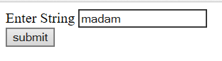  
String is palindrome.

**Aim 2:** Write a PHP program to print first n numbers in Fibonacci Series.

**Program**:

**HTML File**

<html>

<body>

<form name= "fibon"action="fibo.php" method="post">

Enter number: <input type="number" name="n"><br>

<input type="submit" value = Submit>

</form>

</body>

</html>

**PHP File**

<html>

<body>

<h3>Fibonacci Series </h3>

<?php $num= $_POST["n"];

echo "The series of 1st $num numbers are : ";

fibo($num);

function fibo($num)

{

$n0=0;

$n1=1;

$sum=0;

$i=0;

echo $n0." ",$n1." ";

while ( $i< $num-2)

{

$sum = $n0+$n1;

$n0=$n1;

$n1=$sum;

echo $sum." ";

$i++;

}

}

?>

</body>

</html>

**Output:**

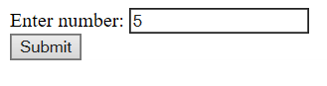



**Aim 3:** Programs to create simple Login and Logout using sessions.

**Program:**

**HTML File:**

<!DOCTYPE html>

<head></head>

</body>

<form method="POST" action="#">

<div id="success"></div>

<label>Username<span class="required">*</span></label>

<input type="text" name="user" required>

<br><br>

<label>Password</label><span class="required">*</span>

<input type="password" name="password">

<br><br>

<input class="btn btn-default" value="Login" name="submit" type="submit" />

</form></body>

</html>

**PHP File: Login.php**

<?php

if(isset($_POST['submit']))

{

session_start();

$user=$_POST['user'];

$_SESSION['username']=$user;

header('location:welcome.php');

}

?>

**Welcome.php**

<?php

session_start();

echo "Welcome ".$_SESSION['username'];

?>

<!DOCTYPE html>

<html>

<body>

<form method="post">

<input type="submit" value="Logout" name="logout">

</form>

</body>

</html>

<?php

if(isset($_POST['logout']))

{

header("location:login.php");

}

?>

**Output:**

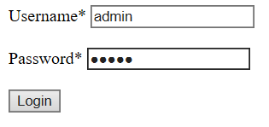

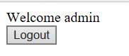

**Aim 4:** Write a program to demonstrate the use of COOKIE in PHP.

**Program:**

**PHP File:**

<?php

$cookie_name = "user";

$cookie_value ="abc";

setcookie($cookie_name,$cookie_value,time()+(86400*30),"/");

if(!isset($_COOKIE[$cookie_name]))

{ echo "Cookie named '".$cookie_name."'is not set!"; }

else

{ echo "Cookie '".$cookie_name."' is set!<br>";

echo "value is : ".$_COOKIE[$cookie_name]; }

?>

**Output**:

