SUPERSTORE SALES ANALYSIS AND INTERACTIVE DASHBOARD
1. INTRODUCTION
Data analysis plays an important role in understanding business performance and making better decisions. Businesses collect large amounts of sales data, but this data needs to be analyzed to identify useful patterns and trends.
This project focuses on analyzing Superstore sales data to understand sales performance, profitability, customer segments, product categories and regional performance.
An interactive dashboard is created using Tableau to present the analysis through charts, graphs, KPIs and filters.
2. PROBLEM STATEMENT
The objective of this project is to analyze Superstore sales data and identify important business trends, patterns and performance indicators.
The project aims to understand which products and regions generate higher sales and profits, identify top-performing cities and categories, and analyze monthly sales trends.
The analysis helps businesses identify areas of improvement and make better data-driven decisions.
3. DATASET INFORMATION
The project uses the Superstore dataset, which contains information about customer orders, products, sales, profits and shipping details.
Dataset details:
- Dataset Name: Superstore Sales Dataset
- Main Table: Orders
- Data Type: Retail Sales Data
- File Format: CSV / Excel
- Tool Used: Tableau
Important Columns
Column | Description
Order ID | Unique order identification
Order Date | Date when the order was placed
Ship Date | Date when the order was shipped
Customer Name | Name of the customer
Segment | Customer segment
Region | Geographical sales region
City | Customer city
Category | Product category
Sub-Category | Product sub-category
Sales | Total sales amount
Quantity | Number of products sold
Discount | Discount provided
Profit | Profit earned
4. DATA CLEANING PROCESS
Data cleaning is performed to improve data quality and make the dataset suitable for analysis.
The following checks and cleaning activities are included:
- Missing Values: Checked the dataset for blank or missing values.
- Duplicate Records: Checked for duplicate records.
- Data Types: Verified that date, numerical and text columns have appropriate data types.
- Inconsistent Values: Checked category, region and segment names for inconsistencies.
- Date Formatting: Ensured that order dates and shipping dates are in the correct date format.
- Unnecessary Columns: Reviewed columns and removed unnecessary fields where required.
The cleaned dataset is used for further analysis and dashboard creation.
Note: Keep only the cleaning operations you actually performed. Add the number of missing values or duplicates removed if you have those results.
5. EXPLORATORY DATA ANALYSIS (EDA)
Exploratory Data Analysis is performed to understand the dataset and identify useful business patterns.
The following calculations and analysis are performed:
- Total Sales: Calculated using SUM(Sales).
- Total Profit: Calculated using SUM(Profit).
- Total Orders: Calculated using COUNTD(Order ID), if counting unique orders.
- Total Quantity: Calculated using SUM(Quantity).
- Average Discount: Calculated using AVG(Discount).
These calculations help in understanding overall business performance.
6. DATA VISUALIZATION
Different charts are created using Tableau to understand sales and profit performance.
6.1 Monthly Sales Trend
A line chart is used to analyze monthly sales performance.
It helps identify months with higher and lower sales and understand changes in sales throughout the year.
6.2 Sales by City
A bar chart is used to compare sales across different cities.
It helps identify cities that contribute more to the overall sales.
6.3 Profit by Region
A bar chart is used to compare profit across four regions: Central, East, South and West.
It helps identify the most and least profitable regions.
6.4 Sales by Category
A pie chart is used to compare sales across three product categories:
- Furniture
- Office Supplies
- Technology
It helps understand the contribution of each category to total sales.
6.5 Sales by Sub-Category
A horizontal bar chart is used to compare sales across different product sub-categories.
It helps identify the products that contribute the most to sales.
6.6 Sales by State
A filled map is used to display geographical sales performance across different states.
It helps understand the geographical distribution of sales.
7. INTERACTIVE DASHBOARD
An interactive dashboard titled "Sales Performance" is developed using Tableau.
The dashboard combines different visualizations in one place to provide a clear overview of business performance.
Dashboard Components
- KPI Cards: Display total orders and total sales.
- Line Chart: Shows monthly sales trends.
- City-wise Sales Chart: Compares sales across different cities.
- Regional Profit Chart: Displays profit by region.
- Category-wise Sales Chart: Shows sales distribution across product categories.
- Sub-Category Chart: Compares sales across product sub-categories.
- Filled Map: Displays geographical sales distribution.
The dashboard helps users understand business performance through visual representations and interactive analysis.
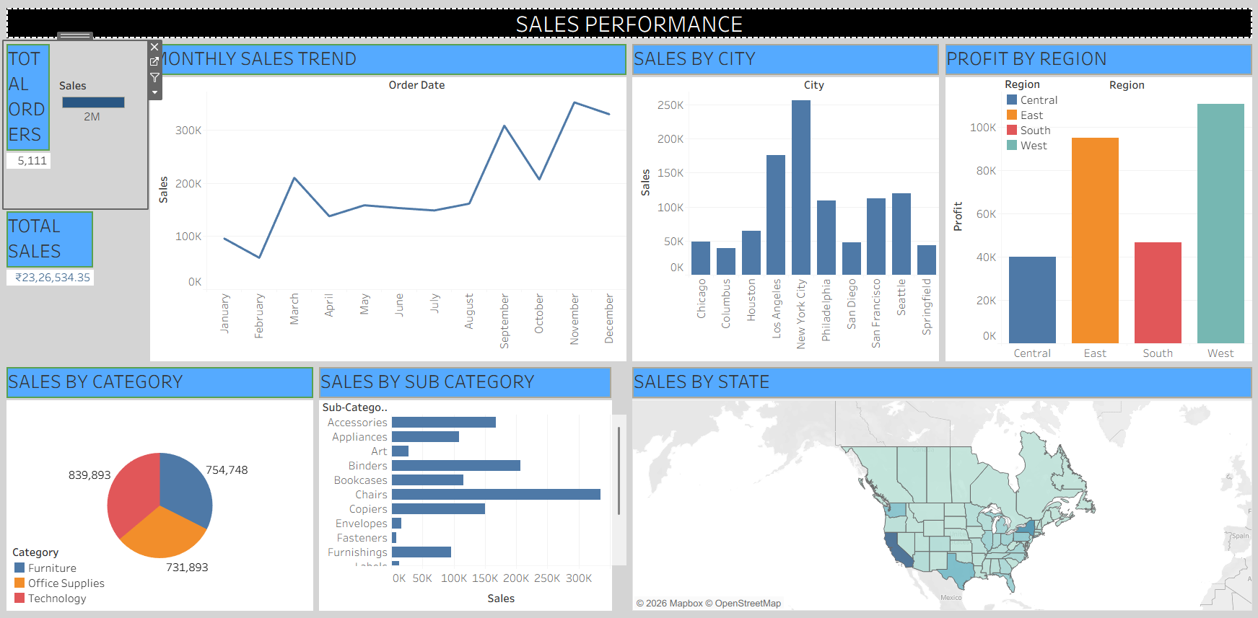8. KEY BUSINESS INSIGHTS
Based on the dashboard analysis, the following business insights are identified:
- Category Performance: Technology contributes the highest sales among the three product categories, followed by Furniture and Office Supplies.
- Regional Profit: The West region generates the highest profit, followed by the East region. The Central region has comparatively lower profit.
- City Performance: New York City records the highest sales among the cities displayed in the dashboard.
- Sub-Category Performance: Chairs show strong sales performance compared to the other displayed sub-categories.
- Monthly Sales Trend: Sales are relatively high in November and December, while February shows comparatively lower sales.
These insights help identify high-performing products, regions and cities and understand monthly sales patterns.
9. CONCLUSION
The Superstore Sales Analysis project provides an understanding of business performance through data analysis and visualization.
The project examines sales, profit, product categories, customer orders and regional performance. Different charts and KPIs are used to identify important business trends and patterns.
The interactive Tableau dashboard presents the findings in a simple and understandable format. These insights can help businesses improve their sales strategies, identify opportunities and make better business decisions.
10. TOOLS AND TECHNOLOGIES USED
- Dataset: Superstore Dataset
- Data Cleaning: Excel / Python (as used)
- Data Analysis: Tableau
- Data Visualization: Tableau
- Dashboard Development: Tableau
- Project Documentation: Microsoft Word
- Project Hosting: GitHub
11. PROJECT DELIVERABLES
The final project includes:
- Original Superstore dataset.
- Cleaned dataset.
- Exploratory data analysis.
- Data visualizations.
- Interactive Tableau dashboard.
- Key business insights.
- Final project report.
- GitHub repository containing the project files.

