***Q1. What are explosives & how they can be classified? Also define power index.***

***A.***

* An explosive material, is a reactive substance that contains a great amount of potential energy that can produce an explosion if released suddenly, usually accompanied by the production of light, heat, sound and pressure.
* An explosive charge is a measured quantity of explosive material, which may be composed of a single ingredient or a combination of two or more.
* An explosion is a type of spontaneous chemical reaction that, once initiated, is driven by both a large exothermic change and a large positive entropy change (great quantities of gases are released) in going from reactants to products, thereby constituting a thermodynamically favourable process in addition to one that propagates very rapidly.
* Explosives are substances that contain a large amount of energy stored in chemical bond.
* Explosive materials can be classified by the speed at which they expand. Materials that detonate (the front of the chemical reaction moves faster through the material than the speed of sound) are said to be "high explosives" and materials that deflagrate are said to be "low explosives".
* Mechanism of igniting a low explosive is thermal (Fuse/Spark), electric current/spark, friction and impact
* Low explosives are used in propellants and to ignite high explosives.
* High explosives do not ignite or detonate without high pressure compression associated with shock wave.
* To detonate primary explosives detonators are used because they produce shock wave and detonation, not just ignition or deflagration.
* The explosive power of a bomb depends on the heat evolved (Q) and volume of gaseous product produced (V) and expressed as the product of these two quantities.
* Explosive power = Q x V
* Power index is defined as the relative power of one explosive compared with another.
* Power Index = Q x VExplosive  / Q x VPicric acid

***Q2. Write brief note on the following***

***a) Analysis of fire debris***

***b) Physical and chemical properties of explosives***

***A.*** **Analysis of fire debris:**

* The most common accelerants are petroleum distillates like petrol, jet fuel and kerosene.
* Classification of ignitable fuels plays important role in the analysis of fire debris and each class of fuel is sub-divided into three groups on the basis of carbon chain length which correlates with volatility.
* Fire debris evidence is collected paint coated can (container) having predrilled hole sealed with septum.
* Sample preparation for analysis of fire debris is:
  + Steam Distillation
  + Solvent extraction of fire debris with pentane & carbon disulphide (CS2).
  + Headspace Methods
  + Solid Phase Micro-extraction
  + Instrumental Method
* Gas Chromatography coupled with Mass Spectrometer or Flame Ionization Detector.
* Collection and analysis of background samples (matrix control) is also essential. For example, debris containing an accelerant collected on carpet, sample of carpets made up of polymer (many polymers are derived from petrochemical products.

**Physical and chemical properties of explosives:**

* Explosions are inherently powerful and dangerous to people and property.
* An explosion is a sudden and violent escape of gases from a central point accompanied by high temperature, violent shock and loud noise.
* Explosives can be organized into six distinct chemical “families”, which are based upon chemical structure.
* Explosives can be classified based upon their explosive power and explosive mechanism. This results in two main types of explosives: low explosives and high explosives.
* Explosives can be further classified based upon their manufacturer and purpose. Hence, they can be of three types: Commercial, Military and Improvised.
* 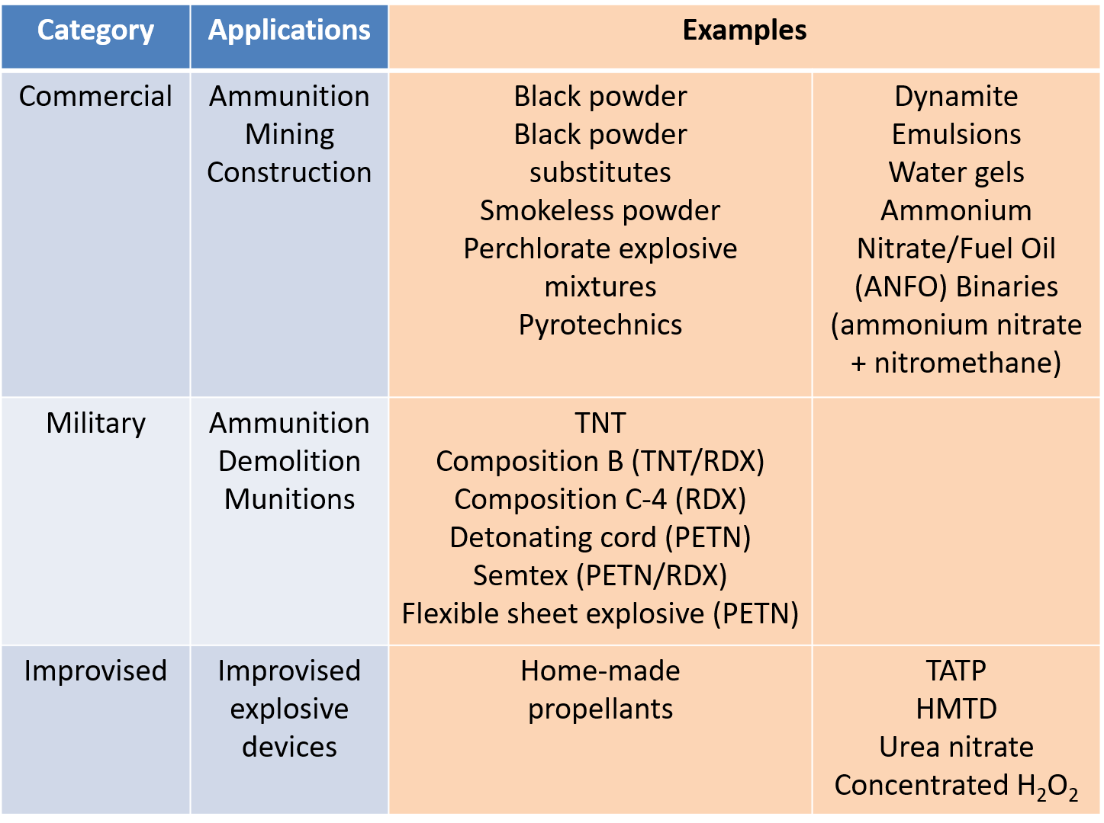The following table shows the three types with its examples:

***Q3. Descriptive note on the following***

***a) Gun Powder b) RDX c) Perchlorate d) TNT***

***A.*** **a) Gun powder:**

* Black Powder or Gun powder is a low explosive powder made from a combination of Sulphur (10%), charcoal (15%) and potassium nitrate (75%).
* The main role of Sulphur gunpowder is to decrease the ignition temperature. A sample reaction for sulphur-free gunpowder would be

6 KNO3 + C7H4O → 3 K2CO3 + 4 CO2 + 2 H2O + 3 N2

* The main role of Potassium nitrate is to provide oxygen necessary for combustion reaction.
* Charcoal consists of broken-down cellulose and provides carbon and other fuel for the reaction.
* Black Powder deflagrates rather than explodes (i.e., has a velocity of Detonation < 1000m/s) when confined and as such is suited for use in ‘gentle’ blasting applications such as dimension stone production.

**b) RDX:**

* **RDX** or Research Department explosive or Royal Demolition explosive, formally cyclotrimethylenetrinitramine, also called cyclonite, hexogen, or T4.
* It is an organic compound with the formula (O2NNCH2)3. It is a white solid without smell or taste, widely used as an explosive.
* Chemically, it is classified as a nitramide. It is more energetic explosive than TNT.
* Its molar Mass is 222.22 G/mole and appearance is colourless crystal.
* Its melting Point is 205.5 °C and boiling point is 234 °C. Density at 20 °C is 1.82g/ml while explosive velocity is 8750 m/s.
* It does not have enough oxygen in its molecular formula to completely oxidize everything during an explosion.
* It is only after contact with the atmospheric oxygen that can allow complete combustion to occur. The decomposition reaction of RDX

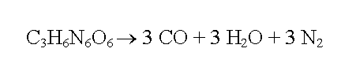

**c) Perchlorate:**

* A perchlorate is the name for a chemical compound containing the perchlorate ion, ClO−4.
* Perchlorate salts are mainly used for propellants, exploiting properties as powerful oxidizing agents and to control static electricity in food packaging.
* Perchlorate is the anion resulting from the dissociation of perchloric acid and its salts upon their dissolution in water.
* Most of the perchlorates are colourless solids that are soluble in water. Many perchlorate salts are soluble in non-aqueous solutions.
* Four perchlorates are of primary commercial interest: Ammonium perchlorate (NH4ClO4), Perchloric acid (HClO4), Potassium perchlorate (KClO4), and Sodium perchlorate (NaClO4).
* Chemically, the term perchlorate refers to the anion consisting of a chlorine molecule in a +7 valence state combined with four oxygen molecules in a typical sp3 tetrahedron.
* The chlorine in the perchlorate anion is a closed shell atom and is well protected by the four oxygens.
* Most perchlorate compounds, especially salts of electropositive metals such as sodium perchlorate or potassium perchlorate, do not oxidize organic compounds until the mixture is heated.
* Despite its oxidative potential, the perchlorate anion is surprisingly stable and typically requires high activation energy in order to overcome the kinetic barrier to its reduction. These characteristics distinguish perchlorate compounds.
* This property is useful in many applications, such as flares/fuse, where ignition is required to initiate a reaction.
* Ammonium perchlorate is stable when pure but can form potentially explosive mixtures with reactive metals or organic compounds.
* Perchlorate’s oxidative ability is evidenced by the reduction potentials for its reduction to chloride and chlorate:

ClO4 – + 8 H+ + 8 e ↔ Cl- + 4 H2O Eº = 1.287 V

ClO4 – + 2 H+ + 2 e ↔ ClO3 - + H2O Eº = 1.201 V

**d) TNT:**

* 2,4,6-Trinitrotoluene or TNT is an explosive chemical that can cause skin irritation and other toxic consequences.
* Its chemical formula is C7H5N3O6
* It is a yellow, odourless solid that does not occur naturally in the environment.
* It is combustible and flammable, bubbling, fizzing and colour change to yellow when reacting with atmospheric oxygen.
* Its melting point is 80.25°C, boiling point is 240.0 °C and density is 1.654 g/cm3.
* Its water solubility is 115mg/L at 23°C, vapour density is 7.85, and ionization potential is 10.59 eV.
* Upon detonation, TNT decomposes as follows:

2 C7H5N3O6 → 3 N2 + 5 H2O + 7 CO + 7 C

2 C7H5N3O6 → 3 N2 + 5 H2 + 12 CO + 2 C

* The reaction is exothermic but has a high activation energy in the gas phase which is almost equal to 62 kcal/mol.
* The condensed phases (solid or liquid) show markedly lower activation energies of roughly 35 kcal/mol due to unique bimolecular decomposition routes at elevated densities.
* Due to the production of carbon, TNT explosions have a sooty appearance.
* Because TNT has an excess of carbon explosive mixtures with oxygen-rich compounds can yield more energy per kilogram than TNT alone.