Machine Learning Algorithm for Soil Analysis and Classification of Micronutrients in IoT-Enabled Automated Farms

In this paper author employing deep learning based algorithm called Extreme Learning Model (ELM) to classify soil nutrients which helps in predicting crop growth. High nutrients make soil more fertile so using IOT sensor author collecting soil nutrients such as PH, potassium, nitrogen etc. This nutrients will get trained with ELM algorithm and this training model can be applied on new test data to predict soil as ‘Less Fertile, Medium and high fertile’.

To train above algorithm we have downloaded soil fertility dataset from below KAGGLE URL

<https://www.kaggle.com/datasets/rahuljaiswalonkaggle/soil-fertility-dataset>

author compare propose ELM performance with existing algorithm like SVM and each algorithm performance is evaluated in terms of accuracy, precision, recall and FSCORE.

To implement this project we have designed following modules

1. User Login: any user can login to system using username and password as ‘admin and admin’
2. Process dataset: after login user can load dataset and then perform dataset processing like removing missing values, shuffling and normalization and then split dataset into train and test where application using 80% dataset for training and 20% for testing
3. Existing SVM: using this module application will input 80% training data to SVM algorithm to train a model and this model will be applied on 20% test data to calculate prediction accuracy
4. Propose ELM: using this module application will input 80% training data to ELM algorithm to train a model and this model will be applied on 20% test data to calculate prediction accuracy
5. Comparison Graph: will plot comparison graph between both algorithms
6. Predict Fertility: using this module will plot test data and then ELM will predict soil fertility.

SCREEN SHOTS

To run project double click on run.bat file to get below screen

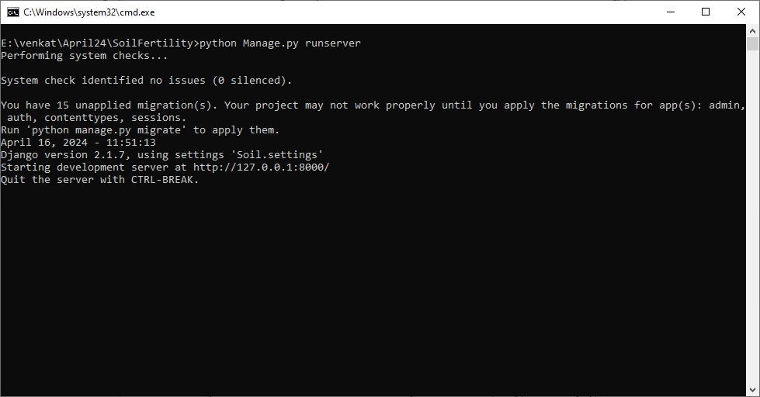

In above screen python server started and now open browser and enter URL as <http://127.0.0.1:8000/index.html> and press enter key to get below page



In above screen click on ‘User Login’ link to get below page

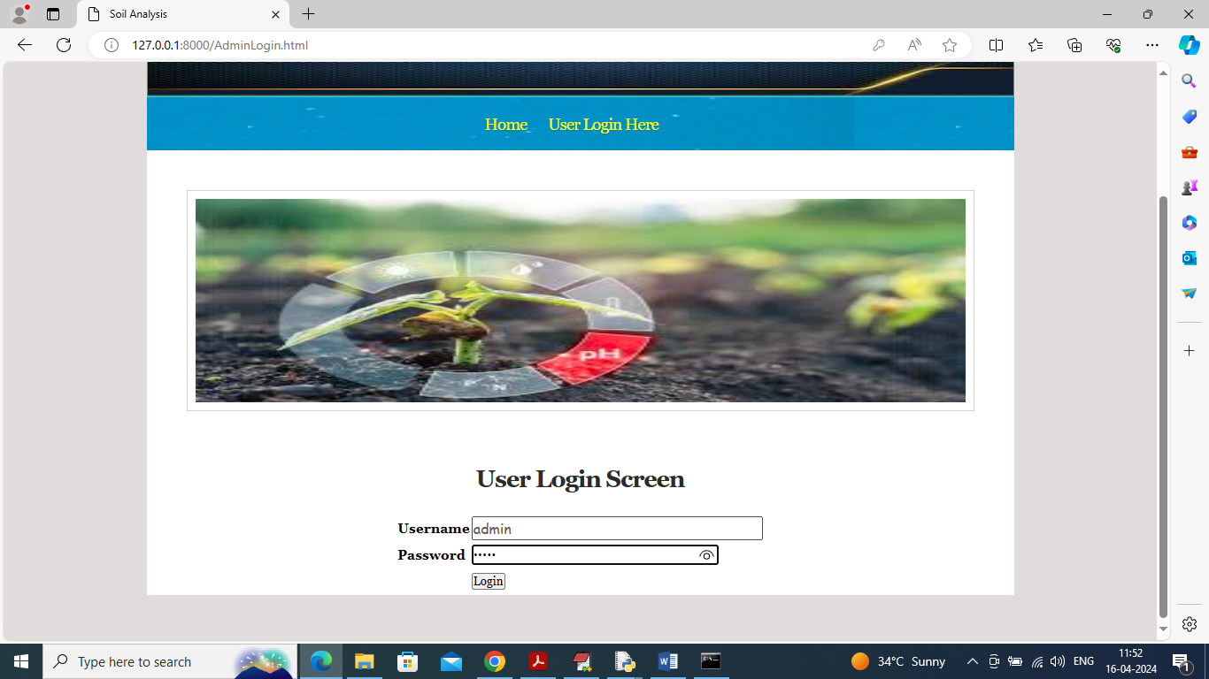

In above screen user is login and after login will get below page



In above screen user can click on ‘Process Dataset’ link to load and process dataset and get below page

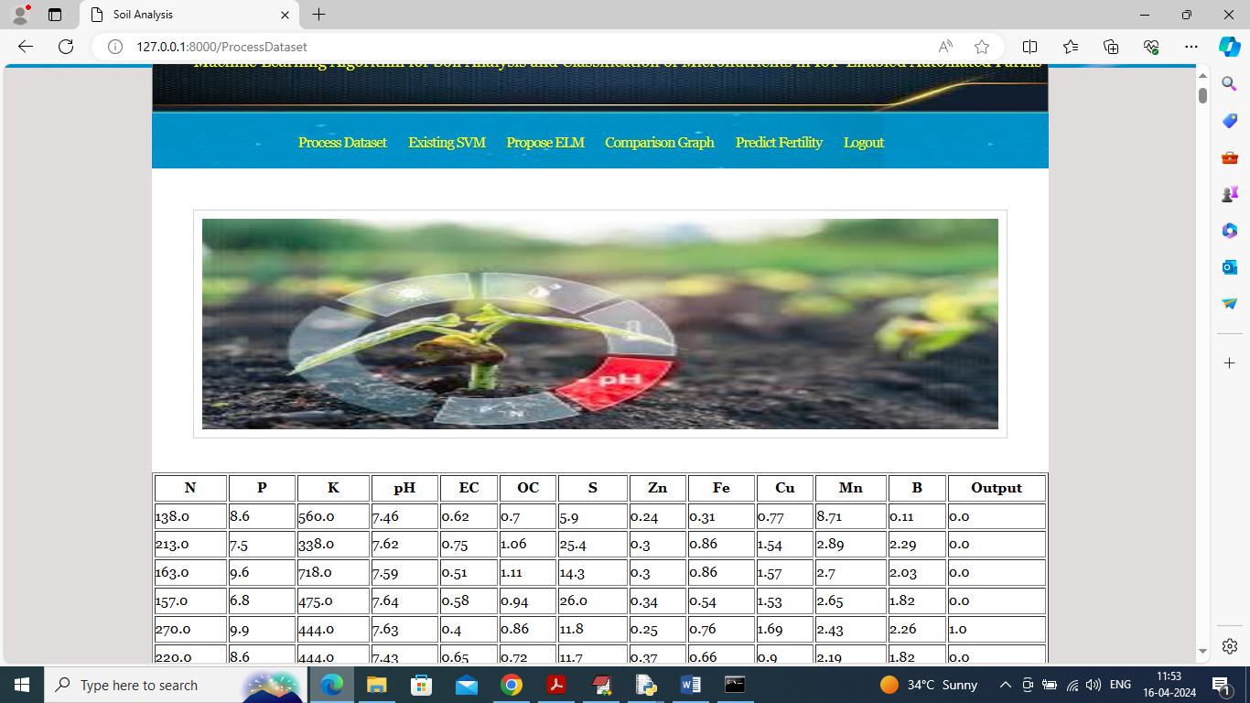

In above screen dataset loaded and can see all soil nutrients values and now click on ‘Existing SVM’ link to train SVM and get below output

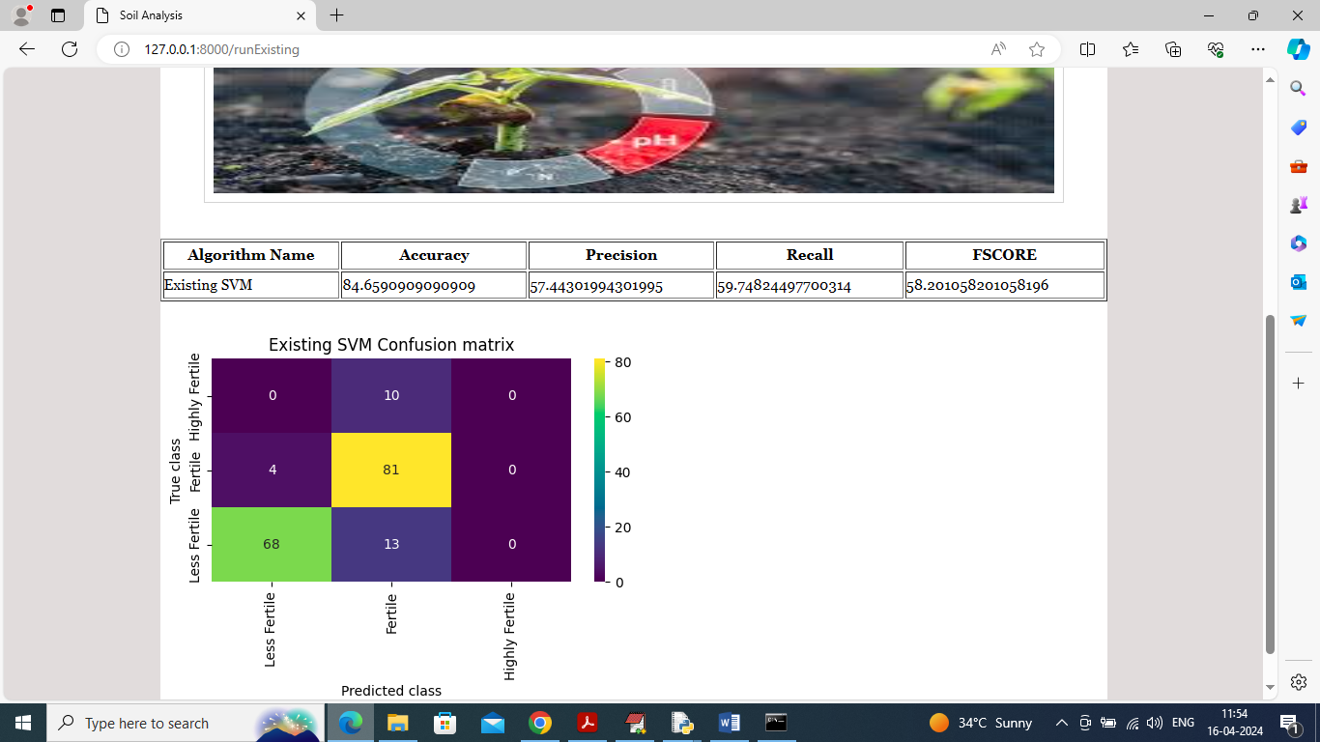

In above screen SVM training completed and can see accuracy as 84% and can see other metrics like precision, recall and FSCORE. In confusion matrix graph x-axis represents Predicted Labels and y-axis represents True Labels and then all different colour boxes in diagnol represents correct prediction count and remaining blue boxes represents incorrect prediction count which are very few and now click on ‘Propose ELM’ link to train propose model and get below page

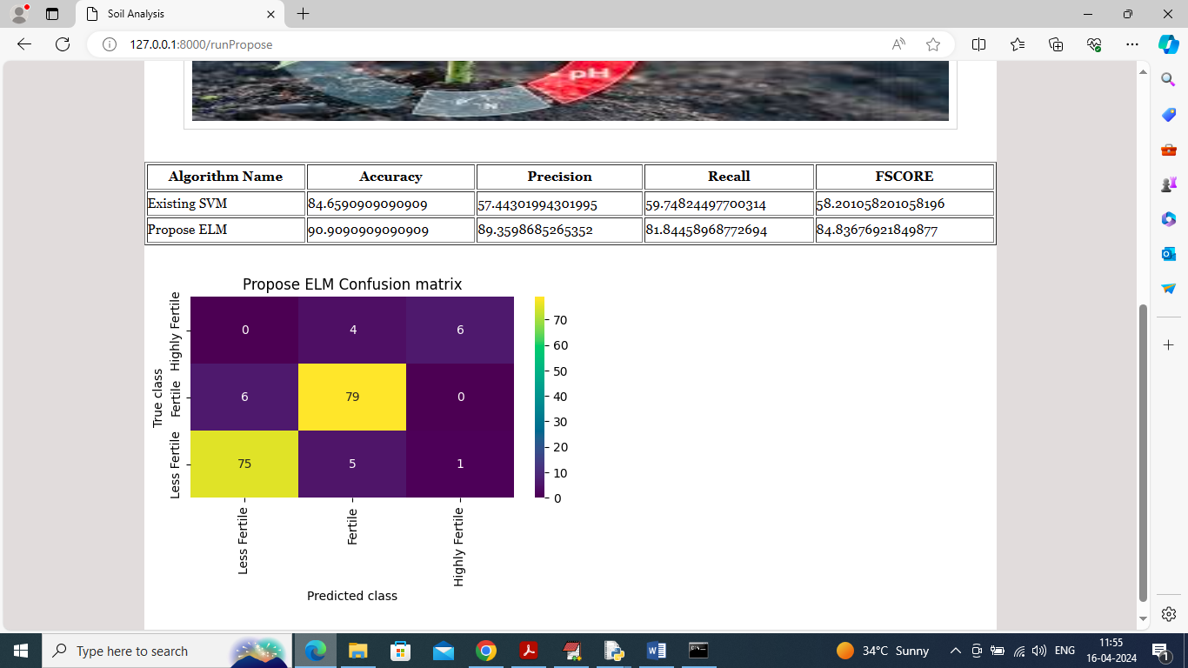

In above screen propose ELM got 90% accuracy and can see other metrics also and now click on ‘Comparison Graph’ link to get below page

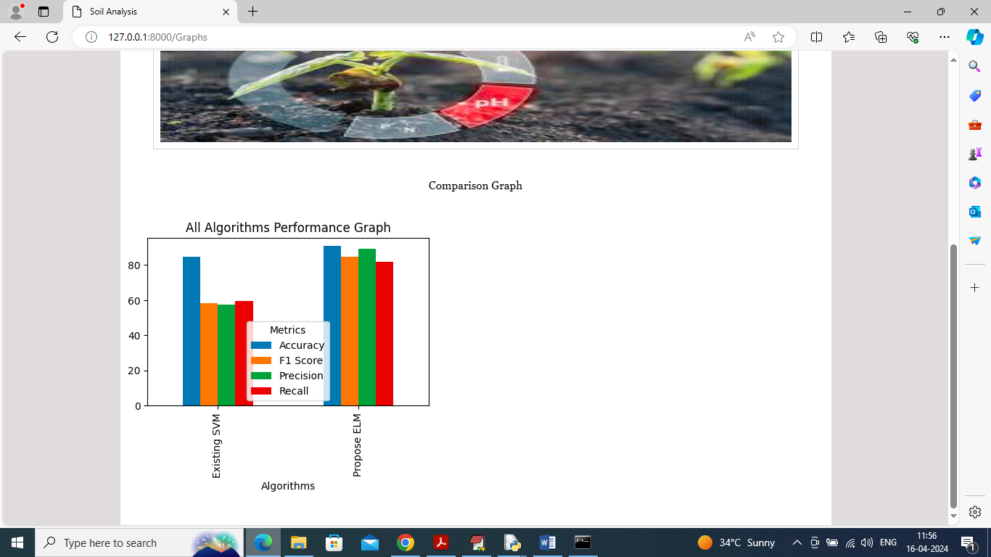

In above graph x-axis represents algorithm names and y-axis represents accuracy and other metrics in different colour bars and in both algorithms propose got high accuracy and now click on ‘Predict Fertility’ link to get below page

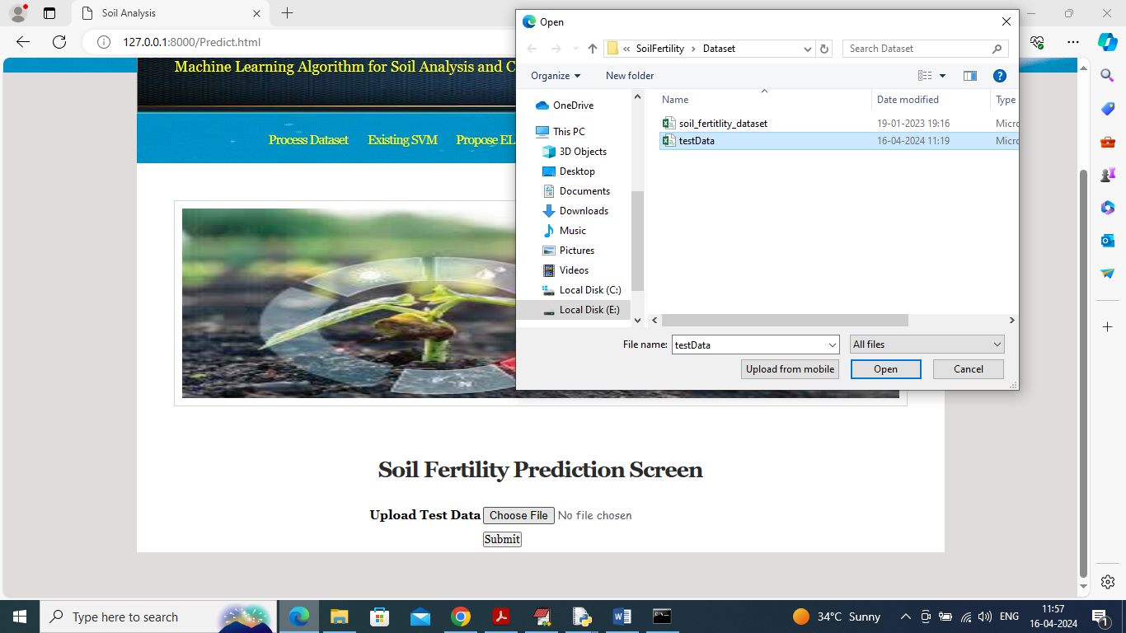

In above screen selecting and uploading ‘test data’ and then click on ‘Open’ and ‘Submit’ button to get below page

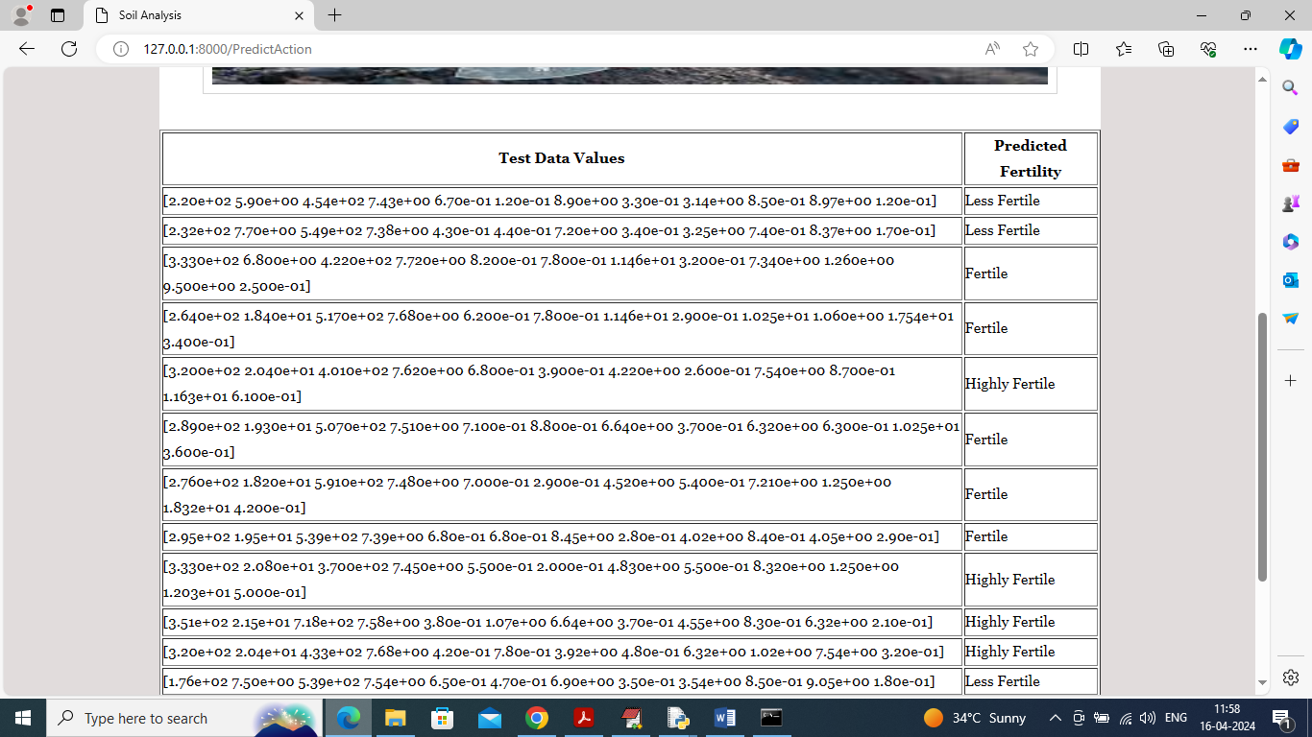

In above screen in first column can see soil test data and then in second column can see soil prediction as ‘High, low and medium’.